**Lesson 3 Demo 1**

**Creating Services for Data in App**



**Steps to perform:**

1. Generate a service named **products**

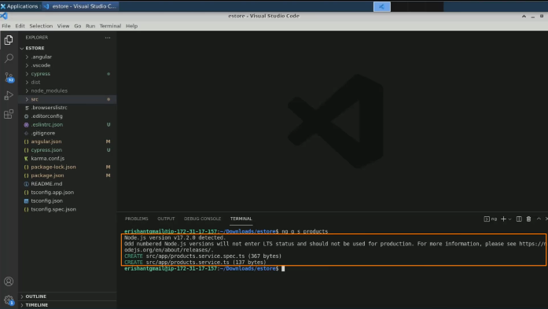

1. Open **products.components.ts** file

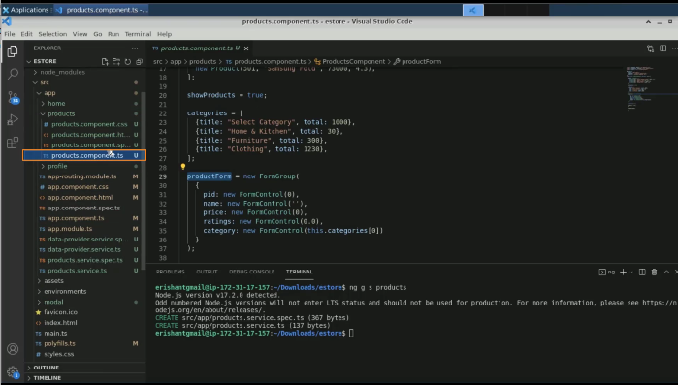

1. Get the array of products from here:

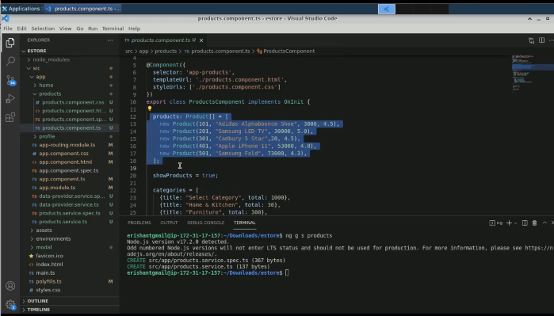

1. Bring it to the **service.ts** file

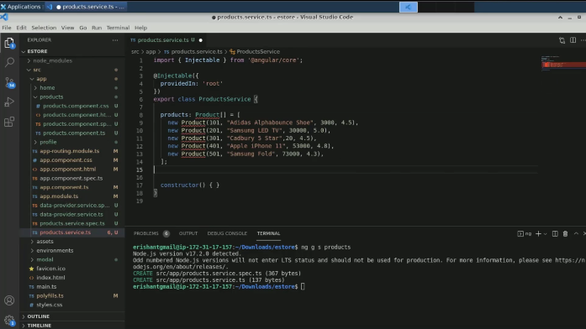

1. Add one more function named **products**

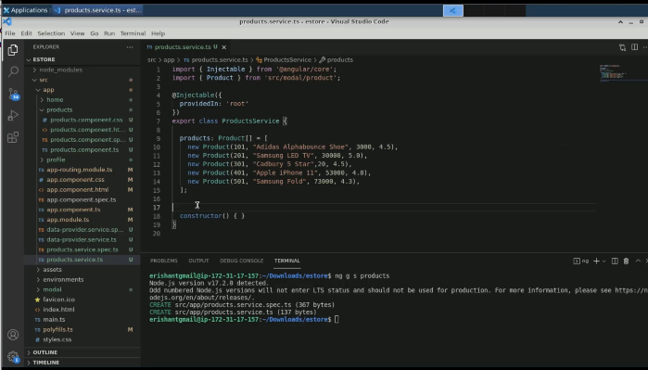

1. Pass a return command

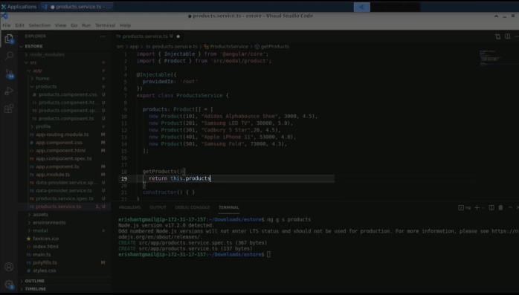

1. Open **products.component.html** file

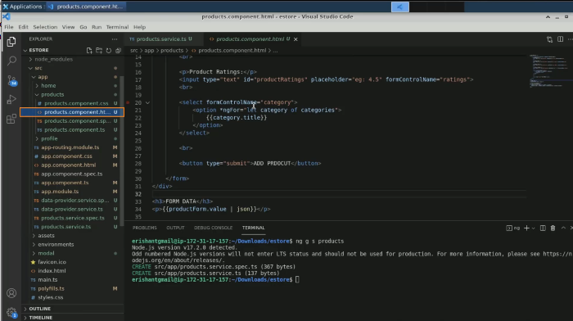

1. Add a service injection command in **products.component.ts**

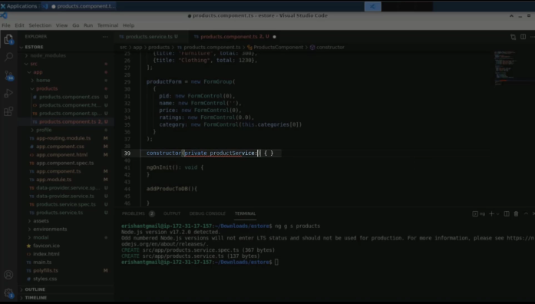

1. Copy that and bring it to **products.service.ts**

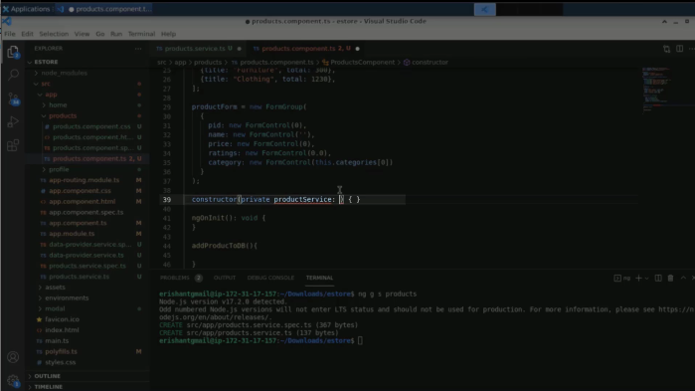

1. Add a command for it instead of component

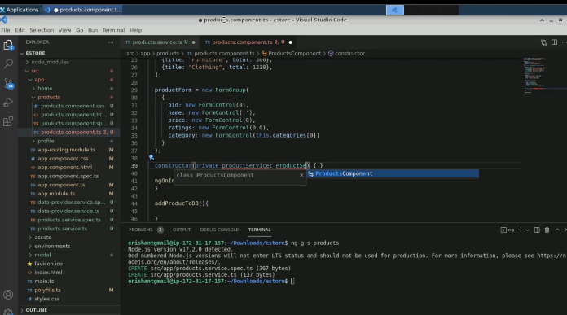

1. Have a separate data structure for products

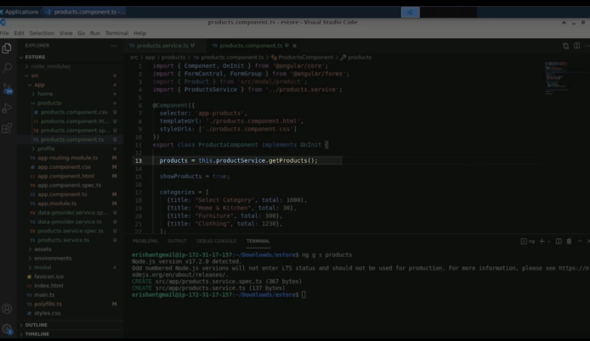

1. Add one more product

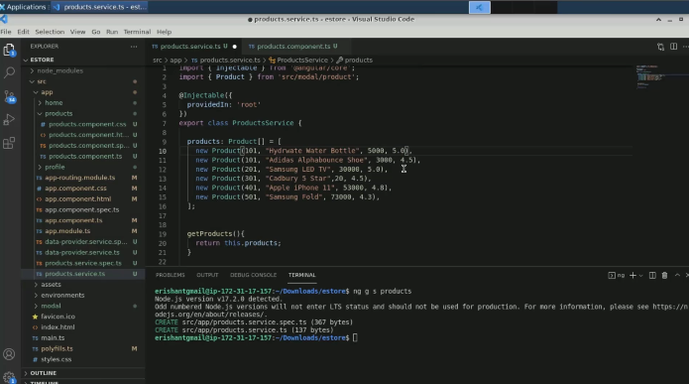

1. Execute the code

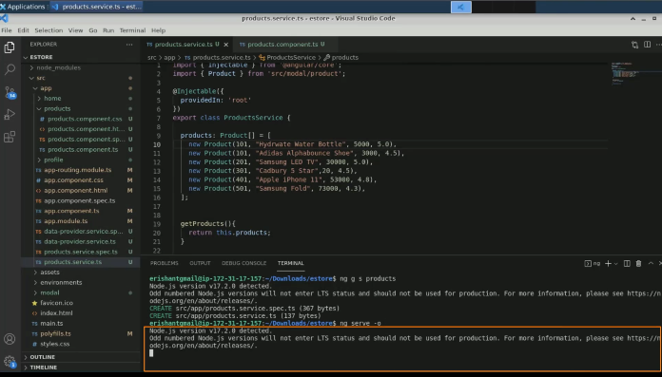

1. The output will look like this:

