**Lesson 3 Demo 2**

**Consuming a Restful Web Service with HTTP Client**



**Steps to perform:**

1. Generate a component called **news**

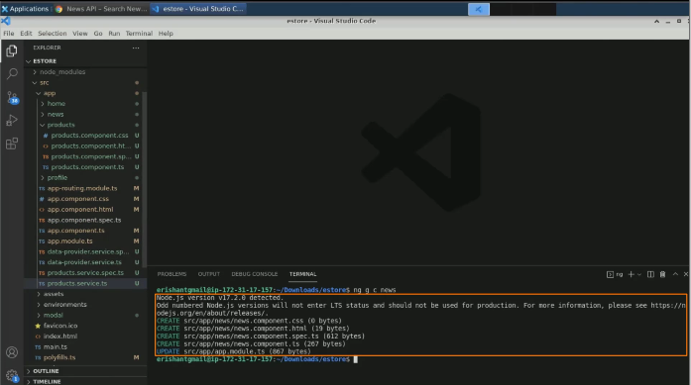

1. Navigate to the **app routing** module

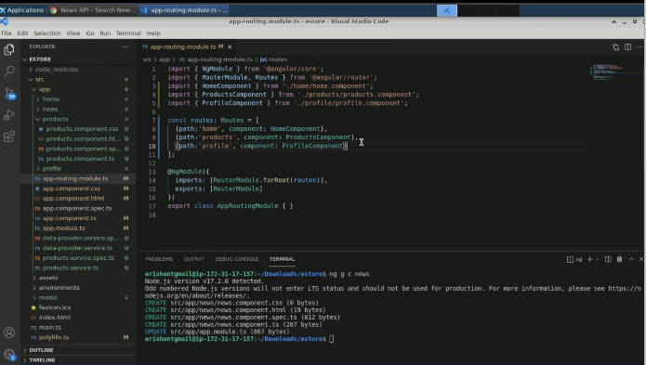

1. Add one more root called **news**

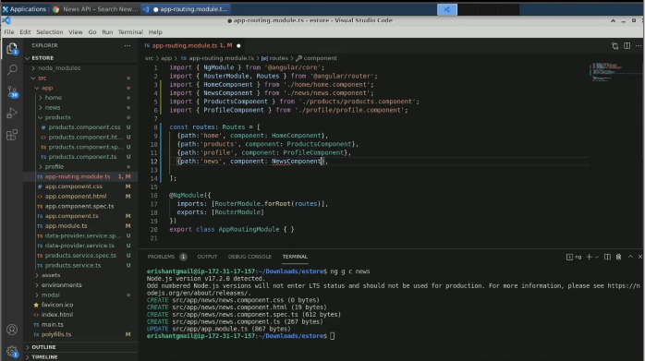

1. Open the **app.component.html** file and add one more navigation link

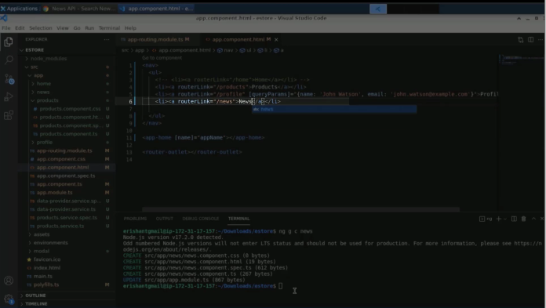

1. Execute the command: **ng serve -o**

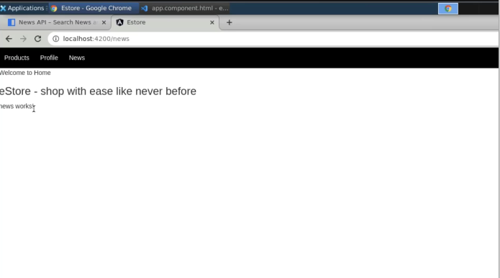

1. Add HTTP client module in **app module.ts**

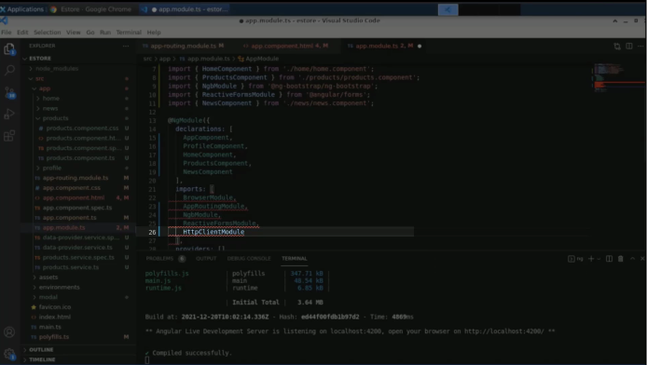

1. Change the statement to import

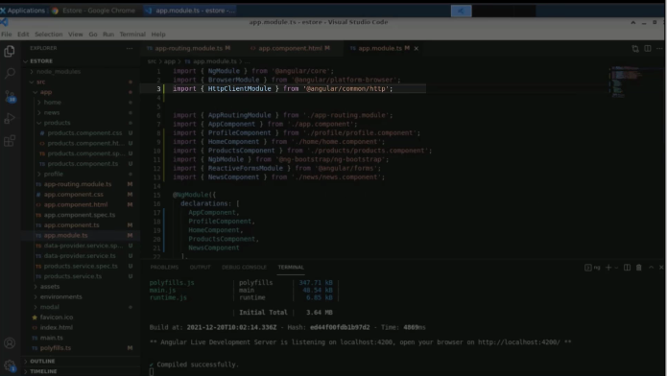

1. In the typescript file, define a web service endpoint with a URL

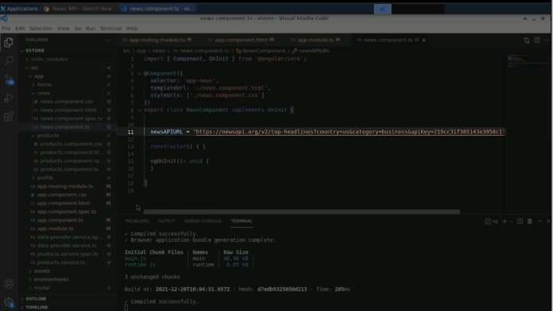

1. Create a dependency injection for the HTTP client module

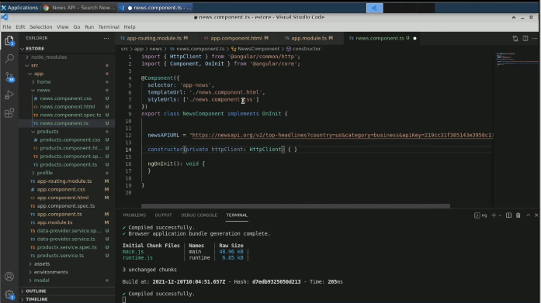

1. Save **this.httpClient.get**

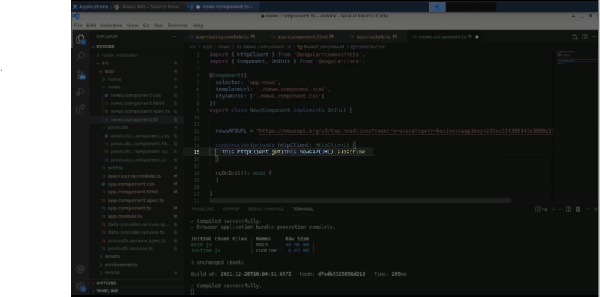

1. Handle the response with a log

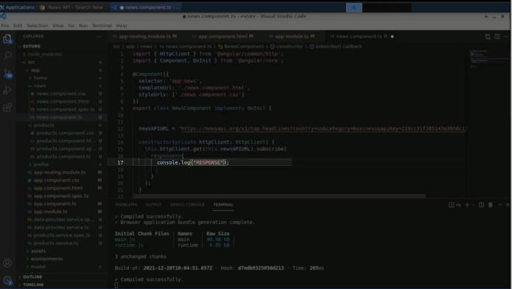

1. Open the console to see the response

