**Lesson 1 Demo 1**

**Develop CSS for Authentication UI Page**

Steps to be followed:

* Develop CSS for Authentication UI page

**Step 1: Develop CSS for Authentication UI page**

* 1. Open the web app with the Visual Studio Code.  
       
     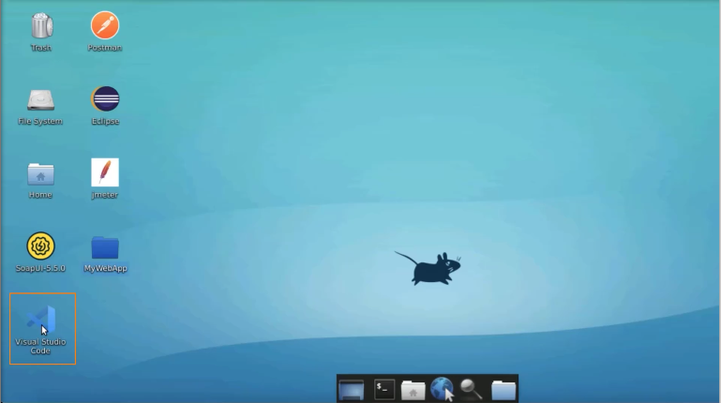
  2. Navigate to the **login.html** page and open it in a browser  
       
     Graphical user interface, application

     Description automatically generated
  3. Add a div tag surrounding the code  
       
     A screenshot of a computer

     Description automatically generated
  4. Create a style tag inside the head tag  
       
     A screenshot of a computer

     Description automatically generated
  5. Create a div tag and add 16-pixel padding, #e5e5e5 as a background color, and border-radius as 12 pixels  
       
     A screenshot of a computer

     Description automatically generated
  6. Refresh the browser  
       
     Graphical user interface, application

     Description automatically generated
  7. Add input type text fields, with the width as auto  
       
     A screenshot of a computer

     Description automatically generated
  8. Refresh the page  
       
     Graphical user interface, text, application

     Description automatically generated
  9. Change to 100%  
       
     Graphical user interface, text, application

     Description automatically generated
  10. Add display attribute as an inline, border as 1 pixel, and color as solid #ccc  
        
      A screenshot of a computer

      Description automatically generated
  11. Refresh the browser  
        
      Graphical user interface, application

      Description automatically generated
  12. Set the border radius to 6 pixels. Add a box-sizing as a border box, and add padding and margin as well  
        
      A screenshot of a computer

      Description automatically generated
  13. Execute the file again  
        
      Graphical user interface, text, application

      Description automatically generated
  14. Change the input type to a password  
        
      A screenshot of a computer

      Description automatically generated
  15. Refresh the page  
        
      Graphical user interface, text, application

      Description automatically generated
  16. Add an input type submit. Replace the display with the background color. Also, change the text color.  
        
      A screenshot of a computer

      Description automatically generated
  17. Refresh the page  
        
      Graphical user interface, text, application

      Description automatically generated