**Lesson 2 Demo 2**

**Develop CSS to Create a User Profile UI**

Steps to be followed:

* Develop a CSS to create a User Profile UI

**Step 1:** **Develop a CSS to create a User Profile UI**

* 1. Open my web app with Visual Studio Code  
       
     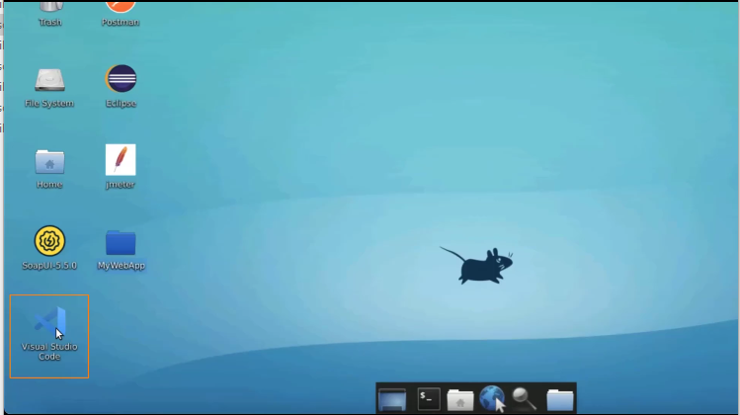
  2. Open **profile.html** file  
       
     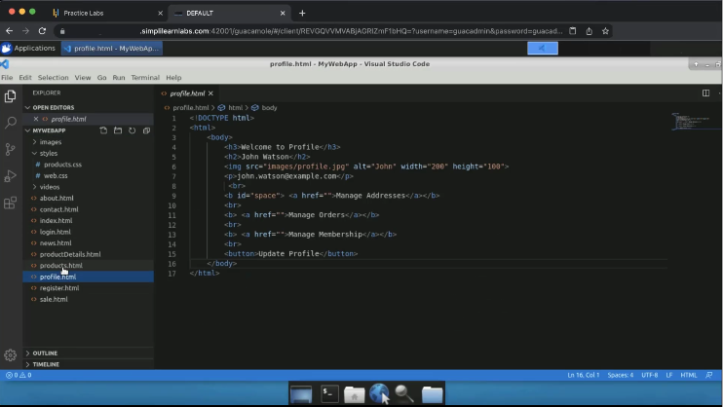
  3. Open the file in the browser  
       
     Graphical user interface, application

     Description automatically generated
  4. Create a div tag  
       
     A screenshot of a computer

     Description automatically generated
  5. Create a head tag and add a style tag within it  
       
     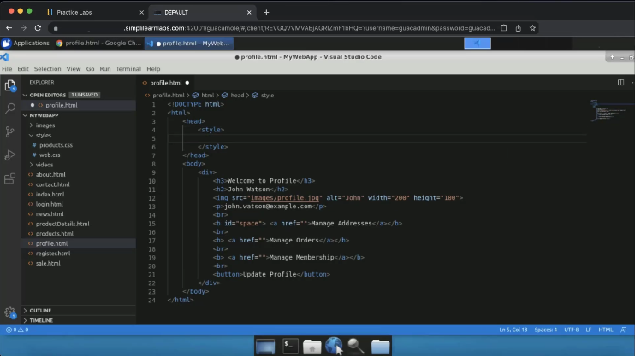
  6. Write **text align** as center  
       
     A screenshot of a computer

     Description automatically generated
  7. Refresh the page  
       
     Graphical user interface, website

     Description automatically generated
  8. Add width as 64 pixel and height as 64 pixel as well to the image  
       
     A screenshot of a computer

     Description automatically generated
  9. Add a border radius as 50%  
       
     A screenshot of a computer

     Description automatically generated
  10. Refresh the page  
        
      Graphical user interface, website

      Description automatically generated
  11. Change width to 128 pixel and height to 128 pixel  
        
      A screenshot of a computer

      Description automatically generated
  12. Refresh the page  
        
      Graphical user interface

      Description automatically generated
  13. Add a box shadow as 0, 4 pixel, 8 pixel and add rgb function with black shadow and alpha as 0.2 in the div tag  
        
      A screenshot of a computer

      Description automatically generated
  14. Refresh the page  
        
      Graphical user interface, website

      Description automatically generated
  15. Add the width attribute to 240 pixels, and save it  
        
      A screenshot of a computer

      Description automatically generated
  16. Refresh the page  
        
      Graphical user interface, text, application

      Description automatically generated
  17. Add margin from the left and right sides as auto  
        
      A screenshot of a computer

      Description automatically generated
  18. Refresh the page  
        
      Graphical user interface, application, website

      Description automatically generated
  19. Add padding to 12 pixels and refresh the page  
        
      Graphical user interface, application

      Description automatically generated