**Lesson 3 Demo 1**

**Integrate Bootstrap with Forms**

Steps to be followed:

* Integrate Bootstrap with forms

**Step 1: Integrate Bootstrap with forms**

* 1. Go to bootstrap  
       
     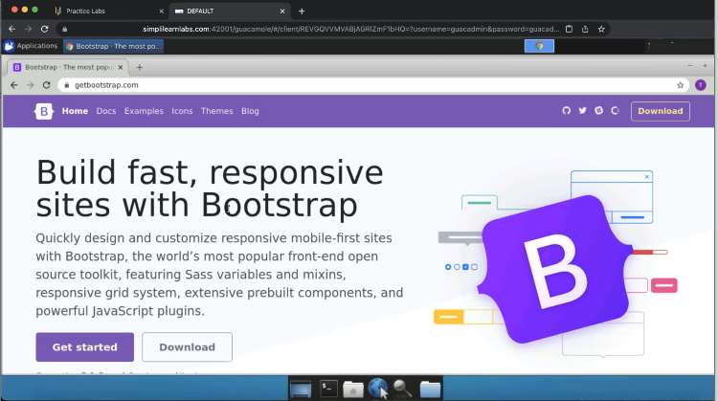
  2. Open **tailwindcss**  
       
     Graphical user interface, website

     Description automatically generated
  3. Click on **get started**  
       
     Graphical user interface, application

     Description automatically generated
  4. Copy the CSS  
       
     Graphical user interface, text, application

     Description automatically generated
  5. Open it with the visual studio code  
       
     A screenshot of a computer

     Description automatically generated
  6. Open the **register.html** file with the browser  
       
     Graphical user interface, text, application

     Description automatically generated
  7. Create a head tag in the html tag and paste the link inside it  
       
     A screenshot of a computer

     Description automatically generated
  8. Open the Docs tab on the bootstrap and select components from the option  
       
     Graphical user interface, application, Teams

     Description automatically generated
  9. Open the form option and select layout  
       
     Graphical user interface, application, Teams

     Description automatically generated
  10. Add an input type as **text**, and the class as **form-control**  
        
      A screenshot of a computer

      Description automatically generated
  11. Refresh the page  
        
      Graphical user interface, text, application

      Description automatically generated
  12. In the body tag, create a **div class** as nb-3  
        
      A screenshot of a computer

      Description automatically generated
  13. Refresh the page  
        
      Graphical user interface, text, application

      Description automatically generated