**Lesson 3 Demo 2**

**Implement CSS for Gradients and Cards**

Steps to be followed:

* Add CSS for gradients and cards

**Step 1: Add CSS for gradients and cards**

* 1. Open the web app with the visual studio code  
       
     Graphical user interface, website

     Description automatically generated
  2. Navigate to **profile.html**  
       
     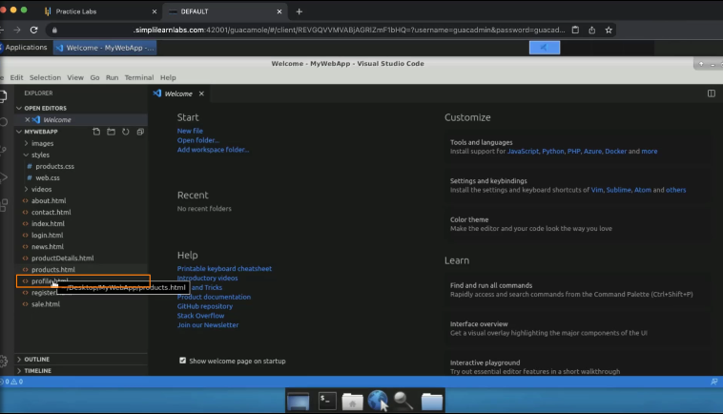
  3. Click on **Open in other browsers**  
       
     A screenshot of a computer

     Description automatically generated
  4. Set the background color as **red**  
     A screenshot of a computer

     Description automatically generated
  5. Refresh the page  
       
     Graphical user interface, application

     Description automatically generated
  6. Add a **linear-gradient** function and pass red and orange colors  
       
     A screenshot of a computer

     Description automatically generated
  7. Refresh the page  
       
     Graphical user interface

     Description automatically generated
  8. Add a border radius of 12 pixels  
       
     A screenshot of a computer

     Description automatically generated
  9. Refresh the page  
       
     Graphical user interface

     Description automatically generated
  10. Add 120 degrees to the gradient.  
        
      A screenshot of a computer

      Description automatically generated
  11. Refresh the page  
        
      Graphical user interface, website

      Description automatically generated
  12. Add 50% opacity  
        
      A screenshot of a computer

      Description automatically generated
  13. Refresh the page  
        
      Graphical user interface, application

      Description automatically generated
  14. Now, set the background as **radial-gradient** and pass red and orange colors  
        
      A screenshot of a computer

      Description automatically generated
  15. Set the background as **conic- gradient** with colors red and orange  
        
      A screenshot of a computer

      Description automatically generated
  16. Refresh the page  
        
      Graphical user interface

      Description automatically generated
  17. For linear- gradient background, add a degree of 180. Pass the color code #39ef74 and #4600f1  
        
      A screenshot of a computer

      Description automatically generated
  18. Refresh the page  
        
      Graphical user interface

      Description automatically generated
  19. Change the degree to 120 and the opacity to 100%  
        
      A screenshot of a computer

      Description automatically generated
  20. Refresh the page  
        
      Graphical user interface, application

      Description automatically generated  
        
      Graphical user interface, application

      Description automatically generated