**Lesson 3 Demo 3**

**Implement CSS for Animation**

Steps to be followed:

* Implement CSS for animation

**Step 1: Implement CSS for animation**

* 1. Open the web app with the visual studio code

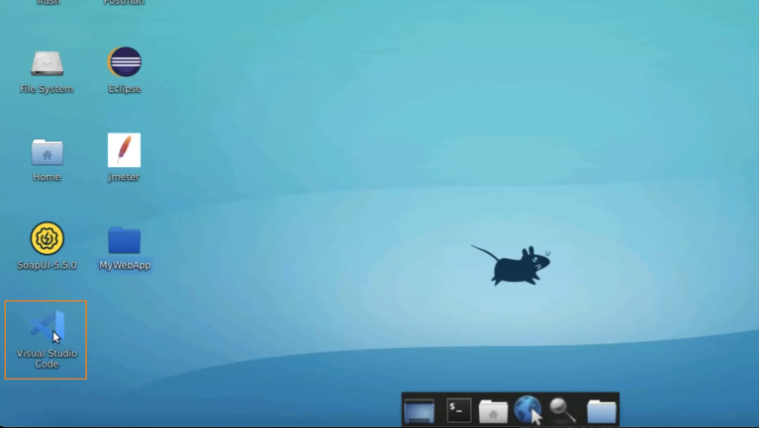

* 1. Open the **profile.html**  
       
     A screenshot of a computer

     Description automatically generated
  2. Click on **Open in other browsers**  
       
     A screenshot of a computer

     Description automatically generated
  3. You will now see a card  
       
     Graphical user interface, application

     Description automatically generated
  4. Add keyframes, with which you can add a name to the frame animation  
       
     A screenshot of a computer

     Description automatically generated
  5. Write **50%** and use the property **transform**. Also, add a rotate function and pass the degree of rotation  
       
     A screenshot of a computer

     Description automatically generated
  6. Use an **animation** property in the **div** tag  
       
     A screenshot of a computer

     Description automatically generated
  7. Add the name as **rotateCard**, the duration as **3 seconds**, and set the frequency as **infinite**  
       
     A screenshot of a computer

     Description automatically generated
  8. Navigate back to **profile.html** and refresh the page  
       
     Graphical user interface

     Description automatically generated
  9. Change speed to **7 seconds**  
       
     A screenshot of a computer

     Description automatically generated
  10. The speed is now slowed down  
        
      Graphical user interface

      Description automatically generated