**Lesson 1 Demo 1**

**Product UI Page for eCommerce**



Steps to be followed:

* Create an unordered list
* Add list for the unordered list
* Edit the grid template and create a new page

**Step 1: Create an unordered list**

* 1. Open the web app with the Visual Studio Code.  
       
     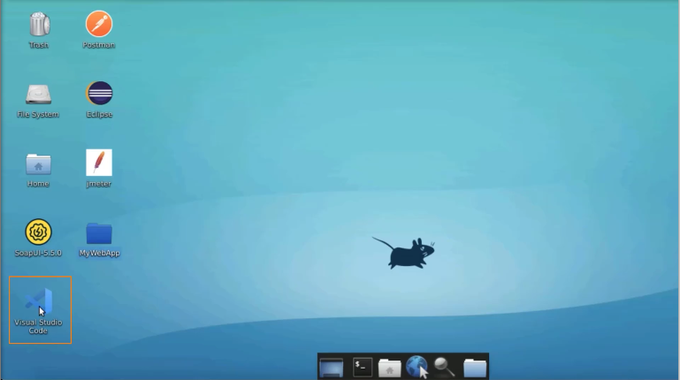
  2. Open **products.html page**  
       
     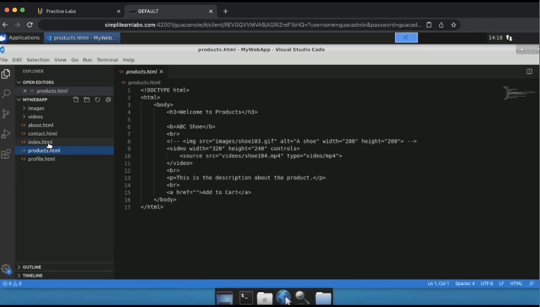
  3. Open the product.html page on the web browser  
       
     Graphical user interface, text, application

     Description automatically generated

**Step 2: Add list for the unordered list**

* 1. Create an unordered list. Within the list of items, select the entire code and place it here  
       
     A screenshot of a computer

     Description automatically generated
  2. Change product detail to **shoe101.jpg**  
       
     A screenshot of a computer

     Description automatically generated
  3. Change **ABC Shoe** to **XYZ Shoe**, and change **shoe102.gif** to **shoe102.jpg**  
       
     A screenshot of a computer

     Description automatically generated
  4. Change the other one as **PQR Shoe** and **gif file**  
       
     A screenshot of a computer

     Description automatically generated
  5. Change it to MNO Shoe, and a video file  
       
     A screenshot of a computer

     Description automatically generated
  6. Refresh the page  
       
     Graphical user interface, text, application

     Description automatically generated

**Step 3: Edit the grid template and create a new page**

* 1. Add a head tag and inside that add a style tag. Add list for unordered list and remove the styling by adding **none**  
       
     A screenshot of a computer

     Description automatically generated
  2. Add a display grid  
       
     A screenshot of a computer

     Description automatically generated
  3. Add two columns to the grid  
       
     A screenshot of a computer

     Description automatically generated
  4. Set padding to **12 pixels**  
       
     A screenshot of a computer

     Description automatically generated
  5. Add text-align to the center  
       
     A screenshot of a computer

     Description automatically generated
  6. Refresh the page  
       
     Graphical user interface, application, website

     Description automatically generated
  7. Add one more column to the grid template  
       
     A screenshot of a computer

     Description automatically generated
  8. Refresh the browser  
       
     Graphical user interface, website

     Description automatically generated
  9. Create a new page as **productDetail.html**  
       
     A screenshot of a computer

     Description automatically generated
  10. Add a link to the image  
        
      A screenshot of a computer

      Description automatically generated
  11. Add a **DOCTYPE HTM**L tag, an **html** tag, and a **body** tag  
        
      A screenshot of a computer

      Description automatically generated
  12. Put the details as Available in sizes: 6, 7, 8, 9  
        
      Text

      Description automatically generated
  13. Use the center tag for styling on the page  
        
      A screenshot of a computer

      Description automatically generated
  14. Refresh the page  
        
      Graphical user interface, application, website

      Description automatically generated