**Lesson 2 Demo 2**

**Table Backgrounds**



Steps to be followed:

* Add background to a table

**Step 1: Add background to a table**

* 1. Open the web app with the visual studio code

* 1. Open **sale.html** file  
       
     A screenshot of a computer

     Description automatically generated
  2. Open the file with google chrome  
       
     Graphical user interface, application, Teams

     Description automatically generated
  3. Add background color in the style section  
       
     A screenshot of a computer

     Description automatically generated
  4. Add #E5E5E5, which is the light greyish tone  
       
     A screenshot of a computer

     Description automatically generated
  5. Refresh the page, and you will see the table in light greyish color  
       
     A picture containing graphical user interface

     Description automatically generated
  6. Style the table rows with the background color as **cadet blue**  
       
     A screenshot of a computer

     Description automatically generated
  7. Refresh the page  
       
     Graphical user interface, application

     Description automatically generated
  8. Add border radius to 16 pixels. Run the code  
       
     Graphical user interface, application

     Description automatically generated
  9. Copy the line of code and comment it out. And below that have a similar definition for the table  
       
     A screenshot of a computer

     Description automatically generated
  10. Pass an image URL for the background image  
        
      A screenshot of a computer

      Description automatically generated
  11. Add the path of the image  
        
      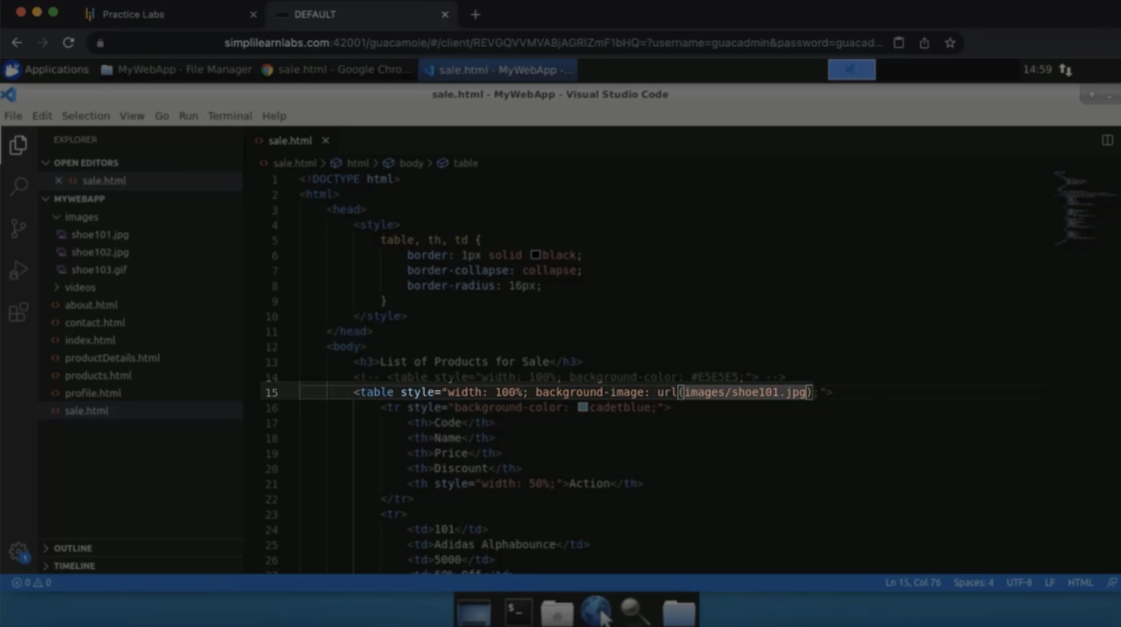
  12. Refresh the page  
        
      Graphical user interface, text

      Description automatically generated