**Lesson 3 Demo 1**

**Developing Authentication UI Page**



Steps to be followed:

* Develop authentication UI page

**Step 1: Develop authentication UI page**

* 1. Open the Visual Studio Code and create a new file under your webpage with the name **login.html**  
       
      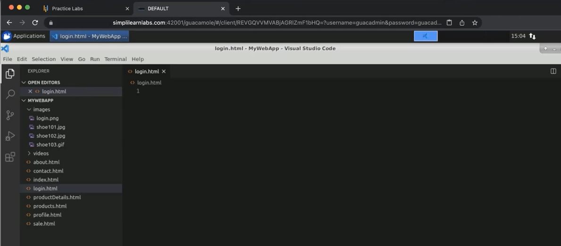
  2. Enter Doctype, enter the HTML page structure, where you will have a body  
       
     Graphical user interface, text

     Description automatically generated
  3. Inside a body, enter an h3 tag with Welcome, Please Login with your details’. Create a form action=”” method=”POST”. Img src=”images/login.png” alt=”Login” width=”100” height=”100”  
       
     A screenshot of a computer

     Description automatically generated
  4. Go to the desktop, open the login page in the Chrome browser  
       
     Graphical user interface, application

     Description automatically generated
  5. Change the height to 80 and refresh the Chrome page  
       
     A screenshot of a computer

     Description automatically generated  
       
     Graphical user interface, text, website

     Description automatically generated
  6. Enter Break tag i.e <br>. Enter ‘<b>User Name</b>. Add a break tag i.e</b>. Enter <input type=”text” name=”txtUserName” placeholder=”john@example.com”> required>. Enter a break tag i.e</b>  
       
     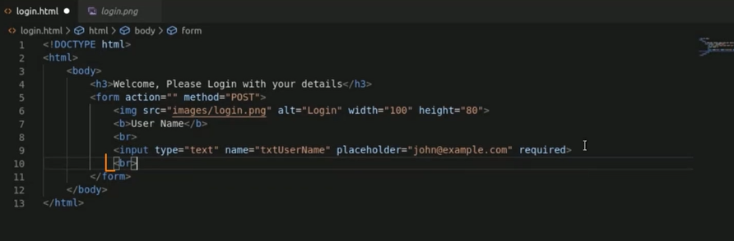
  7. Enter ‘<b>Password</b>. Add a break tag i.e</b>. Enter <input type=”password” name=”txtPassword” placeholder=”minimum 6 characters”> required>. Enter a break tag i.e</b>  
       
     Text

     Description automatically generated
  8. For creating a button, enter **<input type=”submit” value=”LOGIN”>**  
       
     Text

     Description automatically generated
  9. Open Chrome and refresh the screen  
       
     Graphical user interface, text, email, website

     Description automatically generated
  10. To add a check box, enter **<input type=”checkbox” checked=”checked” name=”rememberMe”> Remember Me**  
        
      Text

      Description automatically generated
  11. Go to Chrome and refresh it  
        
      Graphical user interface, text, application

      Description automatically generated
  12. In the visual studio code, create a new file called **register.html**. Copy the content from the **login.html** and paste it into **register.html**  
        
      A screenshot of a computer

      Description automatically generated
  13. Add a new input field same as others. Change the h3 to ‘Welcome, Please Register with Us’. Enter ‘<b>Full Name</b>. Add a break tag i.e</b>. Enter <input type=”text” name=”txtFullName” placeholder=”John Watson”> required>  
        
      Text

      Description automatically generated
  14. Enter **<input type=”submit” value=”REGISTER”>**  
        
      Text

      Description automatically generated
  15. Navigate to login.html and add one more break tag i.e <br>, enter **<a href=”register.html”>New User? Register Here</a>**  
      Text

      Description automatically generated
  16. Open Chrome and refresh the screen  
        
      Graphical user interface, text, application, email

      Description automatically generated
  17. Click on **Register Here**  
        
      Graphical user interface, text, application

      Description automatically generated