**Lesson 3 Demo 2**

**Develop Profile UI Page**



Steps to be followed:

* Develop a profile UI page

**Step 1: Develop a profile UI page**

* 1. Open the web app visual studio code

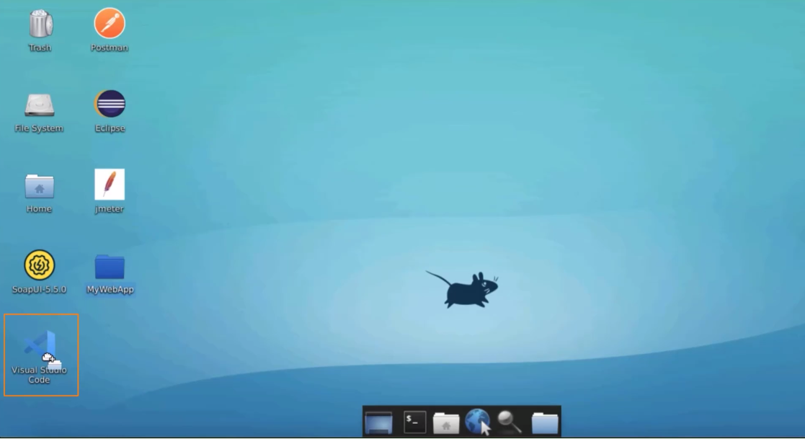

* 1. Write the name of the user

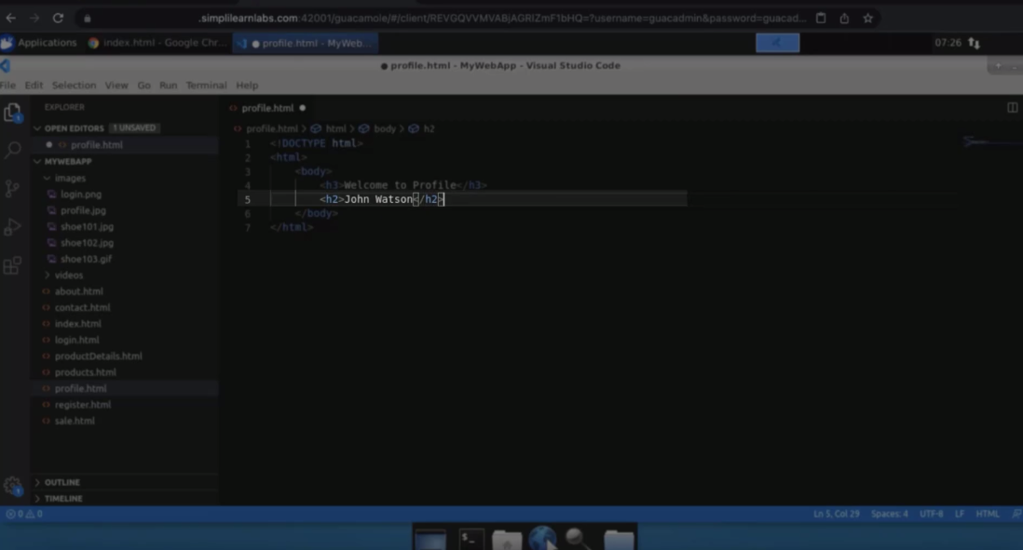

* 1. Add user image

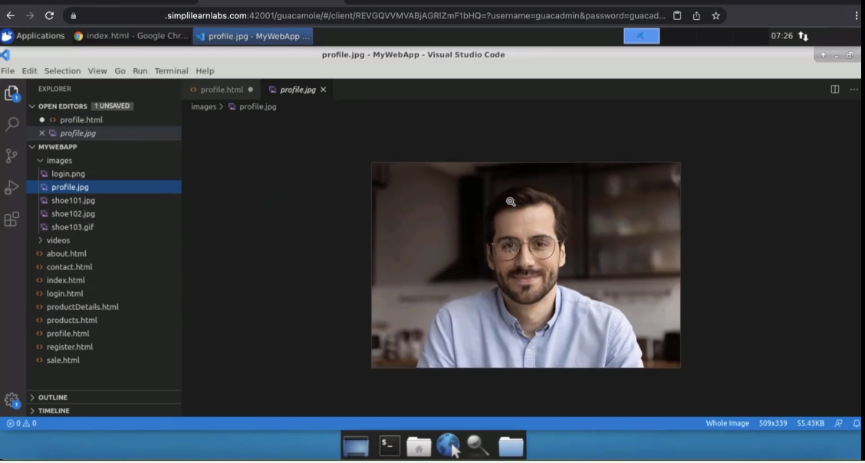

* 1. Create an update profile button

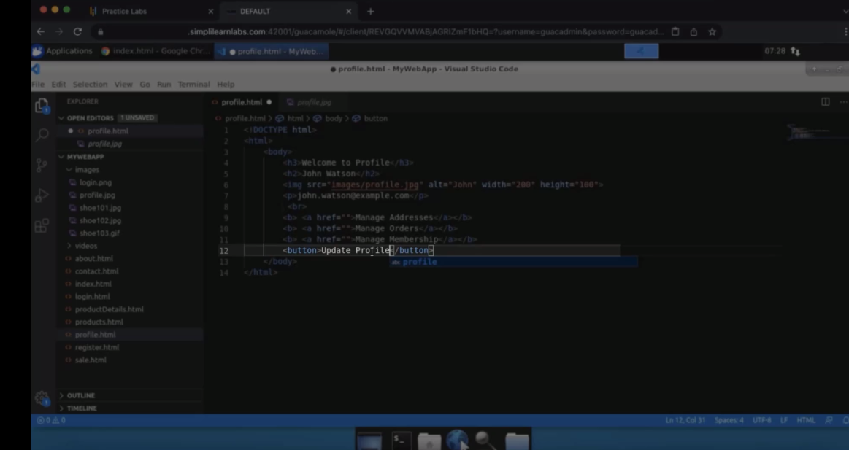

* 1. The final code looks like this:

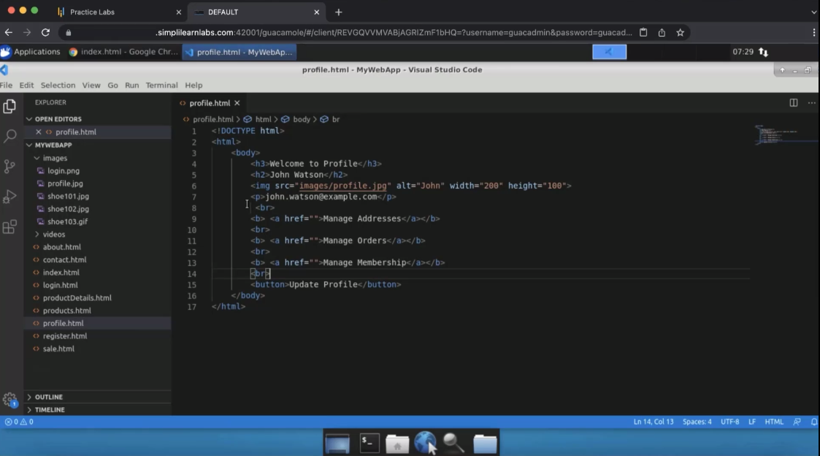

* 1. Run in google chrome  
       
     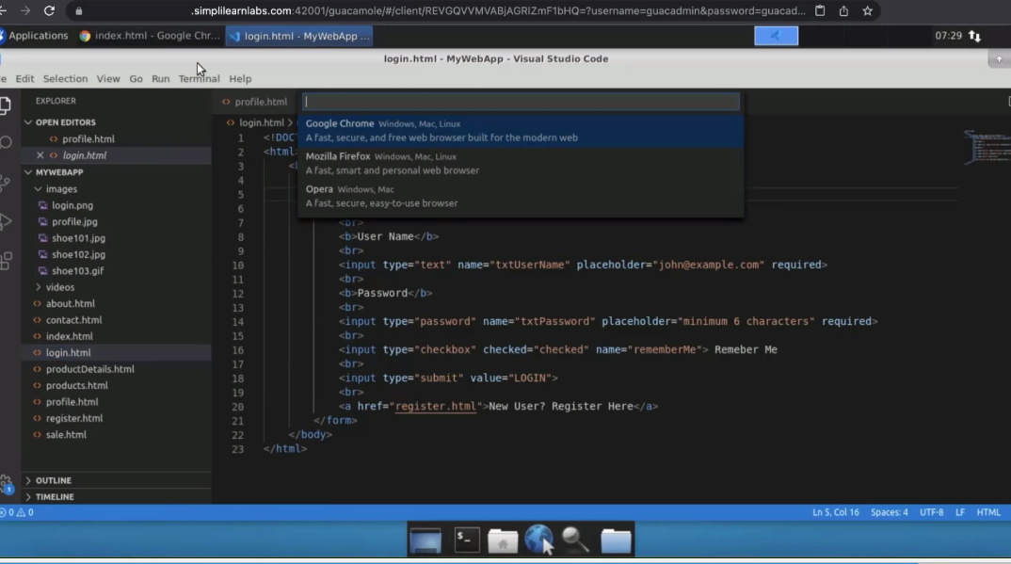
  2. You can see the profile

