**Lesson 3 Demo 3**

**Different Ways to Embed CSS**



Steps to be followed:

* Create different ways to embed CSS

**Step 1: Create different ways to embed CSS**

* 1. Open the Visual Studio Code and create a web page named **news.html**  
       
      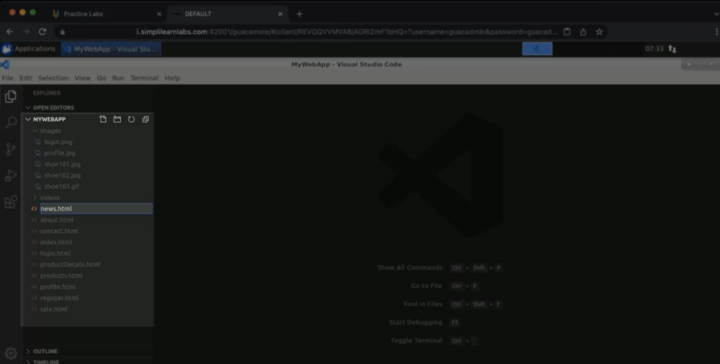
  2. Enter Doctype, enter the HTML page structure, where you will have a body  
       
     Graphical user interface

     Description automatically generated with medium confidence
  3. Inside a body, write a heading ‘Welcome to New Section’. Save it and run it using google chrome  
     Graphical user interface, application

     Description automatically generated  
       
     Graphical user interface, text, application

     Description automatically generated
  4. Go to the Visual studio code, and inside the headline, enter ‘styles=”color: Chocolate; font-size:small; margin:16px”. Save it  
       
     Text

     Description automatically generated
  5. Go back to google chrome and refresh the screen  
       
     Graphical user interface, text, application

     Description automatically generated
  6. Change the font size of the headline to **x-large**  
       
     Text

     Description automatically generated
  7. Go back to google chrome and refresh the screen  
       
     Graphical user interface, text, application

     Description automatically generated
  8. In the visual studio, create a new HTML with a section called head. Inside the head, create style. Enter h1 { color:cornflowerblue; margin:auto; font-family:monospace;}  
       
     Text

     Description automatically generated
  9. Go to the body section, create another h1 tag with the heading **This is a news section for India**. Save it and run the code in chrome  
       
     Text

     Description automatically generated  
       
     Graphical user interface, text, application, website

     Description automatically generated
  10. In the visual studio code, inside the style, enter **style type=text/css**  
        
      Graphical user interface, application

      Description automatically generated with medium confidence
  11. Go to the web app and create a directory as styles  
        
      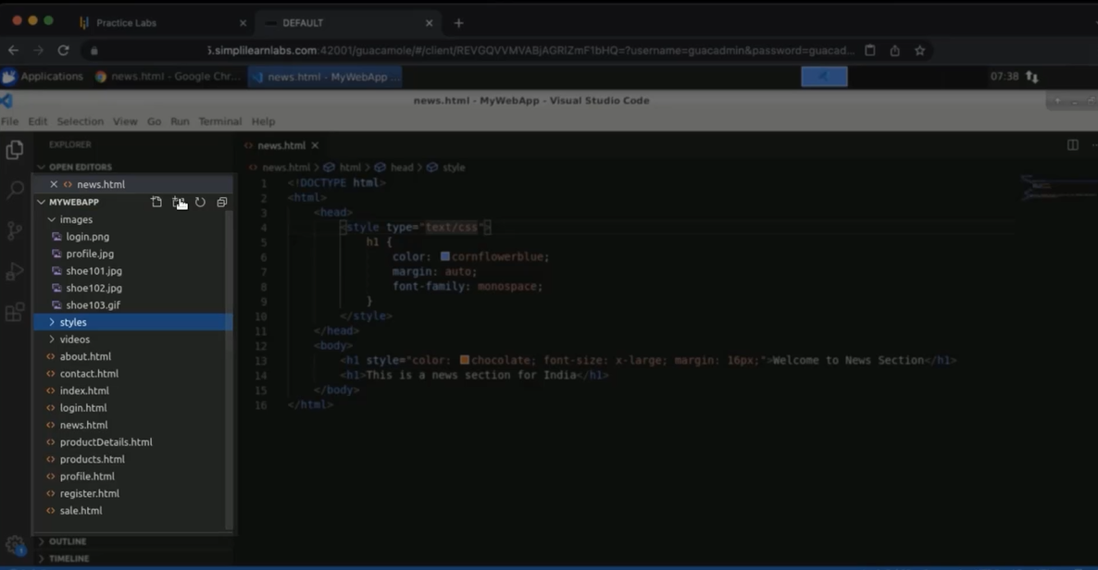
  12. In styles, create a CSS with a name you like e.g. webcss  
        
      A screenshot of a computer

      Description automatically generated
  13. In news.html. Inside a head in the code, enter <link rel=”stylesheet” href=”web.css” type=text/css>  
        
      A screenshot of a computer

      Description automatically generated