**Lesson 4 Demo 1**

**Creating Product User Object for eCommerce Store**



**Steps to perform:**

1. Open visual studio code.  
     
   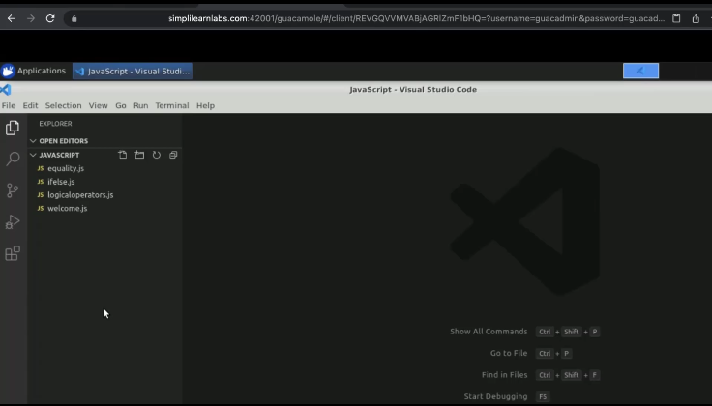
2. Create a new file named ‘object.js’.  
     
   A screenshot of a computer

   Description automatically generated
3. Create an object as ‘user’.  
     
   A screenshot of a computer

   Description automatically generated
4. Add key and value for an object.  
     
   A screenshot of a computer

   Description automatically generated
5. Pass e-mail, phone number, and address, where the address can be in a nested form.  
     
   Text

   Description automatically generated
6. Add a log statement for object ‘user’.   
     
   Text

   Description automatically generated
7. Add one more log statement as ‘type of user’.  
     
   Text

   Description automatically generated
8. Execute the program in the terminal.  
     
   A screenshot of a computer

   Description automatically generated
9. Create another key called ‘orders’.  
     
   Text

   Description automatically generated
10. Pass order id, amount and date in ‘orders’.  
      
    A screenshot of a computer

    Description automatically generated
11. Add another object under the ‘orders’.  
      
    A screenshot of a computer

    Description automatically generated
12. Re-run the program.  
      
    A screenshot of a computer

    Description automatically generated
13. Add a log again and access the attributes of the key.  
      
    A screenshot of a computer

    Description automatically generated
14. Execute the program.  
      
    A screenshot of a computer

    Description automatically generated with medium confidence
15. Use User of orders zero indexes.  
      
    A screenshot of a computer

    Description automatically generated
16. Save it and re-run the code.  
      
    A screenshot of a computer

    Description automatically generated with medium confidence
17. Nest the statement one more time with the attribute as ‘amount’.  
      
    A screenshot of a computer

    Description automatically generated
18. Create an object called ‘product’.  
      
    A screenshot of a computer

    Description automatically generated
19. Add product id, name, brand, and price as attributes.  
      
    A screenshot of a computer

    Description automatically generated
20. Add more attributes as ‘inventory’. Pass objects within it such as; size, units, etc  
      
    A screenshot of a computer

    Description automatically generated
21. Manage inventory for more objects with different sizes and units.  
      
    A screenshot of a computer

    Description automatically generated
22. Some more objects can be as follows:  
      
    A screenshot of a computer

    Description automatically generated
23. Log the product.  
      
    A screenshot of a computer

    Description automatically generated with medium confidence
24. Save and run the code.  
      
    A screenshot of a computer

    Description automatically generated with medium confidence
25. Write product inventory as a zeroth index and update the units with seven.  
      
    A screenshot of a computer

    Description automatically generated with medium confidence
26. Run the program.  
      
    A screenshot of a computer

    Description automatically generated with medium confidence
27. Put a product id as 201 in a new product object.  
      
    A screenshot of a computer

    Description automatically generated
28. Run the program.  
      
    A screenshot of a computer

    Description automatically generated with medium confidence