**Lesson 4 Demo 2**

**Using Various String Built-in Methods**



**Steps to perform:**

1. Open a visual studio code.  
     
   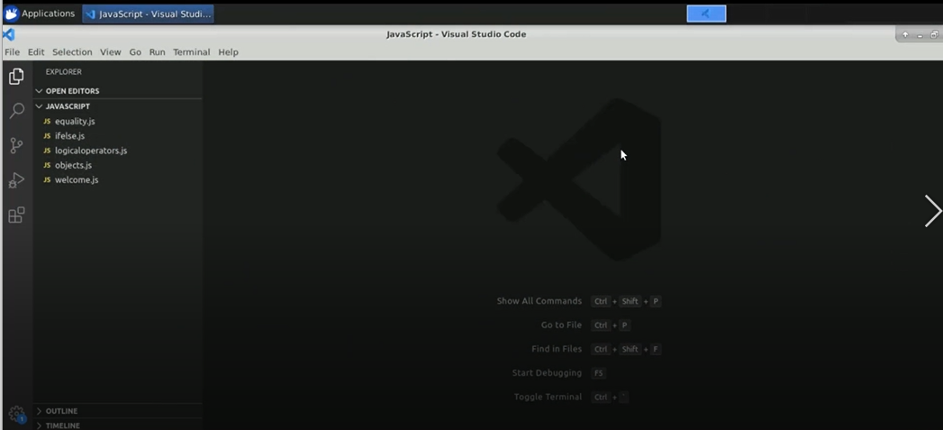
2. Create a file name strings.js.  
     
   A picture containing text

   Description automatically generated
3. Create a string variable.  
     
   Graphical user interface, text

   Description automatically generated
4. Enter ‘console.log(“names: “+names+” data type: “+typeof names);’.  
     
   Text

   Description automatically generated
5. Run the code in the terminal. Enter ‘node strings.js’.  
     
   Graphical user interface, text

   Description automatically generated
6. Enter ‘console.log(“names.length);’.  
     
   Text

   Description automatically generated
7. Run the code in the terminal. Enter ‘node strings.js’.  
     
   Text

   Description automatically generated
8. Enter ‘names.toUpperCase()  
    console.log(“Names in Uppercase: “+names);’.  
     
   Graphical user interface, text, application

   Description automatically generated
9. Run the code in the terminal. Enter ‘node strings.js’.  
     
   Text

   Description automatically generated
10. Enter ‘let result = names.toUpperCase()’  
    Enter ‘console.log(“Result is: “+result);’.  
      
    Text

    Description automatically generated
11. Enter ‘result = names.replace(‘J’,’K’);

‘console.log(“Result is: “+result);’

1. Run the code in the terminal. Enter ‘node strings.js’.  
     
   Text

   Description automatically generated
2. Create a list of contact names.  
     
   Text

   Description automatically generated
3. Enter ‘let searchKeyword = ‘ia’;’.  
     
   Graphical user interface, text, application

   Description automatically generated
4. Create a for loop.  
     
   Text

   Description automatically generated
5. Run the code in the terminal. Enter ‘node strings.js’.  
     
   Text

   Description automatically generated
6. Enter ‘result = names.substring(0, 7);’. Enter ‘console.log(result);’.  
     
   Text

   Description automatically generated
7. Run the code in the terminal. Enter ‘node strings.js’.  
     
   Graphical user interface, text

   Description automatically generated
8. Enter ‘let splittedNames = names.split(“,”)’’. Enter ‘console.log(splittedNames);’.  
     
   Text

   Description automatically generated
9. Run the code in the terminal.  
     
   Text

   Description automatically generated
10. Enter a for loop.  
      
    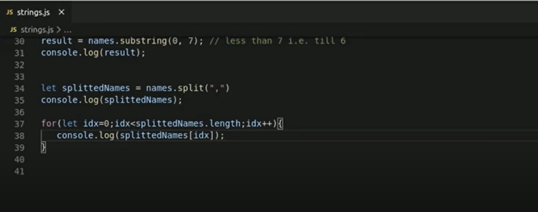
11. Run the code in the terminal.  
      
    Graphical user interface, application, Teams

    Description automatically generated
12. Enter ‘.trim()’ to eliminate the white space.   
      
    Text

    Description automatically generated
13. Run the code in the terminal.  
      
    Graphical user interface, text

    Description automatically generated