**Lesson 4 Demo 04**

**Using If-Else in Applying Promo Codes**



Steps to be followed:

* Use if-else in applying promo codes

**Step 1:** Use if-else in applying promo codes

* 1. Create a file in JavaScript named ‘ifelse.js’.  
       
     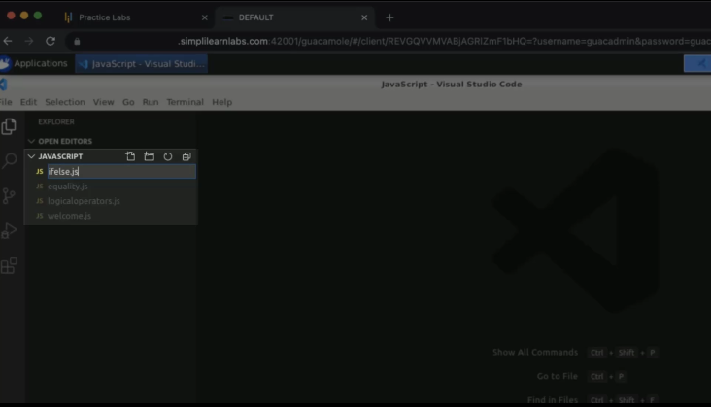
  2. Consider a scenario and pass the statements stated below:  
       
     Graphical user interface, text

     Description automatically generated
  3. Add other statements as promo code as BINGO and discount as 50%.  
       
     Graphical user interface, text

     Description automatically generated
  4. Set starting amount as 1000.   
       
     Graphical user interface, text

     Description automatically generated
  5. Pass the conditions for the promo code as follows.  
       
     Text

     Description automatically generated
  6. Specify the condition with the amount description.  
       
     Text

     Description automatically generated
  7. Put the ‘else’ loop in the code and add a log statement.  
       
     Text

     Description automatically generated
  8. Add a log statement in the ‘if’ loop as well.  
       
     Text

     Description automatically generated
  9. Run the program in the terminal window.  
       
     Text

     Description automatically generated
  10. Change the amount to ‘100’ and run the program.  
        
      Text

      Description automatically generated
  11. Set an amount to ‘1000’ again. Change promo code to ‘HAPPY’.  
        
      Text

      Description automatically generated
  12. Run the program.  
        
      Text

      Description automatically generated
  13. Copy the if-else code and paste it below the actual code.  
        
      Text

      Description automatically generated
  14. Add one more else if statement.  
        
      Text

      Description automatically generated
  15. Pass two conditions in the new else if statement.  
        
      Text

      Description automatically generated
  16. Add an if statement below the else if statement.  
        
      Text

      Description automatically generated
  17. Pass the amount condition within the if loop.  
        
      Text

      Description automatically generated
  18. Add an else loop with the amount as 200.  
        
      Text

      Description automatically generated
  19. Change the promo code to BINGO.  
        
      Text

      Description automatically generated
  20. Pass a log statement to print the algorithm.  
        
      Text

      Description automatically generated
  21. Execute the program.

* 1. Change the amount to 360.  
       
     Graphical user interface, text

     Description automatically generated
  2. Run the program again.  
       
     Text

     Description automatically generated