**Lesson 5 Demo 1**

**Creating Shopping Cart List of Product Objects**



**Steps to perform:**

1. Open a visual studio code.  
      
   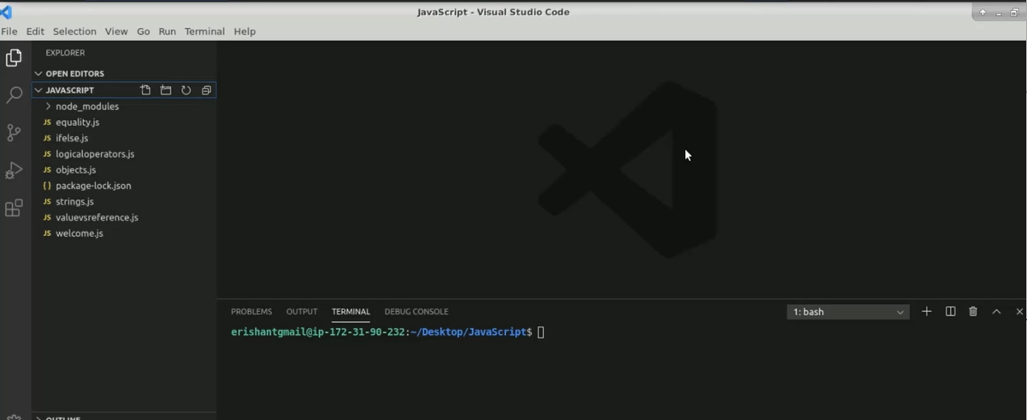
2. Create a file name arrays.js.  
     
   Graphical user interface

   Description automatically generated with low confidence
3. Create a menu object.   
     
   Text, application

   Description automatically generated with medium confidence
4. Create a cart array.  
     
     
   Application

   Description automatically generated with medium confidence
5. Enter ‘console.log(“Cart[“+cart.length+”] Details: “+cart);’.  
     
   Text

   Description automatically generated
6. Run the code in the terminal. Enter ‘node arrays.js’.  
     
   Text

   Description automatically generated
7. Enter ‘npm I prompt-sync’.  
     
   Text

   Description automatically generated
8. Create a variable called Prompt. Enter ‘let prompt = require(‘prompt-sync’)();’.  
     
   Text

   Description automatically generated
9. Enter ‘let choice = prompt(“Enter your choice:”)  
    ‘console.log(“Your choice: “+choice);’  
     
   Text

   Description automatically generated
10. Run the code in the terminal. Enter ‘node arrays.js’.  
      
    Text

    Description automatically generated
11. Write one infinite loop.  
    Enter ‘while(true){  
     let dishName = prompt(“Enter Dish Name:”)  
     let dish = {

name: dishName,  
 Price: menu[dishName]  
 }  
 cart.push(dish);  
}  
  
1. Enter ‘if(dishName == “quit”){  
    break  
    }  
     
   Graphical user interface, text

   Description automatically generated
2. Enter ‘console.log(“Final Cart[“+cart.length+”] Details: “+cart);

1. Run the code in the terminal. Enter ‘node arrays.js’.  
     
   Text

   Description automatically generated
2. Enter ‘for (let dish in cart){  
    console.log(dish.name+” “+dish.price);’  
     
   Text

   Description automatically generated
3. Run the code in the terminal. Enter ‘node arrays.js’.  
     
   Text

   Description automatically generated
4. Run the code again. Enter ‘node arrays.js’.  
     
   Text

   Description automatically generated
5. Enter for loop to iterate the cart.  
     
   Text

   Description automatically generated
6. Run the code again. Enter ‘node arrays.js’.  
     
   Text

   Description automatically generated