**Lesson 6 Demo 1**

**Creating Function to Sort the Product List Based on the Price**

**Steps to perform:**

1. Create a file named ‘sorting.js’.  
     
   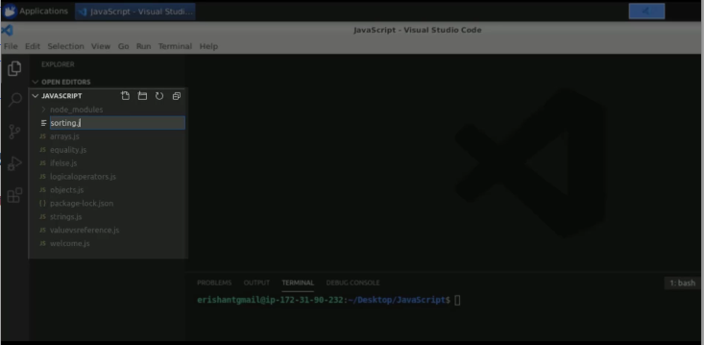
2. Create a variable called ‘products’.  
     
   A screenshot of a computer

   Description automatically generated
3. Create an object with a name and price.  
     
   A screenshot of a computer

   Description automatically generated
4. Create some more objects with different names and prices.  
     
   A screenshot of a computer

   Description automatically generated
5. Print the array using the print array function using for loop.  
     
   Text

   Description automatically generated
6. Run the program.  
     
   Graphical user interface, text

   Description automatically generated
7. Use a function, to sort based on price.  
     
   A screenshot of a computer

   Description automatically generated
8. The product one is:  
     
   A screenshot of a computer

   Description automatically generated
9. Pass a function ‘sortOnPrice’.  
     
   A screenshot of a computer

   Description automatically generated
10. Perform sort operation on custom objects.  
      
    A screenshot of a computer

    Description automatically generated
11. Execute the code.  
      
    A screenshot of a computer

    Description automatically generated
12. Update the ‘return’ statement.  
      
    A screenshot of a computer

    Description automatically generated
13. Re-run the code.  
      
    A screenshot of a computer

    Description automatically generated