**Lesson 6 Demo 2**

**Creating Function to Filter the Product List**



**Steps to perform:**

1. Create a file named ‘filterproducts.js’.  
     
   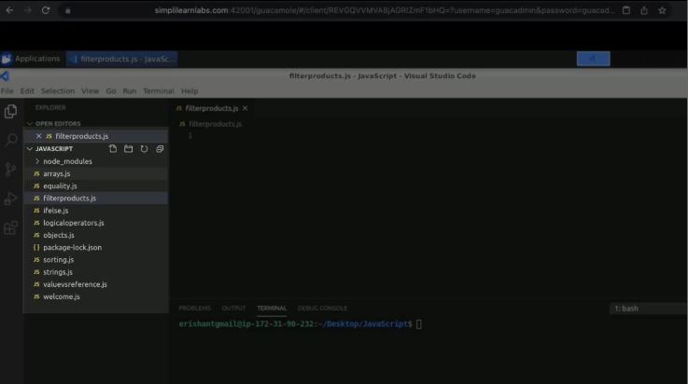
2. Copy the code from the previous snippet ‘sorting.js’.  
     
   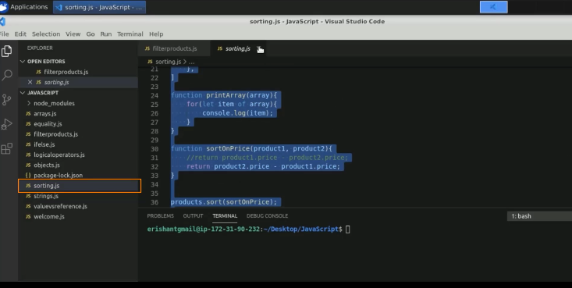
3. Bring that code to the filter section.  
     
   A screenshot of a computer

   Description automatically generated
4. Execute the program.  
     
   A screenshot of a computer

   Description automatically generated
5. Define a function as filter by price.  
     
   A screenshot of a computer

   Description automatically generated with medium confidence
6. Pass a return function.  
     
   A screenshot of a computer

   Description automatically generated
7. Pass a filter by price as an input, and execute the code.  
     
   A screenshot of a computer

   Description automatically generated
8. Write the result statement and introduce one log statement.  
     
   Text

   Description automatically generated
9. Run the code.  
     
   A screenshot of a computer

   Description automatically generated
10. Change the product price to 7000.  
      
    A screenshot of a computer

    Description automatically generated with medium confidence
11. Run the code.  
      
    A screenshot of a computer

    Description automatically generated