**Lesson 6 Demo 3**

**Working on Hoisting**



**Steps to perform:**

1. Create a file named ‘hosting.js’.  
     
   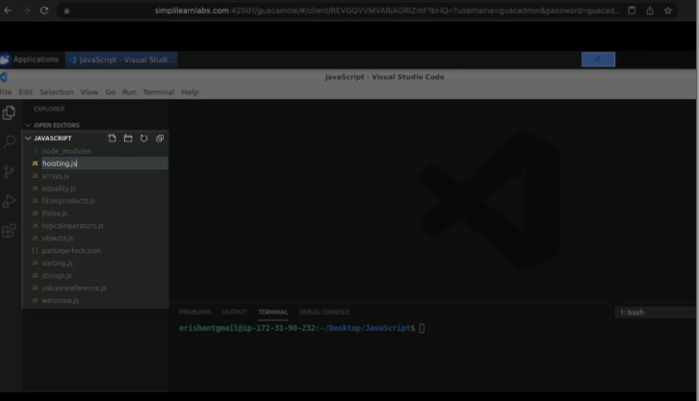
2. Add a function named ‘greet’.  
     
   A screenshot of a computer

   Description automatically generated
3. Add a log statement to execute the ‘greet’ function with the name.  
     
   A screenshot of a computer

   Description automatically generated
4. Run the code.  
     
   A screenshot of a computer

   Description automatically generated
5. Replace the name in the code.  
     
   A screenshot of a computer

   Description automatically generated
6. Execute the program.  
     
   A screenshot of a computer

   Description automatically generated