**Lesson 6 Demo 4**

**Working with Try-Catch**

**Steps to perform:**

1. Create a file named ‘exceptions.js’.  
     
   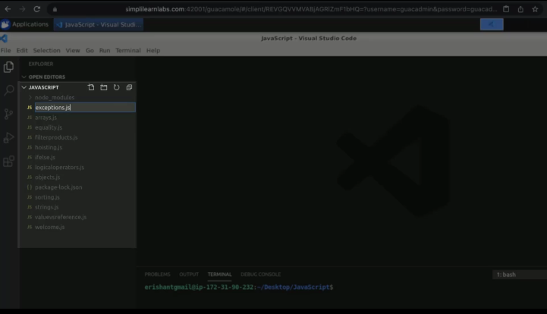
2. Add a function named ‘getCashBack’ with input as ‘luckyNumber’.  
     
   A screenshot of a computer

   Description automatically generated
3. Create a cashbacks array with some random numbers.  
     
   Text

   Description automatically generated
4. Pass a return function.  
     
   A screenshot of a computer

   Description automatically generated
5. Add a console. Log statement.  
     
   A screenshot of a computer

   Description automatically generated
6. The second log statement should return ‘Cashback app finished’.  
     
   A screenshot of a computer

   Description automatically generated
7. Add a code with a log statement within a function as ‘cashBackEarned’.  
     
   Text

   Description automatically generated
8. Run the code.  
     
   Text

   Description automatically generated
9. If you pass the number as 13, then it will show the following result.  
     
   Text

   Description automatically generated
10. Add one if else loop.  
      
    Text

    Description automatically generated
11. Re-run the program.  
      
    Text

    Description automatically generated
12. Create an object of an error with a message.  
      
    Text

    Description automatically generated
13. Use the keyword ‘throw’ the error.  
      
    Text

    Description automatically generated
14. Run the program.  
      
    Text

    Description automatically generated
15. Add a try block.  
      
    Text

    Description automatically generated
16. Add a catch block as well.  
      
    Text

    Description automatically generated
17. Pass a log message.  
      
    Text

    Description automatically generated
18. Execute the code.  
      
    Text

    Description automatically generated