**Lesson 7 Demo 1**

**Async Programming in JS**



**Steps to perform:**

1. Open the visual studio code  
      
   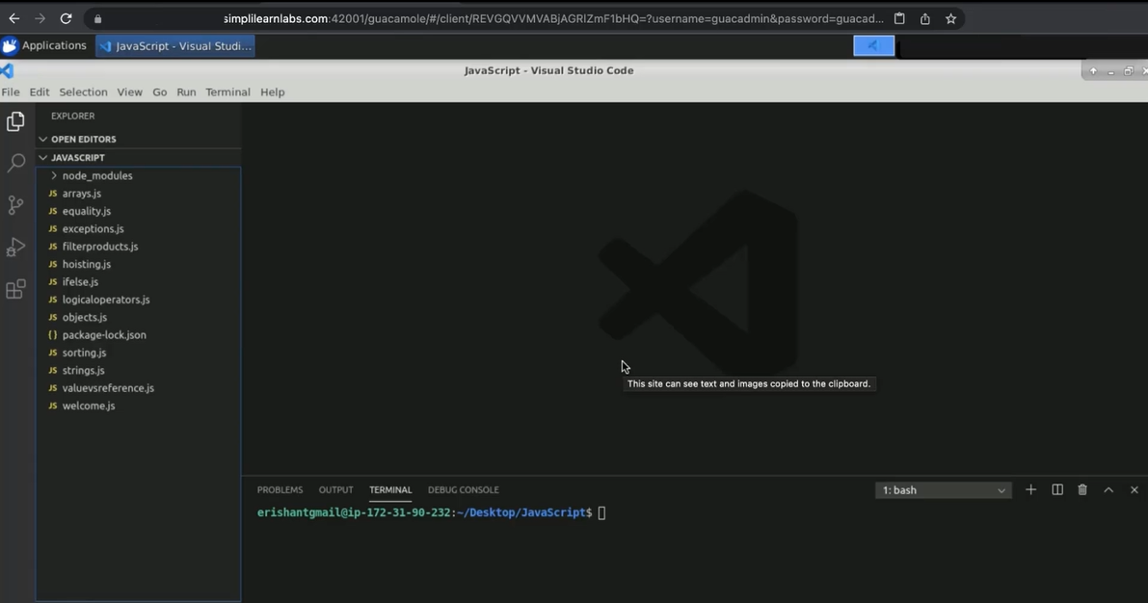
2. Create a file name async.js  
     
   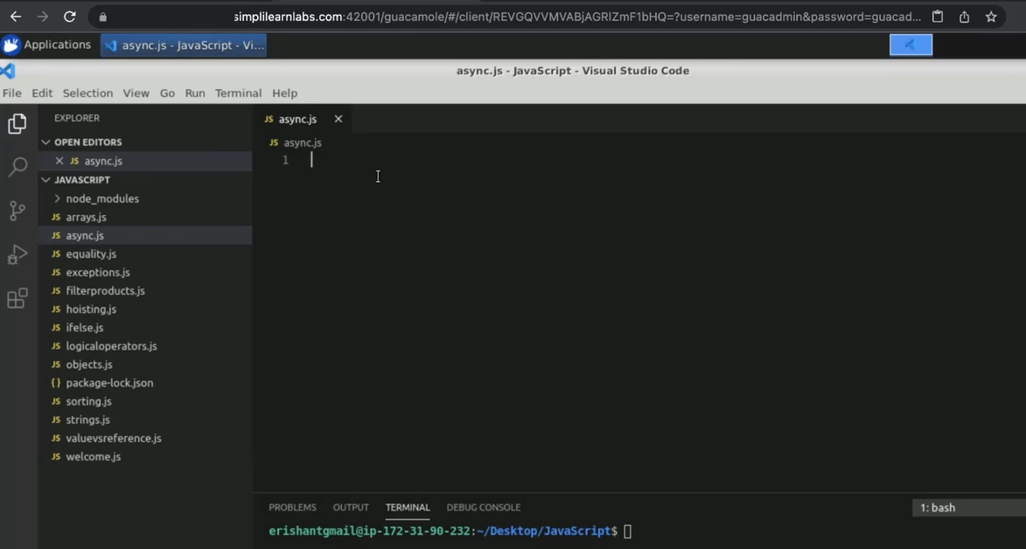
3. Create a function to upload a file. Enter ‘let uploadFile = () => “File Uploaded Successfully”;’.  
     
   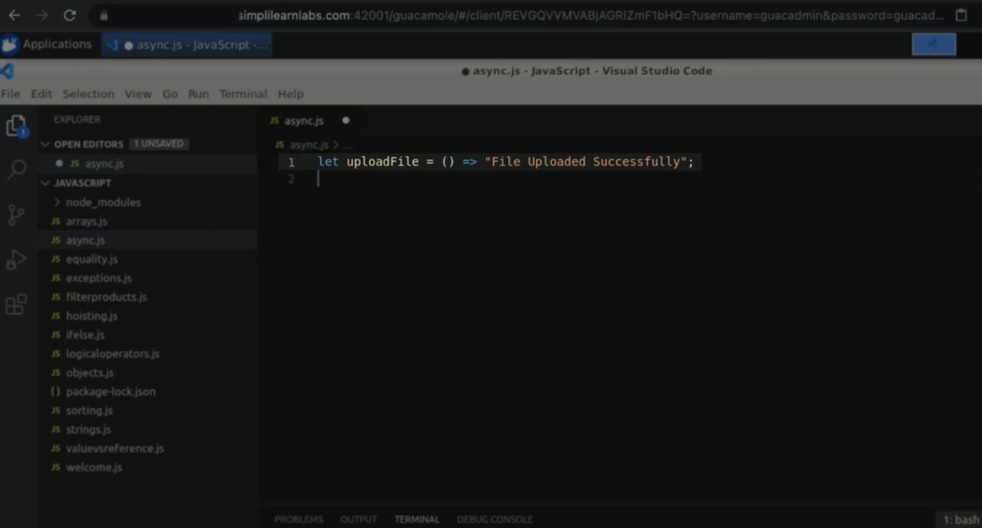
4. Create one more function.   
   Enter ‘let updateUserProfile = () => {   
    let result = uploadFile();  
    console.log(“Result is: “+result);

}  
  
1. Execute updateUserProfile() method.  
     
   Text

   Description automatically generated
2. Enter ‘node async.js’ in terminal.  
     
   Text

   Description automatically generated
3. Enter ‘async’ keyword with uploadFile() function.  
     
   Text

   Description automatically generated
4. Run the code in terminal.  
     
   Text

   Description automatically generated
5. Add another method. Enter result.then(  
   (value) => console.log(“Value is: ”+value);  
   );  
     
   Text

   Description automatically generated
6. Run the code in terminal.  
     
   Graphical user interface, text, application

   Description automatically generated
7. Enter ‘async’ keyword with updateUserProfile() function.  
     
   Text

   Description automatically generated
8. Enter ‘await’ in result upload file function().  
     
   Text

   Description automatically generated
9. Enter ‘console.log(“Result is: “+result);.  
     
   Text

   Description automatically generated
10. Run the code in terminal.  
      
    Text

    Description automatically generated
11. Create new promise object. Enter ‘ let myPromise = new Promise(  
    function(resolve, reject){ }.  
      
    Text

    Description automatically generated
12. Inside {}, Enter ‘//Algo goes here  
     let isDataFetched =true;  
     if (isDataFetched){  
     resolve();  
     }else{  
     reject();  
     }.  
      
    Graphical user interface, text

    Description automatically generated
13. Enter ‘myPromise.then(  
     () => console.log(“Data Fetched Successfully”)  
     ).catch(  
     () => console.log(“Data Fetched Operation Failed”)  
     );.  
      
    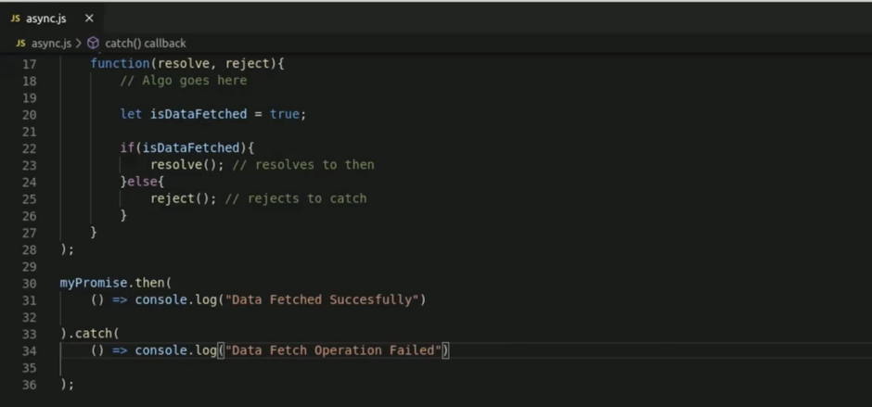
14. Run the code in terminal.  
      
    Graphical user interface, text, application

    Description automatically generated
15. Enter ‘isDataFetched = False;’.  
      
    Text

    Description automatically generated
16. Run the code in terminal.  
      
    Text

    Description automatically generated