DEPLOYMENT REQUIREMENTS

1-Any Hadoop distribution on centos6 distribution (I used cloudera CDH 5) with YARN installed in at least 2 nodes server (2 nodes is optional you can also run standalane mode spark, please refer to calculator.py to **change from yarn-client mode to local mode/spark stand-alone mode**) Please create a folder as "jpmorgan/portfolios/ " (defined in calculator.py) under directory profile and place the following file as portfolio.tsv:



1-Spark 1.3 should be installed, Spark on should be installed in each node

*[root@bigdata1 ~]# cd spark-1.2.0.2.2.0.0-82-bin-2.6.0.2.2.0.0-2041*

*[root@bigdata1 spark-1.2.0.2.2.0.0-82-bin-2.6.0.2.2.0.0-2041]# export YARN_CONF_DIR=/etc/hadoop/conf*

*[root@bigdata1 spark-1.2.0.2.2.0.0-82-bin-2.6.0.2.2.0.0-2041]#  ./bin/spark-shell --master yarn-master --driver-memory 256m --executor-memory 256m*

3-Python 2.7 in all servers (please ensure that they are the primary python installations, because in remote node there might be version conflicts) Then please install the following packages:

Mandatory

pip2.7 install django

pip2.7 install django_tables2

pip2.7 install numpy

pip2.7 install SimPy

Optional

pip2.7 install scipy

pip2.7 install statsmodels

pip2.7 install Matplotlib

pip2.7 install networkx

(If there is a problem please refer to me [anil.sener@student.ie.edu](mailto:anil.sener@student.ie.edu) )

4-Please install PyCharm IDE and open the /mortgagebalanceforecastingengine project file (file->open) in the package (pycham is run by run.sh). Please don’t forget to change python interpreter settings, by File->Settings->Project:jpmorgan->Project Interpreter as python2.7 and please press apply. Finally please check on right edge of pycharm there is database please check sql lite is available with its tables.

SQLlite Table SQLs are provided below:

CREATE TABLE default.portfolios(

ID INT,

Channel STRING,

Origination_Date STRING,

State STRING,

Original_Loan_Amount BIGINT,

OLTV INT,

OFICO INT,

Term INT,

Annual_Interest_Rate DECIMAL,

Balance DECIMAL,

Age INT)

ROW FORMAT DELIMITED

FIELDS TERMINATED BY '\t'

LOCATION '/user/anil/jpmorgan/portfolios';

LOAD DATA INPATH '/user/anil/jpmorgan/portfolio.tsv' OVERWRITE INTO TABLE default.portfolios;

DROP TABLE forecastingengine_macroecon;

CREATE TABLE forecastingengine_macroecon

(

id INTEGER PRIMARY KEY AUTOINCREMENT NOT NULL,

Date DATE NOT NULL,

HPI_NY DECIMAL NOT NULL,

HPI_CA DECIMAL NOT NULL,

MTG DECIMAL NOT NULL,

userID INTEGER NOT NULL,

isForecast BOOLEAN NOT NULL,

estimation DECIMAL DEFAULT 0

);

DROP TABLE auth_user;

CREATE TABLE auth_user

(

username VARCHAR NOT NULL,

password VARCHAR NOT NULL,

email VARCHAR NOT NULL,

last_login DATETIME,

is_superuser BOOLEAN,

first_name VARCHAR NOT NULL,

last_name VARCHAR NOT NULL,

is_staff BOOLEAN,

is_active BOOLEAN,

date_joined datetime NOT NULL

);

DROP TABLE django_session;

CREATE TABLE django_session

(

id INTEGER PRIMARY KEY AUTOINCREMENT NOT NULL,

session_data VARCHAR NOT NULL,

session_key VARCHAR NOT NULL,

expire_date DATETIME

);

5- In case of multiple python distribution installations please change spark-env.sh as below (/opt/cloudera/parcels/CDH/lib/spark/conf or /etc/spark/conf) and after restart please restart spark masters and slaves with ./start-all.sh and ./start-all.sh (/opt/cloudera/parcels/CDH/lib/spark/sbin or /etc/spark/sbin)

#!/usr/bin/env bash

##

# Generated by Cloudera Manager and should not be modified directly

##

export SPARK_HOME=/opt/cloudera/parcels/CDH-5.3.0-1.cdh5.3.0.p0.30/lib/spark

export DEFAULT_HADOOP_HOME=/opt/cloudera/parcels/CDH-5.3.0-1.cdh5.3.0.p0.30/lib/hadoop

export PYTHONPATH=$SPARK_HOME/python:$SPARK_HOME/python/build:$PYTHONPATH

export PYSPARK_PYTHON=python2.7

export PATH=/usr/local/bin:$PATH

### Path of Spark assembly jar in HDFS

export SPARK_JAR_HDFS_PATH=${SPARK_JAR_HDFS_PATH:-/user/spark/share/lib/spark-assembly.jar}

### Let's run everything with JVM runtime, instead of Scala

export SPARK_LAUNCH_WITH_SCALA=0

export SPARK_LIBRARY_PATH=${SPARK_HOME}/lib

export SCALA_LIBRARY_PATH=${SPARK_HOME}/lib

export HADOOP_HOME=${HADOOP_HOME:-$DEFAULT_HADOOP_HOME}

if [ -n "$HADOOP_HOME" ]; then

export LD_LIBRARY_PATH=$LD_LIBRARY_PATH:${HADOOP_HOME}/lib/native

fi

export HADOOP_CONF_DIR=${HADOOP_CONF_DIR:-/etc/hadoop/conf}

**USAGE GUIDELINES**

1-Build the application as follows (before you can change .setMaster to local or yarn-client in calculator.py, and you can improve memory and cpu configurations as your platform supports) I advice to firstly test in local mode because both environments should be identical in terms of spark and python installations to run yarn-client successfully as in calculator.py:

conf = (SparkConf()

.setMaster("yarn-client")

#.setMaster("local")

#you can shift between local and yarn-client mode, it is very important to have same python2.7 version in all servers

.setAppName("forecastingengine")

.set("spark.executor.memory", "512m")

.set("spark.driver.memory", "512m")

.set("spark.python.worker.memory", "4g") #My environment didnt support more please increase to 8gb

.set("spark.shuffle.memoryFraction", 0.4)

.set("spark.default.parallelism",2) #I am using only 2 nodes for execution

.set("spark.executor.instances", 2)

.set("spark.executor.cores", 2) #My environment didnt support more please increase to 4 cores

)

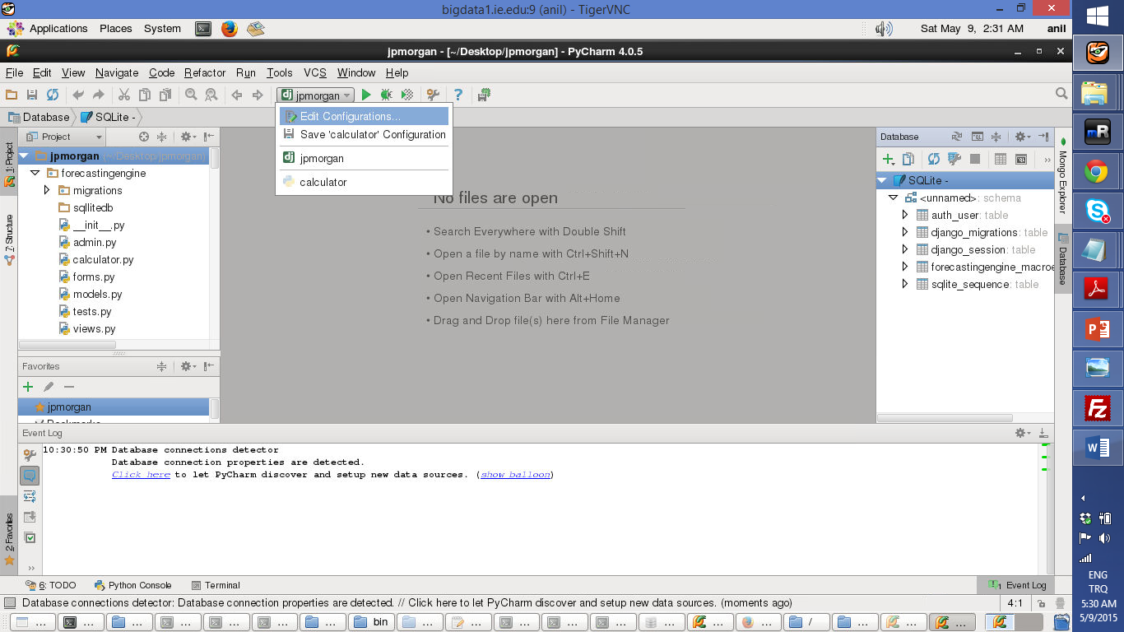

2-Please open Mozzila firefox and login to the application with <http://127.0.0.1:8000/forecastingengine/> link.

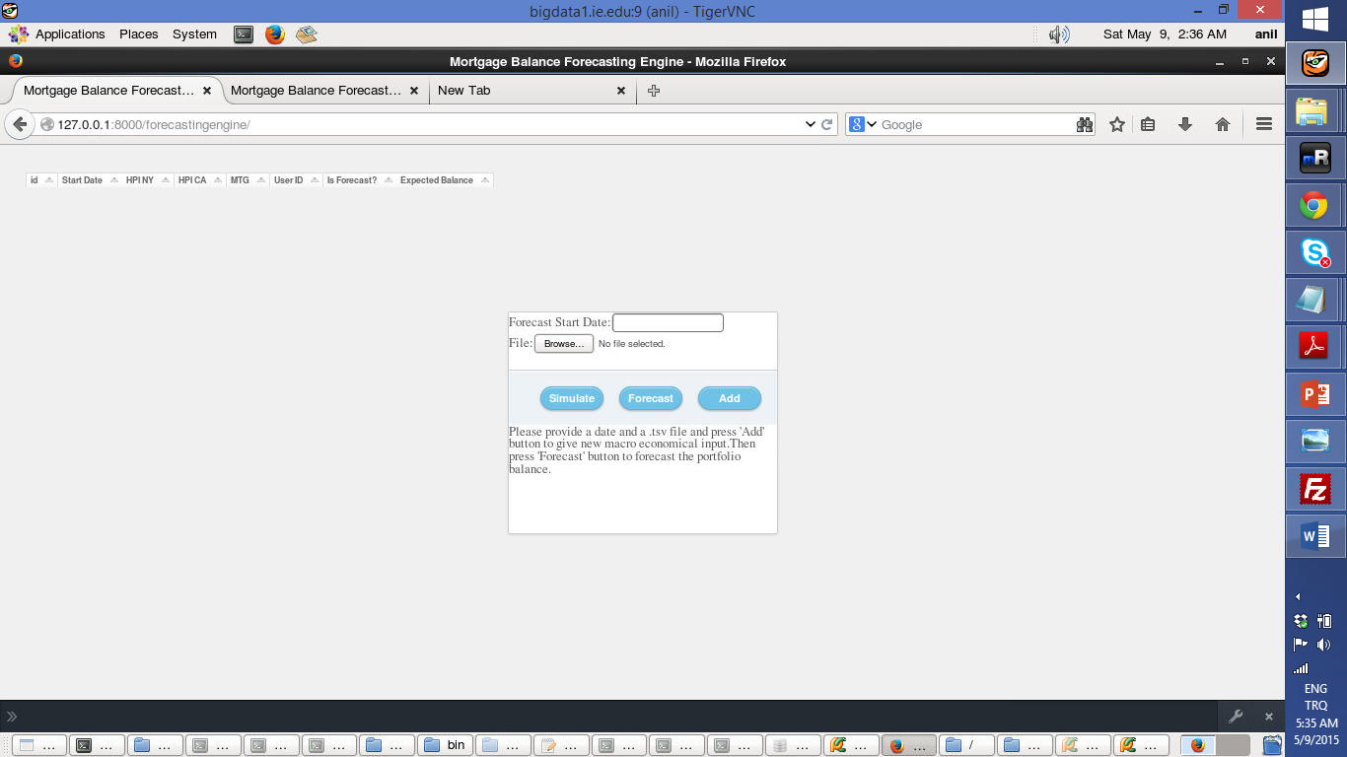

3-Please enter a forecast start as 10/01/2013 (Please us this format, I didn’t want to spend time on format checks other than Django provides by default) and browse macro_econ.tsv file below to upload macro economic inputs and press Add.



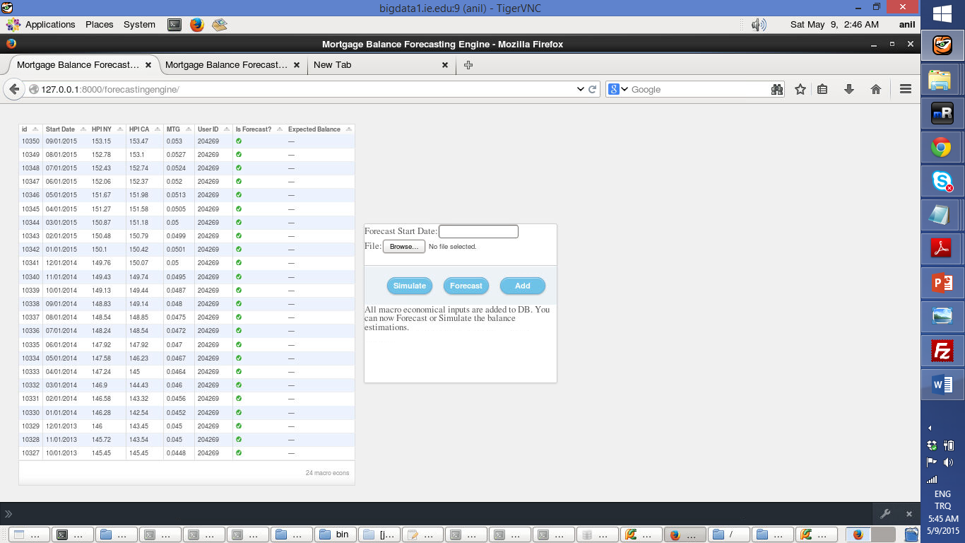

4-After the inputs are added you can press Forecast (Problem 2) or Simulate (Bonus) as you like:

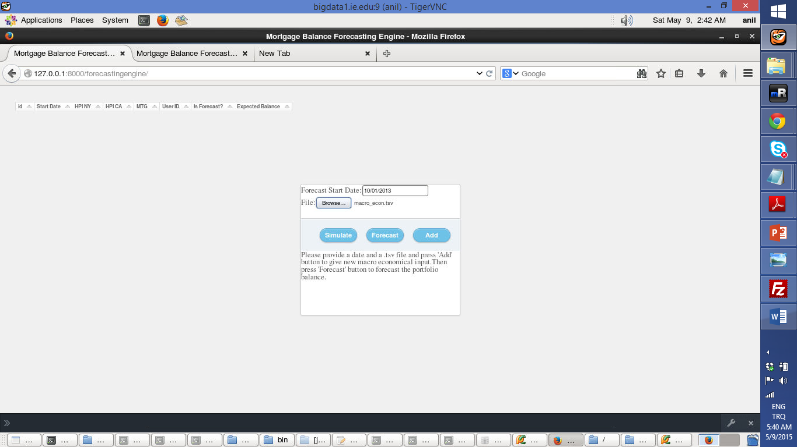

5- The output for forecast:

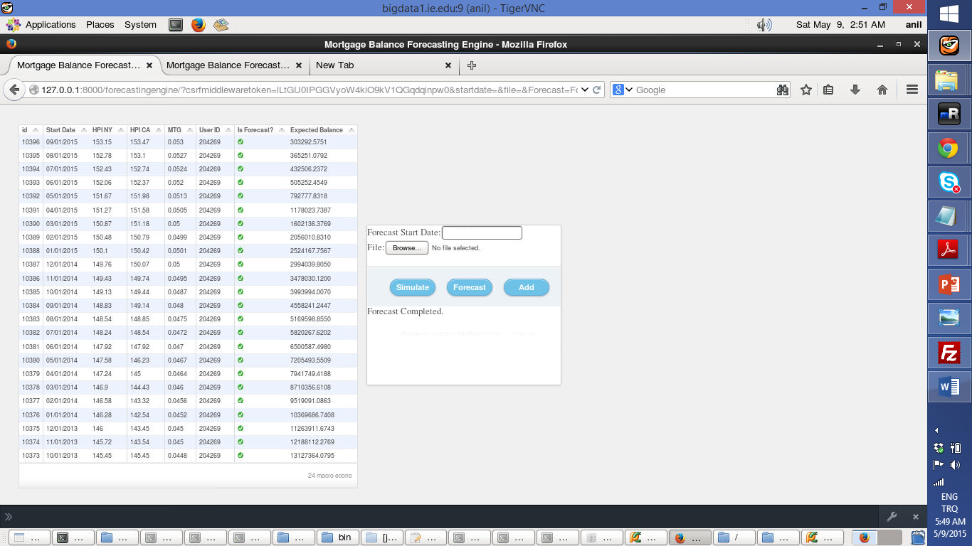

6-The output for simulate:

