Chapter 2.1: Analysis

Introduction to analysis

Analysis is the process of breaking down of complex form into the smaller datum. In this project the task has been also decomposed into different categories in order to perform more accurate and easier. The analysis parts consist of the feasibility study, requirement analysis consist of functional, non-functional, Moscow and SRS, use case and class diagram.

The some of the activities that are involved in the analysis are described below:

Requirement determination:

In this stage requirements are gathered for the system that is going to be developed. But in this case requirements are with the most prioritized are gathered. They must be included in the system and parts of the system.

Requirement specification:

The system or the application on which requirements are listed in order to fulfill the requirement held in this process. Users specifications are gathered and collected as what actual need through discussion.

Feasibility study:

The feasibility study shows the requirement that actually meet the requirement with user needs. It is also as a cross checking for the product identifying the technical, operational, efficiency of the product.

Final statement:

This shows the actual achievements of the systems. What things have been achive and left to do. Shows the stages or level of achievements still required and fulfill by the team shows in the SRS formats. In this stage maximum requirements have been captured.

Hardware requirement:

In this stage the products that developed by the team goes to its size and requirement for the overall management are analysis. If system took low or high amount of resources depends on the size of the project. Hardware, data, response time, volume are measured in this level.

System design:

This is the main parts of the projects where real-life implementation of the requirements are captured and implementation. Building of database, logical design, testing, implementation is done in this stage.

Implementation of system:

Includes of coding to the system, testing, user testing, database and documentation are done in this stage.

Evaluation:

Evaluating the system from the technical and the user views. Meet the requirement and still have doubt. Can be improve or can be listed the problem for better improvement.

Modification:

The unapproved or default listed on evaluation are further used as modification of system. It generally helps to improve the system from the adding, updating, fixing the features.

The main reasons for performing the analysis are:

* Can easy to identify problems:

The major information is to identify the problem before the project begins. So, that the problem can be easily minimized before the begin.

* Task can be prioritized:

Major systems and heir requirements can be prioritized before the beginning of the work. So, according to the requirement system can be developed according to the major prioritized.

* System can be breakdown:

So, according to the needs as per the work the system can be breakdown in order to divide the task. So, brings up the piles of work into the routine wise schedule. Helps in the effective and efficiencies in the system.

* Requirement analysis:

Requirement can be easily identified if the analysis process can do early stages. Including economic, technical, resources and other requirements.

CATWOE analysis:

For this project CATWOE analysis is preferred as the main analysis as it confirm to the business and decision making. It is the technique for undertaking the customer or stockholder problems and follow the different processes in order to finish the problem trend. (Elmansy, 2015)

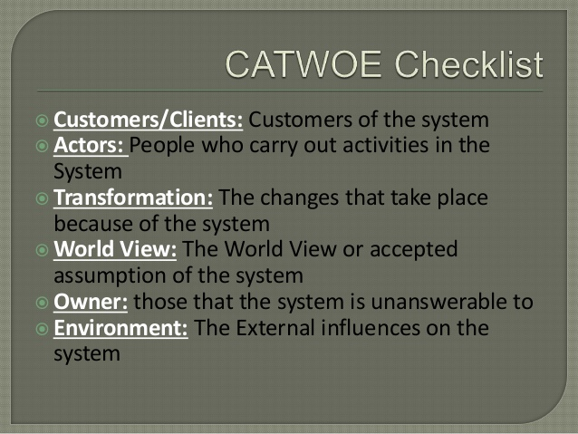

The CATWOE analysis includes of number of stages which are explain below:

Customer:

The team manages to solve or gather the problematic condition of user or customer. In this project the customer is gym management system where I am stockholder the requirement given for the project as a client.

Actor:

Refer to those who participate in the situation directly or indirectly might be stockholders or employee. This project belongs me as actor because of I am involved to carry out the system.

Transformation:

Determining the process of inputs and their outputs in this system. What kinds of input does it takes and through back the output? And all the processes between them are realized. (pham, 2014) for the gym management system

World View:

It simply clarifies the definition and the understanding of project with problematic and its solutions. It refers to the important framework of CATEOE analysis in this assessment.

Owner:

Represent the person who fully have control over the project and stand against the system to lead whether to implement or not. The owner has fully control over the system and lead to the overall project till the end with the highest decision.

Environmental constraint:

The environment constraint gives the meaning of internal and external matters that affects will be constraint through over the projects like resources, financial, laws, ethical factors. (Kukhnavets, 2017)

2.2 feasibility study

A feasibility study determines the wide range of area which includes all the causes that needs to be view to implement the project. The study shows technical, legal, social, environmental, economic, resource. The feasibility shows the major identify whether the project begin or does not meet the feasibility requirement. (mukund, 2018)

The feasibility study is classified into the different sub tasks are:

1. Economic feasibility:

In this assessment economic feasibility includes cost that need to required during the task. As like electricity, components, devices that need during the projects. In this assessment the economic feasibility is possible to manage for the project.

1. Technical feasibility:

Generally technical feasibility show available resources is capable of converting them into to productivity. This includes the hardware, software and other determines that how it will make different in working system. In this assessment the technically requirement is possible.

1. Schedule feasibility:

The project is divided into the different sub tasks in order to finish the product on schedule. The chance of pass and fail determined by the schedule time and achievement. In this assessment most important is scheduling and success. The time and schedule conducting throughout the project is possible.

1. Operational feasibility:

It shows the delivery product and their productivity against the complete product. Weather the product satisfied the requirement well or not. To satisfy the terms and the requirement in this assessment can be success to manage.

1. Legal feasibility:

The legal parts also need to be view while drawing this assessment because whether the legal conflict brings. The legal feasibility helps to clarify the legal site of project whether the boundary on favor. The project that I am going to developed is not against legal and should be legal free software to developed.

2.3. Requirement analysis

Requirement analysis is the process of identifying the major requirement of the customer in order to meet the quality, acceptance and upraise from the failure. It defines the user expectation in the application.

1. Functional requirement:

Functional requirement is those behavior of the system that made the system more accurate and well balanced. Make the system more accurate, efficiency, acceptances, performance and well developed with user perspective. (eriksson, 2012)

* Admin registration
* Admin Login
* Admin update profile
* Dashboard
* Add customer data
* Change customer data
* View customer data
* Delete customer data
* Customer payment details
* Customer report
* Search details
* Add sales items
* Bill generation

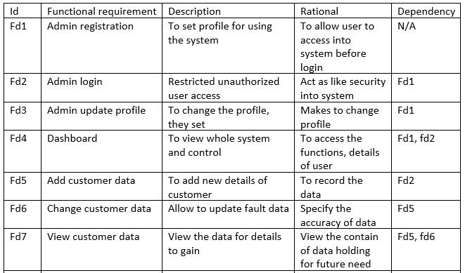

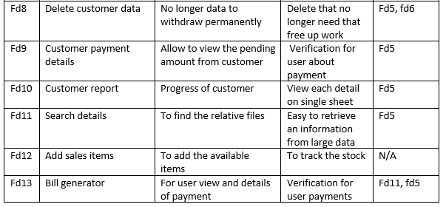

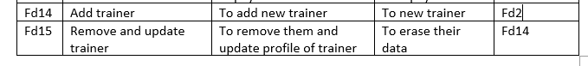

1. Non-functional requirements:

Basically, the non functional defines the how the system works. Most of the requirement are based on functional due to which large gap between functional and non-functional are common. (Eriksson, 2011)

* Usability
* Performance
* Reliability
* Availability
* Security
* Portability
* Reusability
* Modifiability

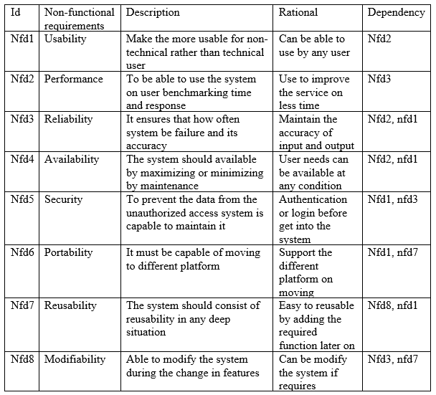

1. MOSCOW prioritization:

The MoSCoW prioritization shows the priority given to the stockholders and their needs. It implements the must have, should have, could have and won’t have the four principle.

M stand for: must have which should be include

S stand for: should have which is necessary but not include

C stand for: could have which will include on later on if necessary

W stand for: won’t have ignored by stockholders

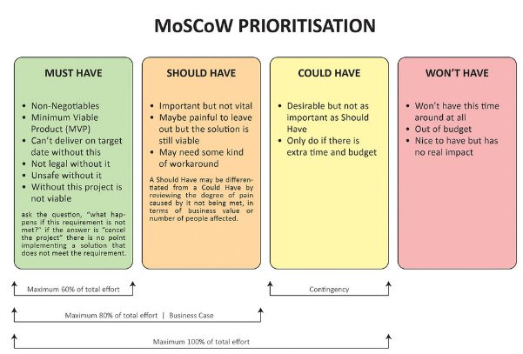

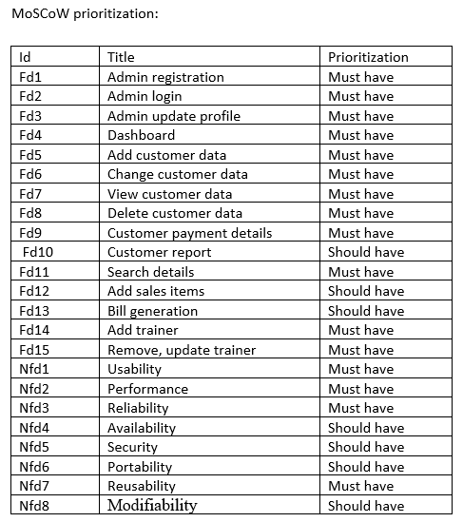

1. System requirement specification

System requirement specification includes of all the functional and the non-functional and also a stockholder requirement. It helps to improve the project and prevent from failure. This also make it to reduce the redesign process. In this project the requirement for the project development are

|  |  |
| --- | --- |
| Operating system (OS) | Windows 7/8/9/10 |
| System type | 32-bit or 64-bit operating system |
| Processer | Intel(R) core M480 2.66GHz |
| Ram | 2GB/ higher |
| Database | Microsoft SQL server |
| Programming language | C# |

Use case diagram:

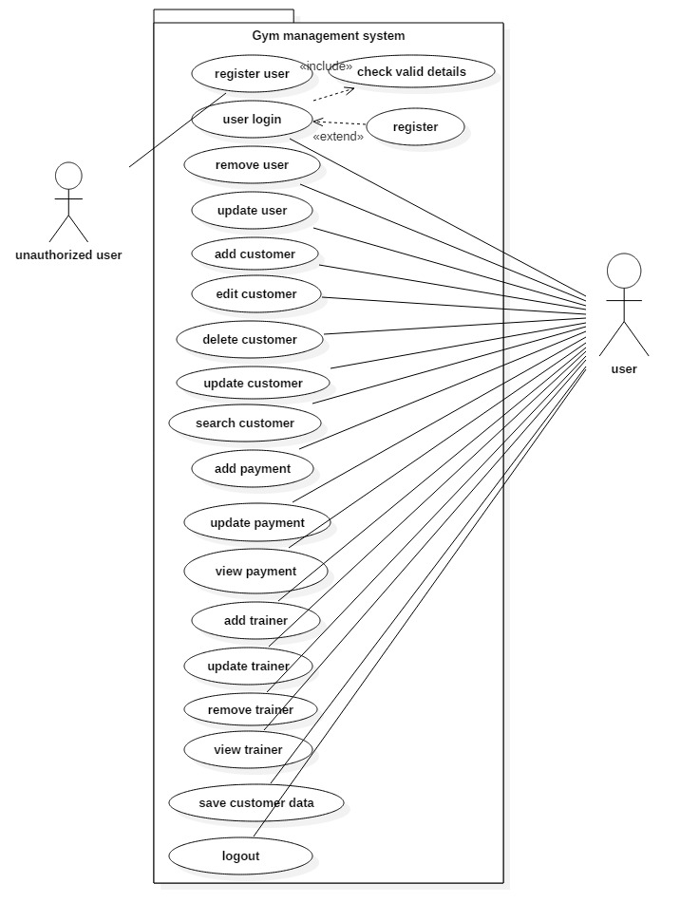

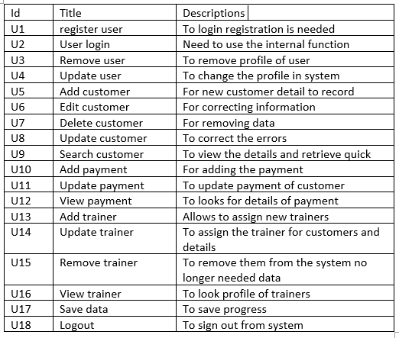

User story:

Gym management system is appliation that used to manage day to day activities to keep the record details of the customers. The system will keep the data recorded in the database. The system is handled by those who operates preffered as admin. The cuatomer can provide the details on the front desk and system use can insert the data into the system. The main system user have privillage of data insert, update, delete as well as view.

The customer can get their data to view if he/she prffered to view it. The system also tried to sales the items from the place but not as important. The customer payment details also recorded . For the billing process the management can have alternative possiblities. For the easyness the search for the details also be included. Their time period also recorded as trainer assged them.

The selected nouns, vebs and adjective are given below from the user story:

|  |  |  |
| --- | --- | --- |
| Candidate class lists (noun) | Attribute of candidate list (adjective) | Canddate list of (verb) |
| System, customer, user, trainer | System, details, record | Insert, update, delete, view, edit, remove |

Class diagram:

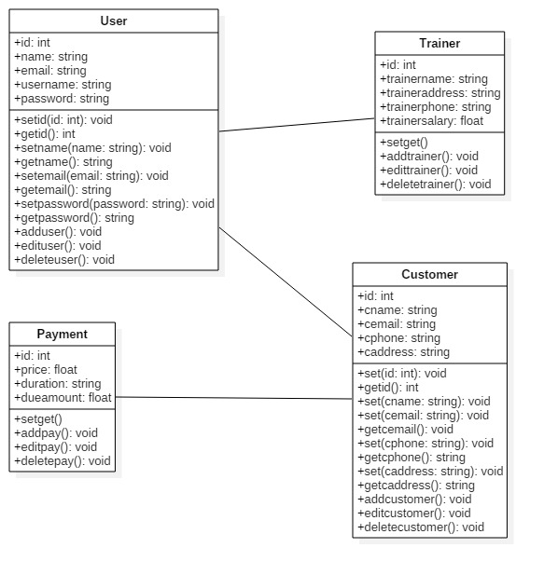

Conclusion:

The gym management system analysis part is done with the user requirement. For the better and quality, the functional and non-functional parts are done through in this assessment. The term of requirement is shown in the form of MoSCoW prioritization. The use case diagram shows the actual movement of the system how it works and initial class diagram also added in the analysis part.