Design

Introduction:

In gym management system the design of different perspectives plays the significant role to achieve the project. In this project the design parts involve of different pattern of sub division of the parts of system. This includes the structural design that consist of class and data flow diagram. The behavioral design includes activity and sequence diagrams where as database includes data dictionary and ER-diagram. The architecture design has user interface and prototyping.

For this project the requirement od design are sketch through the help of star UML. This star UML helps to create the diagram makes it easy to sketch. Unified modeling language (UML) is used to build software and relative of any software system.

Structural design:

The structural design pattern basically shows the relationship between entities. Shows the object and classes how they are interrelated to each other combination of large complexity into easy design. In this project this structural design makes the project more complex into simple easy understanding form to know how the system going to implement. (tomar, 2012)

1. Class diagram (final):

The class diagram shows the relationship between each classes and their class name,attribute and methods. In this project the relationsip are shown through the simple association that is solid line.

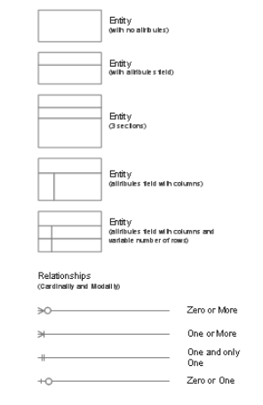

The some of the notation used in the class diagrams are shown in above screen. Some of them are described below:

* Entity: they can be used to identify the class which comes from the user story by filtering it.
* Entity attribute: they can be considered at attribute of classes
* Entity method: represent the process made by the attibute to draw the process

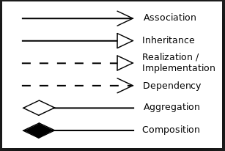

This notation can be used to join the classes with other classes.

* The association: it indicates that object in one class have relationship with object in another class
* The inheritance: the behaviour of parent class transfer to the child class
* Aggregation: it indicate that parent class can exist if there is missing the single part of child class
* Composition: it indicates that child class cannot exist if there does not exist parent class

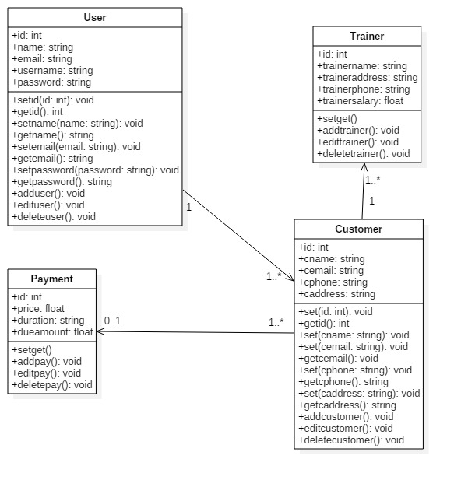

screen 1: final class diagram

the class diagram shows the entity, method and the attribute into the system. Identify and display the role of class. Their attribute and the methods that implement by the class.

Important:

* It generally shows static diagram of any system.
* Better to develop for new or another member.
* Shows relationship between classes.

1. Data flow diagram:

The data flow diagram shows the flow of information through the system and process. The different notation and symbols are used to identify the flow of data. They describe the entity and the relational flow. The flow makes the better understanding of system and improvement further on future development.

The data flow diagram are two types physical and logical. But the both diagrams shows same information flow.

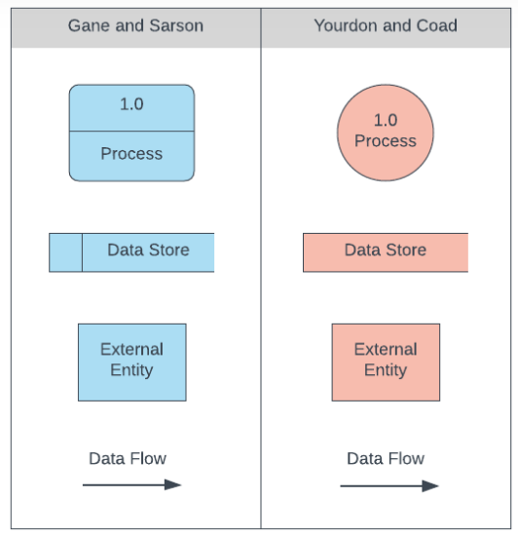

The above diagram in which the different notation has different meanings:

* Process: this known as process in which it known as input and output on DFD. Actually, transport incoming data to outgoing data.
* Data store: this stores the data that has been already processed. Input process are stored in the data and output is retrieved from database.
* External entity: they are the actor, entity of the system. They are initial beginning before the processed.
* Data flow: identify the flow from entity to the process and process to the database. They can be reserve back.

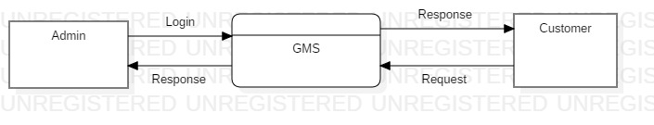

screen 2: DFD level 0

0 level DFD does not have more details but shows that the flow of information from external entity into the internal process.

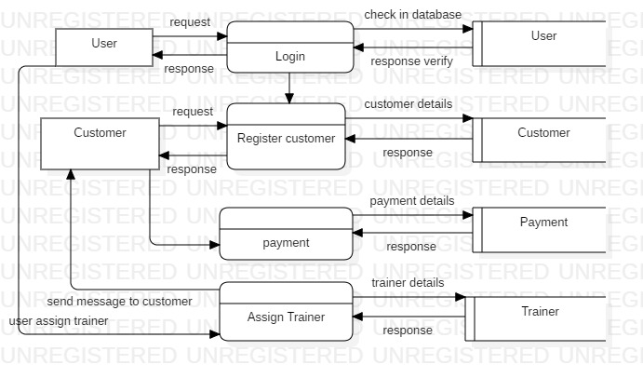

screen 3: DFD level 1

level 1 DFD shows the flow of information from the entity to the process and from process to the internal database system. How they perform the function between them?

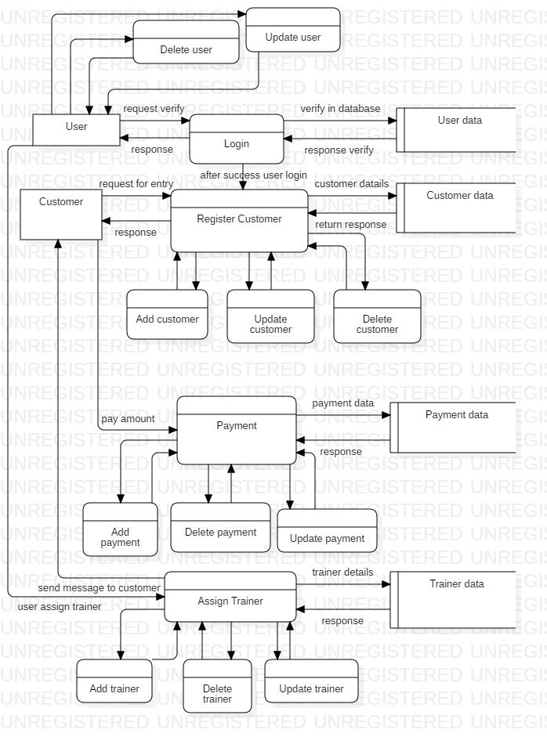

screen 4: DFD level 2

level 2 DFD shows the entire process of the entity and their major activities. From CRUD process to their impact into database and processes.

Behavioral design:

The behavioral design represents the activity and sequence diagrams. This diagram helps to identify the activities of user and admin where as the sequence show the flow of order of data.

Activity diagram:

The activity diagram actually performs or shows the flow of activity from anther activity. This represent dynamic aspect of system. This diagram is not used for the visual capturing but also used for forward and reserve engineering. (Warren lynch, n.d.)

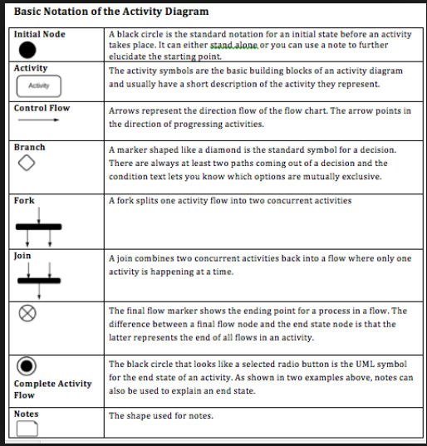

The some of the notation that are sown in above figure. This notation can have meaning with their used. This used combined formed the activity with their meaning. Some of them are described below:

* Initial node: used for starting the system.
* Activity: The activity shows processes in a model process
* Control flow: used to show the flow of data and also preferred as direction flow or control line
* Branch/ decision symbol: identify the decision make during activity
* Fork: helps to split the activity into multiple process
* Join: makes the split of activity into single activity or synchronization
* The flow final symbol: show the ending process flows in a single flow in an activity
* The end symbol: represent the complete end of the process
* The note symbol: allows the diagram creator additional message that do not in the diagram itself

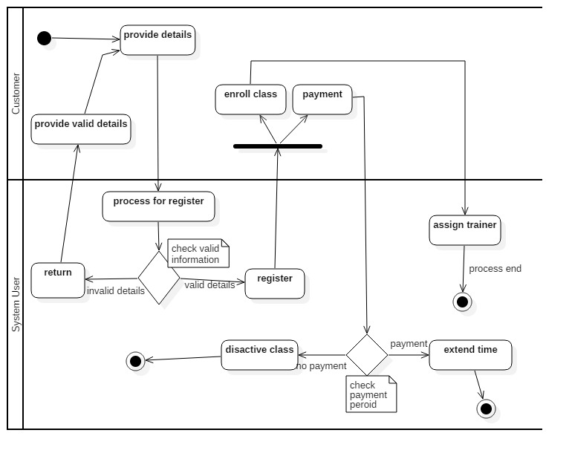

screen 5: Activity diagram

the main activity diagram of whole scenario where the interaction of user with customer are shown. The customer begins the details provided to the system user to register or enroll into the gym. Which flows can be clearly seen in above diagram.

The Swimland divides the activity between the system user and the customer. The notation can show activity of them and flows.

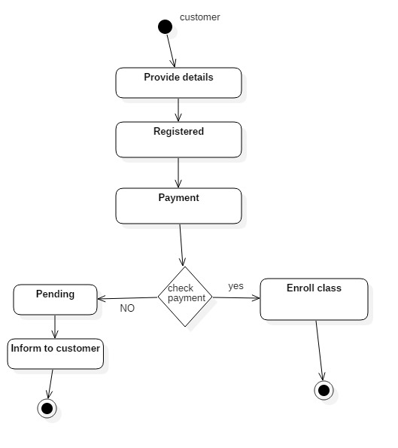

screen 6: Activity diagram of customer

this is activity diagram of customer shows the flow of interaction of customer with the system user. And activity only done by the customer during the process interacting with system user.

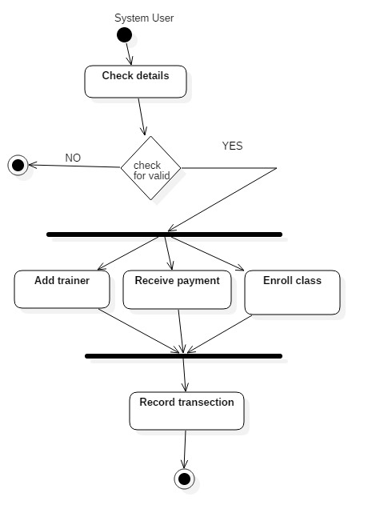

screen 7: Activity diagram of system user

this is the activity single diagram of user. Visualize the activity done by the user considering on certain activities belongs to user during the performance on system. The main system user can make such activities during process.

Importance of activity diagrams:

* Detect order of flow of activity
* Modeling the work by activity
* Easy to model the business requirement
* Understanding of system from high functionality

Sequence diagram:

The diagram helps to identify the each and everything details in this project. It describes the interaction of the different parts of the system. In this project the sequence diagram shows the actual interaction with different entity with each system.

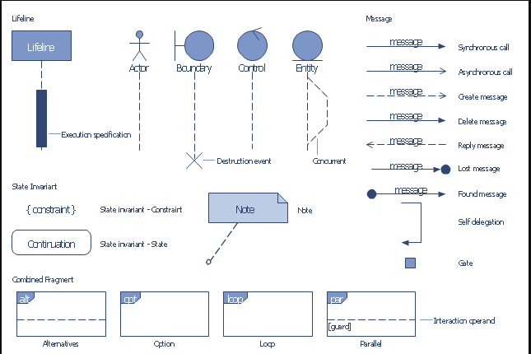

The sequence notation is described below only some of them:

* Object lifeline: indicates that how long the entity life line exist during the whole process of sequence
* Activation: represent the active of the flow of message and the entity that involve on it
* Message: identify the flow of message between the object
* Message synchronous: the kind of message that need to wait response before continuity next
* Message asynchronous: this message does not need to wait for the response
* Return message: the message that come back after send to certain object
* Self-delegation: offer the self-message within the object
* Found message: initial beginning indicated by it
* Alternatives: provides the condition to apply on it
* Loop: consist of same work to continuity for the certain period of time

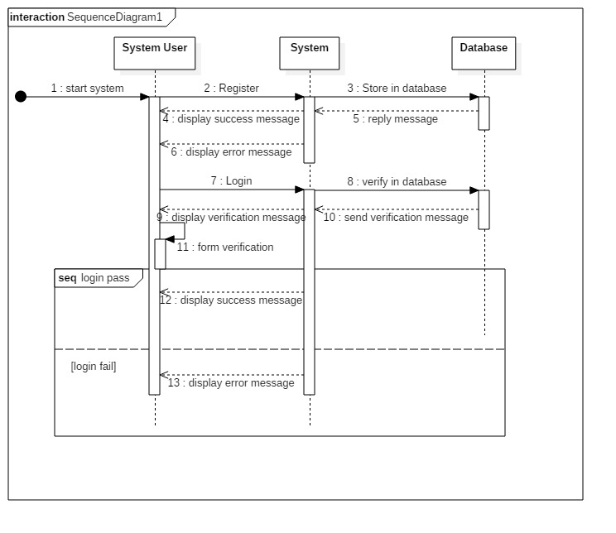

screen 8: Sequence diagram

the initial part of sequence diagram that shows the register for login and the reaction between system user, system and database how actually perform the flow between them before beginning of system. From where the system begin and what function should need to perform to login into system.

The user first register into system before login into the system. And the flow of process shown in the above diagram.

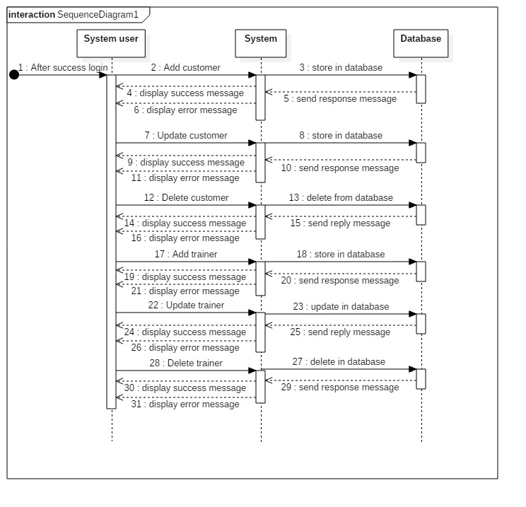

screen 9: Sequence diagram

the second part of the sequence diagram where user perform the system after success login into the system. The different activities can be done after login success. The additional major features can be access to run the system. That includes all features of system.

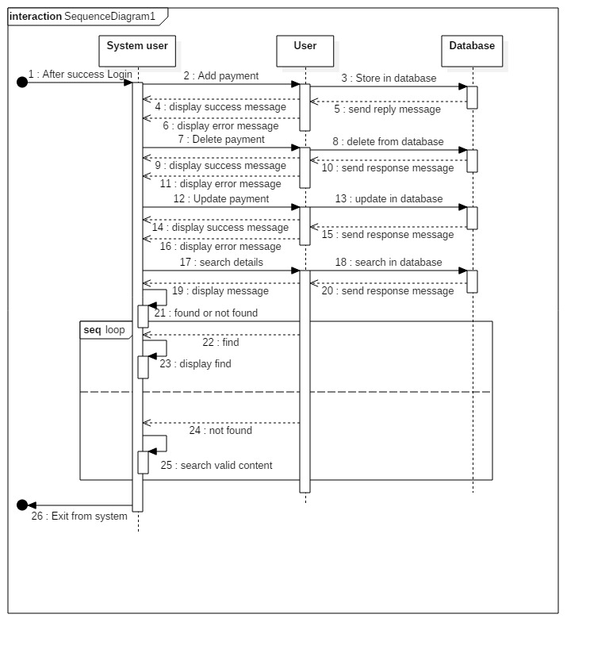

screen 10: Sequence diagram

in this diagram the user can perform the continuity in the search case until the user cannot found the search item. So, loop process is used in search part of sequence diagram. And after the complete process the user can exist from the system.

Important of sequence diagram:

* Deletion and creation of object
* Identify the object actions
* Identify the lifeline of entity
* Makes the reverse engineering

Database:

The database shows the data and their relationship to store the procedures. In this project the database includes data dictionary and entity relationship diagram (ER diagram). The ER- diagram is all about relationship between each entity or classes. Data dictionary includes metadata, datatype, data length and many others.

Data dictionary:

It is the details description of the data that are in the database. Each element in the database has its own metadata. In this data dictionary it identifies or shows the datatype, references, keys and more. Provides the details description of relationship, meaning, sources. (kononow, 2018)

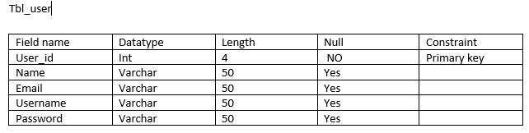

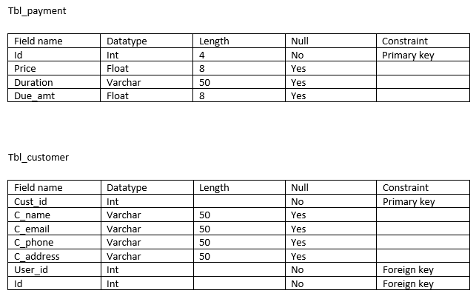

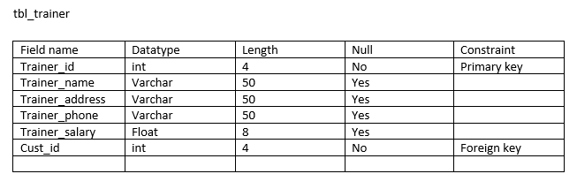

Important of data dictionary:

* Better during utilization of software requirement of data
* Easy to understand nature of data
* Provides the referential integrity
* More secure encryption

Entity relationship diagram (ER-diagram):

The ER-diagram provides the better development od database and their relationship. Provides the relationship between each entity in the system design of database.

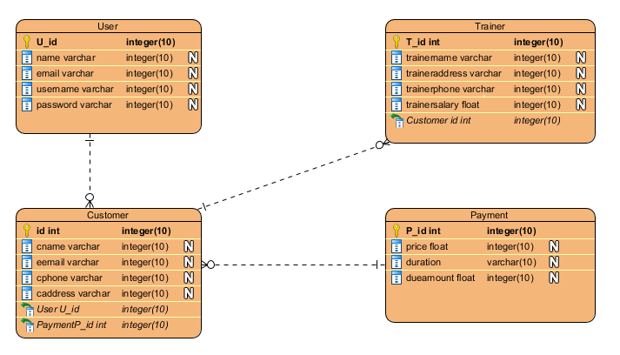

screen 11: ER-diagram

the ER-diagram basically shows the relationship between each entity. In above diagram shows the relationship between each entity involve in gym management system. Shows the clear views and better understanding of data through diagram.

Important of ER-diagram:

* Provides the relationship between each entity
* Easy to understand
* Visual representation
* Effective flow of communication

Architecture Design:

The outer look of the system before the implementation into product. It defines the total structure of the system exactly the same as in the architecture design. So, this design can be easily be understand by the implementation and knowledgeable.

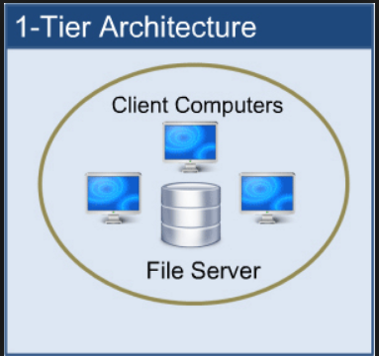

Our desktop base application is based on 1 tier architecture because of the all the layers based on the same unit. It generally consists of three-layer presentation layer, business layer and date layer.

* Presentation layer: this layer is visible as it also known as client layer. Top most layer of an application.
* Business layer: all the logical representation includes in this layer and known as application layer.
* Data layer: where the data stored in the system and perform update, delete, insert functions.

Important of architecture design:

* It is also considered as blue print of system
* Improve quality, function of system
* Visible only system structure but hide implementation process

User interface design (UI Design):

The design is classified into two categories UX-design and UI-design. They are actually different from each other. They perform similar character although role is different. UX refers to user experience where as UI refer to user interface design. The UX design is for customer satisfaction and improving the usability, use. Where as UI design is the process of looking and feeling of the product what would be like. (LAMPRECHT, 2019)

But in this assessment and project I preferred to use the UI-design for the beginning outlook of the program.

Prototype:

In this project the early version of prototype is made by using the Balsamiq mockups software to made prototype. Due to the easiness and easy to sketch.

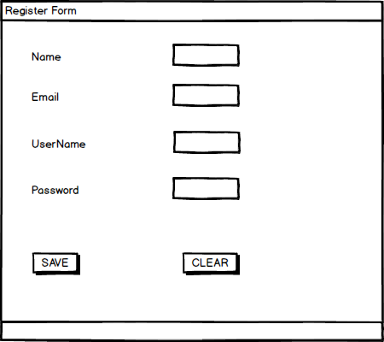

This provide the user to register into system before going to login. So, new user needs to register before to excess into the internal function of system. Prevent from the direct entry of unauthorized user to access the system features.

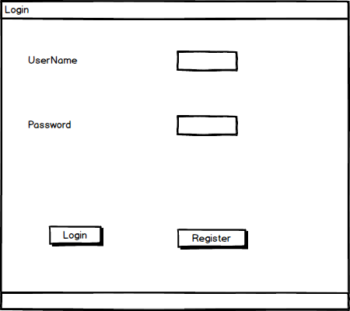

The second step of system is to login after the success register into the system. Each one the interact into internal mechanism need to login through this.

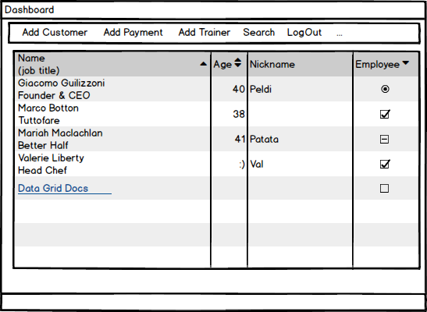

This is the main dashboard of the system. After login success this interface is open and allows user to access different additional features to operate. The user can add customer, payment, search, add trainer from this form.

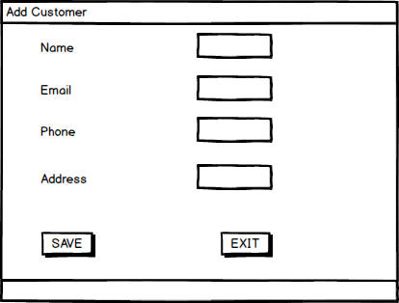

From this form the user can add new members into the system. This form can access after the success login and from the dashboard of the system.

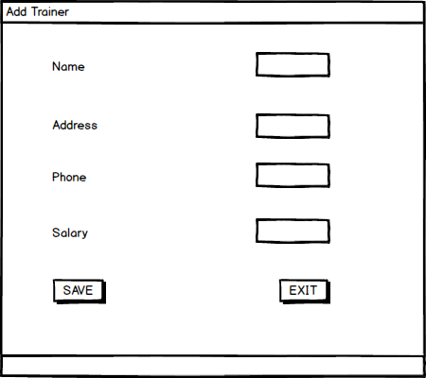

This form considered as the data of trainer to add. This allows to add the details of the trainer in the gym management system.

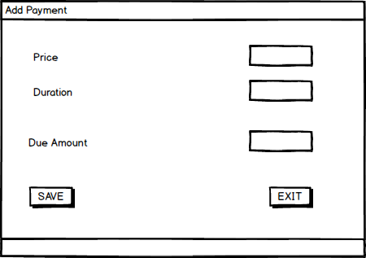

This form can add the payment details of the customer that enroll in the gym management system. Keep the record of transection of payment.

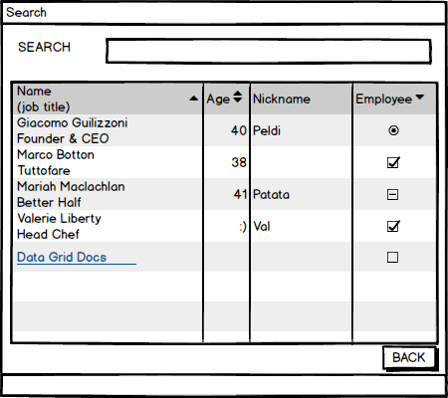

This form allows to user to perform the task more easily. It allows the user to search the details of the customer exist in the system.

Importance of UI-design:

* Allows user to feel the early version of software
* Easy for the developer
* Reduce development cost
* More customer acceptance
* User friendly design

Conclusion

After the effort made on to design that includes all the format is completed. Although there are problems on making all the diagrams are made with the help of software references. Though the design phase of this project has been completed. Different parts of design are done through the required format and process with explanation.