**2)**  
**a)** To select a core for transformer, we firstly calculate the area product formula. Required formula can be seen from application note of Mag-Inc. $$WaAc= \frac{P_{O}*D_{CMA}}{K_{t}*B_{MAX}*f}$$

For P=96W, Dcma= 500, kt=0.0014, Bmax= 1200. WaAc = 0.2857.

Closest value to that are product is 3235 ER core. For lower losses R material are selected. Our final part number is 0R43225EC.

Number of primary turns van be calculated the using formula below.

$$N_{p}=\frac{V_{in}}{4*A_{c}*B_{max}*F_{sw}}$$

By putting our values, we can find that Np≈2.06, we can round it to 2 turn.(Since we selected 0.12T, we can select a little bit lower, moreover, this will help us to have a low core loss). Then we have calculated the turns ratio from part A, our secondary turns ratio is equal to 10. Magnetizing inductance can be found by using the Al value of our core

$$L_{mag}=N_{p}^{2}*Al \\ L_{mag}=11.5720 uH$$

**b)** To select the number of parallel conductors, We started by calculating required cross section area.

$$A_{conductor, primary}=\frac{I_{primary}}{J}$$

Since our mean input current is 8A, and current density is 4A/mm^2, we know that we need 2mm^2 conductor for primary, with same calculation method, we need 0.5mm^2 for secondary.

Due to skin effect, we selected to use 28AWG cables in parallel(which have 170kHz full skin depth), with that configuration our AC and DC resistance will be same. According to the page given, cross section area of 28AWG cable is, 0.080mm^2.

$$Required number of conductors= \frac{Total required cross section area}{Cross section area of each conductor}$$

When we make the calculations, we need 25 parallel conductor for primary, and 7 parallel conductor for secondary.

With that configuration, fill factor can be calculated as

$Fill Factor= \frac{\left(N_{p}*Number of parallel conductors in primary+2*N_{S}*number of parallel conductors in secondary\right)*Cross section of each conductor}{Window Area}$

With that calculation, it turns out to be our fill factor is equal to 0.3541 which is bigger than 0.3 and more importantly, it is still in the usable range.

As we mentioned earlier, due to our conductor selection, our AC and DC resistances almost equal. To calculate the resistance of each winding, we firstly know the resistance value for 1mm 28AWG cable. This value can be calculated using the table given.

$$Resistance of 1mm 28AWG cable=2.12872*{10}^{-4}Ω$$

Next, we need to find the length of our wire to calculate the resistance, of course this will be a just an approximation, but to make a better approximation I assumed that we firstly wind primary then wind the two secondary after that. By this way we can find approximate mean radius of primary and secondary windings separately.

To calculate the end point of primary winding, we can define a fill factor for only primary winding.

$$Fill Factor for primary winding= \frac{\left(N_{p}*Number of parallel conductors in primary\right)*Cross section of each conductor}{Window Area}$$

By this formula we can learn that, only 9.32% of our winding are has used for primary winding. Then we can calculate the radius of last turn in the primary winding by using the formula below.

$$Radius of last conductor=\left(27.4-12.4\right)*fill factor for primary+12.4$$

With that formula we can find that, that radius is equal to 13.78mm, then we can assume that (12.4+13.78)/2 is our mean radius and calculate the resistance.

$$R_{DC,primary}=R_{AC,primary}=7.38*{10}^{-5}Ω$$

With the same process we can calculate the secondary as

$$R_{DC,secondary}=R_{AC,secondary}=0.0023Ω$$

Copper losses are simple I^2R losses and can be calculated as follows.

$$P_{copper, loss, primary}=R_{primary}*I^{2}=5.904*{10}^{-4}W$$

For the secondary part, we should firstly calculate the current value,

$$I_{Secondary}=\sqrt{D*I_{o}^{2}+2*\left(0.5-D\right)*{\left(\frac{I_{o}}{2}\right)}^{2}}=1.34A$$

Then

$$P_{copper, loss,secondary}=R_{secondary}*I^{2}=4.13mW$$

$$P_{copper loss, total}=P_{loss, primary}+2*P_{loss, secondary}=8.85mW$$

**c)** Calculation process of core loss is not simple, to make it simple manufacturer gives us a excel sheet, by using that excel sheet we can approximate our core loss.

tablo içeren bir resim

Açıklama otomatik olarak oluşturuldu

Figure 2.1 Core loss approximation using manufacturers excel sheet

As can be seen from figure above, manufacturer gives us a approximate loss for unit volume. We know from our cores datasheet that, our effective volume is equal to 5.4cm^3, then our total core loss is equal to

$$P_{core loss}=V_{core}*Core loss for unit volume=580mW$$

Core loss is much higher than copper losses. For our transformer, core losses will be dominate.

**d)** For the inductor design process, we decided to use toroid core rather then selecting a E core and calculating the air gap. Design process of Mag-Inc is a quite detailed process; however, it needs iterations. After some iterations we decided to use 60µ cores are suitable for us. Selection of size is completely iterative process, due to restrictions on fill factor.

After some iterations we found that 0077059A7 toroid from Mag-Inc is a good solution for us. Number of turns can be calculated as follows.

$$N=\sqrt{\frac{240000}{Al}}$$

If we directly calculate the value for given Al, then we can find we need 74.7 turns, we must round it to 75 turn. Then we can check the DC bias curve, which is given below.

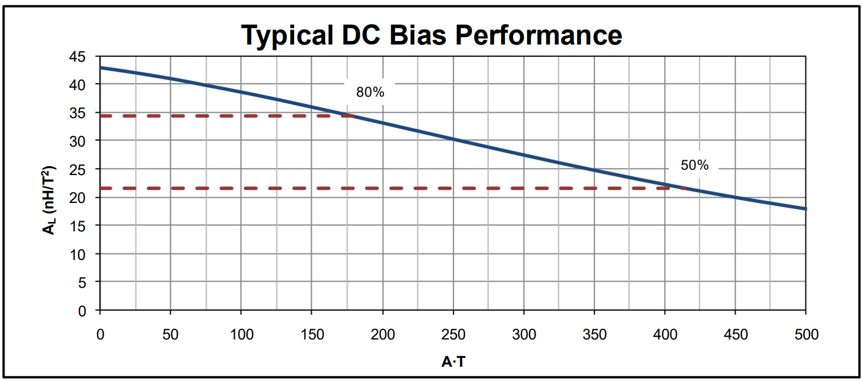  
Figure 2.2 DC bias curve of selected toroid

As can be clearly seen that for our values(75turn*2A) Al value almost dropped the 80% of initial value, that means that our inductance is not equal to what we want at our operating point. To solve that problem lets make our calculations again with assuming that our Al=35 from beginning.

$$N=\sqrt{\frac{240000}{35}}=82.80$$

Now our current turn number is equal to 83, and even in the our operating region our inductance value is equal to approximately 248µH.

**e)** Winding design process pretty much same as the transformer, from the current density we know that we need 0.5mm^2 conductor cross section area. Moreover, our output ripple frequency is double of switching frequency, that means that we need to select thinner conductors to get rid of skin effect. For that reason, we selected 30AWG cable, which as 270kHz skin depth. Cross sectional area of 30AWG cable is equal to 0.0507mm^2, then it is suitable to use 10 parallel conductors.

$$Fill Factor=\frac{Number of turns*Number of parallel conductors*Cross sectional area of each conductor}{A_{W}}$$

$$Fill factor=\frac{830*0.0507}{139}=0.302>0.3$$

Our fill factor satisfies the requirements.

For the calculation of resistance, we can refer to datasheet, for length of each turn.

tablo içeren bir resim

Açıklama otomatik olarak oluşturuldu  
Figure 2.3 Length of each turn with different winding factor

As can be seen from Figure 2.3, our mean length is equal to 32mm for each turn, moreover we can calculate the resistance of 30AWG cable per millimeter using given table as

$$Resistance of 30AWG\frac{cable}{mm}=3.38496*{10}^{-4}Ω$$

$$R_{DC}=R_{AC}=\frac{32*83*3.38496*{10}^{-4}}{10}=0.0899Ω$$

$$P_{loss, copper}=I^{2}*R=359.6mW$$

**f)** To calculate the core loss, we can again refer to manufacturer’s documents.

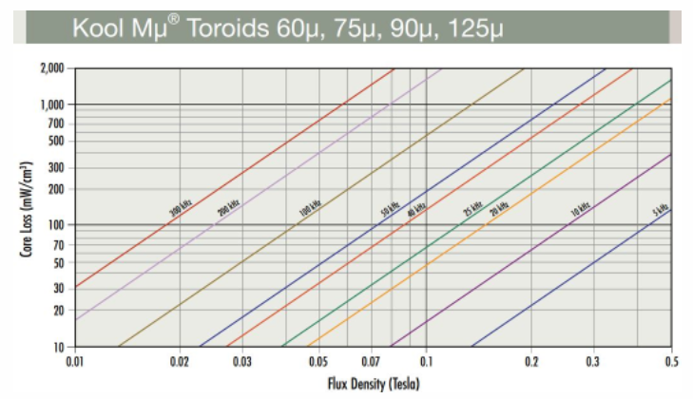  
Figure 2.4 Core loss parameters from manufacturers material sheet

Core loss is about the change in the flux density, that means that we should calculate the delta B value using our ripple current.

$$∆B=\frac{N*∆I*A_{L}}{A_{C}}$$

Since we designed our inductor to satisfy 0.2A ripple, I will take $∆I=0.2A$, we calculated the N previous parts, due to dc bias characteristics we take Al=35nH/N^2 and cross section area of core can be found on datasheet.

$$∆B=0.0183T≈0.2T$$

From the Figure 2.4 at 200kHz, 0.2T change creates loss of approximately 60mW per cm^3, volume of our core is equal to 1.8cm^3, then total core loss equal to 108mW.

For our inductor, core loss is less than copper losses, this is mainly due to DC current cannot create core loss but create copper loss, and most of our current is DC.