Advocate Management System
Client Presentation & Live-Demonstration Plan
One source of truth · Court-connected · A managed practice
A business-facing playbook for demonstrating the AMS to advocates,
managing partners and law-firm owners.
Every feature described is verified in the codebase; anything not yet built
is clearly labelled a Potential Enhancement.

What's inside
- 1. Executive Summary
- 2. Product Positioning
- 3. Target Users
- 4. Problems Solved
- 5. Complete Feature Inventory
- 6. Feature to Business-Value Mapping
- 7. Recommended Demo Story
- 8. 20–30 Minute Presentation Flow
- 9-10. Presenter Script & Screen Actions
- 11. Senior Advocate Experience
- 12. Junior Advocate Experience
- 13. Client Management Flow
- 14. Case Management Flow
- 15. Billing & Invoice Flow
- 16. Management / Dashboard Story
- 17. Top 10 Selling Points
- 18. Potential Missing Features
- 19. Demo Risks
- 20. Demo Preparation Checklist
- 21. Recommended Demo Data
- 22. Final Sales Pitch

The platform at a glance
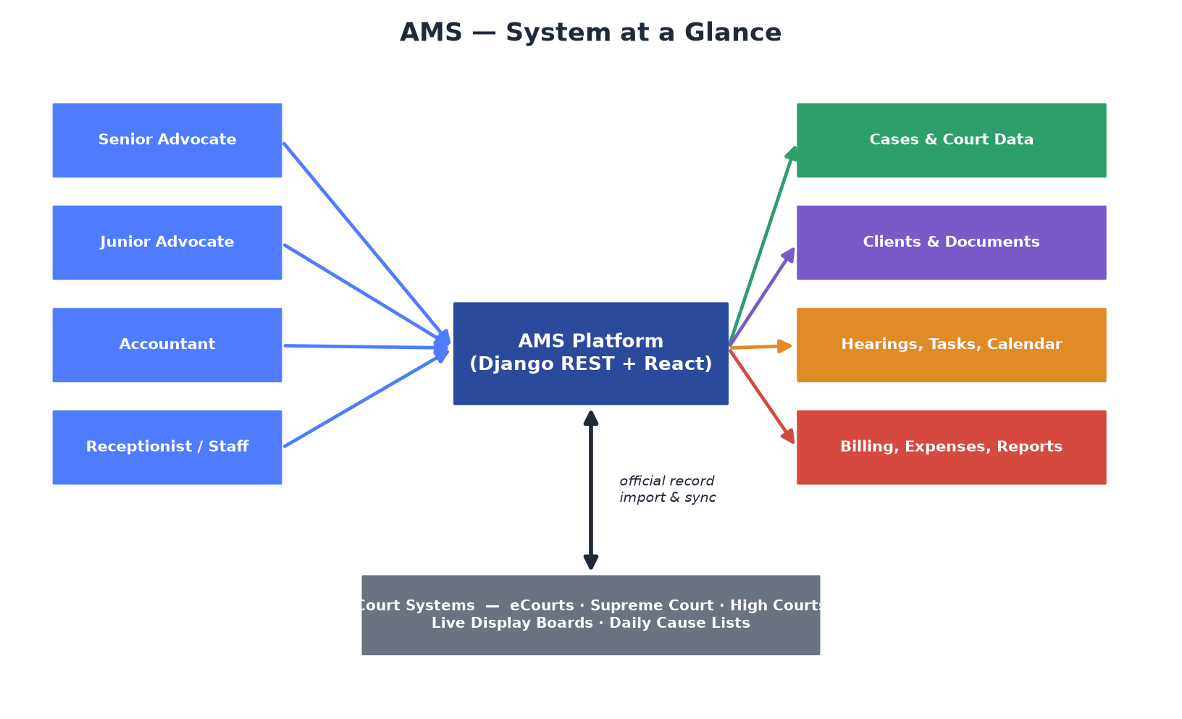
Figure 1 — Roles on the left, feature clusters on the right, court systems wired in at the bottom.
AMS is a practice-management platform for advocates and law firms that puts every matter, client, hearing, document, task and rupee into one system — and plugs directly into Indian court data (eCourts, Supreme Court, High Courts, live display boards and daily cause lists). It replaces the scatter of WhatsApp, Excel, email and paper with a single source of truth, and gives the managing partner visibility across the whole practice without opening every file.

1. Executive Summary
AMS is a practice-management platform for advocates and law firms in India that juggle tens to hundreds of active matters across multiple courts. Its differentiator is deep court-data integration: it pulls the official record straight from the court system, shows you where your matter sits in today's cause list (“you are item 40, the court is on item 29”), and auto-detects when a decided case has been appealed to a higher court.
Who it is for:
- Solo advocates and chambers who need to stop losing dates and files.
- Small-to-mid law firms that need visibility and accountability across a team.
What sets it apart:
- The court connection — most legal CRMs make you type in every detail and remember every date. AMS lets the court tell the system.

2. Product Positioning
Position AMS as “the operating system for your practice, wired into the courts.” Three pillars to repeat throughout the demo:
- 1) One source of truth — nothing lives in someone's head or their phone.
- 2) Court-connected — the system knows what the court is doing.
- 3) Managed practice — senior sees everything, juniors work, roles control access.

3. Target Users
Roles are seeded in the RBAC system and enforced by a permission layer. Access is practice-scoped: a member sees the practice's data; a firm-wide role sees across teams.
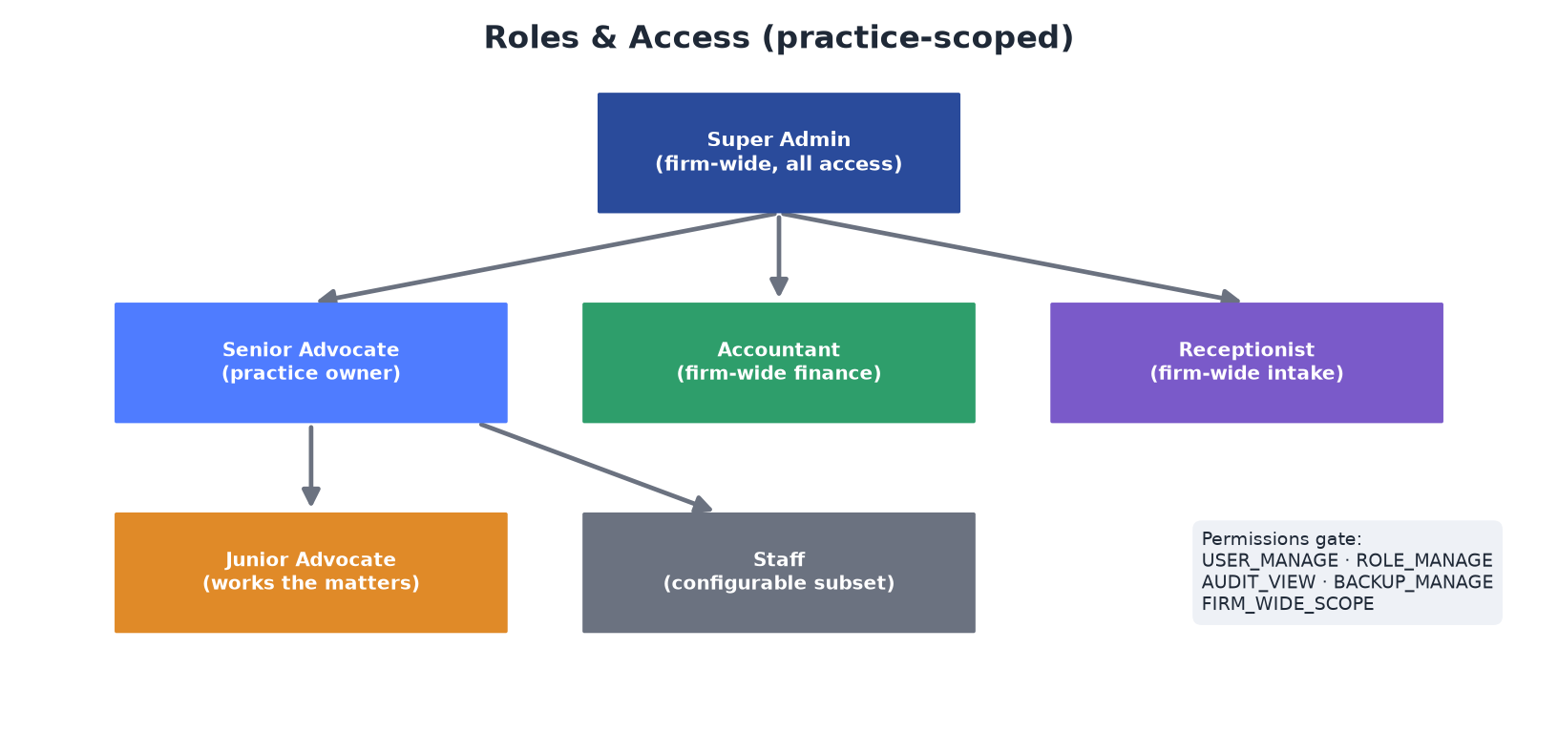
Figure 2 — Role hierarchy and the permission gates that protect admin functions.
Role | Who they are | What they need (supported today)
Super Admin | Firm/system owner | Everything: users, roles, audit, backups, firm-wide data
Advocate (Senior) | Lead counsel / partner | Full case, client, billing, hearing, document, report access
Junior Advocate | Associate / team member | Same operational tools, scoped to the practice
Accountant | Finance | Firm-wide invoices, payments, expenses, reports
Receptionist | Front office | Firm-wide clients, documents, events (intake)
Staff | Support | Configurable subset of permissions

4. Problems Solved
Real law-firm pains this codebase genuinely addresses:
- Case information scattered across WhatsApp / Excel / paper → centralized case workspace (12 tabs).
- Missed hearing dates → calendar + reminders 2 days out + live cause-list “Your Item”.
- Re-typing case data from court portals → court lookup & import prefilling the matter.
- “Is my case listed today?” → Daily Cause List + Display Board with your item number.
- Missing an appeal filed against you → nightly appeal detection.
- “What's happening across my practice?” → role-aware dashboard + firm-wide scope.
- Manual, inconsistent billing → line-item invoices, auto-numbering, PDF, status tracking.
- “Who owes money?” → invoice summary (paid / unpaid / overdue) + dashboard cards.
- Untracked case costs → per-matter expense tracking.
- No document control → categorized document store linked to matters, clients and tasks.
- No accountability / no history → audit log, activity feed, per-matter timeline.
- Reporting is painful → Reports Center with date ranges and PDF / CSV export.

5. Complete Feature Inventory (verified in code)
- Authentication & profile — Email/password login (JWT), OTP password reset, rich advocate profile, office details, branding (logo, signature, seal, brand colours), preferences (theme, currency, date format, timezone, auto-logout).
- Roles & access — Seeded roles, permission modules, Role & User Management UIs, practice membership (owner + members), firm-wide scope, case transfer between members.
- Clients — Full CRUD, address block, email/phone/website, GSTIN, billing currency, archive/restore.
- Cases / matters — Create manually or import from court; 12-tab detail (Parties, Hearings, Orders, Expenses, Invoices, Tasks, Notes, Documents, Related Cases, Acts, Extra Details, Timeline); status, tags, financial fields, inline status edit, share.
- Court data (differentiator) — Case Lookup/Add-Case flow prefilled from the official record; live Display Board (26 courts) with a Your Item column; Daily Cause List with “Your matters today”; CNR-based unified lookup and refresh.
- Hearings & calendar — Month/week/day calendar, event types (Hearing, Meeting, Payment Due, Document), case-linked, today/upcoming feeds.
- Tasks — Priority, deadline, case link, document attachments, complete toggle, standalone or per-matter.
- Documents — Drag-drop upload, categories, link to case/client/task, preview, download, stats, versioning field.
- Billing — invoices — Line-item particulars, auto-numbered, statuses UNPAID/PAID/OVERDUE, PDF generation, mark-as-paid, summary amounts, client + team notifications.
- Expenses & payments — Per-matter expenses (category, mode, status, reference, date, type), client payment recording, today/monthly views, receipt PDF.
- Notifications — In-app bell + Notification Center with delivery history and stats; channels In-App + Email; event triggers; scheduled reminders (hearing 2d, overdue invoices, task deadlines).
- Communication — Per-advocate SMTP config, test send, communication history + CSV export, service-status dashboard.
- Appeal Alert — Nightly sweep detects appeals of your decided cases in higher courts with a match score; confirm/dismiss workflow.
- Acts / legislation — Searchable statutes with sections, link acts to matters, show court-cited acts on a case.
- Dashboard — Metric cards, case-status donut, court-stats bar, income-vs-expense chart, upcoming hearings, activity feed, tasks, document stats; time switcher; Export Dashboard PDF.
- Reports Center — Financial/case/client/hearing sections, date-range filters, PDF + CSV export.
- Global search — Across cases, clients, documents, invoices, expenses, tasks, events, payments.
- Audit & activity — Full audit log (user, action, module, IP, device, status) with CSV/Excel/PDF export; activity feed.
- Backup — Quick/full/database/documents/reports/settings backups, history, restore (typed confirmation), download.
- AI Assistant — Rule-based command router (navigate/create/query) plus an optional LLM chat (Gemini or local) answering read-only questions over the advocate's own data.

6. Feature to Business-Value Mapping
Business problem | AMS capability (real) | Business benefit
Missed hearing dates | Calendar + 2-day reminders + cause-list Your Item | Deadline control
Scattered matter info | Centralized 12-tab case workspace | One source of truth
Re-typing court data | Court lookup & import | Faster, accurate intake
“Is my case listed today?” | Daily Cause List + Display Board | Show up prepared, on time
Missed appeal against you | Nightly appeal detection | Protect the client
No practice-wide visibility | Role-aware dashboard + firm-wide scope | Manage without opening files
Manual billing | Line-item invoices + PDF + auto-number | Faster, professional billing
Who owes money? | Invoice summary (paid/unpaid/overdue) | Cash-flow visibility
Untracked case costs | Per-matter expenses | Cost recovery & accounting
No document control | Categorized, linked document store | Findable, organized files
No accountability/history | Audit log + timeline + activity feed | Trust & traceability
Painful reporting | Reports Center + PDF/CSV | Fast management reporting

7. Recommended Client Demo Story
Thread the whole demo through a single matter so it reads as one story, not a tour.
Element | Value
Firm | Kumar & Associates, Chennai
Senior advocate (owner) | Mr. Rajesh Kumar
Junior advocate | Ms. Priya Nair
Accountant | Mr. Suresh (firm-wide finance)
Client | ABC Constructions Pvt. Ltd.
Matter | ABC Constructions vs XYZ Builders — a High Court writ

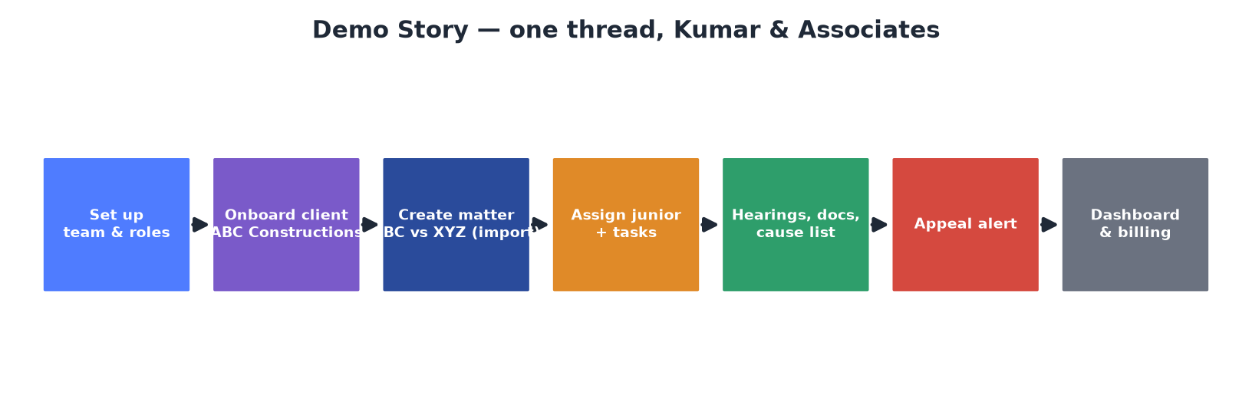
Figure 3 — The single narrative thread the whole demo follows.

8. 20–30 Minute Presentation Flow
Part | Time | Content
1. The Problem | 2–3 min | How a 200-matter practice loses control across phones, Excel and paper
2. The Solution | 2–3 min | AMS philosophy; show the dashboard once, briefly
3. Live Business Story | 10–15 min | Onboard client → create matter (import) → assign & work → hearings/cause list → docs/notes → appeal alert
4. Management View | 3–5 min | Senior's dashboard, firm-wide visibility, reminders, reports, audit
5. Financial / Billing | 3–5 min | Expenses → invoice → PDF → mark paid → summary / cash-flow
6. Closing Value | 2 min | Why adopt: control, visibility, court-connection, discipline, scale

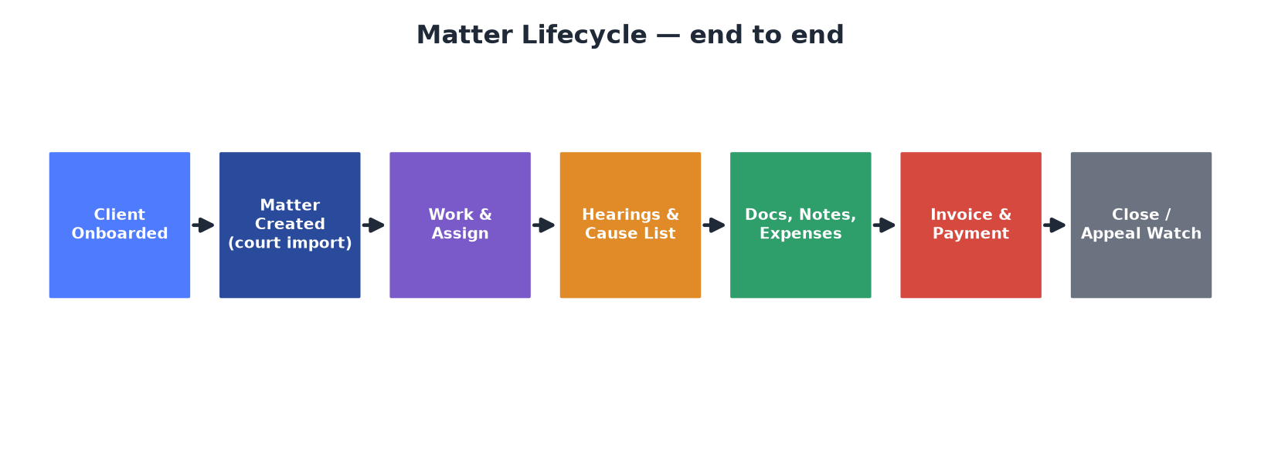
Figure 4 — The matter lifecycle the live story walks through, end to end.

9–10. Presenter Script & Screen-by-Screen Actions
Format per screen: Screen · Do · Say · Why · Transition.

Opening (before any screen)
“Before I open the software — picture a practice running 200 active matters across five different courts. The hearing dates live in one advocate's diary, the client's papers are on WhatsApp, the fee notes are in an Excel sheet, and only one person actually knows the status of any given case. What happens the morning that person is unwell — or the morning a matter is listed and nobody checked? That single gap is what this system is built to close. Let me show you how.”

1. Team & roles
- Screen: User Management → Role Management.
- Do: Show the user list (Rajesh = owner, Priya reports to Rajesh, Suresh = Accountant). Open a role card to show permission checkboxes grouped by module.
- Say: “The firm decides who sees and does what. Priya works the matters, Suresh handles money firm-wide, Rajesh sees everything. This isn't a shared login — access follows the role.”
- Why it matters: Accountability and control; data isn't a free-for-all.
- Transition: “With the team set up, a new client walks in.”

2. Client onboarding
- Screen: Clients → Add Client.
- Do: Create ABC Constructions Pvt. Ltd. — name, email, phone, GSTIN, billing currency INR, address.
- Say: “The client becomes a permanent record — contact details, GST for billing, address for invoices. Everything we do next hangs off this client.”
- Why it matters: One client record feeds matters, invoices and communications automatically.
- Transition: “Now the client hands us a matter — and here's where AMS does something most systems can't.”

3. Matter creation via court import (differentiator — spend time here)
- Screen: Cases → Add New Case.
- Do: Select forum → search the court record → review the prefilled matter → pick client ABC Constructions → Save. If the scraper is down, use Manual Entry (same form, blank).
- Say: “Instead of typing everything from the court website, we pull the official record. Parties, CNR, stage, filing details — filled in for us. The matter is now the central record for everything that follows.”
- Why it matters: Faster, accurate intake; the matter is court-authentic from day one.
- Transition: “Rajesh now hands this to his junior, Priya.”

4. Assign & take ownership
- Screen: Case detail; optionally Cases → Transfer.
- Do: Show the matter open; demonstrate case transfer to a practice member; add a Task (“Draft and file the petition”, High, with a deadline) on the Tasks tab.
- Say: “Rajesh assigns the work. The task carries a priority and a deadline, so responsibility is explicit and shows up on the to-do list and the reminders — not in a WhatsApp message that scrolls away.”
- Why it matters: Accountability and workload visibility. (Note: per-user assignment is light — frame as shared practice + tasks + transfer.)
- Transition: “As Priya works the matter, everything she does builds its history.”

5. Day-to-day case management
- Screen: Case detail tabs — Notes, Documents, Hearings, Expenses, Acts, Timeline.
- Do: Add a Note; upload a Document (Petition); add a Hearing; record an Expense (filing fee); link an Act; open the Timeline.
- Say: “Every action lands in one place and builds a complete, dated history. Six months from now anyone in the practice can open this case and see exactly what happened and when — no reconstruction, no 'ask Priya'.”
- Why it matters: One source of truth; continuity when people are away.
- Transition: “The morning of a hearing is where the court connection really pays off.”

6. Court connection — cause list & display board
- Screen: Cases → Daily Cause List, then Display Board.
- Do: Show “Your matters today” and the Your Item number; open the court's live board; use Send Alert to Client.
- Say: “The court publishes the day's order of business — AMS reads it and tells you 'you are item 40, the court is on item 29.' You know when to be in the room, and you can alert the client in one click.”
- Why it matters: No missed listings; the system watches the court, not just your diary.
- Transition: “And when a matter is decided, the risk shifts to the other side's next move.”

7. Appeal Alert
- Screen: Appeal Alert.
- Do: Show an open detection — your decided case, the appeal found, match score; click “It is an appeal” / “Not related.”
- Say: “Every night the system checks the higher courts for appeals against your decided matters. You find out an appeal exists because the system told you — not because a notice arrived late.”
- Why it matters: Protects the client; catches what's easy to miss.
- Transition: “That's the matter's life. Now let's step back and see it as the managing partner.”

Part 4 — Management View (Senior Advocate)
- Screen: Dashboard → Notifications Center → System Activity.
- Do: Walk the metric cards; show the case-status donut, court-stats bar, upcoming hearings, activity feed, tasks; toggle the time switcher; Export Dashboard PDF. Then show reminders history and the audit log.
- Say: “This is Rajesh's morning. Without opening a single file he sees what needs attention today — hearings this week, invoices overdue, tasks slipping. The system already sent the two-day hearing reminders and overdue-invoice nudges. And every action is on the audit trail — who did what, when.”

Part 5 — Financial / Billing View
- Screen: Case Expenses tab → Invoices.
- Do: Show recorded expenses; Create Invoice with line-item particulars (appearance, drafting, filing) — total auto-sums; save (client emailed); Download PDF; Mark as Paid (client gets a receipt); show the summary cards.
- Say: “Work and costs on the matter turn into a clean, itemized invoice with your firm's branding, as a PDF. The moment it's raised, the client is notified; when it's paid, they get a receipt. And the summary tells the partner exactly what's outstanding across the practice.”
- Honesty note: No tax/discount lines or partial payments today — don't imply them.

11. Senior Advocate Experience
The dashboard is the command centre: active workload, upcoming hearings, overdue invoices, tasks, activity feed, income-vs-expense — with a day/week/month/year switcher and one-click PDF. Firm-wide scope lets a Super Admin see across teams. Reminders are pushed automatically. The audit log answers “who did what.” The pitch: run a 200-matter practice without opening 200 files.

12. Junior Advocate Experience
The junior gets the working tools — practice matters, tasks with deadlines, the calendar, documents, notes, expenses and invoice preparation — scoped to the practice. They do the operational work; the senior keeps control through the dashboard, audit trail and role settings. The pitch: juniors work freely, seniors keep control.

13. Client Management Flow
Add client (contact, GST, billing currency, address) → client links to matters, invoices, documents and communications → auto-email on registration and on case/hearing/invoice/payment → archive/restore for lifecycle. One client record drives everything downstream.

14. Case Management Flow
Create (import or manual) → enrich (parties, notes, tags, documents, acts, related cases) → schedule hearings → track expenses & financial fields → monitor via cause list, display board, reminders and appeal detection → transfer/close. The 12-tab workspace plus timeline is the matter's complete life.
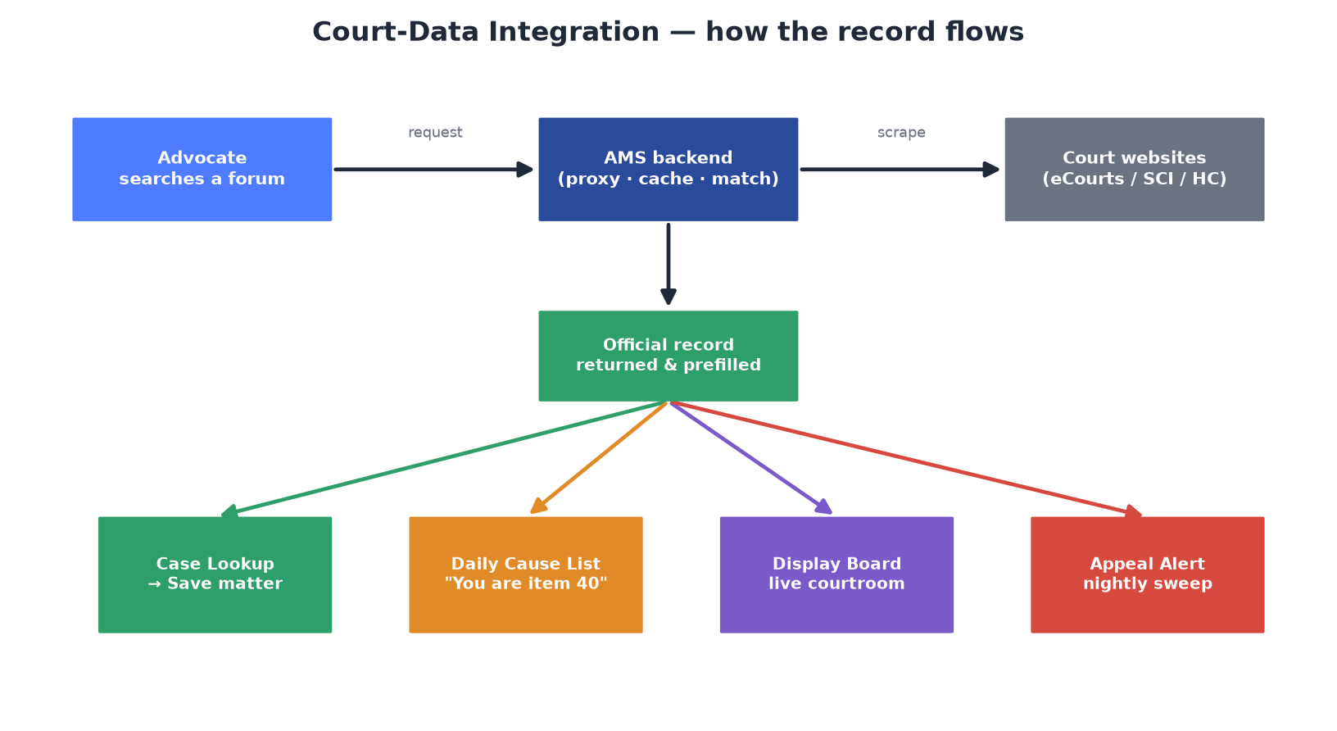
Figure 5 — Court-data integration: how the official record flows into four AMS features.

15. Billing & Invoice Flow
Record case expenses → create invoice with line-item particulars (auto-numbered, auto-total) → client + team notified → generate branded PDF → mark paid (receipt to client) → track via paid/unpaid/overdue summary → report via Reports Center. Overdue reminders fire automatically.
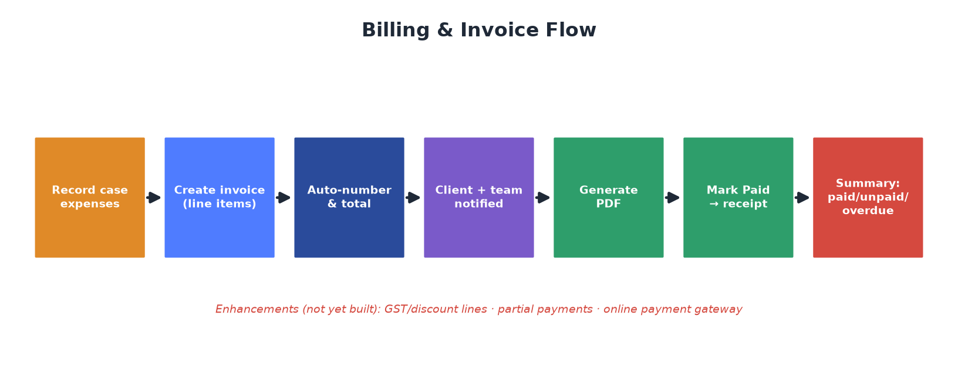
Figure 6 — The billing flow, with roadmap items flagged in red.

16. Management / Dashboard Story
A managing partner logs in and, in under a minute, reads the health of the practice: what's active, what's due, what's overdue, what the team is doing, and what money is in and out — then exports it as a PDF for a partners' meeting. Firm-wide roles widen this to every team.
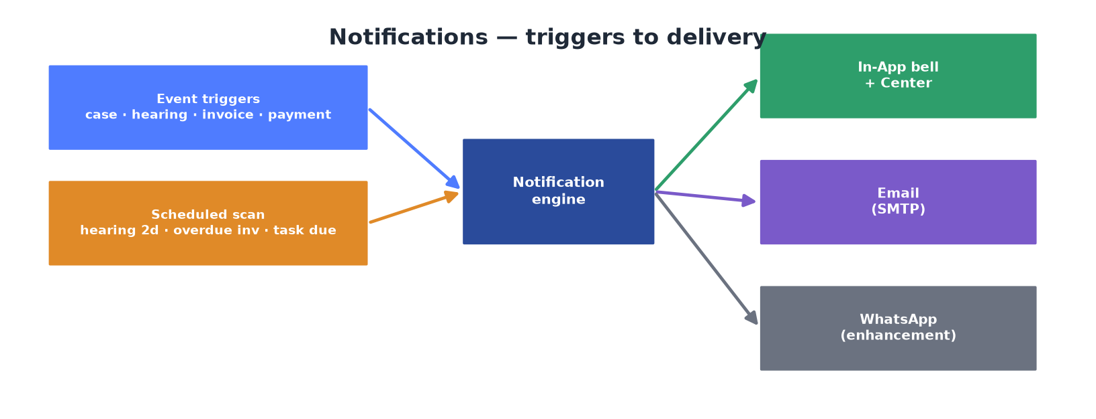
Figure 7 — Notifications: from event and scheduled triggers to in-app, email (and WhatsApp as an enhancement).

17. Top 10 Selling Points
# | Selling point | Why it matters | Priority
1 | Court-data integration | Most CRMs can't. Import ABC vs XYZ straight from the court. | Must demo
2 | Cause list “Your Item” + Display Board | Know your listing position live: “item 40, court on 29.” | Must demo
3 | Appeal detection | Nightly sweep of higher courts catches an appeal against your win. | Must demo
4 | Centralized 12-tab workspace + timeline | Open a matter, see its whole life. No knowledge silos. | Must demo
5 | Role-aware management dashboard | The practice at a glance — Rajesh's morning view. | Must demo
6 | Line-item invoices + PDF + status | Itemized, branded invoice, emailed. Cash-flow visibility. | Must demo
7 | Automatic reminders | Hearings, overdue invoices, task deadlines. Nothing slips. | Good to demo
8 | Roles & practice scoping | Juniors work, seniors control. Accountability. | Good to demo
9 | Client auto-communications | Email on case/hearing/invoice/payment; receipt on payment. | Good to demo
10 | Audit log + backups + reports | Who changed this matter? Enterprise hygiene. | Back-office

18. Potential Missing Features
Honestly labelled — present these as roadmap, never as shipping features.

Critical (for serious firm adoption)
- Client portal — clients cannot log in to see their own matters/invoices.
- Online payment integration — no gateway; invoices are marked paid manually.
- Tax (GST) & discount lines on invoices — no such fields on invoice items.
- Partial / installment payments — invoice is only UNPAID→PAID.

High value
- Granular per-user case/task assignment — access is practice-scoped only.
- WhatsApp notifications — framework present but disabled (no Meta credentials).
- Automatic financial roll-up — case balances are updated manually today.
- Editable email templates — messages are hardcoded.
- Cause-list scheduling & broader court coverage — only SCI has a live source.

Nice to have
- Document OCR / full-text search; document versioning (restore/diff).
- Custom & scheduled reports (fixed report types today).
- E-signature on documents.

Future / advanced
- Mobile app; accounting-software integration; time-tracking / retainer / trust accounting; richer LLM assistant; appeal limitation-period calculation.

19. Demo Risks
- Scraper service down → court lookup, display board and cause list all return a clean 503 and look empty/broken. It is started by hand and nothing restarts it.
- Cause-list banner empty → sync isn't scheduled and only SCI has data; every court-linked demo case is currently closed, so the banner is legitimately empty and looks like a bug.
- Synthetic clutter → 21 DEMO-1-100xx cases and 2 UIPROOF cause-list rows dilute counts; clean before demoing.
- Empty dashboards → without seeded activity, charts show empty states.
- WhatsApp shows “Not available” → don't click into it expecting a working channel.
- “Raise Invoice” in a hearing-history row opens a blank modal — create invoices from the Invoices page instead.
- Immediate client email adds ~5.5s on invoice create/pay — expect a short pause; don't click twice.
- LLM assistant needs Gemini/local configured — verify before promising live AI answers.

20. Demo Preparation Checklist
☐ Backend, frontend and the scraper service (port 8000) all up; confirm Tesseract OK.
☐ Run cause-list sync in the morning OR pre-import one live, pending SCI matter so “Your matters today” lights up.
☐ Delete the 21 DEMO-1-100xx cases and 2 UIPROOF cause-list rows.
☐ Seed the demo story data (§21): firm users, ABC Constructions, the writ matter, a hearing this week, documents, expenses, one draft invoice.
☐ Log in once as senior and once as junior to confirm role-scoped views.
☐ Confirm SMTP configured so client emails send; use the “Send test” button.
☐ Pre-open key tabs (case detail, dashboard, invoices) to avoid live latency.
☐ Verify the invoice PDF renders with the firm's logo/branding.
☐ Have the manual case-entry fallback ready in case the scraper misbehaves.
☐ Confirm at least one appeal detection row exists for the Appeal Alert step.

21. Recommended Demo Data
Entity | Suggested value
Firm | Kumar & Associates, Chennai (logo + brand colour in Settings)
Users | Rajesh Kumar (owner), Priya Nair (junior), Suresh (Accountant, firm-wide)
Client | ABC Constructions Pvt. Ltd. — GSTIN, INR, Chennai address
Matter | ABC Constructions vs XYZ Builders — HC writ, Active, tag “For Argument”
Hearing | This week, type HEARING, linked to the matter
Tasks | “Draft and file petition” (High, due 3 days); “Collect client documents” (Medium)
Documents | Petition (Petition); Client agreement (Agreement)
Expenses | Court filing fee ₹2,500; Photocopying ₹400
Invoice | Appearance ₹15,000 + Drafting ₹10,000 + Filing ₹2,500 = ₹27,500 (one UNPAID, one PAID)
Appeal detection | One open detection against a decided matter

22. Final Sales Pitch (2-minute close)
“Everything you just saw comes down to three promises. First — one source of truth: every matter, client, document, hearing and rupee in one place, so nothing lives in someone's phone or someone's memory. Second — you're wired into the courts: the system imports the official record, tells you where your matter sits in today's cause list, and warns you the night an appeal is filed against you. No other tool on your desk does that. Third — you stay in control: your juniors do the work, your accountant handles the money, and you — from one dashboard — see the whole practice, know what's overdue, and export it in a click, with a full audit trail behind every action.
This is not about replacing your judgment. It's about making sure a missed date, a lost file, or an unbilled matter never costs you a client again — and that as your practice grows from fifty matters to five hundred, it runs on a system, not on memory. That's what Kumar & Associates would be adopting: control, visibility, and a practice that scales.”

Presenter's honesty checklist — do not oversell
No client portal, no online payments, no GST/discount/partial-payment on invoices; WhatsApp is not live; case balances are manual; cause-list coverage is mainly SCI today; per-user assignment is light (practice-scoped). Present all of these as enhancements, honestly.

