TERRALEDGER – Blockchain Based LAnd Registry

REPORT SUBMITTED IN PARTIAL FULFILLMENT OF THE REQUIREMENT FOR THE DEGREE OF

BACHELOR OF TECHNOLOGY
IN
COMPUTER SCIENCE & ENGINEERING

By

Anilabh Barua
Roll Number: 220103005
Rishikesh Verma
Roll Number: 220103004

UNDER THE GUIDANCE
OF
Dr. Satyajit Sarmah
Assistant Professor



DEPARTMENT OF INFORMATION TECHNOLOGY
GAUHATI UNIVERSITY
GUWAHATI, INDIA

GAUHATI UNIVERSITY
DEPARTMENT OF INFORMATION TECHNOLOGY
Gopinath Bordoloi Nagar, Jalukbari Guwahati-781014

DECLARATION

We Anilabh Barua and Rishikesh Verma, bearing Roll No 220103005 and 220103004 respectively, B.Tech. student of the department of Information Technology, Gauhati University hereby declares that we have compiled this report reflecting all our works during the semester long full time project as part of our BTech curriculum.
we declare that we have included the descriptions etc. of our project work, and nothing has been copied/replicated from other’s work. The facts, figures, analysis, results, claims etc. depicted in our thesis are all related to our full time project work.
We also declare that the same report or any substantial portion of this report has not been submitted anywhere else as part of any requirements for any degree/diploma etc.

Anilabh Barua
Branch: Computer Science & Engineering
Date: 29-12-2025

Rishikesh Verma
Branch: Computer Science & Engineering
Date: 29-12-2025


GAUHATI UNIVERSITY
DEPARTMENT OF INFORMATION TECHNOLOGY
Gopinath Bordoloi Nagar, Jalukbari Guwahati-781014

Date: 29-12-2025

CERTIFICATE

This is to certify that “Anilabh Barua” and “Rishikesh Verma” bearing Roll No: “220103005” and “220103004” has carried out the project work “TerraLedger-Blockchain based Registry” under my supervision and has compiled this report reflecting the candidates work in the semester long project. The candidates did this project full time during the whole semester under my supervision, and the analysis, results, claims etc. are all related to their studies and works during the semester.

I recommend submission of this project report as a part for partial fulfillment of the requirements for the degree of Bachelor of Technology in Information Technology/Computer Science & Engineering of Gauhati University.

Dr. Satyajit Sarmah
Assistant Professor Department of Information Technology Gauhati University


GAUHATI UNIVERSITY
DEPARTMENT OF INFORMATION TECHNOLOGY
Gopinath Bordoloi Nagar, Jalukbari Guwahati-781014

External Examiners Certificate

This is to certify that “Anilabh Barua” and “Rishikesh Verma”, bearing Roll No “220103005” and “220103004” has delivered his project presentation on “DD/MM/YYYY” and I examined his/her report entitled “Project Name” and recommend this project report as a part for partial fulfillment of the requirements for the degree of Bachelor of Technology in Computer Science & Engineering of Gauhati University.

______________
(External Examiner)


GAUHATI UNIVERSITY
DEPARTMENT OF INFORMATION TECHNOLOGY
Gopinath Bordoloi Nagar, Jalukbari Guwahati-781014

Date:29-12-2025

TO WHOM IT MAY CONCERN

This is to certify that Anilabh Barua and Rishikesh Verma bearing Roll No 220103005 and 220103004 respectively, B.Tech. student of the department of Information Technology, Gauhati University, has submitted the softcopy of their project for undergoing screening through anti-plagiarism software and the similar report found to be % (in words).

Dr. Satyajit Sarmah
Assistant Professor Department of Information Technology Gauhati University

ACKNOWLEDGEMENTS

We would like to express our sincere gratitude to all those who have contributed directly or indirectly to the successful completion of this project titled “TerraLedger: A Blockchain-Based Land Registry System.”
First and foremost, we extend our sincere thanks to our project supervisor, Satyajit Sarma, for their invaluable guidance, continuous support, and encouragement. Their insights and feedback played a crucial role in shaping the project and ensuring that it met academic and technical standards.
We would also like to acknowledge our teamwork and collaborative efforts throughout the project. As a two-member team, effective coordination, idea sharing, and mutual support played a vital role in overcoming technical challenges and successfully implementing the system.
We are also deeply grateful to the faculty members of the Department of Information Technology, whose knowledge and expertise have been a constant source of inspiration and learning throughout our academic journey. Their teachings and support have laid the foundation for our understanding of machine learning and its applications.

ABSTRACT

Our Primary objective of our project is that many land registration systems in many regions continue to rely on centralized and manual processes, making them vulnerable to issues such as data tampering, lack of transparency, fraudulent ownership claims, and inefficient record management. These challenges often result in disputes, delays, and reduced trust in land administration authorities. To address these limitations, this project proposes TerraLedger, a Blockchain-Based Land Registry System that leverages decentralized ledger technology to ensure secure, transparent, and tamper-resistant land record management.
The proposed system utilizes blockchain technology to store property ownership records in an immutable manner, ensuring that once a land record is registered, it cannot be altered without proper authorization. Smart contracts are employed to automate key operations such as property registration and ownership transfer, thereby reducing manual intervention and enhancing trust between stakeholders. The system supports role-based access, allowing administrators to register properties and property owners to transfer ownership securely through blockchain transactions.
The frontend of the system is developed using modern web technologies to provide a user-friendly interface for interacting with the blockchain network. Wallet-based authentication enables secure user verification and transaction signing, ensuring data integrity and accountability. The backend blockchain infrastructure is implemented using Solidity smart contracts and deployed on a local Ethereum network for testing and validation.
Our project demonstrates how blockchain technology can be effectively applied to land registry systems to enhance security, transparency, and operational efficiency. The project highlights the potential of decentralized solutions in modernizing traditional land administration processes and lays the foundation for future enhancements such as integration with government systems and scalability to public blockchain networks.

TABLE OF CONTENT
- Introduction………………………………………………………………………8
- Review of Literature………………………………………………………….….9
- Methodology/ System Architecture…………………………………………….11
  - System Overview
  - Core Technologies
  - Smart Contract Architecture
  - Frontend System Architecture
  - System Flow Chart
- Proposed Solution/ Implementation……………………………………………17
  - Proposed Solution
  - Smart Contract Implementation
  - Frontend Implementation
  - Blockchain Network and Integration
  - Testing and Validation
- Result and Discussions…………………………………………………….….23
  - Overview of Implemented System
  - User Interface and Accessibility
  - Secure Authentication
  - Property Search and Verification
  - Transaction Recording and History
  - Immutable Records
  - Discussion of Results
- Conclusion and Future works………………………………………….………25
  - Conclusion
  - Future Works
- References………………………………………………………………….….27
- Appendices……………………………………………………………….……28

1. INTRODUCTION
Land ownership and property registration play a crucial role in economic stability, urban planning, and individual asset security. A reliable land registry system ensures legal ownership, prevents disputes, and promotes transparency in property transactions. However, traditional land registration systems in many regions are centralized, paper-based, and highly dependent on manual processes. These systems often suffer from inefficiencies such as data redundancy, lack of transparency, delayed updates, unauthorized record alterations, and vulnerability to fraud.
Blockchain technology has emerged as a promising solution to address these challenges due to its decentralized nature, immutability, and cryptographic security mechanisms. By distributing data across multiple nodes, blockchain ensures that records cannot be altered or deleted without consensus, thereby enhancing trust and accountability.
Our Project (TerraLedger) is a Blockchain-Based Land Registry System designed to modernize the existing land record management process by leveraging the core principles of blockchain technology. The system aims to provide a secure platform where land records are stored in an immutable ledger, and ownership transfers are executed through smart contracts. These smart contracts automate transactions and enforce predefined rules, reducing the dependency on intermediaries and minimizing the risk of manipulation.
The project implements a decentralized architecture where property registration and ownership transfer operations are performed on a blockchain network. An administrator is responsible for registering property details, while authenticated property owners can initiate ownership transfers through secure blockchain transactions. Wallet-based authentication ensures that only authorized users can perform critical operations, thereby maintaining the integrity of the system.
This project also focuses on providing a user-friendly interface to interact with the blockchain network, making the system accessible to users with minimal technical knowledge. By combining blockchain technology with a modern web-based frontend, TerraLedger demonstrates a practical and scalable approach to improving land registry systems. The proposed solution not only enhances security and transparency but also reduces processing time, operational costs, and the likelihood of disputes in land ownership records.
2. REVIEW OF LITERATURE

Traditional land registry systems have historically been maintained through centralized databases and manual record-keeping processes. While these systems serve the fundamental purpose of documenting land ownership, they are often associated with challenges such as lack of transparency, susceptibility to fraud, delayed updates, and difficulty in verifying the authenticity of records. Several studies have highlighted that centralized control over land records increases the risk of unauthorized data manipulation and reduces public trust in land administration authorities.
With the emergence of digital record systems, governments and organizations have attempted to modernize land registries by adopting computerized databases. Although digital systems improve accessibility and storage efficiency, they still rely on centralized architectures. As a result, these systems remain vulnerable to single points of failure, cyberattacks, and internal misuse of authority. Researchers have emphasized that merely digitizing records without addressing the core issue of centralized control does not fully eliminate the risks associated with land record management.
Blockchain technology has gained significant attention in recent years as a decentralized and secure method for managing sensitive data. Several research works propose the use of blockchain for applications such as financial transactions, supply chain management, healthcare records, and digital identity systems. The key characteristics of blockchain, including immutability, decentralization, transparency, and cryptographic security, make it particularly suitable for applications that require high levels of trust and data integrity.
In the context of land registry systems, multiple studies suggest that blockchain can provide a tamper-resistant ledger for storing land ownership records. Smart contracts enable the automation of property registration and ownership transfer processes while enforcing predefined legal and procedural rules. Existing blockchain-based land registry prototypes demonstrate improved transparency and reduced dependency on intermediaries. However, many of these systems face challenges related to scalability, legal integration, and user accessibility.
Recent literature also highlights the importance of integrating blockchain systems with user-friendly interfaces to encourage adoption by non-technical users. Research emphasizes that combining decentralized backend systems with intuitive frontend applications can significantly enhance usability and acceptance. Based on these findings, TerraLedger is designed to address the limitations of traditional and existing digital land registry systems by implementing a decentralized, secure, and transparent solution that leverages blockchain technology along with a modern web-based interface.

3. METHODOLOGY / SYSTEM ARCHITECTURE
3.1 SYSTEM OVERVIEW
The TerraLedger system is architected as a Decentralized Application (DApp) that leverages the Ethereum blockchain to provide an immutable and transparent ledger for land registry. Unlike traditional centralized architectures where a single server manages the database and logic, TerraLedger distributes trust across the blockchain network.
The high-level architecture consists of three main layers:
- The Blockchain Layer (Backend): A restricted permission smart contract deployed on the Ethereum network. This layer acts as the immutable database and business logic executor.
- The Interface Layer (Frontend): A React-based web application that serves as the portal for different user roles (Administrators and Public/Property Owners).
- The Web3 Bridge: The connection between the browser and the blockchain, facilitated by MetaMask and Ethers.js.
3.2 CORE TECHNOLOGIES
The project implementation relies on the following technology stack:
- Solidity (v0.8.20): The primary programming language used for writing the smart contracts. It effectively handles state management and transaction logic on the Ethereum Virtual Machine (EVM).
- Hardhat: A development environment used for compiling, deploying, designing, and debugging the Ethereum software.
- React.js (via Vite): A JavaScript library for building the user interface, ensuring a responsive and component-based frontend architecture.
- Ethers.js: A library that allows the frontend application to interact with the Ethereum blockchain (reading state and sending transactions).
- MetaMask: A browser extension wallet that manages user keys and signs transactions securely.

3.3 SMART CONTRACT ARCHITECTURE
The core of the methodology lies in the TerraLedger.sol smart contract. This contract creates a "State Machine" that governs the existence and ownership of land titles.
3.3.1 Data Structures
To digitally represent a physical land title, a custom data structure is defined. In our implementation, we utilize a struct named Property.
Implementation: The Property struct encapsulates the essential metadata of a land deed:
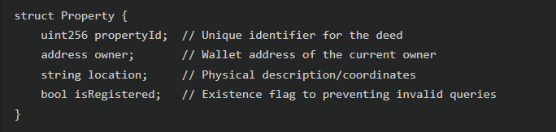 A mapping mapping(uint256 => Property) public properties acts as the primary ledger, allowing O(1) time complexity access to any property record using its unique ID.
3.3.2 Role-Based Access Control (RBAC)
Security is paramount in property registration. The system implements a strict Role-Based Access Control mechanism to ensure that only authorized entities can introduce new land into the system.
Implementation: Upon deployment, the contract constructor sets the owner variable to the deployer's address (typically the government or land registry authority).
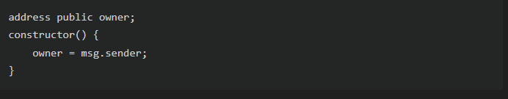
This state variable is used to gatekeep the registration function, ensuring that no arbitrary user can mint fake titles.

3.3.3 Core Logic & Functions
The system implements two primary state-changing workflows. The implementation details of these critical functions are described below.
A. Property Registration (Minting) The registerProperty function is the entry point for new assets. It enforces an administrative check (msg.sender == owner) to prevent unauthorized minting.
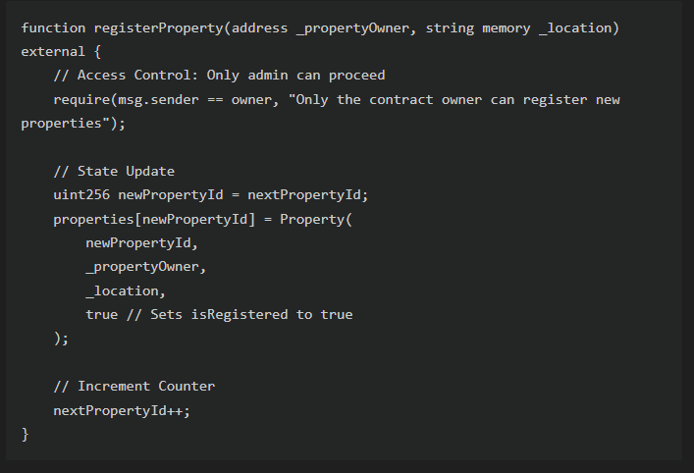

Methodology:
- Validation: The require statement acts as a gatekeeper. If the caller is not the owner, the transaction reverts, consuming gas but making no changes.
- Storage: A new Property struct is instantiated in memory and then written to the properties storage mapping.
- Indexing: The nextPropertyId counter ensures every property has a unique, sequential serial number.
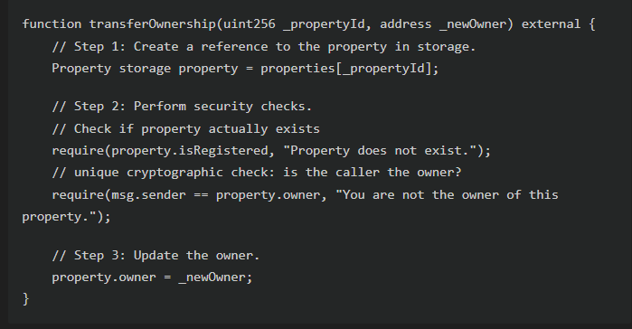
B. Ownership Transfer (Peer-to-Peer) This allows for the decentralized trade of assets without an intermediary. The methodology enforces strict ownership verification at the code level.

Methodology:
- Reference Retrieval: The keyword storage is used to get a reference to the actual data on the blockchain, not a copy.
- Authentication: The check msg.sender == property.owner is the core of the decentralized security model. It proves that the person initiating the transfer holds the private keys for the current owner address.
- Atomicity: If any check fails, the entire transaction is reverted.

3.4 Frontend System Architecture
The client-side application is designed to be purely a view-layer that reflects the state of the blockchain. It maintains no internal database; "Truth" is derived solely from the smart contract.

3.4.1 Component-Based Structure
The application is divided into functional components based on user intent:
- AdminPanel.jsx: A protected route that interacts with the registerProperty contract function. It includes form handling for gathering property metadata.
- SearchPortal.jsx: A public interface that queries the properties mapping. It handles value retrieval and error states (e.g., if a property ID is invalid).
- PropertyCard.jsx: Displays the fetched data. Uniquely, it includes logic to check if currentAccount == propertyOwner. If true, it dynamically renders the "Transfer Ownership" controls, granting the UI capability to write to the blockchain.
3.4.2 Web3 Integration & State Management
The connection to the blockchain is handled through a custom React hook
useAdmin.js. This hook abstracts the complex logic of initiating a connection to the user's wallet.
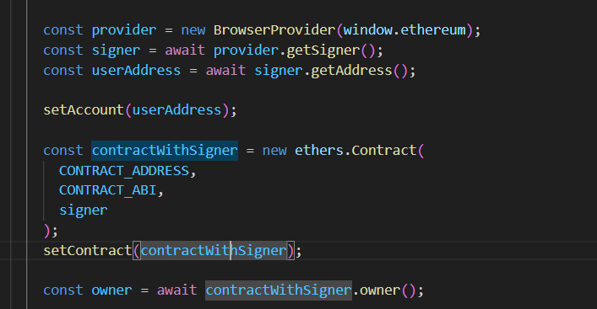
Methodology:
- BrowserProvider: Wraps the standard Ethereum provider injected by MetaMask, standardizing the API for our application.
- getSigner(): Requests access to the user's account to sign transactions. This differs from a read-only provider which can only view data.
- ethers.Contract: Creates a JavaScript object that mirrors the Solidity contract methods, allowing us to call contract.registerProperty(...) directly from our JavaScript code.
3.5 System Flow Chart
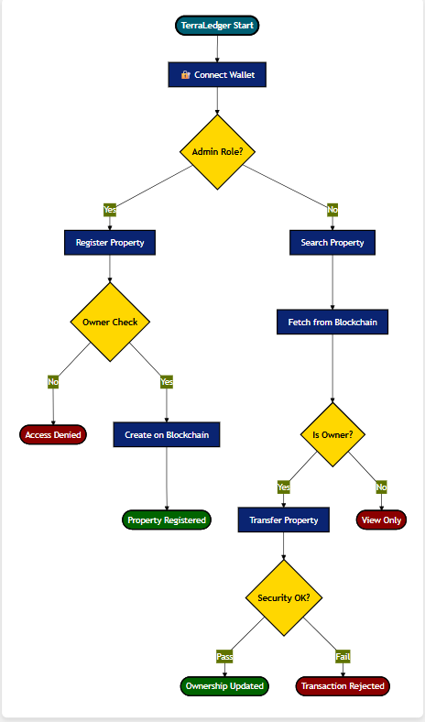
4. PROPOSED SOLUTION / IMPLEMENTATION

The proposed solution, TerraLedger, is implemented as a decentralized web application (DApp) that combines blockchain technology with a modern web-based interface to address the limitations of traditional land registry systems. The implementation focuses on secure land record storage, transparent ownership transfers, and role-based access control using smart contracts.
4.1 Proposed Solution
The core idea behind TerraLedger is to replace centralized land record storage with a decentralized blockchain ledger where ownership records are immutable and verifiable. The system eliminates the dependency on intermediaries by automating land registration and transfer processes using smart contracts. Every transaction is cryptographically secured and permanently recorded, ensuring transparency and trust among stakeholders.
The solution introduces:
- Immutable land ownership records
- Secure wallet-based authentication
- Automated ownership transfer through smart contracts
- Transparent transaction history
4.2 Smart Contract Implementation
The blockchain logic is implemented using Solidity smart contracts (v0.8.20). The smart contract defines the structure of a land record, including property identifiers, owner addresses, and ownership history. Key functionalities implemented in the contract include:
4.2.1 Property Registration
Only the administrator is authorized to register new land records on the blockchain. This ensures controlled onboarding of properties into the system.
Implementation Detail: In TerraLedger.sol, this is enforced using a check against the state variable owner. The registerProperty function validates that msg.sender (the caller) matches the contract owner before writing to the ledger.
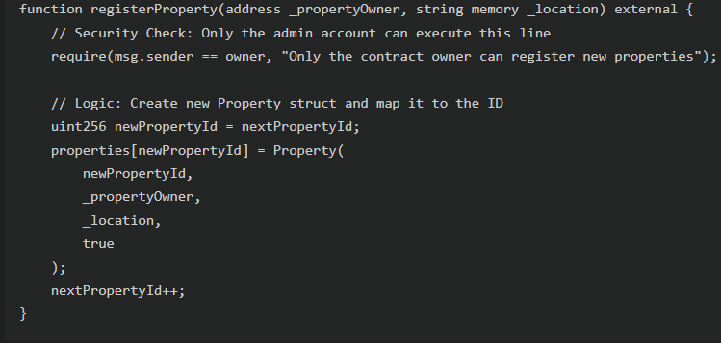
4.2.2 Ownership Transfer
Registered property owners can initiate ownership transfers. The smart contract validates ownership before updating the record, ensuring unauthorized users cannot manipulate data.
Implementation Detail: The transferOwnership function utilizes the cryptographic guarantees of the blockchain. It checks if the transaction signer (msg.sender) is the current owner of record. 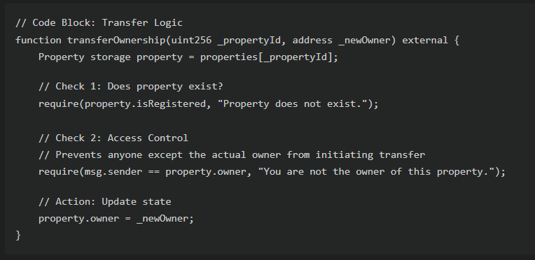
If either require check fails, the transaction reverts, ensuring atomicity and security.
4.2.3 Access Control
Role-based restrictions are enforced at the contract level to maintain system integrity. Once deployed, the smart contract remains immutable, ensuring that the logic governing land transactions cannot be altered. The initial owner is set within the constructor at the moment of deployment.
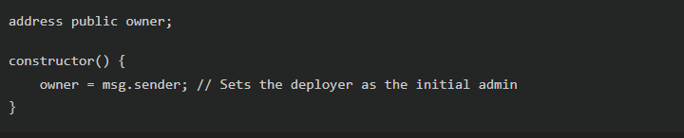
4.3 Frontend Implementation
The frontend of TerraLedger is developed using modern web technologies (React.js + Vite) to provide a clean and intuitive user interface. The application includes separate views and functionalities for administrators and users. Key frontend features include:
- Wallet connection for authentication
- Property registration interface for administrators
- Property search and viewing functionality
- Ownership transfer interface for property owners
- Real-time transaction status updates
Implementation Detail: Wallet Connection The frontend communicates directly with the blockchain using the ethers.js library. This allows users to initiate and confirm transactions through their wallets. We abstracted this logic into a custom hook use in Admin.js.

4.4 Blockchain Network and Integration
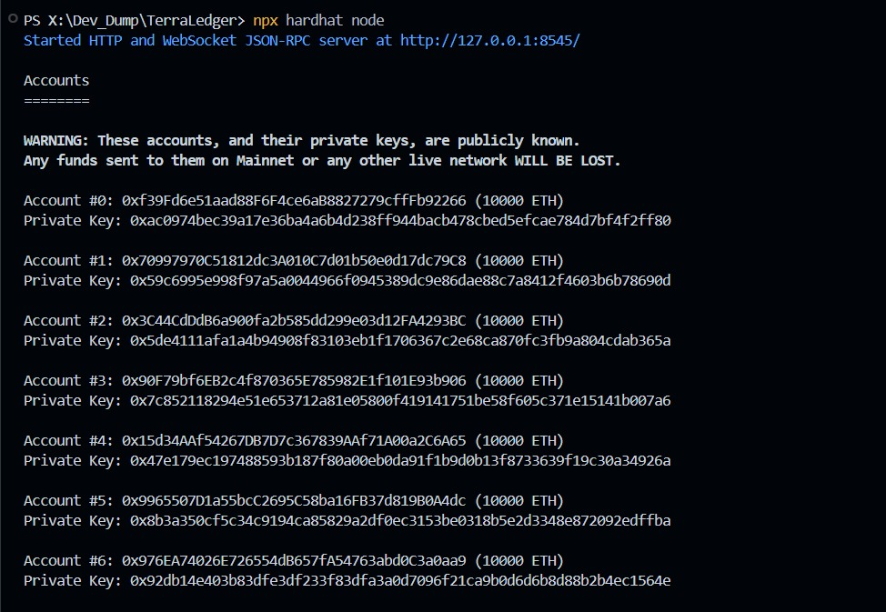
The TerraLedger system is implemented on an Ethereum-based blockchain network to ensure decentralization, security, and transparency in land record management. For development and testing purposes, a local blockchain environment (Hardhat Network) is configured, allowing the deployment and execution of smart contracts without involving real cryptocurrency transactions. This setup enables safe experimentation and validation of the system’s functionalities.
Figure 4.1: Local Blockchain Server (Hardhat Node)

The smart contract developed using Solidity is compiled and deployed onto the blockchain network. Once deployed, the contract is assigned a unique address (e.g., 0x5FbDB...) that serves as a reference point for all interactions. The contract’s Application Binary Interface (ABI) is generated during compilation and is used by the frontend to invoke smart contract functions.

Figure 4.2: Smart Contract Deployment
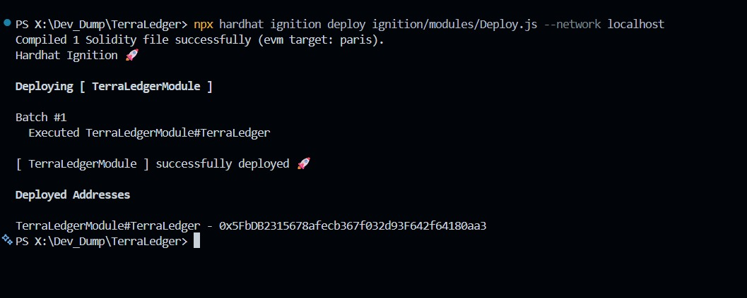
Success message confirming the deployment of the TerraLedger module to the localhost network, providing the contract address used in the frontend configuration.
The frontend application connects to the blockchain through a wallet-based authentication mechanism. Users authenticate themselves by connecting their digital wallets, which allows them to sign and authorize blockchain transactions securely. Each action performed by a user, such as registering a property or transferring ownership, is converted into a blockchain transaction and submitted to the network for validation.
When a transaction is initiated, it is verified and executed by the blockchain according to the logic defined in the smart contract. Upon successful execution, the updated land record is permanently stored on the blockchain, ensuring immutability and traceability. The frontend application listens for transaction confirmations and updates the user interface accordingly to reflect the current state of the land records.
4.5 Testing and Validation
The smart contracts were tested to verify correct execution of property registration and ownership transfer functions. The frontend was tested for proper wallet connectivity, transaction initiation, and user interaction flow. Test cases ensured that unauthorized users could not register or modify land records, thereby validating the security and reliability of the system.
The implementation of TerraLedger demonstrates the practical application of blockchain technology in land registry systems by ensuring secure data storage, transparency, and automation while maintaining usability through a modern web interface.

5. RESULT AND DISCUSSIONS

5.1 Overview of Implemented System
The TerraLedger system successfully implements a decentralized land registry using blockchain technology. The application integrates a React-based frontend with an Ethereum smart contract backend, providing a secure, transparent, and immutable platform for property management. The following sections detail the key results observed from the system's operation, accompanied by screenshots of the working application.

5.2 User Interface and Accessibility
The system features a modern, responsive user interface designed for intuitive interaction. The landing page and dashboard provide users with immediate access to core features such as property registration, searching, and record verification.
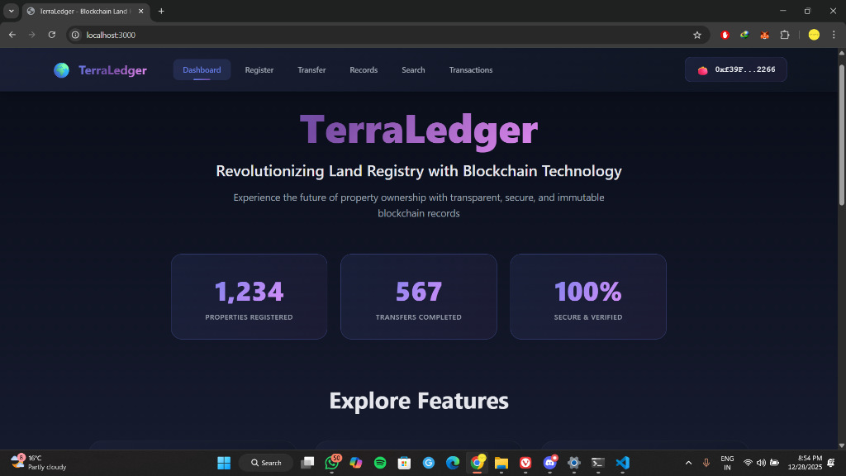Figure 5.1: TerraLedger Landing Page and Dashboard
As shown in Figure 5.1, the interface presents a clear summary of the system's status, including total registered properties and records. The design prioritizes ease of use, ensuring that users can navigate the decentralized application (DApp) without needing extensive technical knowledge of blockchain technology.

5.3 Secure Authentication
Authentication is handled via Web3 wallet integration (MetaMask), eliminating the need for traditional username/password credentials. This ensures that user identities are cryptographically secured.
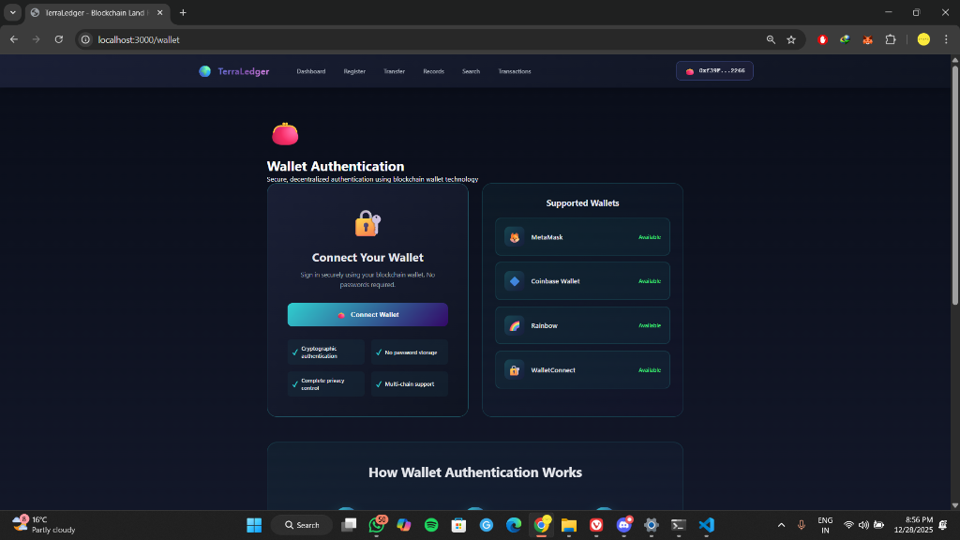Figure 5.2: Wallet Authentication Interface
Figure 5.2 demonstrates the wallet connection interface. Access to the system is restricted to users with a valid Ethereum wallet. This mechanism ensures that only authorized entities (such as confirmed property owners or system administrators) can initiate sensitive transactions like property transfers or new registrations.

5.4 Property Search and Verification
A core feature of TerraLedger is the ability to publicly verify property ownership. The search functionality allows anyone to verify the details of a property using its unique ID.
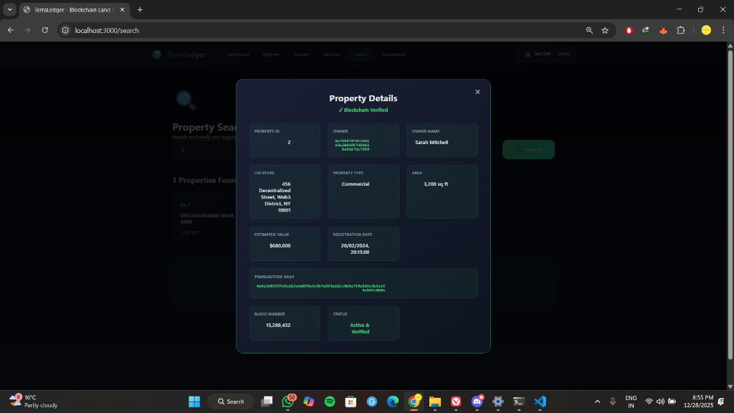Figure 5.3: Verified Property Details
The result of a property query is displayed in Figure 5.3. The system retrieves data directly from the blockchain, displaying the current owner's wallet address, property location, and unique property ID. The "Blockchain Verified" badge confirms that the data displayed is consistent with the immutable ledger.

5.5 Transaction Recording and History
All actions within the system, including registrations and ownership transfers, are recorded as transactions on the Ethereum blockchain.
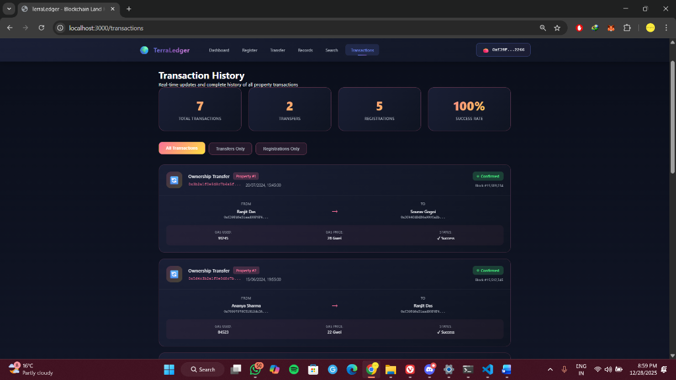Figure 5.4: Transaction History Log
Figure 5.4 illustrates the transaction history view. Each entry includes the transaction hash, gas used, and block number. This transparency provides an audit trail that is tamper-proof, addressing a key limitation of traditional paper-based registries.

5.6 Immutable Records
The system ensures that once a record is created, it cannot be altered. The "Records" view provides a chronological list of all blocks and transactions associated with the registry.
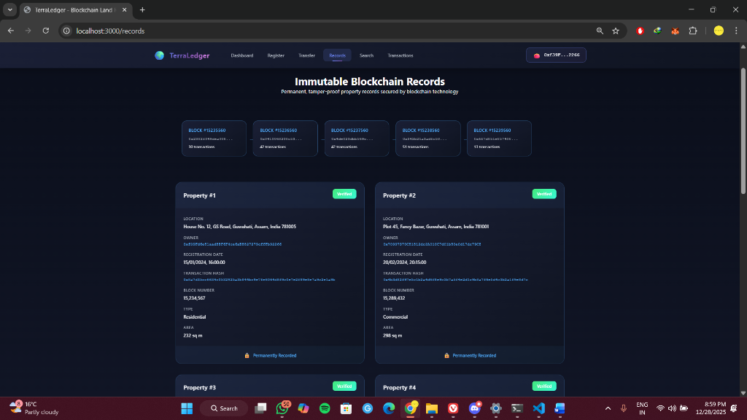Figure 5.5: Immutable Blockchain Records
Figure 5.5 shows the immutable records page. Each block contains a set of validated transactions. This visualizes the underlying blockchain structure, demonstrating how data integrity is maintained over time.

5.7 Discussion of Results
The implemented system demonstrates that blockchain technology can effectively replace centralized databases for land registry management.
- Security: The use of cryptographic signatures (Figure 5.2) prevents unauthorized transfers.
- Transparency: The public search feature (Figure 5.3) allows for trustless verification of ownership.
- Immutability: The transaction logs (Figure 5.4 and 5.5) prove that historical data cannot be manipulated.
The results confirm that TerraLedger meets the primary objectives of reducing fraud, increasing transparency, and streamlining the property transfer process.

6. CONCLUSION AND FUTURE WORKS

6.1 CONCLUSION
This project presented TerraLedger, a Blockchain-Based Land Registry System designed to address the limitations of traditional and centralized land record management systems. By leveraging blockchain technology and smart contracts, the system ensures secure, transparent, and tamper-resistant storage of land ownership records. The decentralized nature of the blockchain eliminates the risks associated with data manipulation, unauthorized access, and single points of failure.

The implementation successfully demonstrated automated property registration and ownership transfer through smart contracts, reducing the need for intermediaries and manual intervention. Wallet-based authentication further enhanced system security by ensuring that only authorized users could initiate and approve transactions. The integration of a modern web-based frontend made the system user-friendly and accessible, even for non-technical users.

Overall, TerraLedger validates the practical applicability of blockchain technology in land registry systems and highlights its potential to improve efficiency, trust, and reliability in property management processes.
6.2 FUTURE WORKS
While TerraLedger achieves its core objectives, several enhancements can be considered to improve its functionality and real-world applicability in the future:
- Integration with Government Systems:
The system can be integrated with official land administration authorities to enable legally binding property registration and verification.
- Deployment on Public Blockchain Networks:
Future versions may be deployed on public or consortium blockchain networks to improve scalability and accessibility.
- Enhanced Security Mechanisms:
Additional security features such as multi-signature approvals and biometric verification can be incorporated for high-value transactions.
- Advanced Search and Analytics:
Analytical tools and advanced search features can be added to analyze land ownership trends and transaction history.
- Legal and Regulatory Compliance:
Smart contracts can be enhanced to comply with regional land laws and regulatory frameworks.
- Mobile Application Support:
A mobile-based application can be developed to increase accessibility and user adoption.
These future enhancements can further strengthen TerraLedger and enable its adoption as a comprehensive and scalable solution for modern land registry systems.

REFERENCES

- Nakamoto, S., Bitcoin: A Peer-to-Peer Electronic Cash System, 2008.
- Wood, G., Ethereum: A Secure Decentralized Generalized Transaction Ledger, Ethereum Project Yellow Paper, 2014.
- Buterin, V., “A Next-Generation Smart Contract and Decentralized Application Platform,” Ethereum White Paper, 2013.
- Christidis, K., & Devetsikiotis, M., “Blockchains and Smart Contracts for the Internet of Things,” IEEE Access, vol. 4, pp. 2292–2303, 2016.
- Crosby, M., et al., “Blockchain Technology: Beyond Bitcoin,” Applied Innovation Review, no. 2, pp. 6–10, 2016.
- Zheng, Z., Xie, S., Dai, H., Chen, X., & Wang, H., “An Overview of Blockchain Technology: Architecture, Consensus, and Future Trends,” IEEE International Congress on Big Data, 2017.
- Szabo, N., “Smart Contracts: Building Blocks for Digital Markets,” 1997.
- Ethereum Foundation, Solidity Documentation, https://docs.soliditylang.org/
- Hardhat Documentation, https://hardhat.org/docs
- MetaMask Documentation, https://docs.metamask.io/

APPENDICES

Appendix A: System Requirements
Hardware Requirements:
- Computer system with minimum 8 GB RAM
- Intel i5 or equivalent processor
- Stable internet connection
Software Requirements:
- Operating System: Windows / Linux / macOS
- Node.js and npm
- Ethereum development environment
- Web browser with wallet extension support
- Code editor (e.g., Visual Studio Code)

Appendix B: Development Tools and Technologies
- Programming Language: JavaScript, Solidity
- Frontend Framework: React with Vite
- Blockchain Platform: Ethereum
- Smart Contract Language: Solidity
- Development Framework: Hardhat
- Wallet Integration: MetaMask
- Version Control: Git and GitHub

Appendix C: Sample Functional Flow
- Admin connects wallet and registers land details.
- Property data is stored securely on the blockchain.
- Owner connects wallet and initiates ownership transfer.
- Smart contract validates the request.
- Ownership record is updated immutably on the blockchain.

Appendix D: Abbreviations
- DApp – Decentralized Application
- ABI – Application Binary Interface
- PoW – Proof of Work
- PoS – Proof of Stake

