# 

# **JAWAHARLAL NEHRU ENGINEERING COLLEGE**

**Department of Computer Science and Engineering**

(Mahatma Gandhi Mission University, Chhatrapati Sambhaji Nagar)

## **DIP PROJECT REPORT**

ON

## **“ID Card Detection System”**

Submitted by:

**Hemant Singh Parmar 202201103143**

**Anil Jangid 202201103142**

## **Subject in-charge/Guide:**

Mrs. Deepali Naglot

Department of Computer Science and Engineering Academic Year 2024-2025

**CERTIFICATE**

This is to certify that the project report

**“ID Card Detection System”**

Submitted by

**Hemant Singh Parmar 202201103143**

**Anil Jangid 202201103142**

is a bonafide work carried out by them under the supervision of Mrs. Deepali Naglot and it is approved for the subject AI lab in academic year 2024-2025 Semester VI at JNEC, MGM University, Ch. Sambhajinagar.

Date:

Mrs. Deepali Naglot Dr. Deepa Deshpande

Guide Head of Department

**Dept. of Computer Sci.&Engineering Dept. of Computer Sci.&Engineering**

Dr. Musande V.B

**Principal**

MGM’s Jawaharlal Nehru Engineering College, Ch. Sambhajinagar

**TABLE OF CONTENTS**

1. **INTRODUCTION**
   1. Purpose
   2. Functional Requirements
   3. Non-Functional Requirements
2. **LITERATURE SURVEY**
3. **SYSTEM DESIGN AND IMPLEMENTATION**
   1. Project Flow
   2. implementation details
4. **CONCLUSION AND FUTURE WORK REFERENCES**
5. **GITHUB Link:**

**https://github.com/hemant-code625/idCard-detection.git**

**INTRODUCTION**

**1.1 Purpose**

The ID Card Detection System project aims to automate the process of verifying whether students are wearing their mandatory ID cards within a campus environment. Using advanced object detection techniques, specifically the YOLOv8 model, the system analyzes video streams from CCTV cameras and detects the presence of ID cards without extracting any personal information. This ensures faster compliance checks, improves campus security, and reduces manual efforts by the security staff.

**1.2 FUNCTIONAL REQUIREMENTS**

* Capture and process real-time frames from CCTV cameras or video files using OpenCV.
* Use a YOLOv8 model to accurately detect the presence of ID cards.
* Display detection results by drawing bounding boxes around identified ID cards.
* Save detection outputs for future review if necessary.
* Enable seamless integration with existing surveillance infrastructure without needing major hardware changes.

**1.3 NON-FUNCTIONAL REQUIREMENTS**

* Achieve real-time detection speed with minimal delay.
* Ensure high detection accuracy even under various lighting conditions and camera angles.
* Maintain privacy by not extracting any text or personal details from ID cards.
* Design the system to be scalable for deployment across multiple locations on the campus.
* Ensure system reliability and robustness under continuous operation.

**LITERATURE SURVEY**

Object detection technologies have significantly evolved, offering faster and more accurate systems compared to traditional manual checking methods. Among these, YOLO (You Only Look Once) models have proven highly effective for real-time object detection. YOLOv8, developed by Ultralytics, brings enhanced speed and accuracy by utilizing advanced deep learning techniques. Label Studio is widely used for dataset annotation, allowing users to prepare high-quality labeled data critical for training detection models. Studies show that deep learning-based object detection methods outperform traditional computer vision algorithms, making them suitable for tasks like ID card detection in dynamic environments such as campuses.

**SYSTEM DESIGN AND IMPLEMENTATION**

**1.1 Project Flow:**

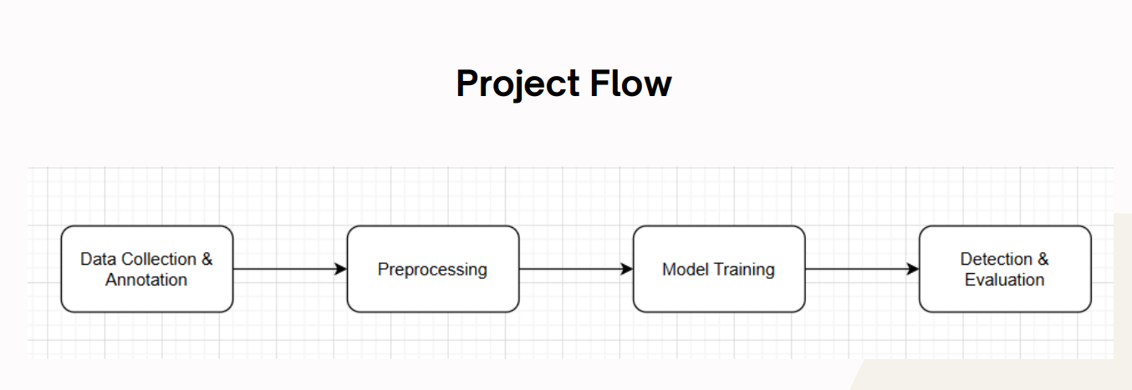

**1.2 Implementation Details**

**CODE :-**

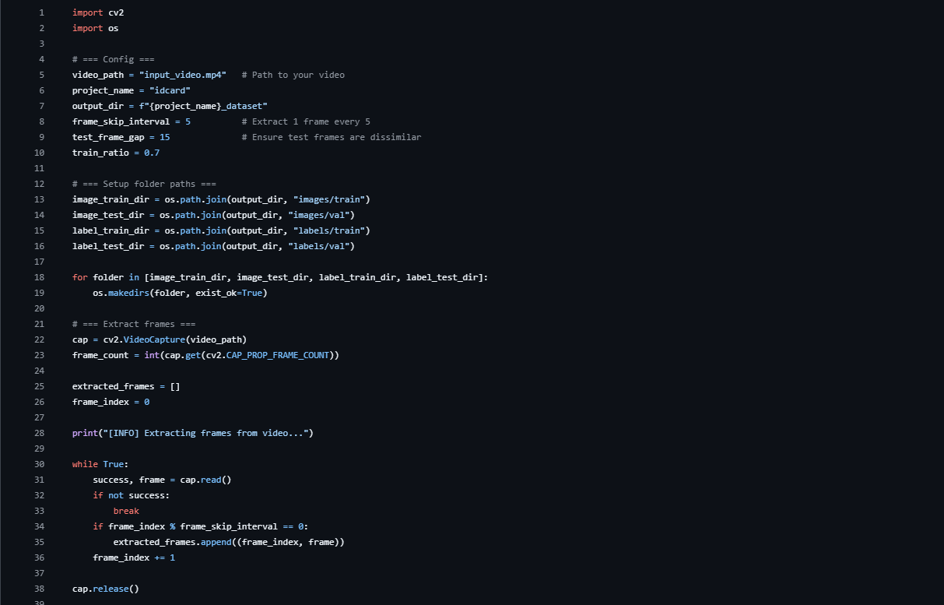

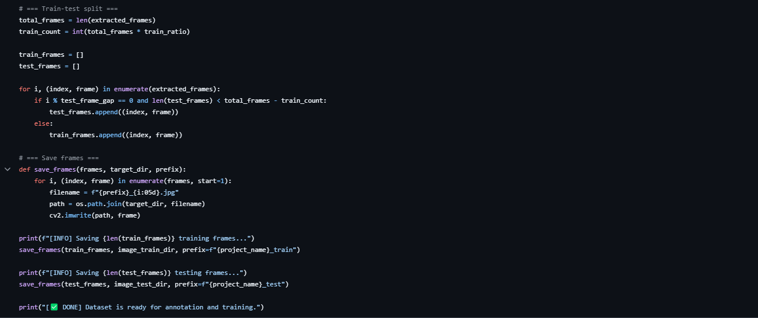

**Project Structure:**

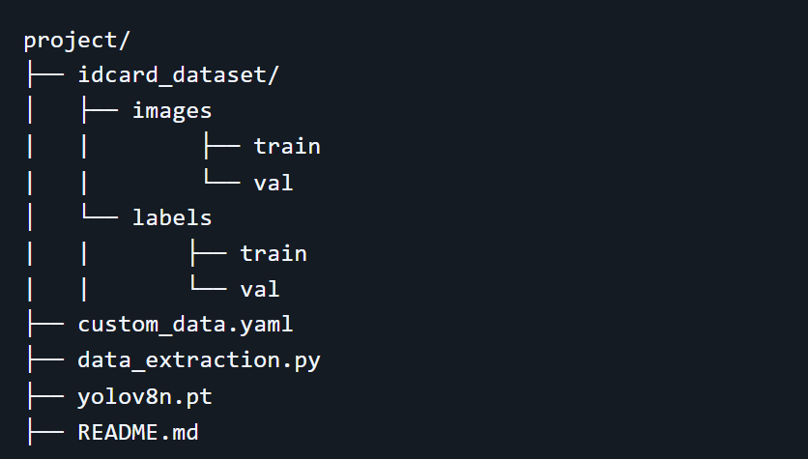

**OUTPUT :-**

**code to run:**

**yolo task=detect mode=train data=custom_data.yaml model=yolov8n.pt imgsz=640 batch=1 workers=0 amp=False**

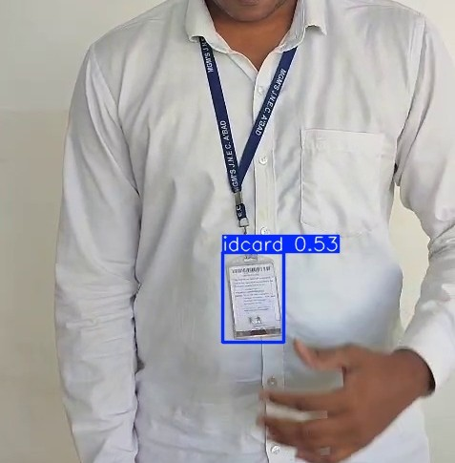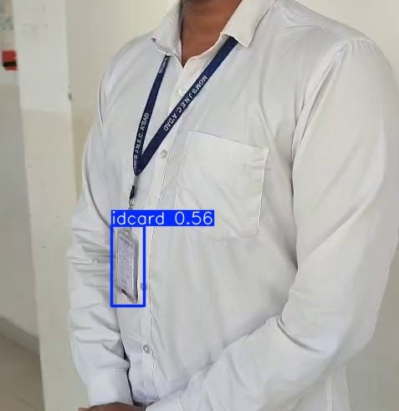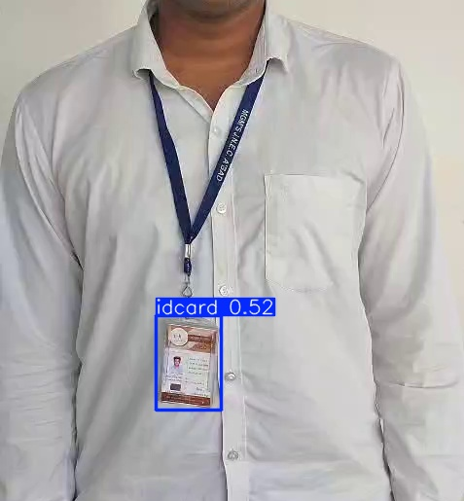

**CONCLUSION**

This project successfully developed an automated ID card detection system using YOLOv8 that enhances campus security by verifying ID card compliance in real-time. It reduces the manual workload of security staff, ensures faster identification, and maintains privacy by not extracting any sensitive information. The system demonstrated high performance and reliability under different conditions, proving its practical applicability.

**FUTURE WORK**

Future improvements could focus on handling extremely poor lighting conditions and challenging camera angles. The system could also be extended to detect other compliance aspects such as uniform adherence or access restrictions to specific areas. Additionally, a mobile application version could be developed for portable ID card verification, and integration with campus management systems could automate incident logging and alerting processes.

## 

## **REFERENCES**

1. Ultralytics YOLOv8 Documentation.
2. OpenCV Documentation.
3. Label Studio Documentation
4. "You Only Look Once: Unified, Real-Time Object Detection" - Research Paper by Redmon et al.
5. Tutorials and blogs on custom object detection using YOLOv8 from Kaggle and Medium.