# A CRM APPLICATION FOR LAPTOP RENTALS

**Project Overview:**

The main goal of this project is to create a CRM system for handling laptop rentals using Salesforce. Through precise inventory tracking, effective customer service, and prompt reporting, the application seeks to expedite the rental process. This solution will maximize user experience, increase operational efficiency, and improve data quality by utilizing Salesforce.

# Objectives

Business Goals:

* **Boost Efficiency**: Reduce manual handling and automate important procedures to streamline the laptop rental process.
* **Enhance Customer Experience**: Offer smooth customer service and engagement, including monitoring maintenance and rentals.
* **Data Accuracy and Reporting**: Create informative reports for strategic decision- making and keep correct records of inventories, rentals, and returns.

Specific Outcomes:

* **Inventory Management**: Keep tabs on the availability of laptops, their rental status, and any maintenance needs.
* **Customer Management**: Keep track of client information, such as preferences, rental history, and support requests.
* **Automated Notifications**: Provide reminders for scheduled maintenance and reservations.
* **Reporting**: Produce up-to-date data on inventory levels, booking patterns, and customer satisfaction indicators.

# Salesforce Key Features and Concepts Utilized

* **Salesforce Object Model** Personalized objects for tracking the number of laptops, customers, laptop reservations, and billing procedures.
* **Automation**: Notifications and updates can be automated with validation rules and flows.
* **Reports and Dashboards**: Tailored dashboards and reports to monitor inventory levels, booking histories, and KPIs.
* **Security**: To guarantee data security and compliance, use user profiles, users, roles, and hierarchy.

# Detailed Steps to Solution Design:

**Task -1: Salesforce Account Creation and activation**

The steps involved in salesforce account creation and activation process are as follows:

1. Creating a developer org in salesforce.
2. Go to <https://developer.salesforce.com/signup>
3. On the sign up form, enter the following details :
   1. First name & Last name
   2. Email
   3. Role : Developer
   4. Company : College Name
   5. County : India
   6. Postal Code : pin code
   7. [Username:username@organization.com](mailto:username@organization.com)
4. Click on sign me up after filling these.
5. Go to the inbox of the email that you used while signing up. Click on the verify account to activate your account. The email may take 5-10mins
6. Click on Verify Account.
7. Give a password and answer a security question and click on change password.
8. Then you will redirect to your salesforce setup page.

# Task-2: Object Creation

Follow the following procedure to create Total Laptops,consumer,Laptop Bookings,Billing process objects.

To create an object:

1. From the setup page >> Click on Object Manager >> Click on Create >> Click on Custom Object.
2. On Custom object defining page:
3. Enter the respective label name, plural label name, record name,datatype and click on Allow reports, Allow searchand track field history.
4. Click on Save.

# Task-3: Tab Creation

1. Go to setup page >> Type Tabs in Quick Find bar >> click on tabs >> New (under custom object tab)
2. Select Object(Total Laptops) >> Select the tab style >> Next (Add to profiles page) keep it as default >> Next (Add to Custom App) uncheck the include tab .
3. Make sure that the Append tab to users' existing personal customizations is checked.
4. Click save.

# Task-4: The Lightning App Creation

To create a lightning app page:

1. Go to setup page >> search “app manager” in quick find >> select “app manager” >> click on New lightning App.
2. Fill the app name in app details as LAPTOP RENTALS >>Next >> (App option page) keep it as default >> Next >> (Utility Items) keep it as default >> Next.
3. Upload a photo that is related to your app.
4. To Add Navigation Items:
5. Select the items (Total Laptops,consumer,Laptop Booking,Billing Process) from the search bar and move it using the arrow button >> Next.
6. To Add User Profiles:Search profiles (System administrator) in the search bar >> click on the arrow button >> save & finish.

**Task-5: Fields Creation in Different Objects**

* 1. **: Creating the field in consumer object**
     1. **: To create field in an object:**
        1. Go to setup >> click on Object Manager >> type object name(consumer) in search bar

>> click on the object.

* + - 1. Now click on “Fields & Relationships” >> New
      2. Select Data Type as a “Phone”
      3. Click on next
      4. Fill them as following:
         * Field Label: Phone number
         * Field Name : gets auto generated
         * Click the required option checkbox.
         * Click on Next >> Next >> Save and new.

# :To create another fields in an object:

* + - 1. Go to setup >> click on Object Manager >> type object name(consumer) in search bar

>> click on the object.

* + - 1. Now click on “Fields & Relationships” >> New
      2. Select Data type as a “Email” and Click on Next
      3. Fill them as following:
         * Field Label: Email
         * Field Name :It’s gets auto generated
         * Click on Next >> Next >> Save and new.

# : To create another fields in an object:

* + - 1. Go to setup >> click on Object Manager >> type object name(consumer) in search bar

>> click on the object.

* + - 1. Now click on “Fields & Relationships” >> New
      2. Select Data type as a “Text Area” and Click on Next
      3. Fill the Above as following:
         * Field Label: Address
         * Field Name : It’s gets auto generated

1. Select Required field.
2. Click on Next >> Next >> Save and new.

# : To create another fields in an object:

* + - 1. Go to setup >> click on Object Manager >> type object name(consumer) in search bar

>> click on the object.

* + - 1. Now click on “Fields & Relationships” >> New
      2. Select Data type as a “Picklist” and Click on Next
      3. Fill the Above as following:
         * Field Label: consumer Status
         * Value - Select enter values with each value separated by a new line
* Student
* Employee
* Others
  + - 1. Select required
      2. Field Name :It’s gets auto generated
      3. 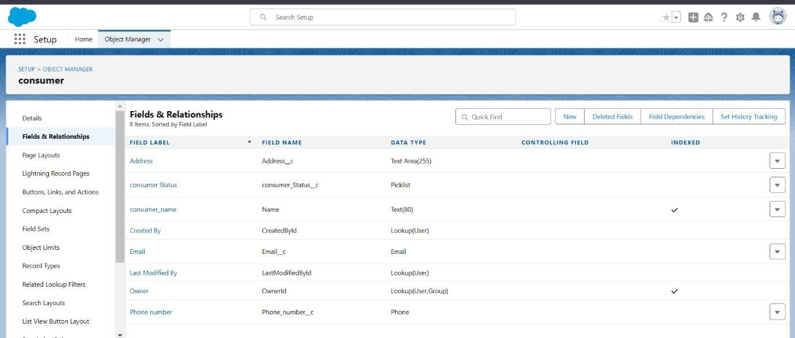Click on Next >> Next >> Save and new. These are the fields created in consumer Object:

# : Creating the field in Laptops Bookings object

* + 1. **:To create fields in an object:**
       1. Go to setup >> click on Object Manager >> type object name(Laptop Booking) in the search bar >> click on the object.
       2. Now click on “Fields & Relationships” >> New
       3. Select Data Type as a “Picklist”
       4. Picklist values are:-1.Dell 2. Acer 3.Hp 4.Mac
       5. Select required
       6. Click on Next >> Next >> Save and new

# : To Create a Fields & Relationship to an Laptop Booking Object

* + - 1. Go to setup >> click on Object Manager >> type object name(Laptop Booking) in the search bar >> click on the object.
      2. Now click on “Fields & Relationships” >> New
      3. Select Data Type as a “Picklist”
      4. Picklist values are:-1.core i3 2. Core i5 3. Core i7 .
      5. Select required
      6. Click on Next >> Next >> Save and new

# :To create fields & relationship to an object:

* + - 1. Go to setup >> click on Object Manager >> type object name(Laptop Booking) in the search bar >> click on the object.
      2. Click field dependency and next
      3. Click the include value for dell-core i3,i5,i7 and for acer i3,i4,i5 and for hp i3,i4,i5 and also for mac bionic chip include the values for it.
      4. Click save.

# : To create fields & relationship to an object:

* + - 1. Go to setup >> click on Object Manager >> type object name(Laptop Booking) in the search bar >> click on the object.
      2. Now click on “Fields & Relationships” >> New
      3. Select Data Type as a “Lookup Relationship”
      4. Click on Next
      5. Click on the Related to drop down and Select the “consumer” object and click on Next
      6. Fill them as following:
         * Change the Field Label: Name
         * Field Name :It’s gets auto generated
      7. Click on Next >> Next >> Save and new.

# : To create fields in an object:

* + - 1. Go to setup >> click on Object Manager >> type object name(Laptop Booking) in the search bar >> click on the object.
      2. Now click on “Fields & Relationships” >> New
      3. Select Data Type as a “Currency”
      4. Click on Next
      5. Fill them as following:
         * Field Label: Amount
         * Length: (18,0)
         * Field Name :It’s gets auto generated
      6. Click on Next >> Next >> Save and new

# : To Create a Fields & Relationship to an Object

* + - 1. Go to setup >> click on Object Manager >> type object name(Laptop Booking) in the search bar >> click on the object.
      2. Now click on “Fields & Relationships” >> New
      3. Select Data Type as a “Lookup Relationship”
      4. Click on Next
      5. Click on the Related to drop down and Select the “Total Laptops” object and click on Next
      6. Fill them as following:
         * Change the Field Label: Total No Of Laptops
         * Field Name :It’s gets auto generated

1. Click on Next >> Next >> Save and new.

# : To Create a Fields & Relationship to an Laptop Booking Object

* + - 1. Go to setup >> click on Object Manager >> type object name(Laptop Booking) in the search bar >> click on the object.
      2. Now click on “Fields & Relationships” >> New
      3. Select Data Type as a “Email”
      4. Click on Next and save it.

NOTE:- fill the records which you have created in consumer and laptop bookings and give relations also. After saving the records go to the laptop bookings object and edit lookup to master the detailed relationship.

# : To Create a Rollup Summary Field in “Total Laptops Object”

* + - 1. After Creating the Lookup Relationship Than Only you can create the Rollup Summary
      2. Go to setup >> click on Object Manager >> type object name(Total Laptops) in the search bar >> click on the object.
      3. Now click on “Fields & Relationships” >> New
      4. Select Data type as a “Roll-up Summary” and Click on Next

1. Fill the Above as following:
   * Field Label: Laptops delivered
   * Field Name :It’s gets auto generated
2. Click on Next
3. Select the Laptop Bookings in the Summarized Object
4. Select the count Radio button in the select Roll-up Type

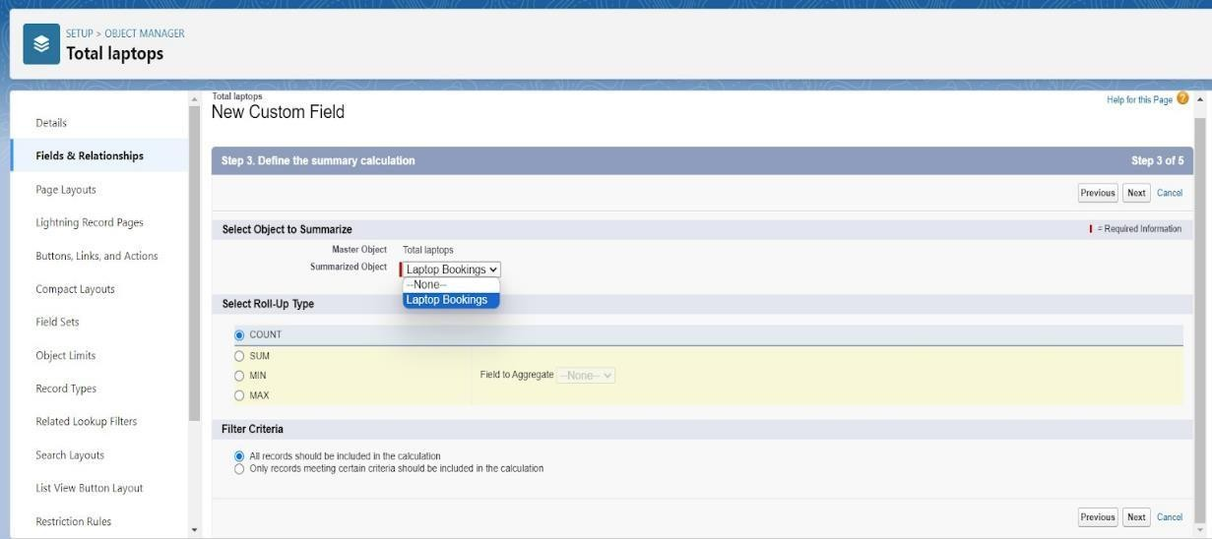

1. Click Next>Save it.

# : To create fields in an object:

* + - 1. Go to setup >> click on Object Manager >> type object name(Laptop Booking) in the search bar >> click on the object.
      2. Now click on “Fields & Relationships” >> New
      3. Select Data type as a “Formula” and Click on Next
      4. Fill the Above as following:
         * Field Label: Laptops Available
         * Field Name : It’s gets auto generated

1. Select the Formula Return Type as “Number”

6. Select the Decimal places as “0” and Click on Next

1. Click on the Advanced Formula and Enter the value in formula box “ 50 - ” and Click on insert field than you will find a pop window under the Laptop Booking select the Total No Of Laptops in the second Column and select the Laptops delivered in the third column and click on insert

8. “ 50 - Total_no_of_laptops r.Laptops_delivered c ” and Check Syntax

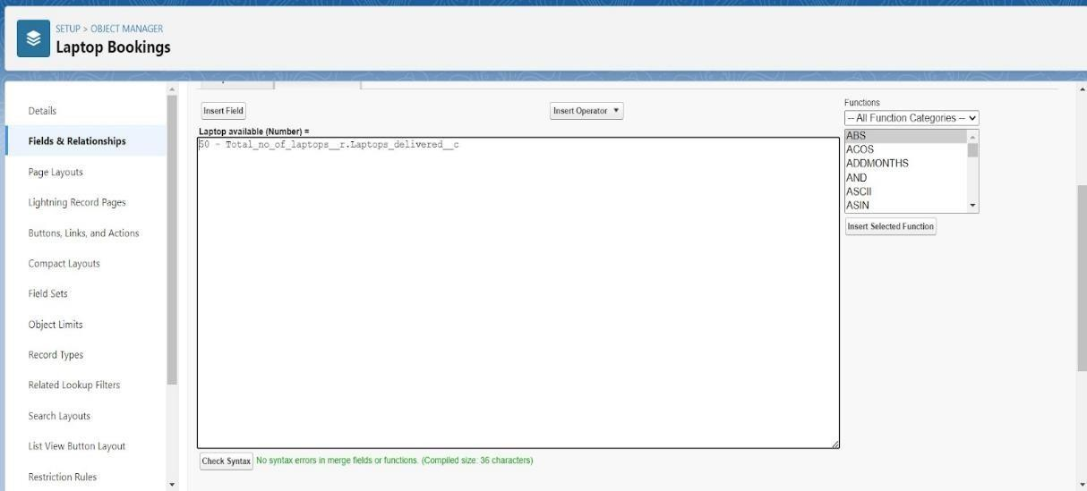

1. Click on Next >> Next >> Save and new

# : To create fields in an object:

* + - 1. Go to setup >> click on Object Manager >> type object name(Laptop Booking) in the
      2. search bar >> click on the object.

1. Now click on “Fields & Relationships” >>New
2. Select Data Type as a “picklist”
3. Picklist values are 1.2.3.4.5
4. Click and save it.

These are the fields created in Laptop Bookings Object:

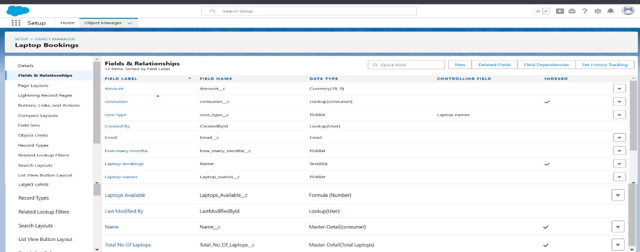

# : Creation of Fields & Relationship for Billing Process Object

**5.3.1. To create fields & relationship to an object:**

1. Go to setup >> click on Object Manager >> type object name(Billing Process) in the search bar >> click on the object.
2. Now click on “Fields & Relationships” >> New
3. Select Data Type as a “Master-detail Relationship”
4. Click on Next
5. Click on the Related to drop down and Select the consumer object and click on Next

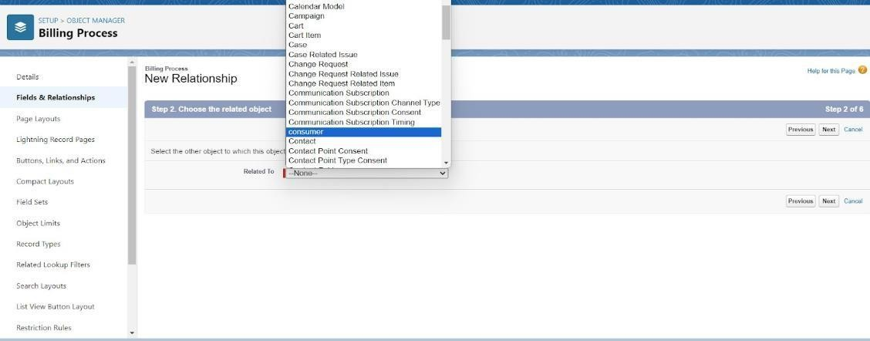

1. Fill the Above as following:

* Change the Field Label: Name
* Field Name :It’s gets auto generated

1. Click on Next >> Next >> Save and new.

# : To create another fields & relationship to an object:

* + - 1. Go to setup >> click on Object Manager >> type object name(Billing Process) in the search bar >> click on the object.
      2. Now click on “Fields & Relationships” >> New
      3. Select Data Type as a “Lookup Relationship”
      4. Click on Next
      5. Click on the Related to drop down and Select the Laptop Booking object and click on Next

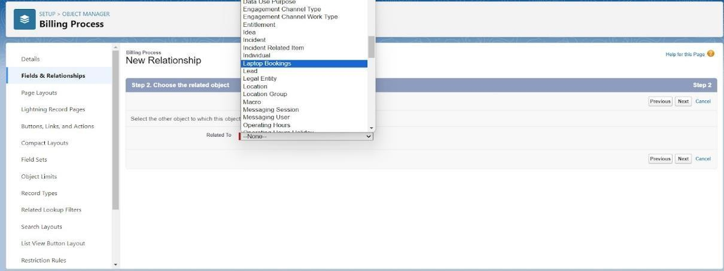

* + - 1. Fill the Above as following:
         * Change the Field Label: Laptop Booking
         * Field Name :It’s gets auto generated

1. Click on Next >> Next >>Save and new.

# : Creation of another fields for the billing process object

To create fields in an object:

* + - 1. Go to setup >> click on Object Manager >> type object name(Billing Process) in the search bar >> click on the object.
      2. Now click on “Fields & Relationships” >> New
      3. Select Data Type as a “Picklist”
      4. Fill the Above as following:
         * Field Label: Payment Mode
         * Value >> Select enter values with each value separated by a new line

1. Cash
2. Check
3. Credit card
4. Debit card
5. UPI
6. Phonepe
7. Gpay
8. Paytm
9. Select required
10. Click on Next >> Next >> Save and new.

# : Create a Cross object formula Field in billing process Object

* + - 1. Go to setup >> click on Object Manager >> type object name(Billing Process) in the search bar >> click on the object.
      2. Now click on “Fields & Relationships” >> New
      3. Select Data Type as a “Formula”
      4. Click on Next
      5. Enter the Field label: Amount, the Field name gets auto generated and click on Next.(Formula return type Number).
      6. In the Advanced Formula Click on the Insert field in the popup Screen Select the Billing Process and in the second drop down select the Laptop Booking and in the three drop down select the Amount field and click on Insert
      7. “ Laptop_Booking r.Amount c ”
      8. Click on the Check syntax: No syntax errors in merge fields

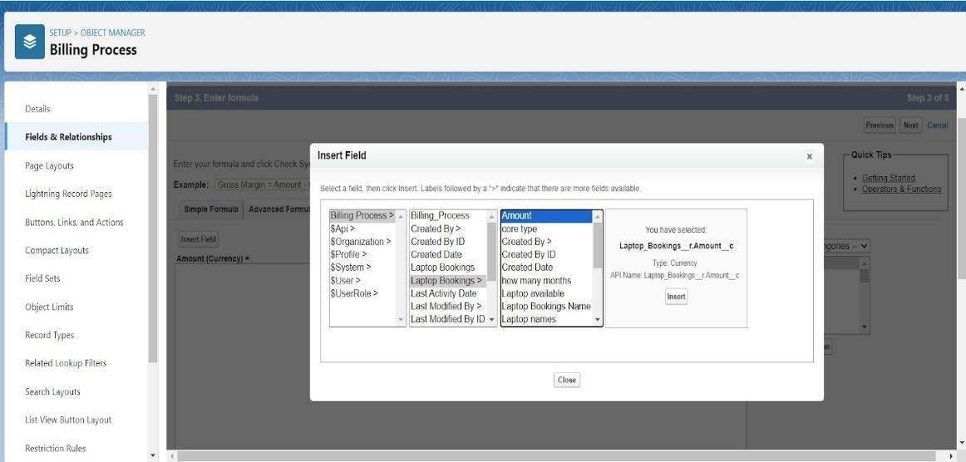

* + - 1. Click on Next >> Next >> Save and new. These are the fields created in Billing Process Object:

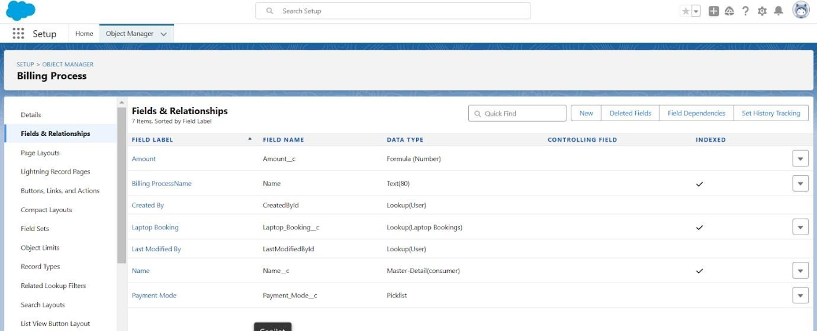

# : Creating the field in Total Laptops object

**5.4.1. To create fields in an object:**

1. Go to setup >> click on Object Manager >> type object name(Total Laptops) in search bar >> click on the object.
2. Now click on “Fields & Relationships” >> New
3. Select Data type as a “Formula” and Click on Next
4. Fill the Above as following:
5. Field Label: Laptops Available
6. Field Name : It’s gets auto generated
7. Select the Formula Return Type as “Number”

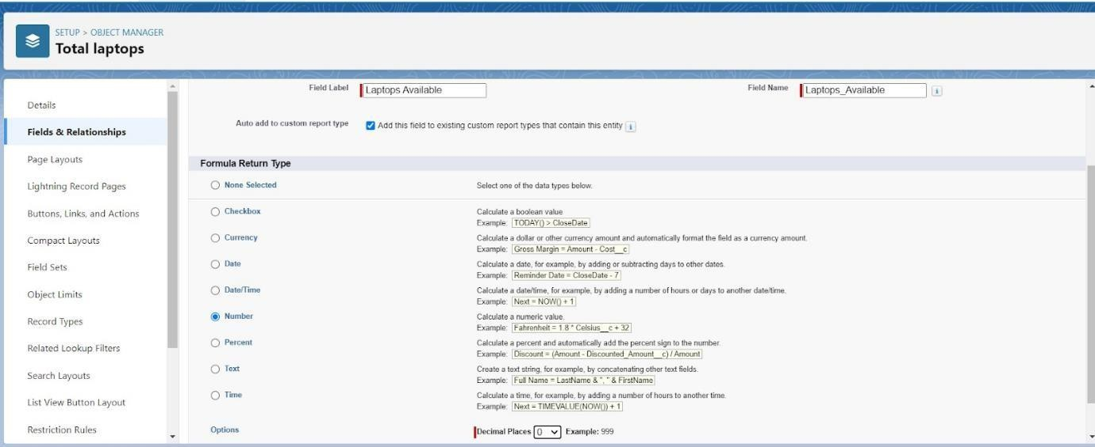

1. Select the Decimal places as “0” and Click on Next
2. Click on the Advanced
3. Formula “ 50 - Laptops_delivered c ” and Check Syntax
4. 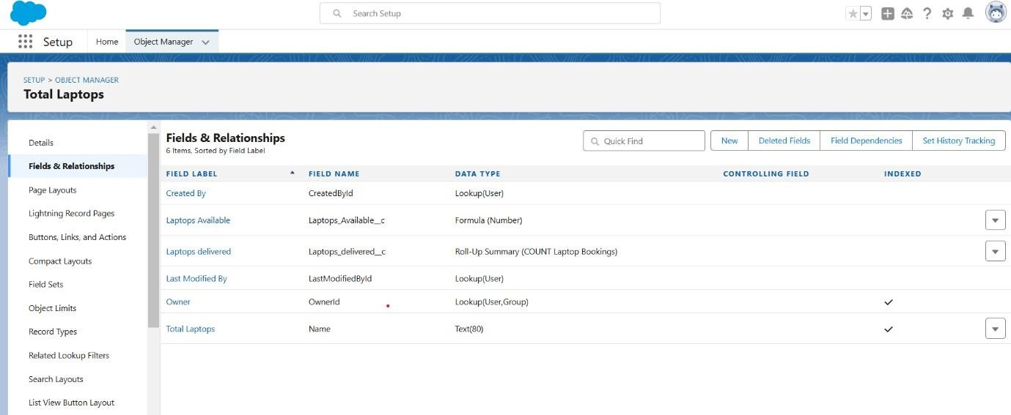Click on Next >>Next >>Save and new. These are the fields created in Total Laptops Object:

# Task-6: Validation Rule

Creating the validation rule for phone number field in consumer object

1. Go to the setup page >> click on object manager >> From drop down click edit for consumer object.
2. Click on the validation rule >> click New.
3. Enter the Rule name as “Phonenumberoremailblankrule ”.
4. Enter the description as “phone number and email number should not be blank”.
5. Enter the formula as “OR( ISBLANK( phone_number c ) , ISBLANK( email c )

)” and check the syntax.

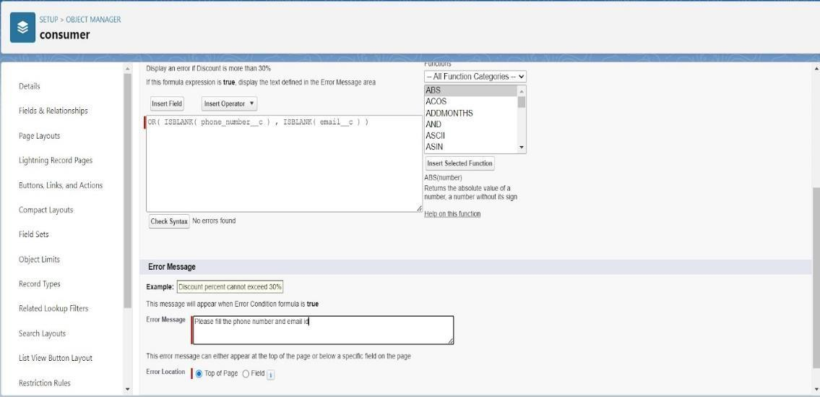

1. Save the validation rule.

# Task-7: Profiles

* 1. **: Owner Profile**

To create a new profile:

* + 1. Go to setup >> type profiles in quick find box >> click on profiles >> clone the desired profile (Standard User) >> enter profile name (owner) >> Save.
    2. Scroll down to Custom Object Permissions and Give access permissions for Total Laptops, consumers , Laptop Booking and Billing Process objects as mentioned in the below diagram.
    3. Give Access and Save it.

# : Agent Profile

* + 1. Go to setup >> type profiles in quick find box >> click on profiles >> clone the desired profile (Standard Platform User) >> enter profile name (Agent) >>Save.
    2. While still on the profile page, then click Edit.
    3. Scroll down to Custom Object Permissions and Give access permissions for Total Laptops, consumer , Laptop Bookings and Billing Process objects as mentioned in the below diagram.

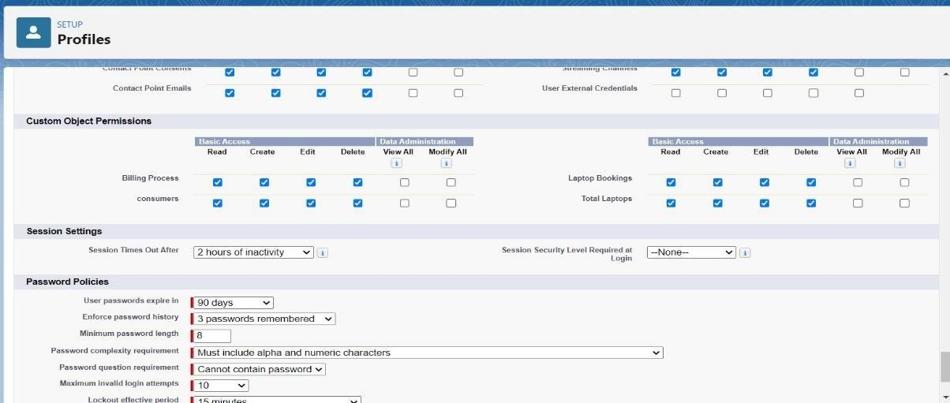

* + 1. Give access and save it.

# Task-8: Roles and hierarchy

* 1. **: Creating owner Role:**
     1. Go to quick find >> Search for Roles >> click on set up roles.
     2. Click on Expand All and click on add role under whom this role works.
     3. 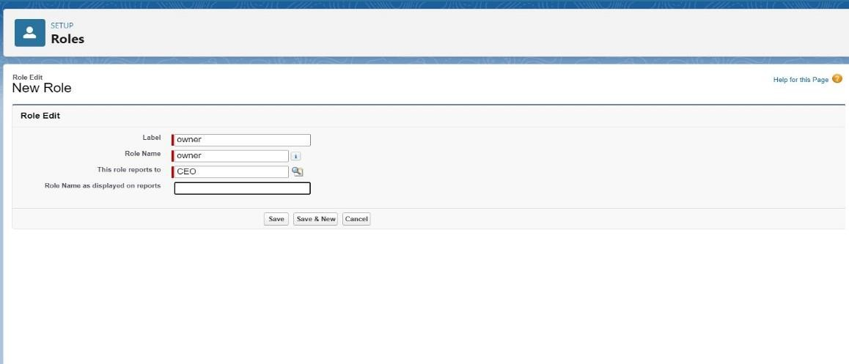Give Label as “owner” and Role name gets auto populated. Then click on Save.
     4. Click and save it.

# : Creating Agent roles

Creating another two roles under manager

* + 1. Go to quick find - Search for Roles - click on set up roles.
    2. Click plus on CEO role, and click add role under owner.
    3. Give Label as “Agent” and Role name gets auto populated. Then click on Save.

# Task-9: Users

* 1. **: Create User**
     1. Go to setup - type users in quick find box - select users -click New user.
     2. Fill in the fields
        1. First Name : vicky
        2. Last Name : y
        3. Alias : Give a Alias Name
        4. Email id : Give your Personal Email id
        5. Username : Username should be in this form: [text@text.text](mailto:text@text.text)
        6. Nick Name : Give a Nickname
        7. Role : owner
        8. User license : Salesforce
        9. Profiles : Standard User

2. Save it.

# : Creating another users

* + 1. Go to setup -type users in quick find box - select users -click New user.
    2. Fill in the fields
* First Name : ram
* Last Name : ram
* Alias : Give a Alias Name
* Email id : Give your Personal Email id
* Username : Username should be in this form: [text@text.text](mailto:text@text.text)
* Nick Name : Give a Nickname
* Role : Agent
* User license : Salesforce platform
* Profiles : standard platform user.

1. Save it.

# Task-10: Creating Flows for dell,hp,mac,acer

1. Go to setup >>type Flow in quick find box >> Click on the Flow and Select the New Flow.
2. Select the Record-triggered flow and Click on Create.
3. Select the Object as a Laptop Booking in the Drop down list.
4. Select the Trigger Flow when: “A record is Created or Updated”.
5. Select the Optimize the flow for: “Actions and Related Records” and Click on Done.
6. Under the Record-triggered Flow Click on “+” Symbol and In the Drop down List select the “Decision Element”.
7. Enter the Details Label: Field should be Update, API name: Gets Automatically Generated.
8. Enter the Outcome Details Label: dell , Outcome API name: Gets Automatically Generated.
   * Resource: Select Record.Laptop booking c.
   * Operator: Select Equals.
   * Value: Select dell
9. Add the same outcome order to acer , hp,mac.
10. Go to flow page
11. Below dell there is a symbol ‘+’ click on that.
12. Again select decision.
13. Enter the Details Label: Field should Update(any one u want), API name: Gets Automatically Generated.
14. Select the Outcome Details Label: dell core i3 , Outcome API name: Gets Automatically Generated.
    * Resource: Select Record.core type.
    * Operator: Select Equals.
    * Value: Select core i3.
15. Then again click the symbol ‘+’ outcome details.
16. Repeat this for dell core i5,i7

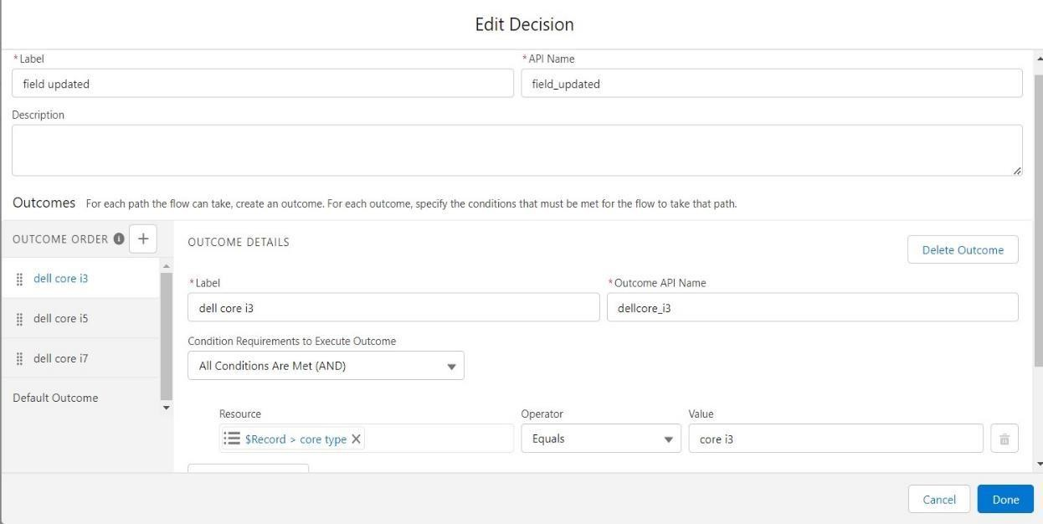

1. So go to the flow page select ‘+’ after core i3 then again select the decision.
2. Enter the Details Label: months selected , API name: Gets Automatically Generated.
3. Enter the Outcome Details Label: dell 1(i3) , Outcome API name: Gets Automatically Generated.
   * Resource: Select Record.how many months.
   * Operator: Select Equals.
   * Value: 1.
4. Similarly by selecting ‘+’ add dell 2(i3),dell 3(i3),dell 4(i3),dell 5(i3) with respective values 2,3,4,5 respectively
5. After dell 1(i3) there is ‘+’ symbol (similar for dell 2(i3),dell 3(i3),dell 4(i3),dell 5(i3)).
6. Click on ‘+’ then select update records
7. Enter the Details Label: one month of dell i3 rate , API name: Gets Automatically Generated.
8. Field:- Amount c , value:- for dell 1(i3)-1000, dell 2(i3)-2000, dell 3(i3)- 3000, dell 4(i3)-4000, dell 5(i3)-5000. Follow for all these.
9. Finally, Click done.
10. So go to the flow page select ‘+’ after core i3 then again select the decision.
11. So go to the flow page select ‘+’ after core i3 then again select the decision.
12. Enter the Details Label: months selected for dell i7, API name: Gets Automatically Generated.
13. Enter the Outcome Details Label: dell 1(i7) , Outcome API name: Gets Automatically Generated.
    * Resource: Select Record.how many months.
    * Operator: Select Equals.
    * Value: 1.
14. Similarly by selecting ‘+’ (beside outcome) add dell 2(i7),dell 3(i7),dell 4(i7),dell 5(i7) with respective values 2,3,4,5 respectively
15. After dell 1(i7) there is a ‘+’ symbol(similar for dell 2(i7),dell 3(i7),dell 4(i7),dell 5(i7)).
16. Click on ‘+’ then select update records
17. Enter the Details Label: one month of dell i5 rate , API name: Gets Automatically Generated.
18. Field:- Amount c , value:- for dell 1(i7)-2000, dell 2(i7)-4000, dell 3(i7)- 6000, dell 4(i7)-8000, dell 5(i7)-10000. Follow for all these.
19. Finally ,Click done.
20. Similarly do for acer core i5,mac bionic chip,hp core i7.

# Task-11: APEX

Trigger code:

trigger LaptopBooking on Laptop_Bookings c (After insert,after update) { if(trigger.isAfter && ( trigger.isInsert || trigger.isupdate))

{

LaptopBookingHandler.sendEmailNotification(trigger.new);

}

}

Class code:

public class LaptopBookingHandler {

public static void sendEmailNotification (List<Laptop_Bookings c> lapList){

for(Laptop_Bookings c lap:lapList)

{

Messaging.SingleEmailMessage email = new Messaging.SingleEmailMessage();

email.setToAddresses( new List<String>{lap.Email c});

email.setSubject('Welcome to our company');

string body = 'Dear ' +lap.Name +', \n';

body += 'Welcome to Laptop Rentals! You have been seen as a valuable customer to us.\n Please continue your journey with us, while we try to provide you with good quality resources. \n Laptop Amount = ' + lap.Amountc + ' \n core type = '+lap.core_typec +' \n Laptop type = '+lap.Laptop_namesc;

email.setPlainTextBody(body);

Messaging.sendEmail(new List<Messaging.SingleEmailMessage>{email});

}

}

}

Note: Before creating reports just fill the 10-12 records in the Laptop Bookings object.

Create records for each one you have to create at least 2 different records i.e dell(i3), dell(i7),acer(i3),hp(i5),mac(bionic chip)

# Task-12: Reports

* 1. **: Create Report**
     1. Go to the app -click on the reports tab
     2. Click New Report.
     3. Select report type from category or from report type panel or from search panel “consumer with Laptop Bookings and total laptops” >> click on start report.
     4. Customize your report
     5. Add fields from left pane as shown below
     6. Click the column drop down and select bucket list.

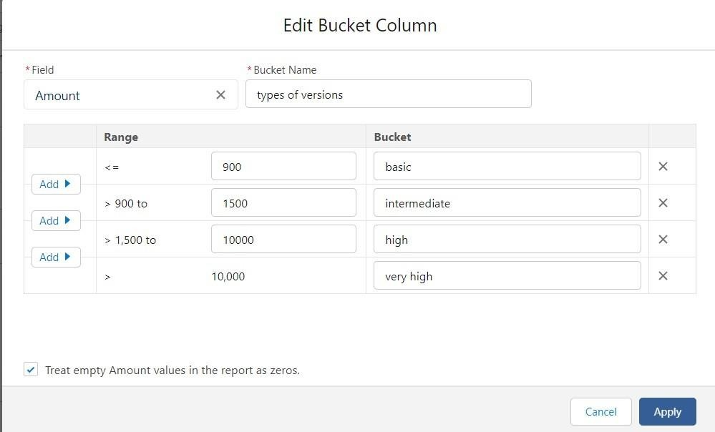

1. Click apply it.
2. Then save and run it.

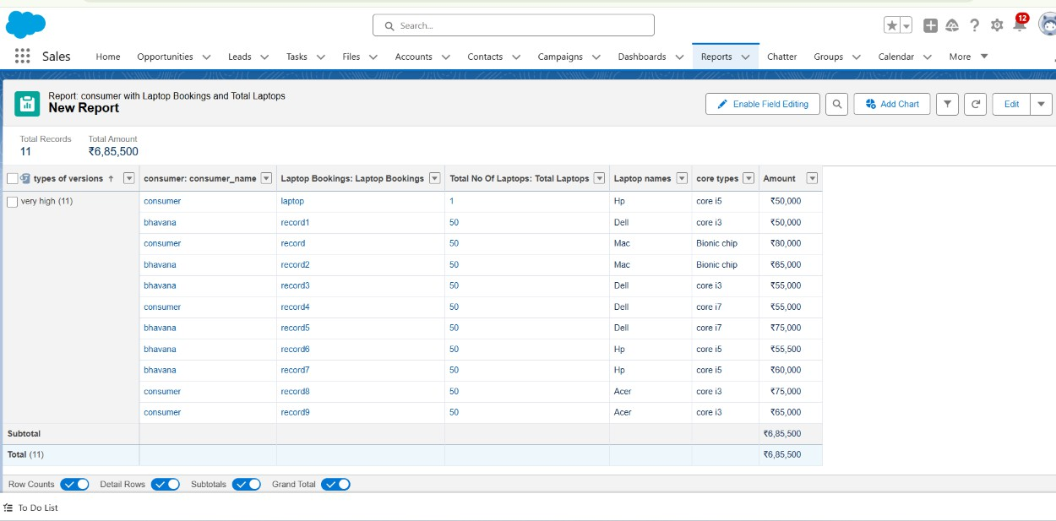

# : Sharing report to owner

* + 1. Click edit drop down and select subscribe option
    2. After selecting the daily,time and run report as a “another person” select your personal account or whom you want to send that mail to.
    3. Click save.

NOTE: The owner gets daily email notification of that laptop booking report.so that he can see all data remotely.

# Task-12: Dashboards

* 1. **: Create Dashboard Folder**
     1. Click on the app launcher and search for the dashboard.
     2. Click on the dashboard tab.
     3. Click the new folder, give the folder label as “total rent amount”.
     4. Folder unique names will be auto populated.
     5. Click save.

# : Create Dashboard

* + 1. Go to the app >> click on the Dashboards tabs.
    2. Give a Name and select the folder that was created, and click on create.

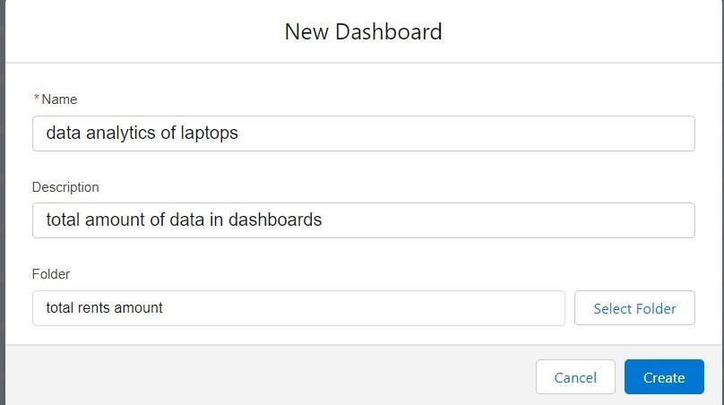

* + 1. Select add component.
    2. Select a Report and click on select.

1. Select the dark component and add to the dashboards.
2. Save it.
3. Click done.

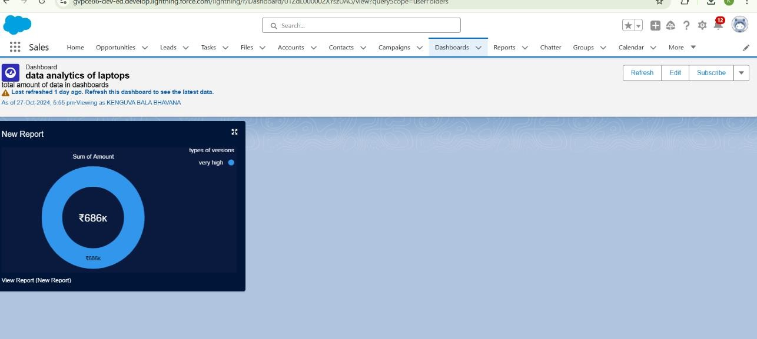

# Testing and Validation Unit Testing:

* + **Apex Classes and Triggers**: Test cases for each automation, ensuring accurate fee calculations, reminders, and status updates.

# Key Scenarios Addressed by Salesforce in the Implementation Project:

* + **Rental Booking**: User can book a laptop rental, view available inventory, and receive booking confirmation.
  + **Customer Support**: Integrated customer support for managing rental inquiries and resolving issues.

# Conclusion:

* + Successfully implemented a CRM solution to manage laptop rentals using Salesforce.
  + Enabled efficient tracking and management of inventory and customer information.
  + Enhanced the customer experience through automated reminders and support