**1) Create one vpc in N.virginia region.**

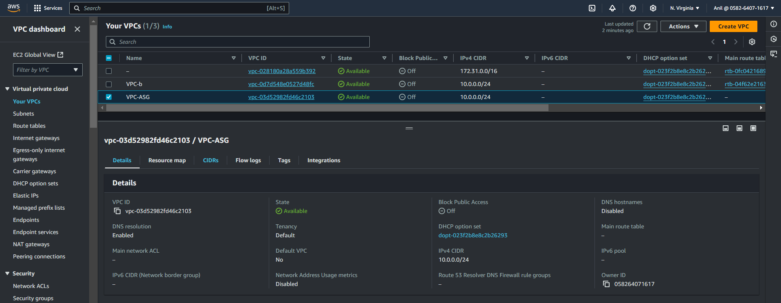

**2) Create two subnets. One Public subnet and one private subnet.**

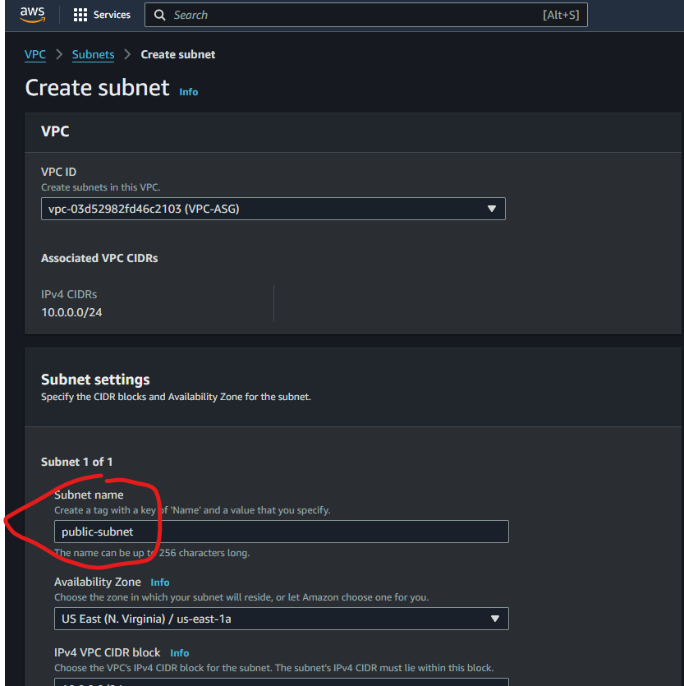

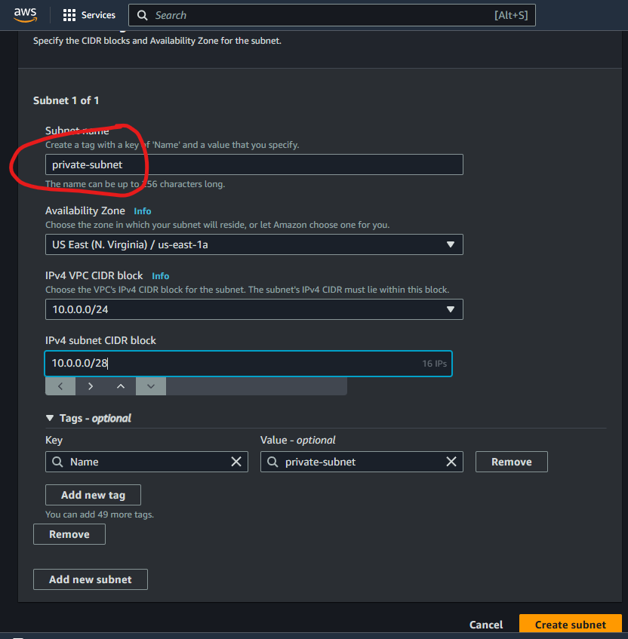

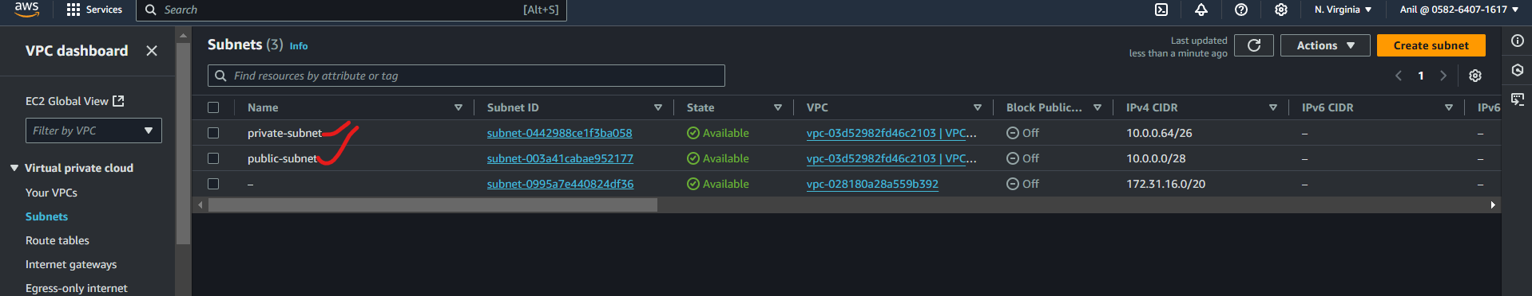

**3) Provide the IGW to the vpc.**

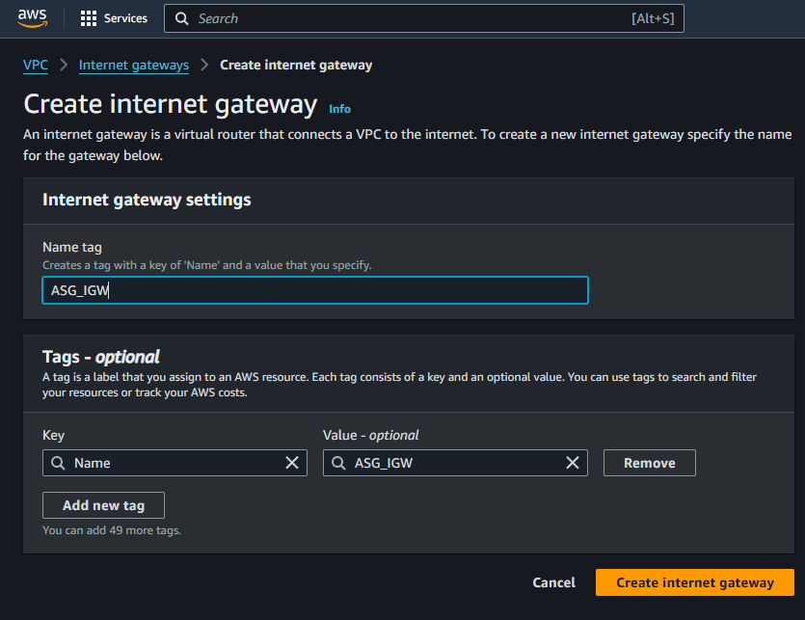

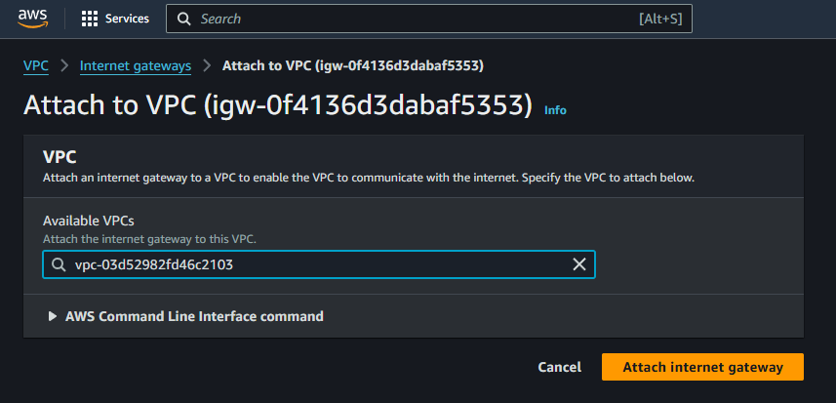

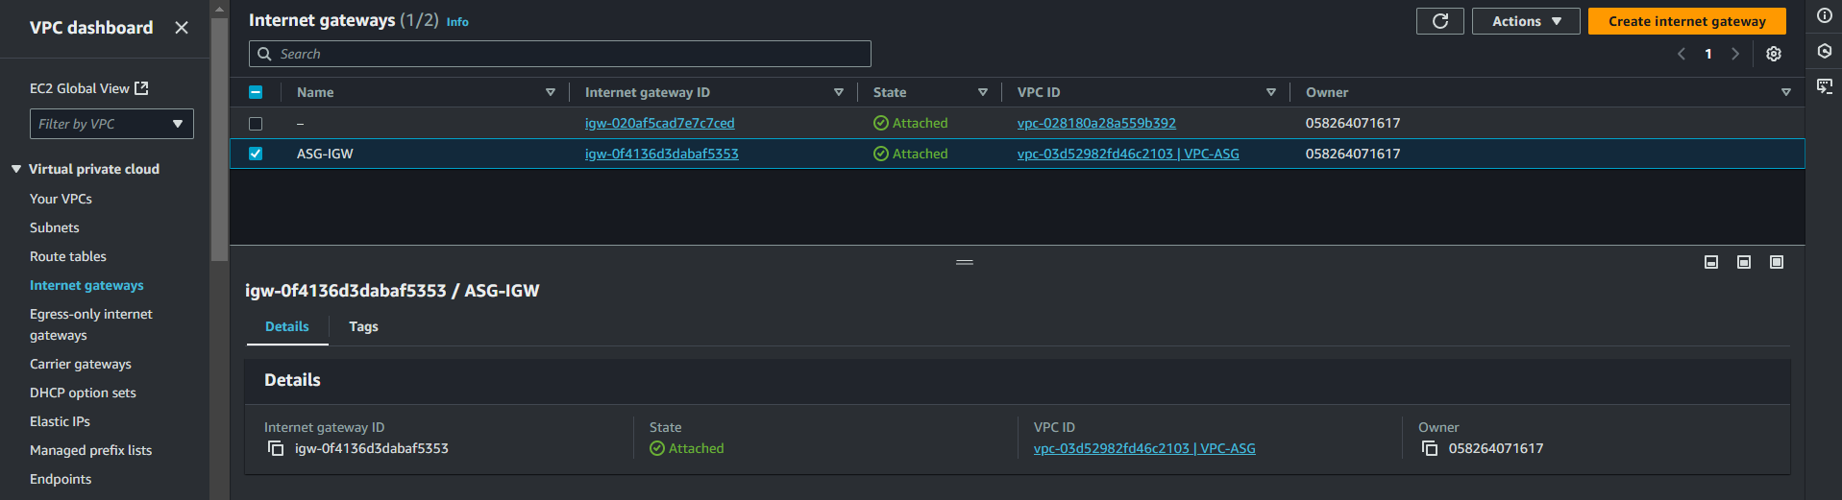

**4) Create One public RT and one private RT.**

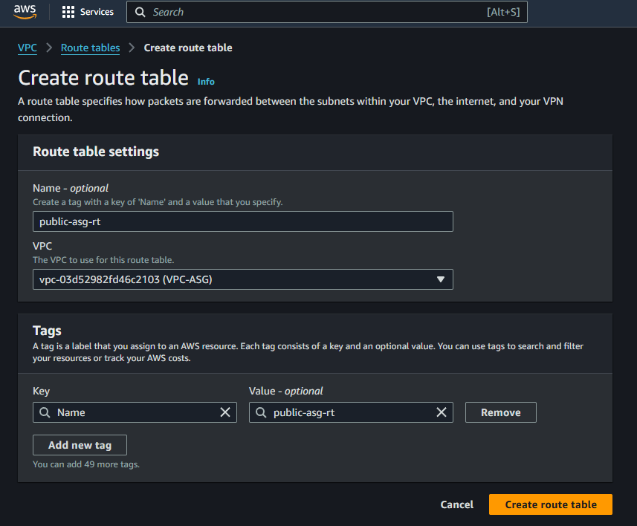

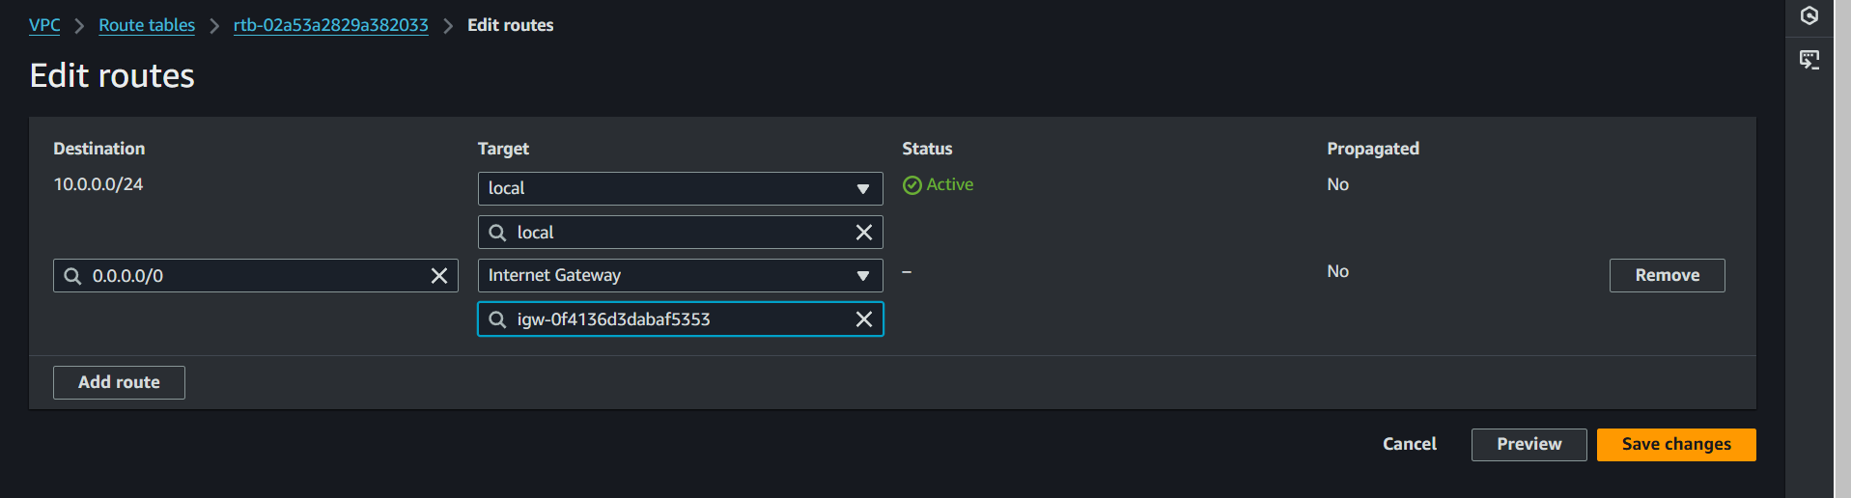

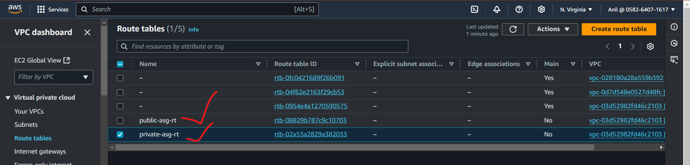

**5) Deploy NAT gateway on public subnet and attach the NAT gatewat to private subnet.**

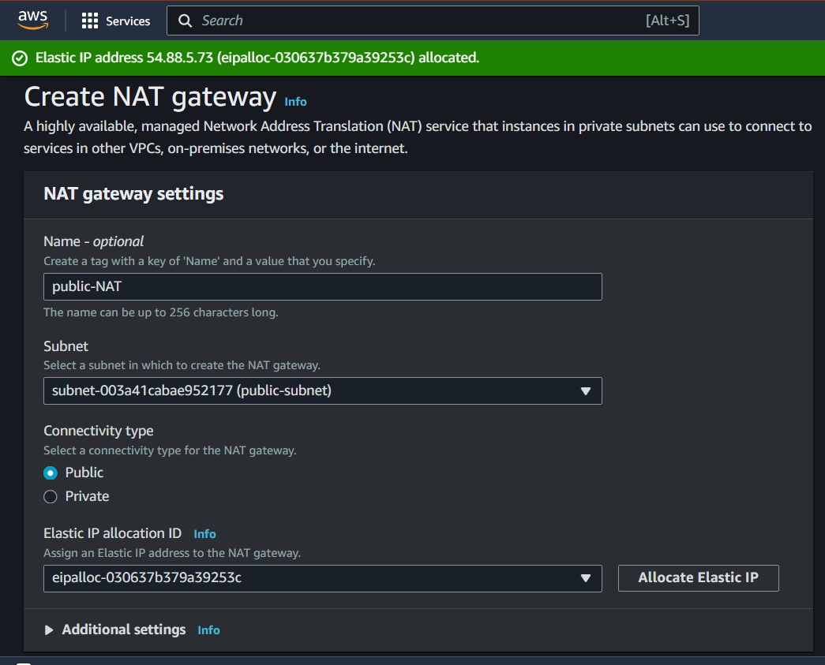

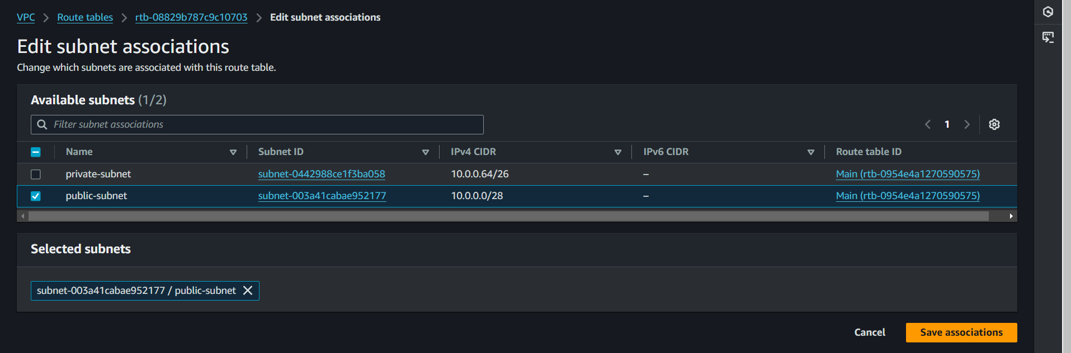

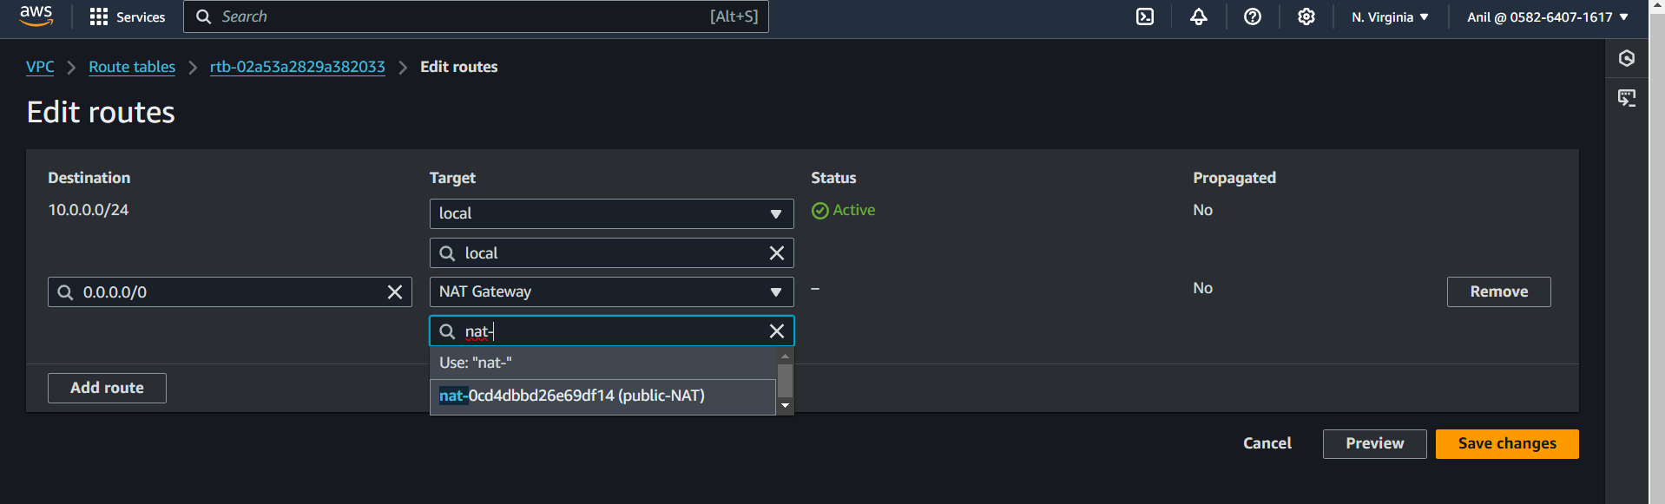

**6) Create Two instances,one in public subnet and one in private subnet.**

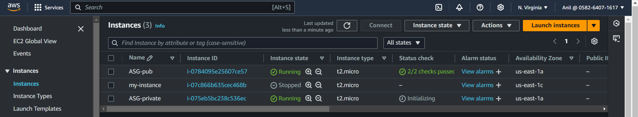

**7) Store the vpc flow logs to cloudwtach group.**

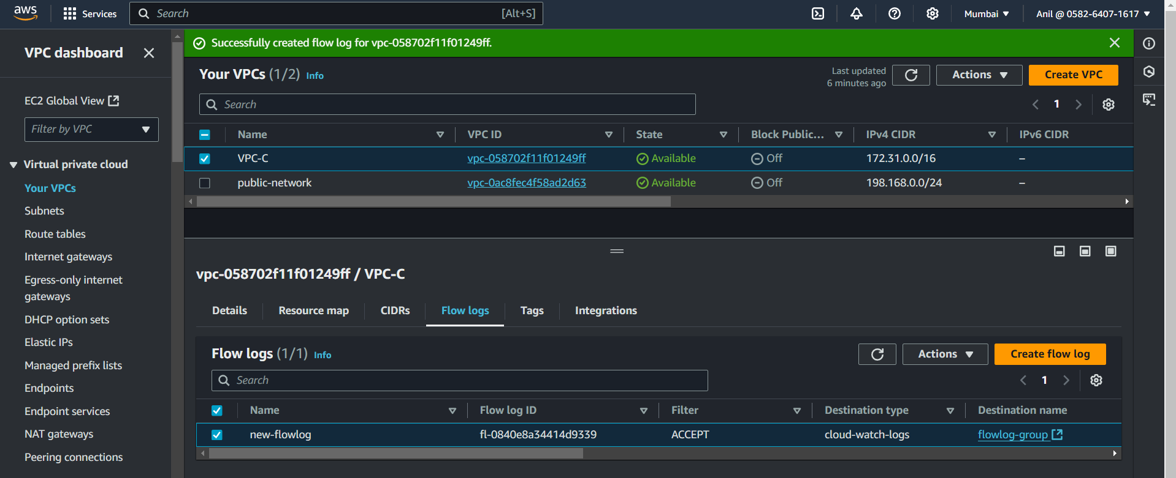

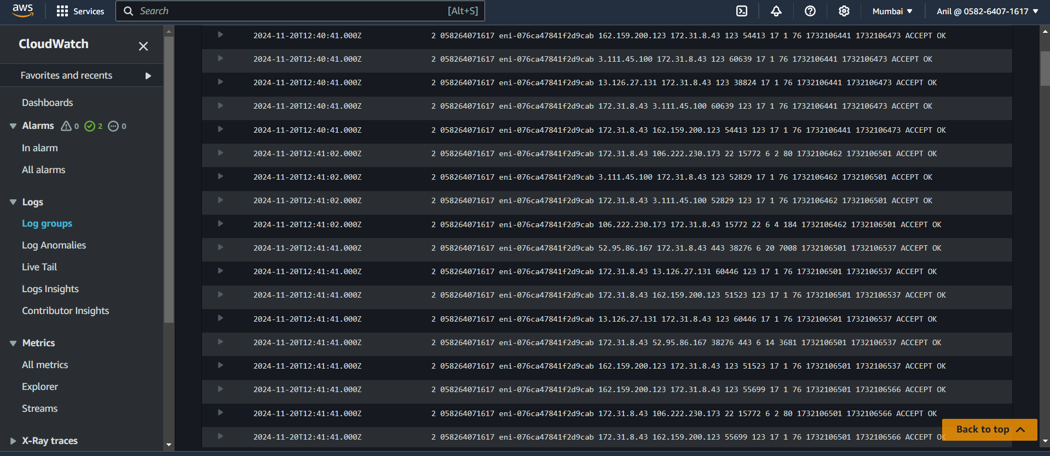

**8) Deploy Apache server on both the ec2 instances with sample index.html file.**

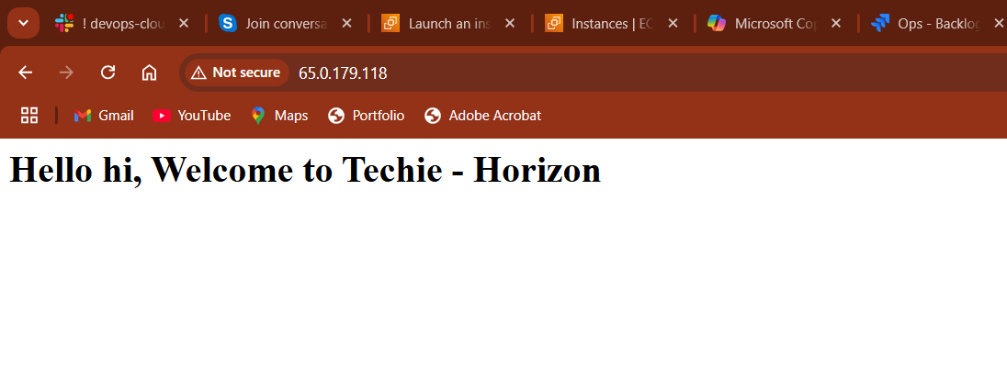

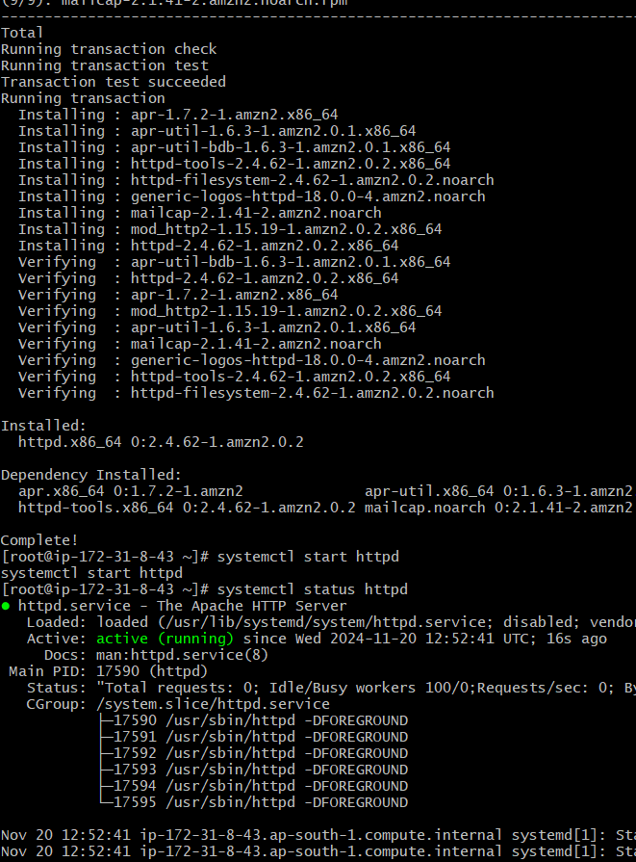

**9) Store Application load balancer logs to s3.**

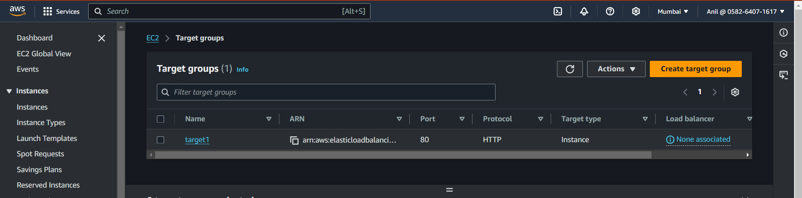

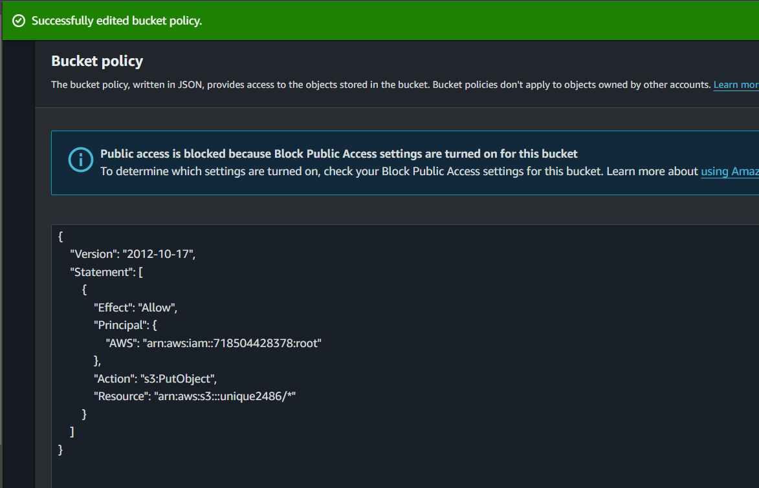

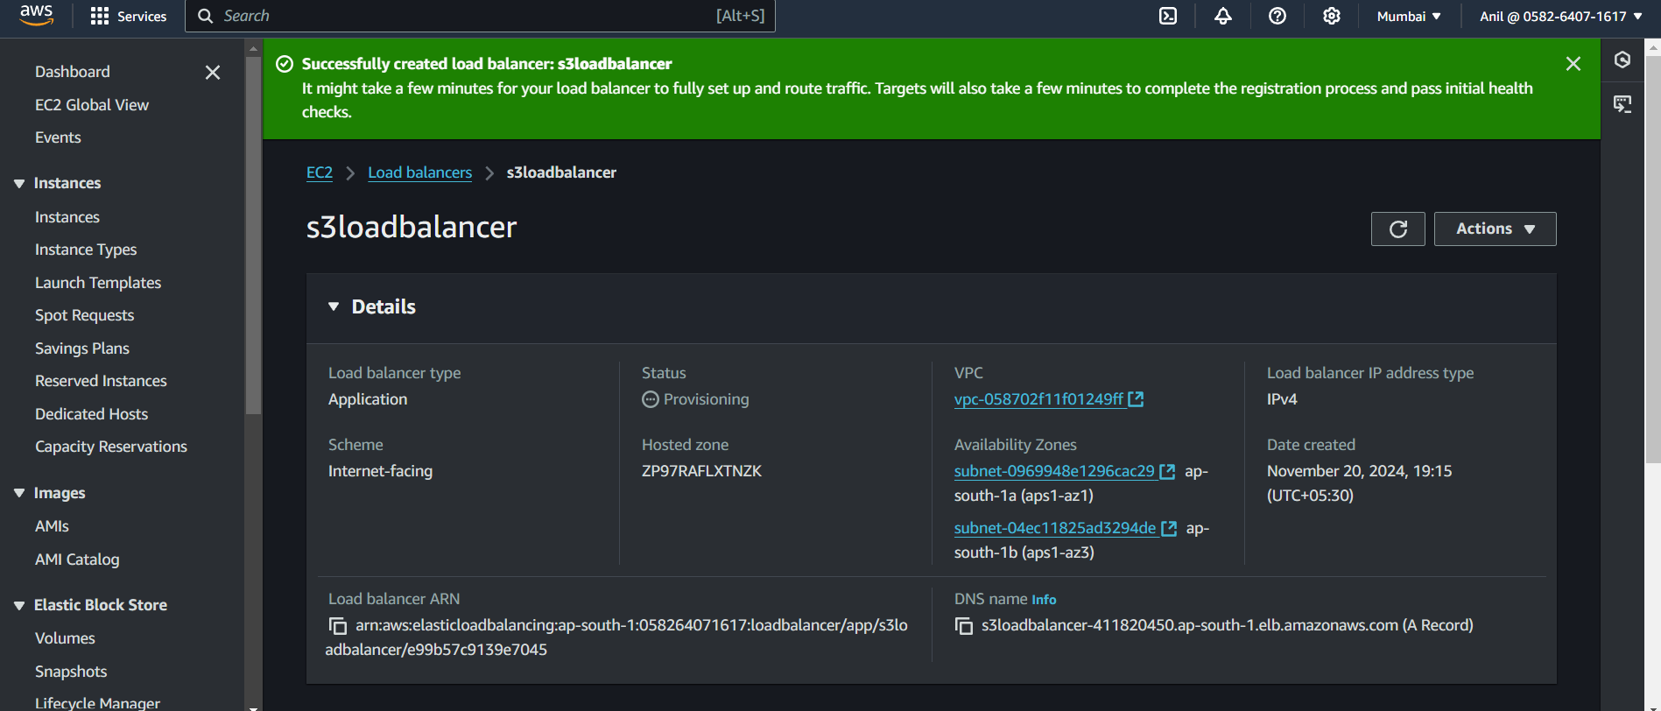

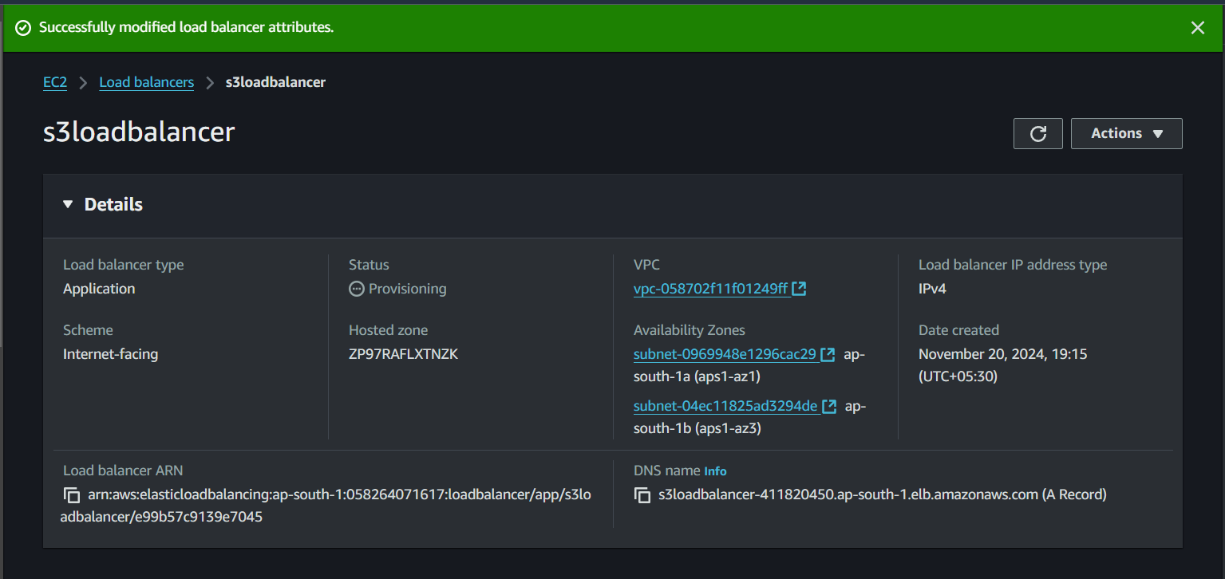

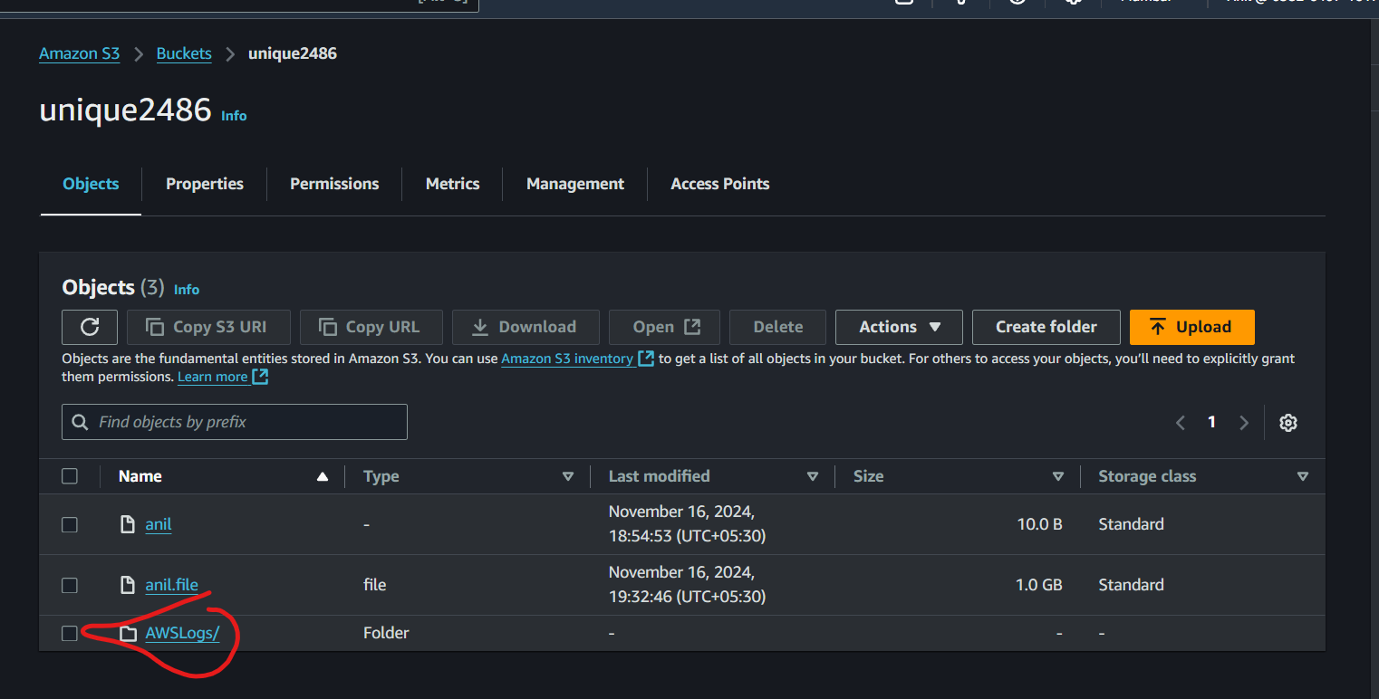

**11) Create Monitoring Dashboards to monitor cpu utilization and to monitor apache service.**

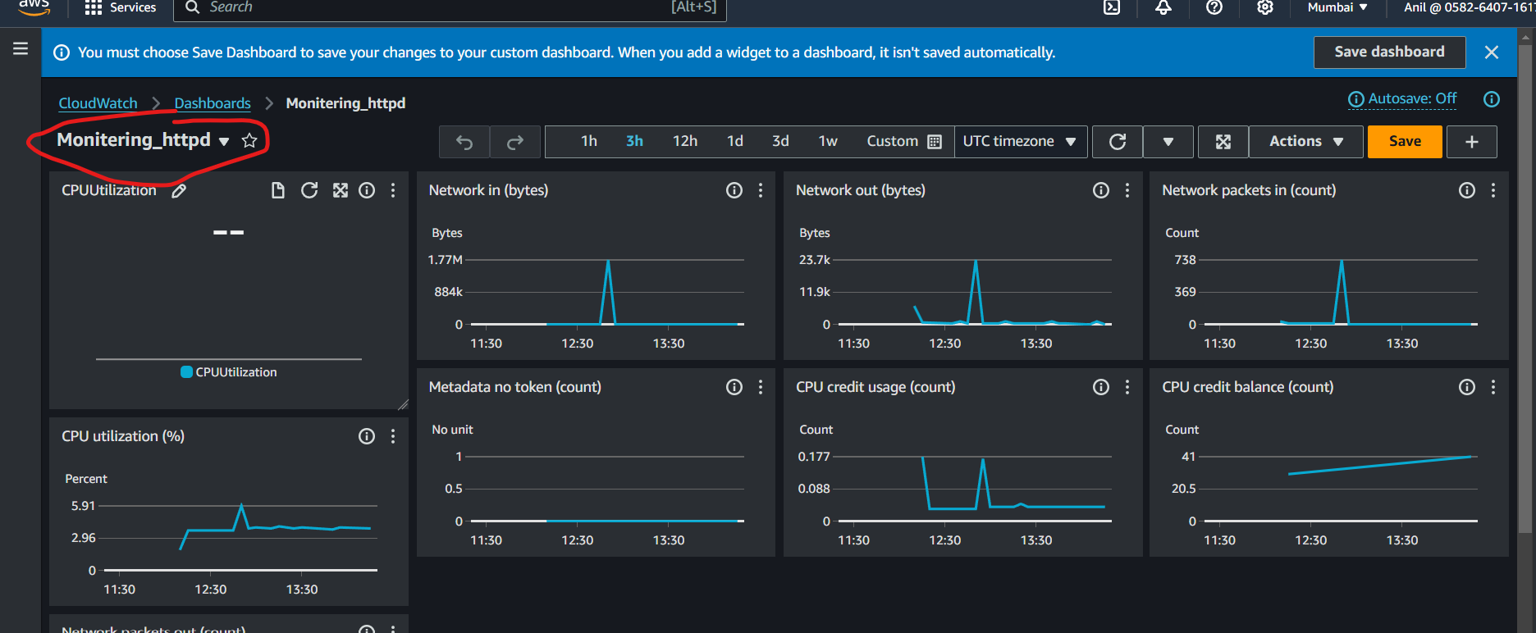

**12) CPU utilizationis more than 70% then it should triggereAutoscaling and launch new instance.**

