**Jenkins-clone sonarqube integration  
==================================**

**1) Create one jenkins job using the below code and create three stages.  
stage1: Git clone to download the source code. stage2: Sonarqube Integration to check the quality of code   
stage3: Slack Integration to send the alerts to slack.**

**URL:** [**https://github.com/betawins/VProfile-1.git**](https://github.com/betawins/VProfile-1.git)

CI/CD Pipeline Stages:-  
----------------------------

Git clone  
sonarqube integration  
post build actions --- > email (or) slack

stage1: Git clone to download the source code.  
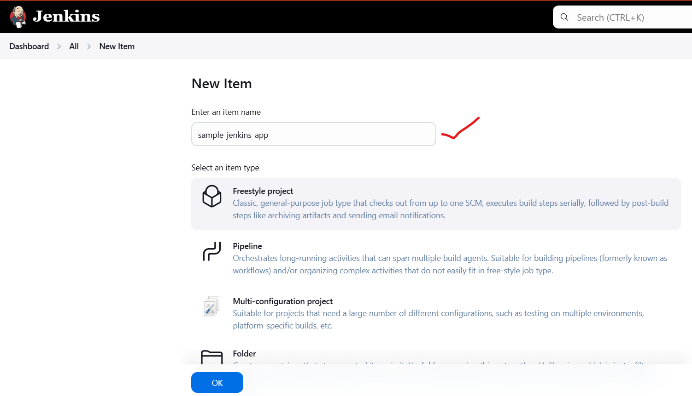

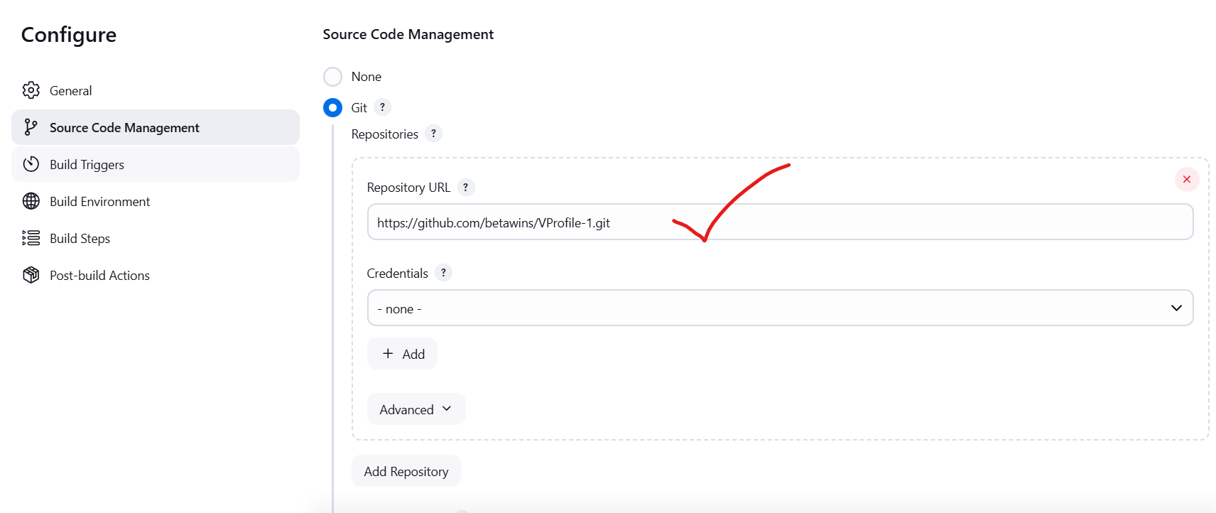

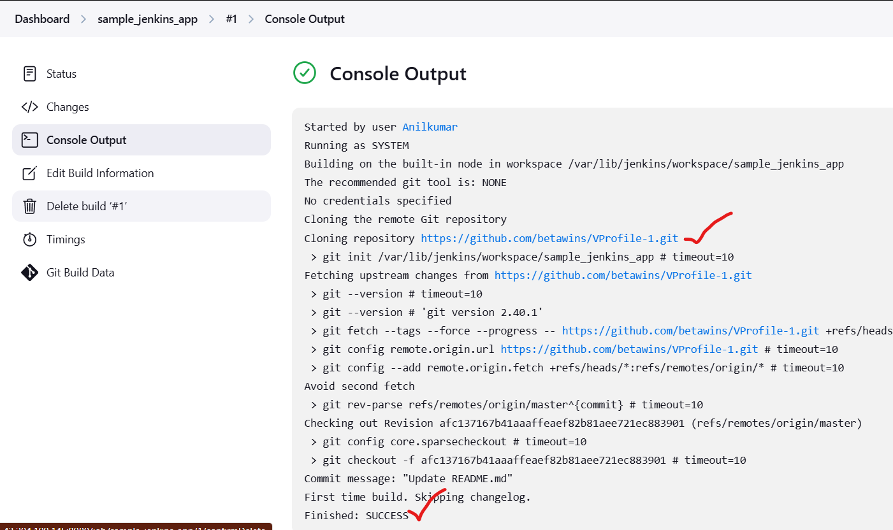

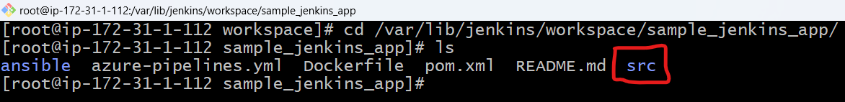

**stage2: Sonarqube Integration**

sonarqubeIntegration: To check for the quality of code  
prerequisites :  
1.Ec2 instance with Java installed  
2.Use t2.large with atleast 20gb memory to run sonarqube  
3.MySQL Datebase Server or MySQL RDS instance

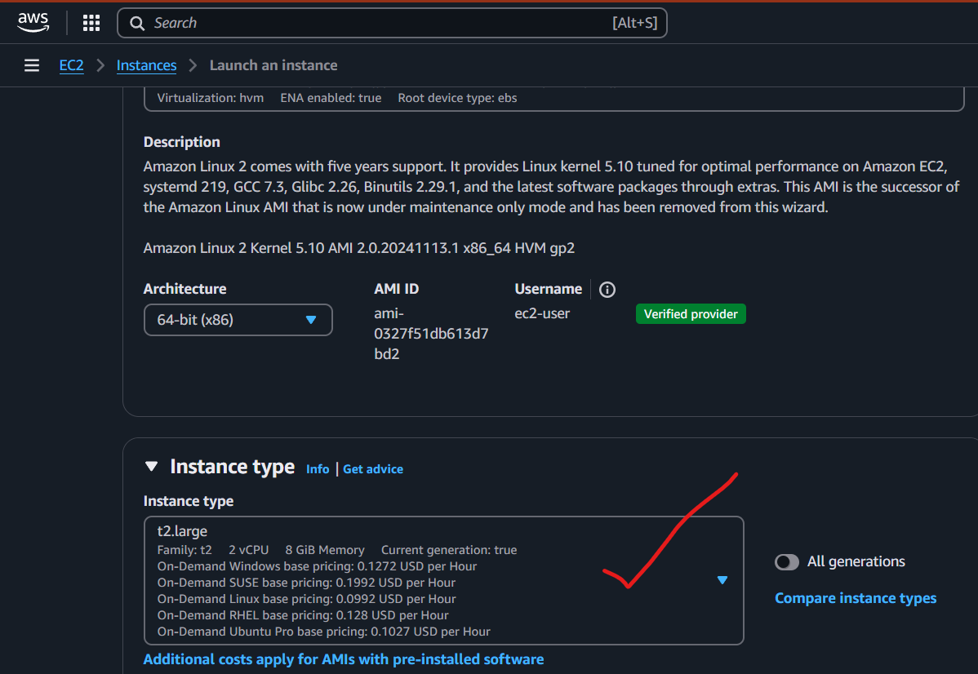  
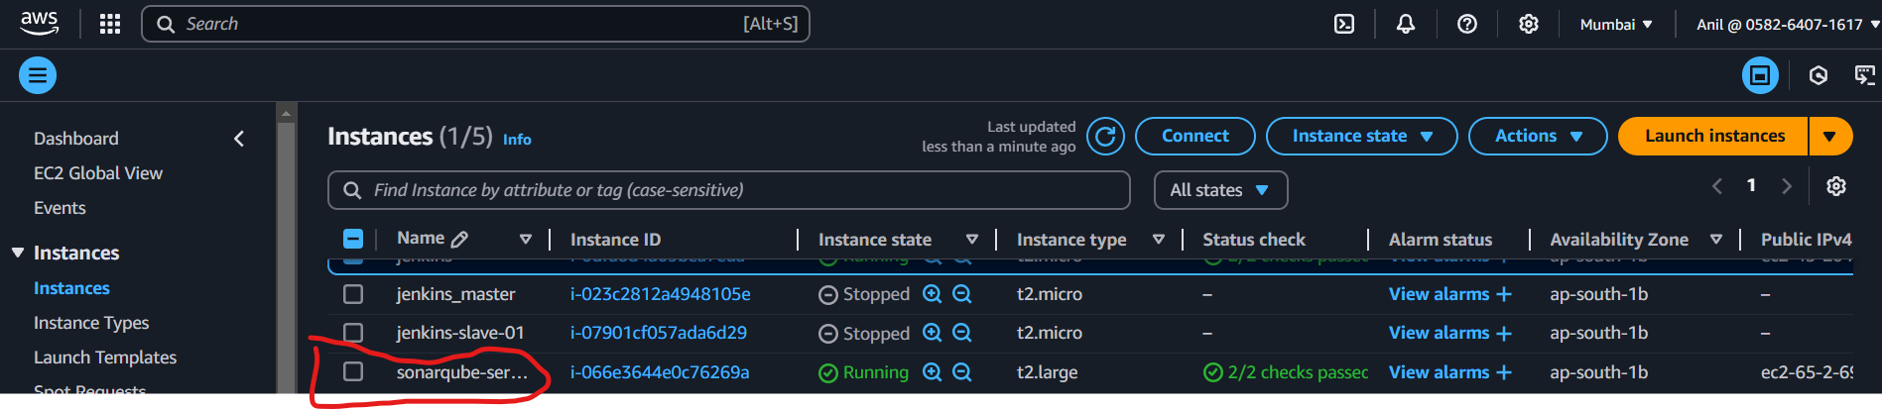

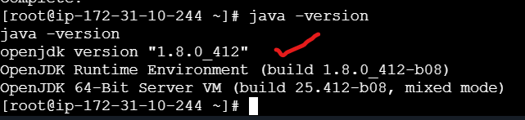

yum update

sudo wget https://dev.mysql.com/get/mysql57-community-release-el7-11.noarch.rpm

sudo yum localinstall mysql57-community-release-el7-11.noarch.rpm

rpm --import https://repo.mysql.com/RPM-GPG-KEY-mysql-2022

sudo yum install mysql-community-server

sudo systemctl start mysqld.service

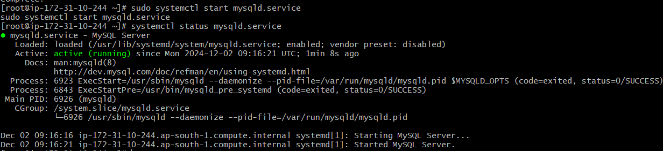

Install sonarqube  
-----------------

# cd /opt

# wget https://binaries.sonarsource.com/Distribution/sonarqube/sonarqube-6.6.zip

# unzip sonarqube-6.6.zip

# mv /opt/sonarqube-6.6 /opt/sonar

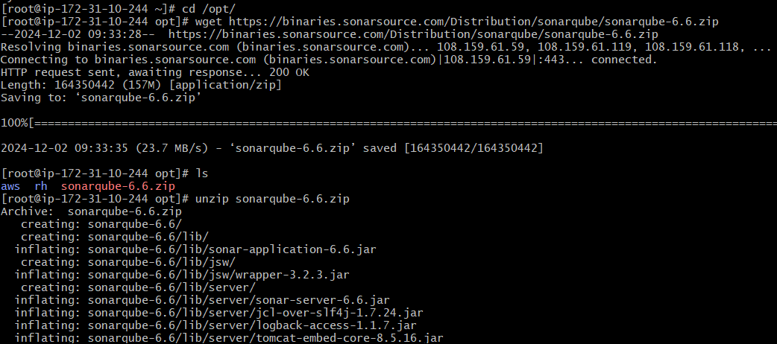



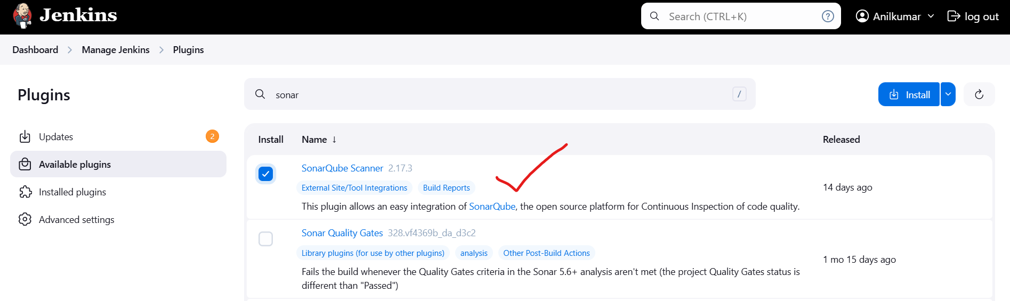

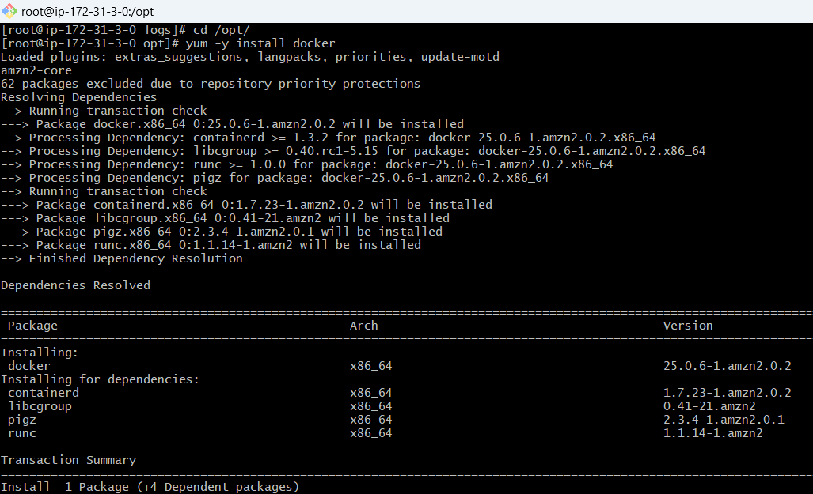

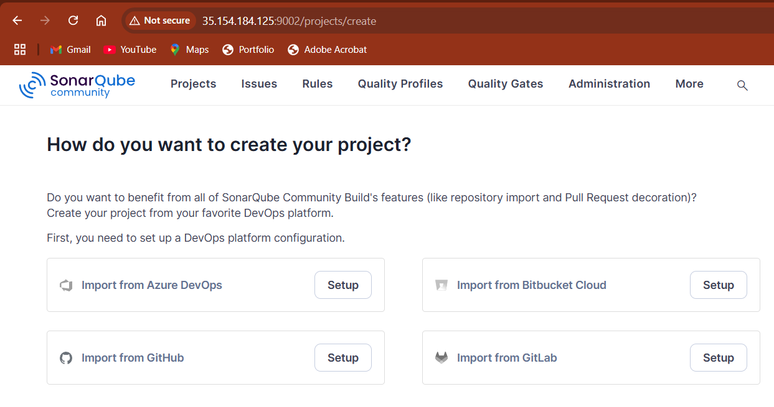

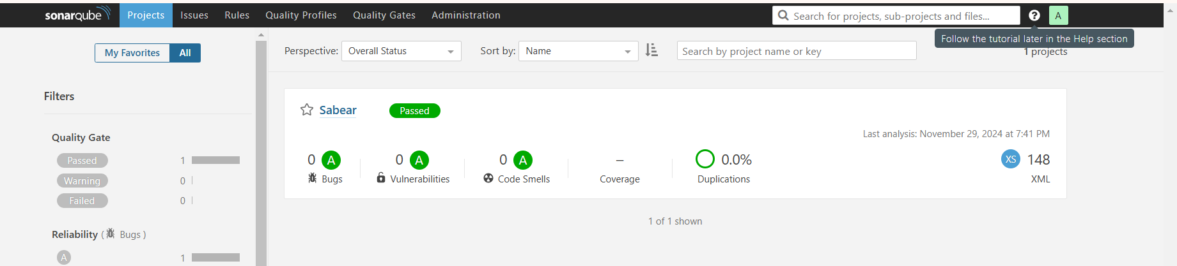

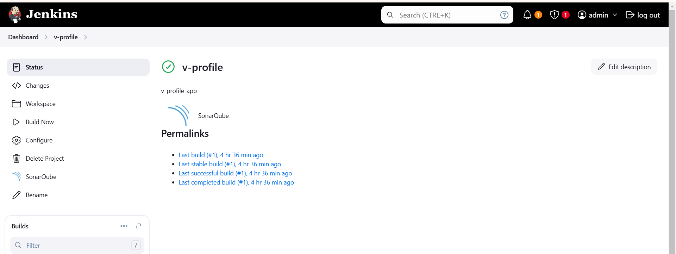



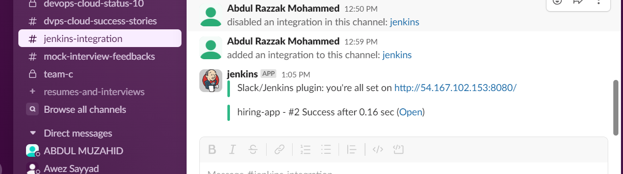

2)Create one jenkins job using the below code and create three stages.   
stage1: Git clone to download the source code. stage2: Sonarqube Integration to check the quality of code  
stage3: Slack Integration to send the alerts to slack.  
URL: <https://github.com/betawins/hiring-app.git>

