**1) Configure Classic Load balancer.**

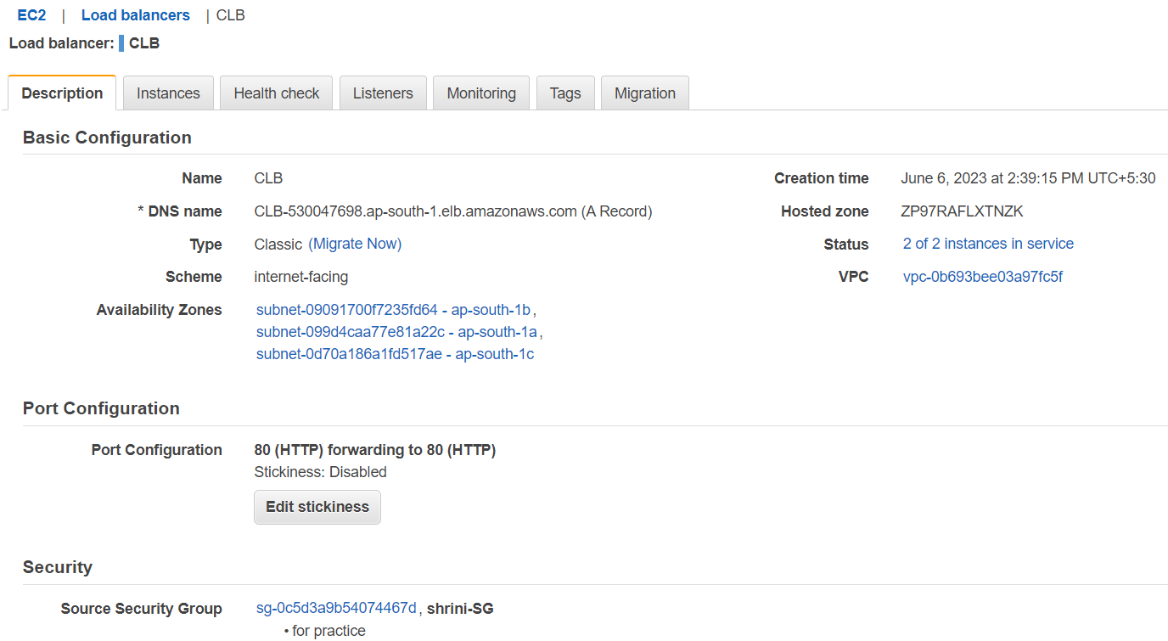

**\*\*if any one server having issue then CLB gives 300 seconds to hold on it**

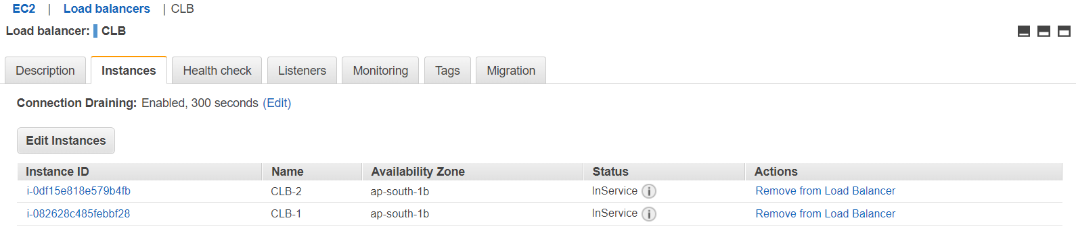

**\*\*With the help of CLB-DNS we can see the check it is controlling the traffic:  
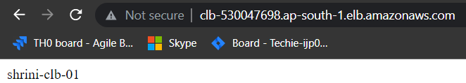**

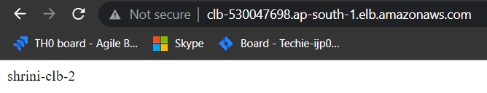

**2) Configure Application Load balancer**

* **We have to use prefix for verifying the ALB**
* **We have to create TARGET GROUP with proper configuration and also we can increase the health check status time by “200-499”**
* **After creating TG we have to connect the TG with the ALB**
* **In the listeners we are adding the port and rules to perform the ALB**

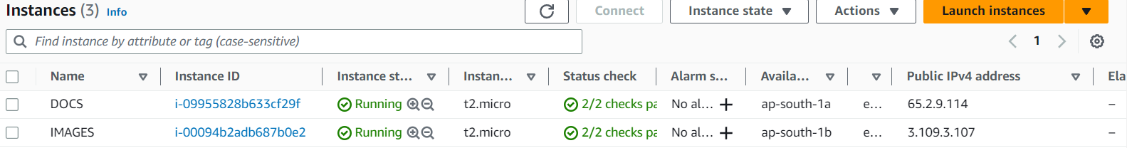

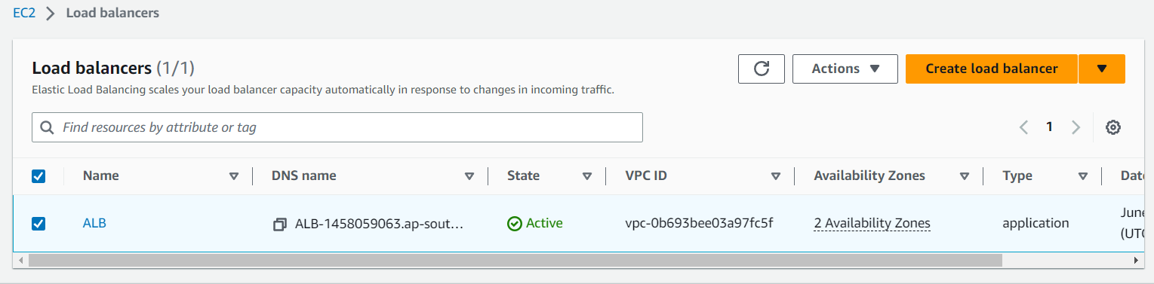

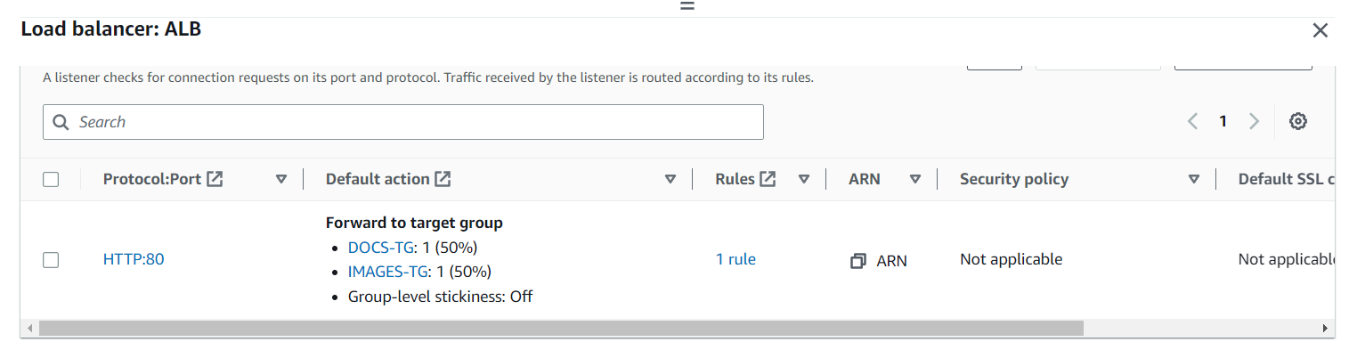

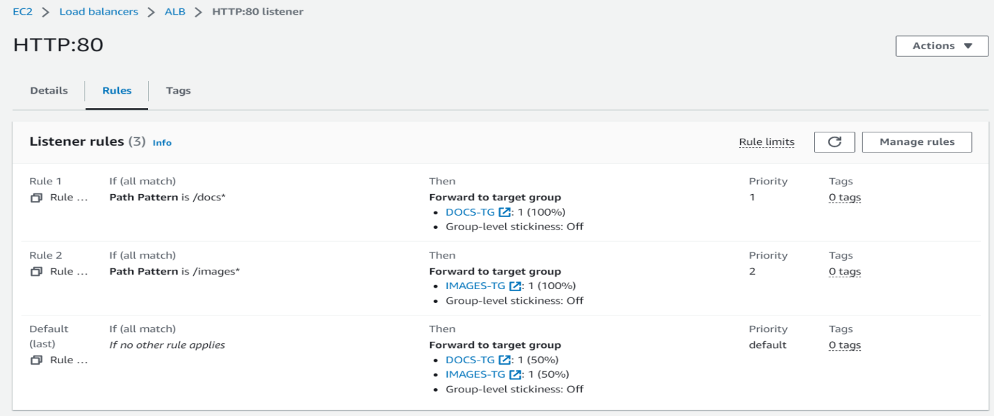

**TARGET GROUP**

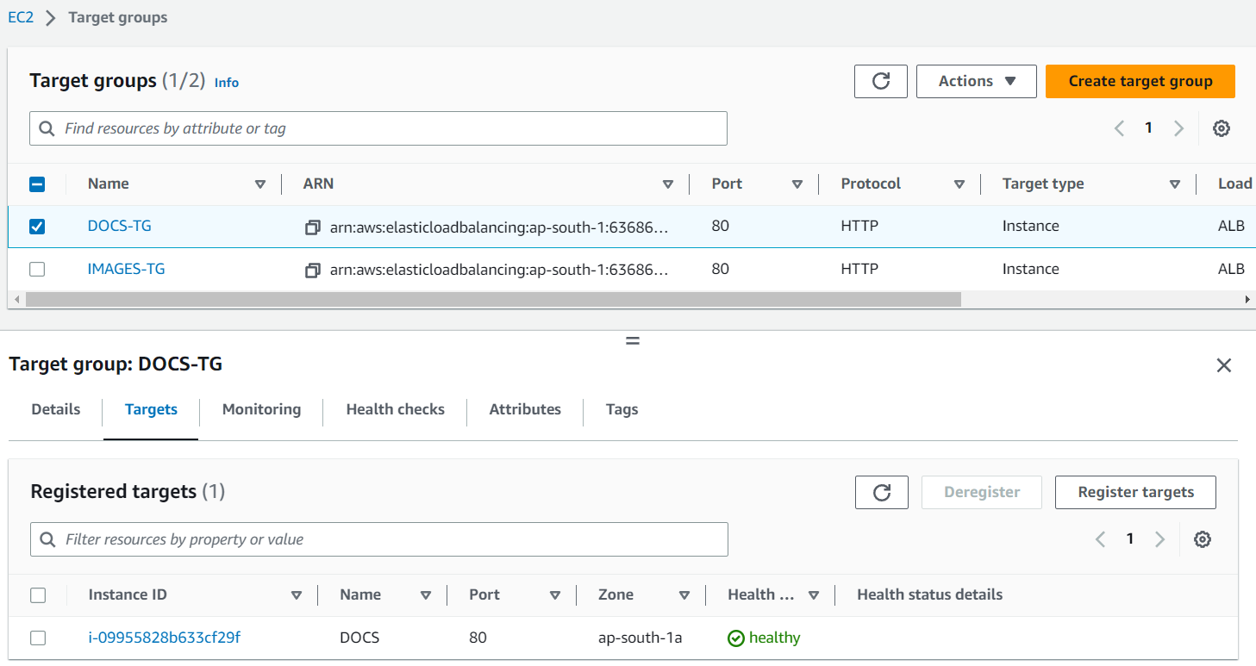

**3) Configure NETWORK Load balancer**

* **It only works on TCP and UDP(53) NETWORK PROTOCOL**
* **So we have to change the port of instances/Target Group with TCP and UDP**

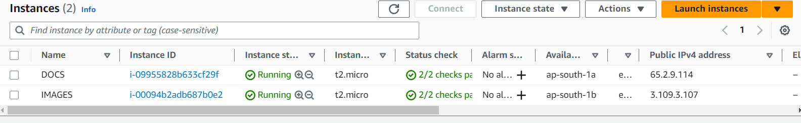

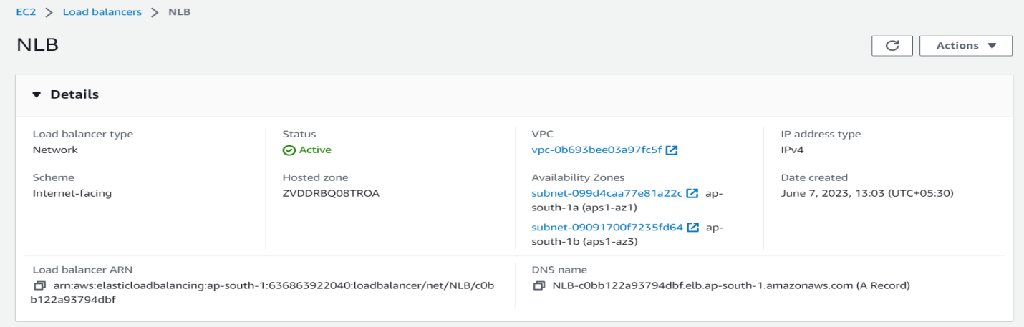

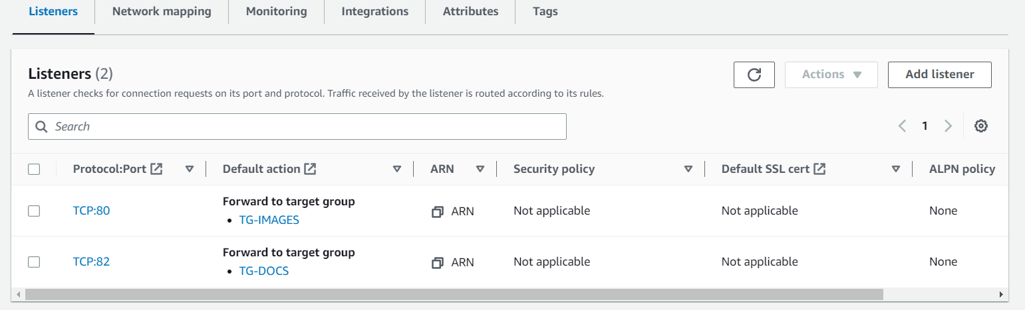

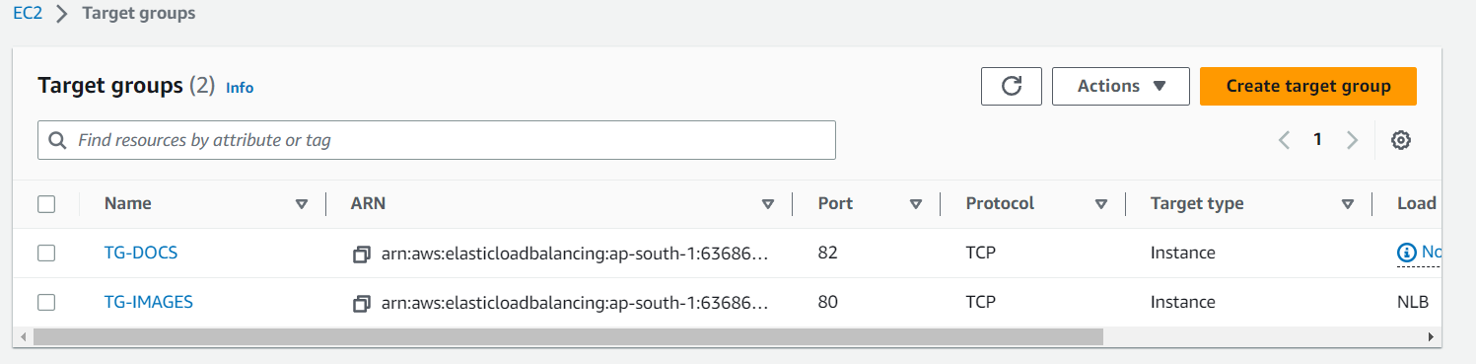

**4) Map any one Load balancer with R53 and also attach ssl certificate to Load balancer.**

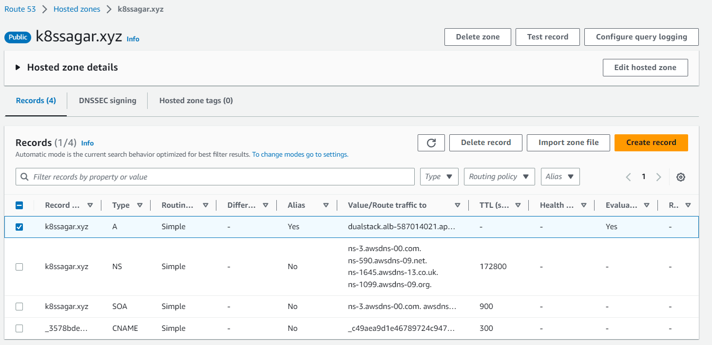

**DOMAIN NAME : k8ssagar.xyz /we have to add the HTTPS listeners to ALB   
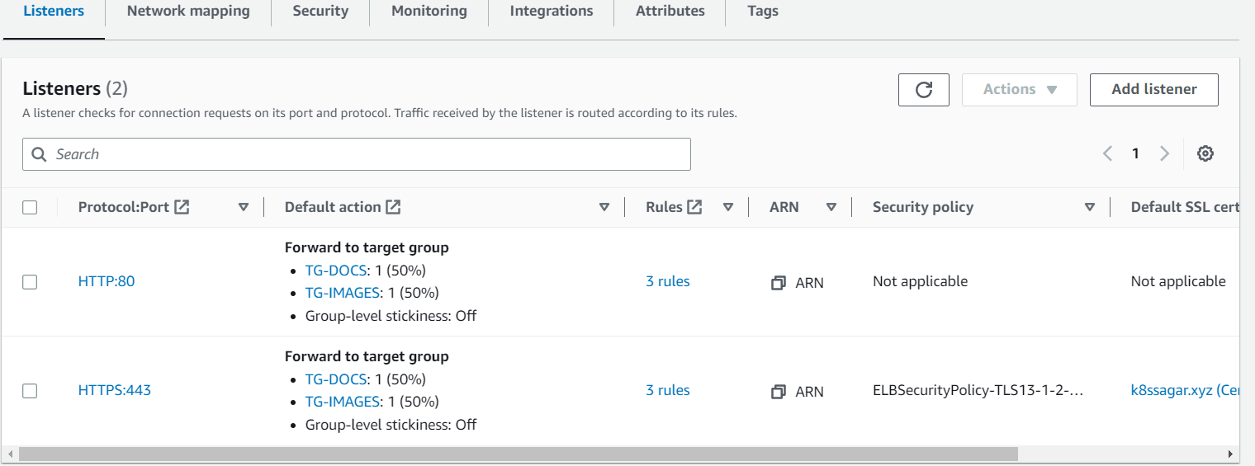**

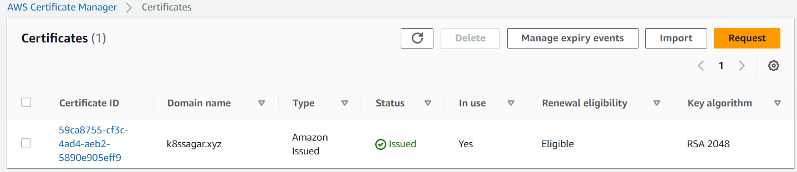

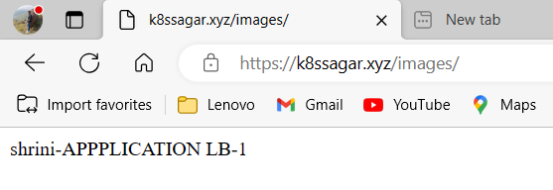

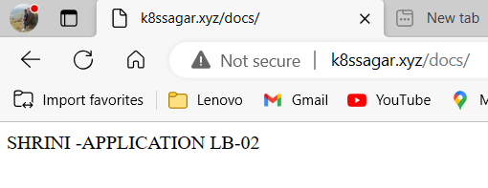

**5) Push application load balancer logs to s3 bucket.**

**FIRST GIVE A POLICY TO THE BUCKET AS GIVEN BELOW:-**

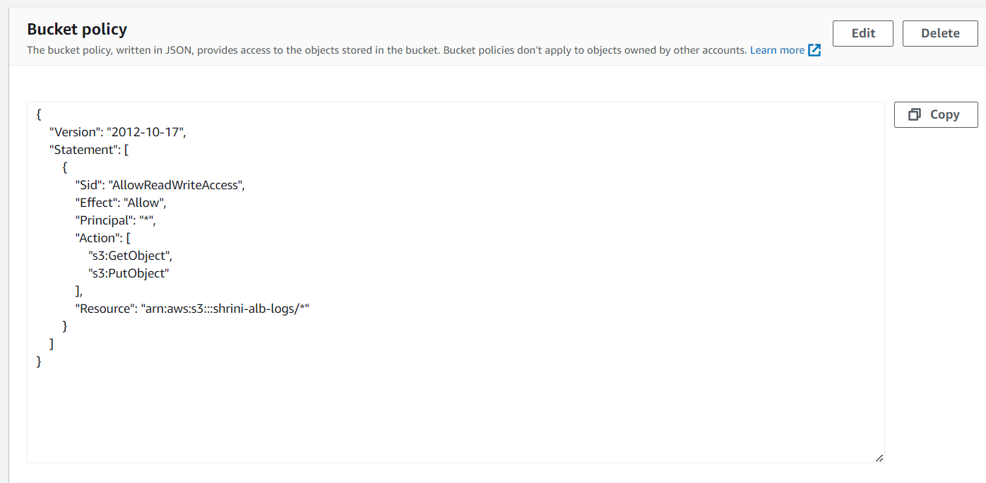

**THEN ON THE ATTRIBUTES OF YOUR “LB” JUST GIVE THE PERMISSION OF MONITORING ACESS LOG WITH THE GIVEN BUCKET URI  
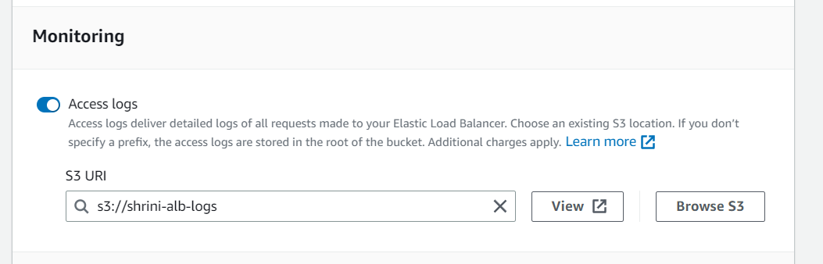**

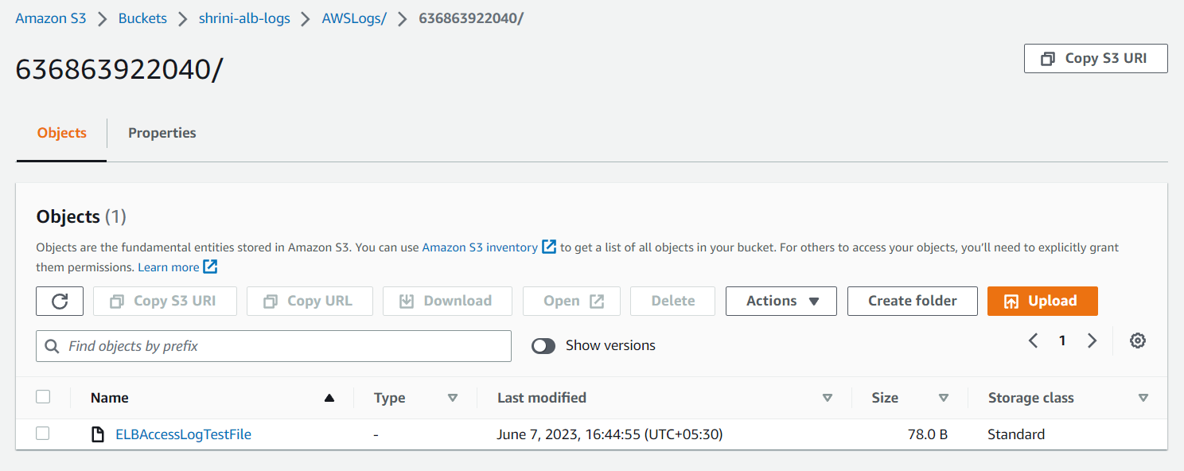

**6) Push the application load balancer logs to s3**

