1) Launch one linux instance in aws

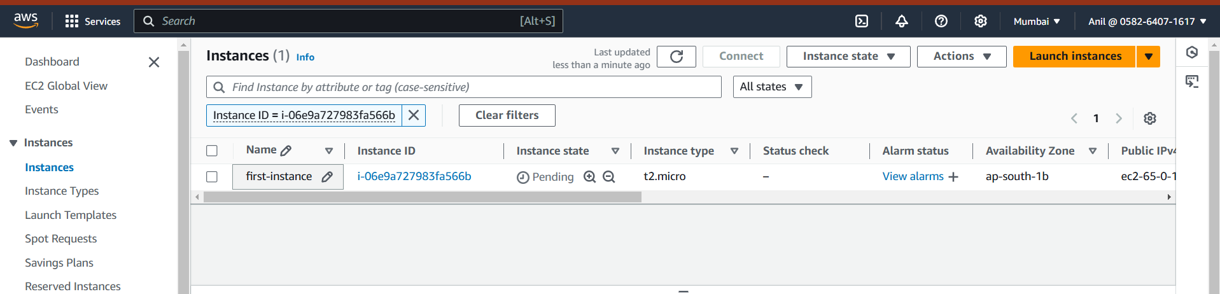

2) create on file with name techie

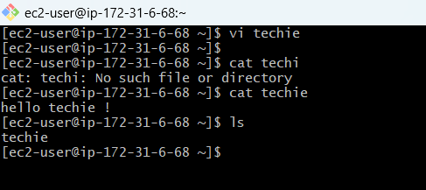

3) Install Jenkins the server created in step1

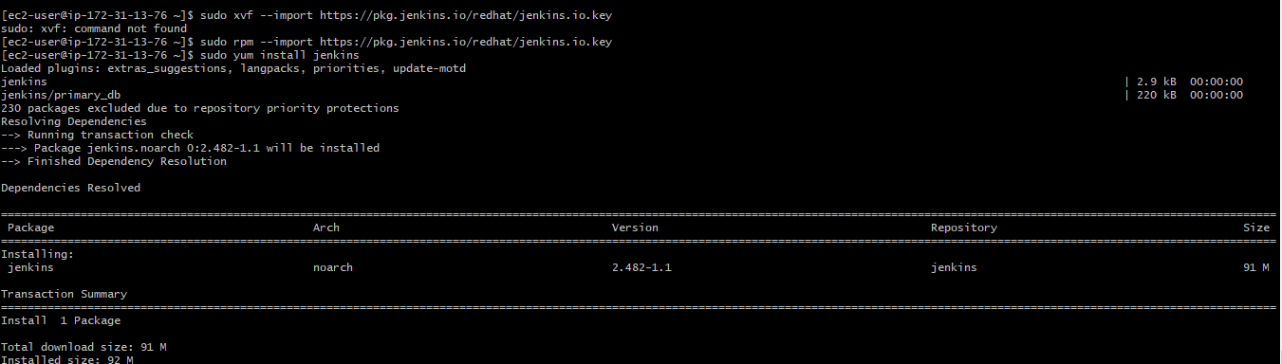

5)Install httpd,nginx,Apache Tomcat.

Nginx  
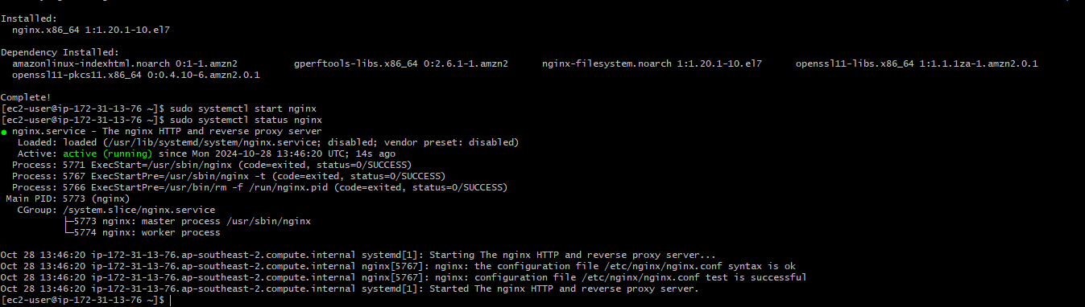

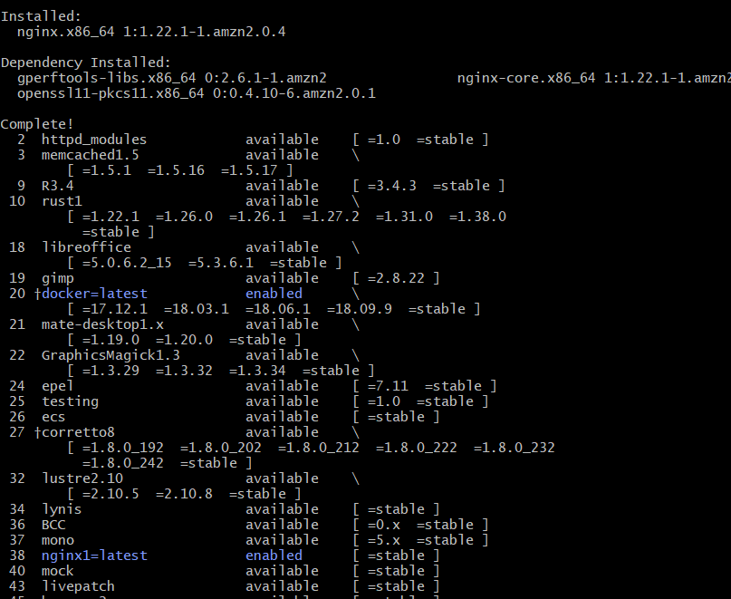

Httpd  
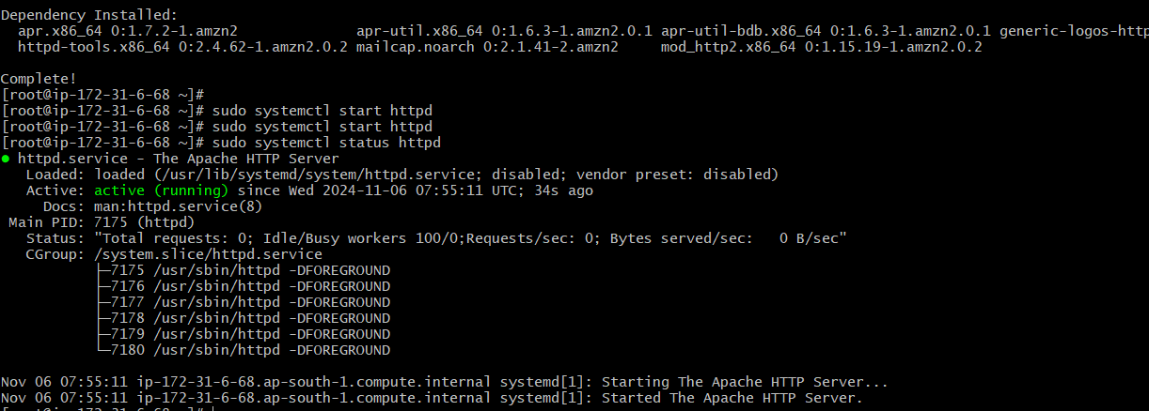

Apache tomcat

