1. Install nginx and run nginx on port number 81.

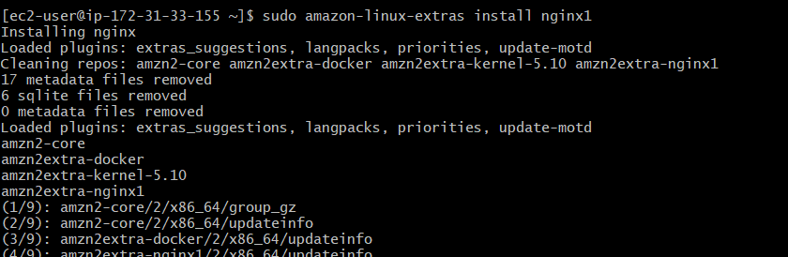

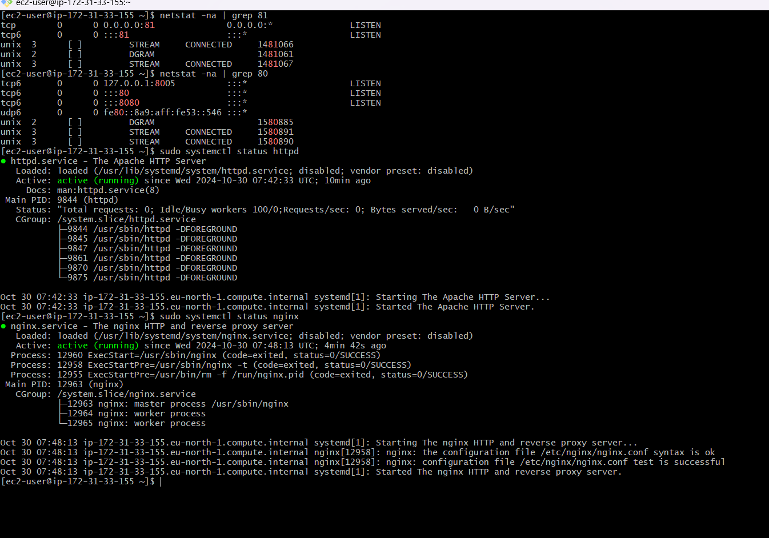

1. Deploy a sample index.html file on nginx.

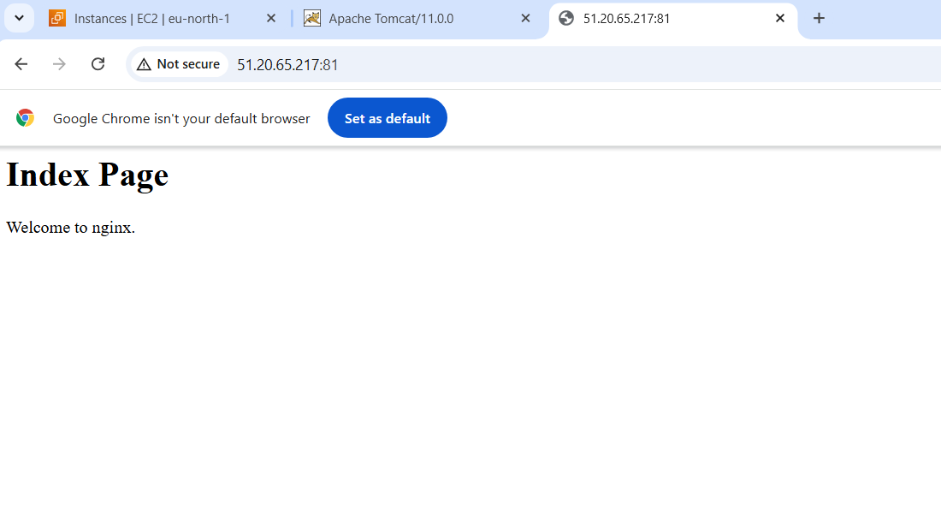

1. Install Apache and run Apache on port number 82

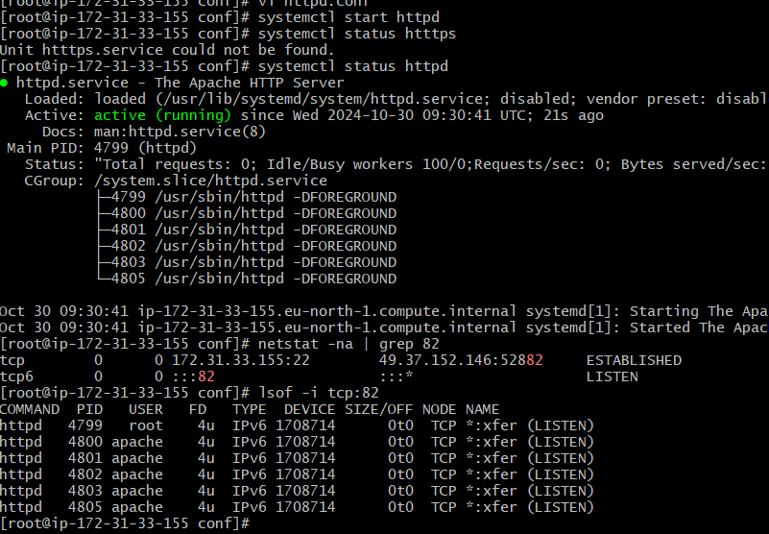

1. Deploy a sample index.html file on Apache.

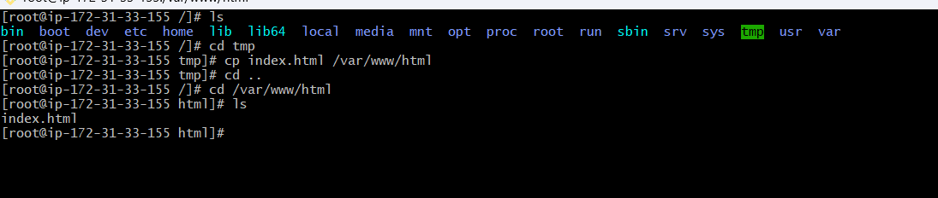

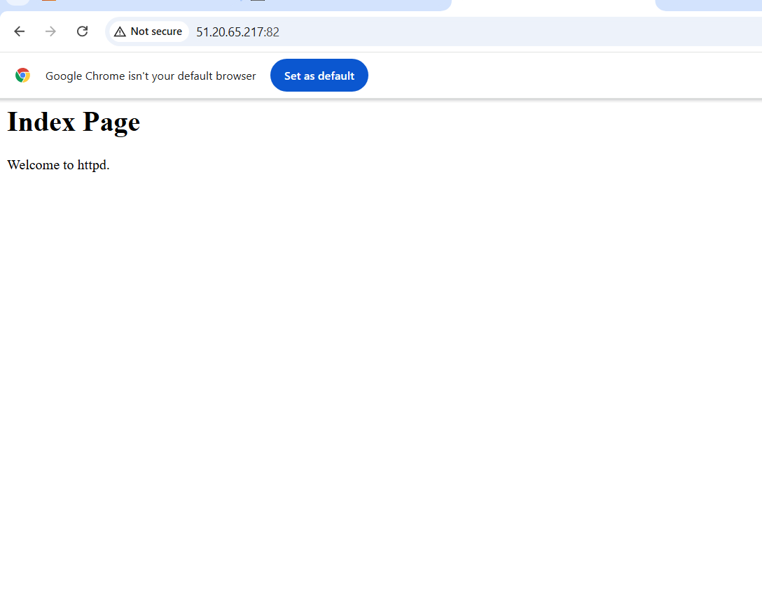

1. Install Apache tomcat on port number 8082

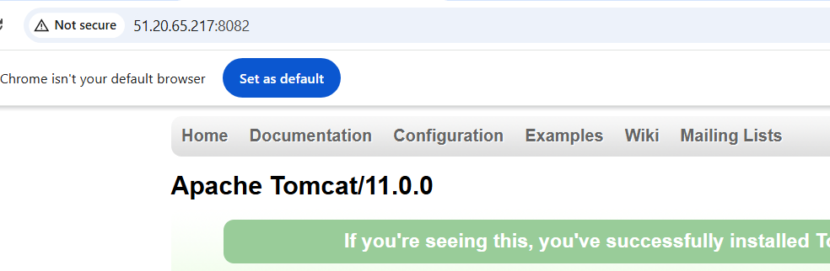

1. Deploy a sample app on webapps

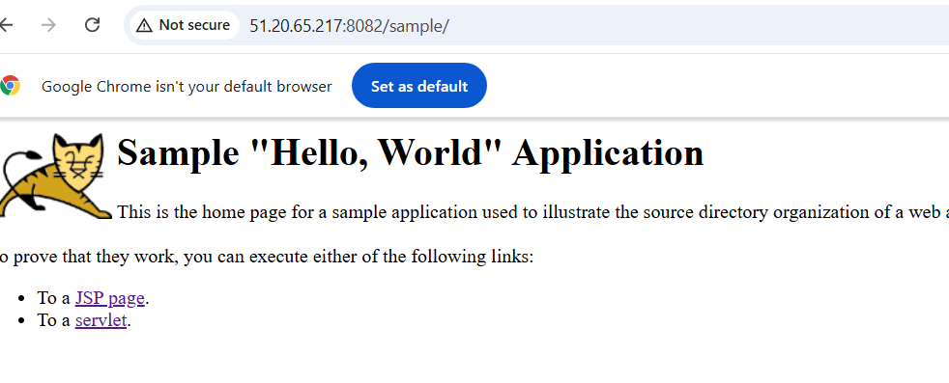

1. Create a tomcat.service file for tomcat.
2. Configure HA Proxy server