**1) Create mariadb db on ec2.**

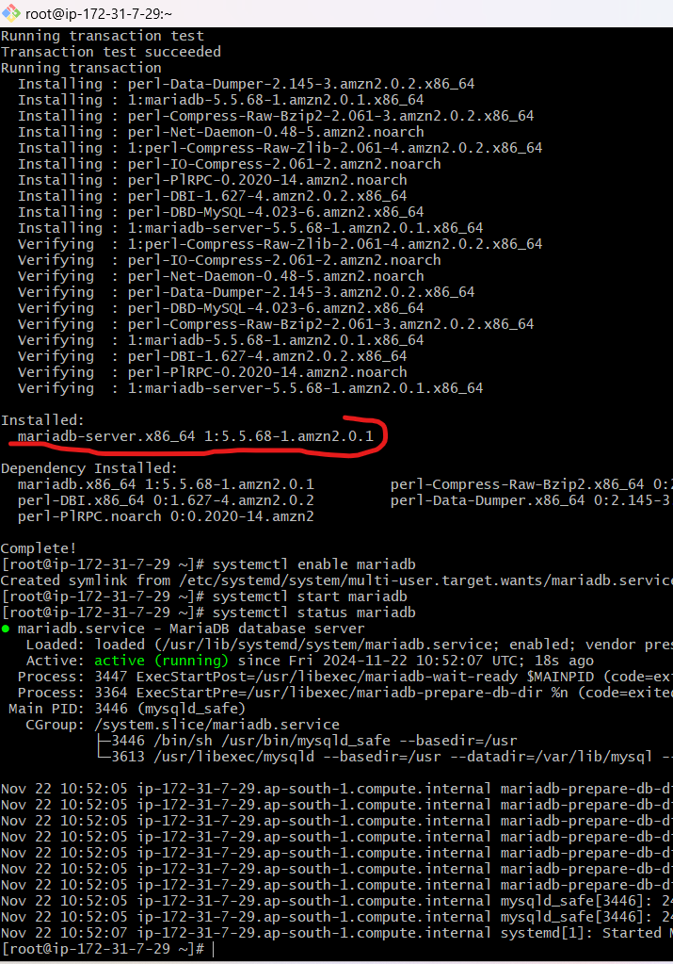

**SQL run on “3306” port only;**

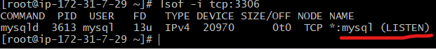

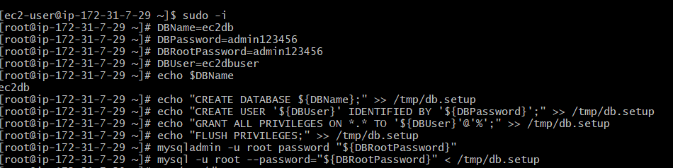

**Databases:**

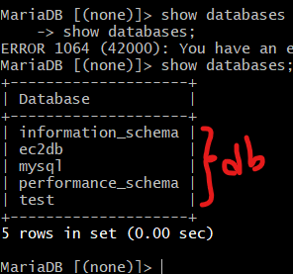

**2) Insert some dummy data**

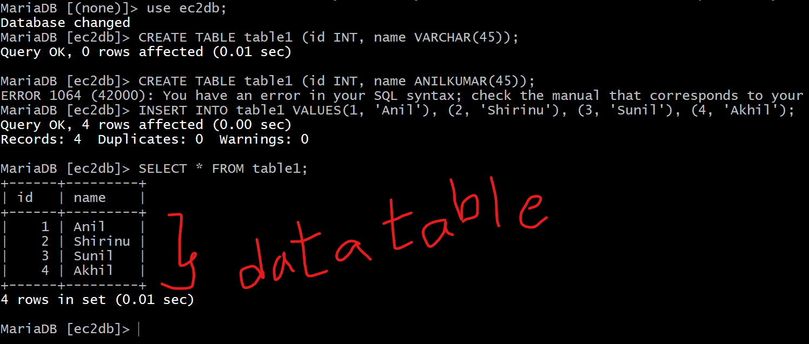

**3) launch Mariadb RDS instance.** 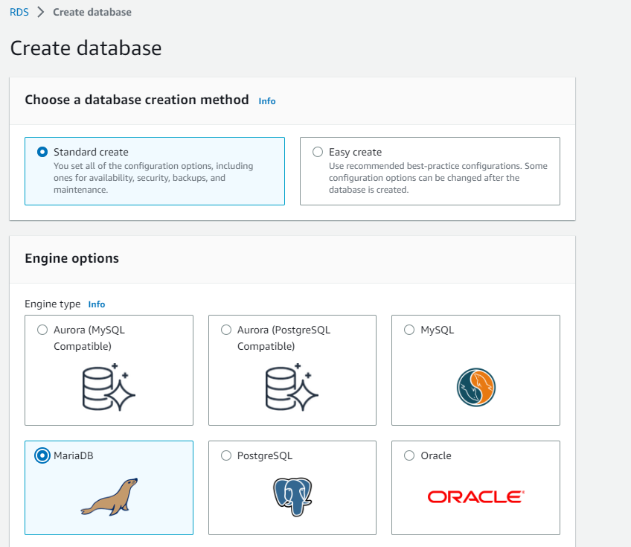

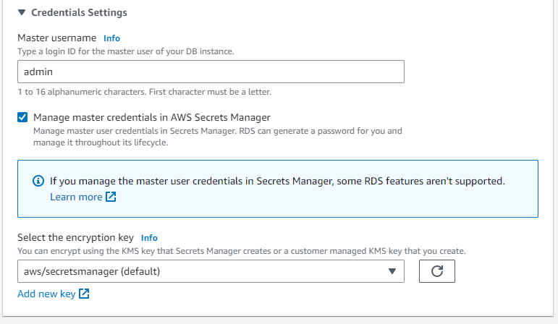

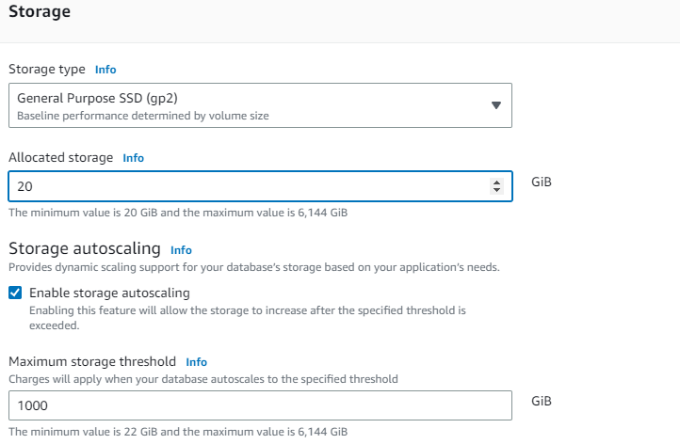

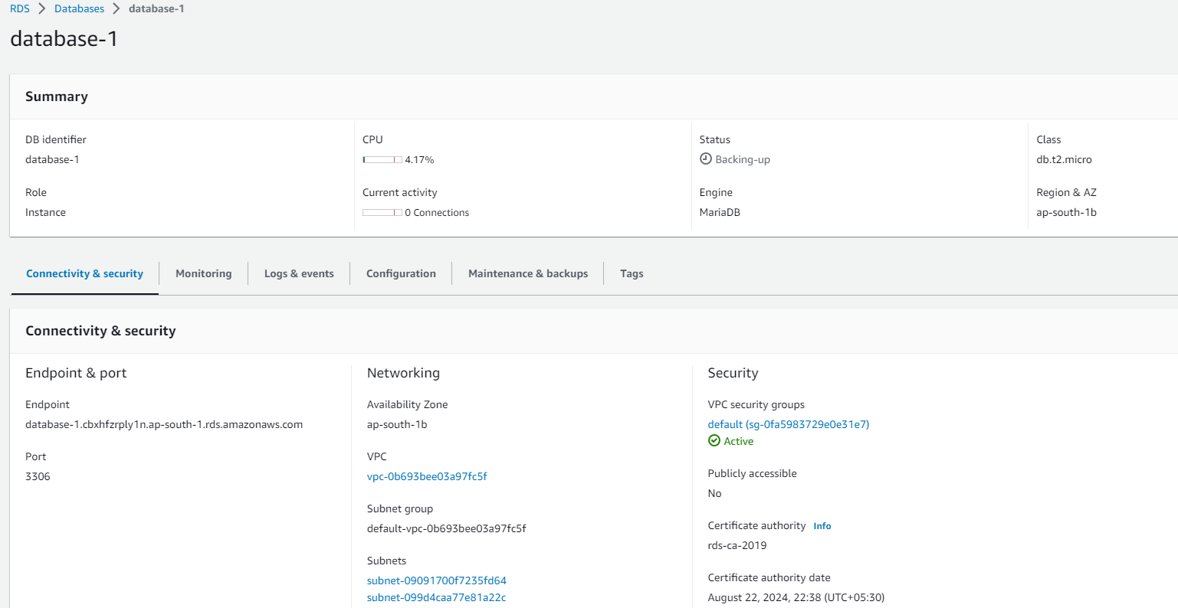

**4) launch Mariadb RDS instance.**

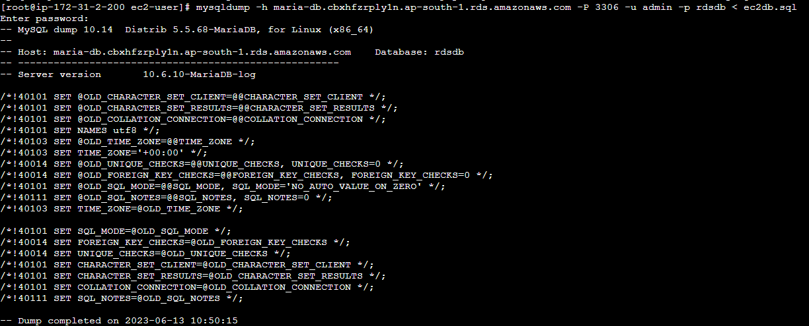

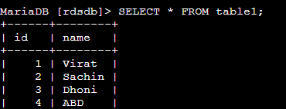

**5) Installing MYSQL db on ec2;**

**Follow the doc for installing mysql in aws ec-2;**[**https://tecadmin.net/how-to-install-mysql-8-on-amazon-linux-2/**](https://tecadmin.net/how-to-install-mysql-8-on-amazon-linux-2/)

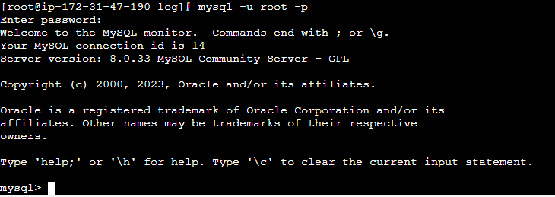

**Inserted some dummy data in mysql ec2/ and taking backup;**

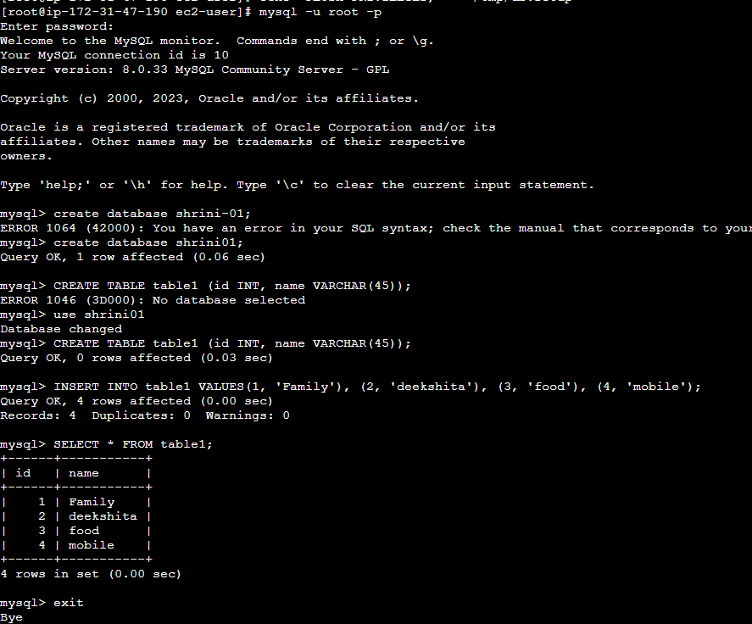

**Now taking backup of above ec-2 db named “shrini01” with SQL file;**

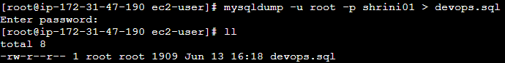

**Password will be given on MYSQL installation will be used here**

**Now, we moved the backup file of ec2-db named “devops.sql” but we have to create a DB inside the RDS-DB named “shrini”;**

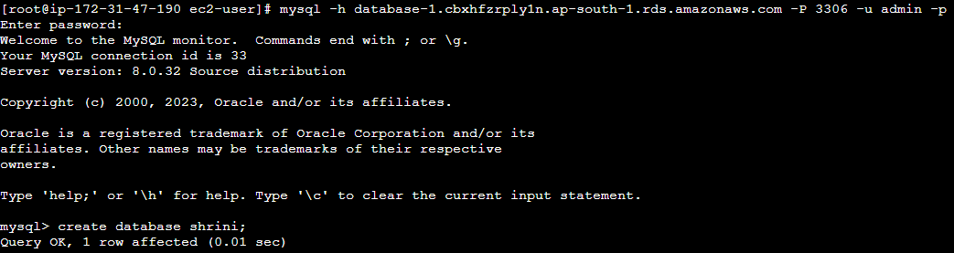

**So DB is created and we have to backup the ec2-DB(Anil01) to RDS-DB(Anil)**

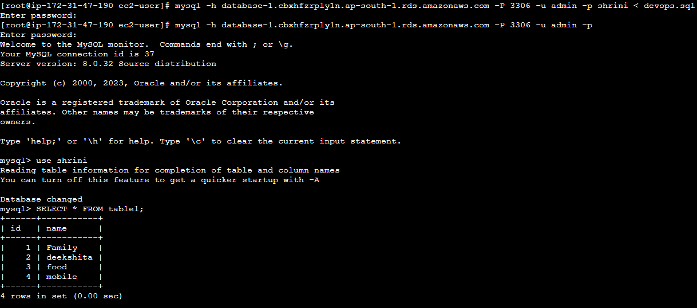

**“Above pic we can see our ec2-db content has been backup in RDS-DB”**

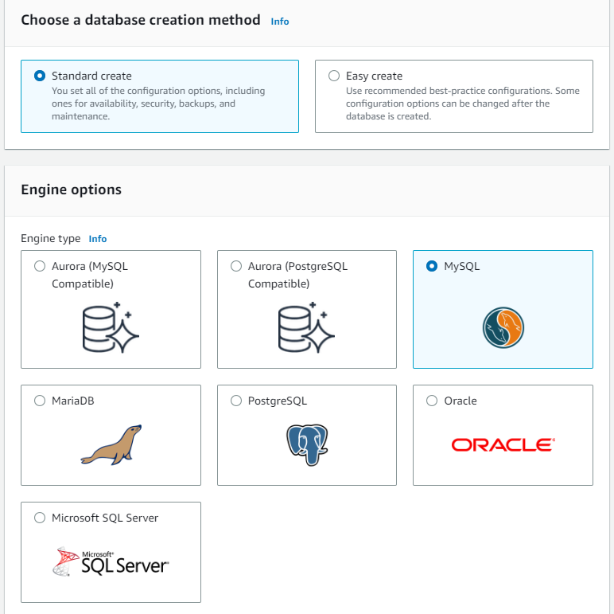

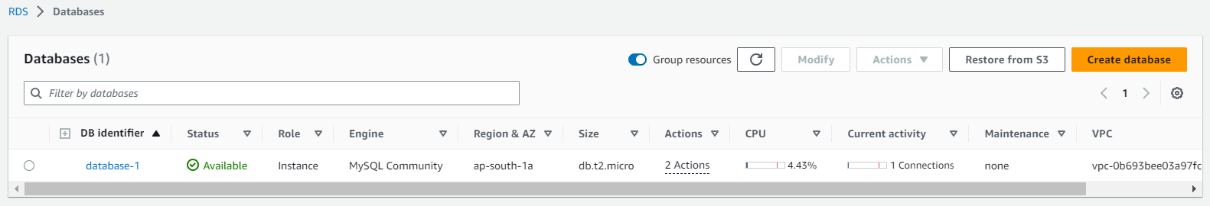

**6) COnfigure multi AZ**

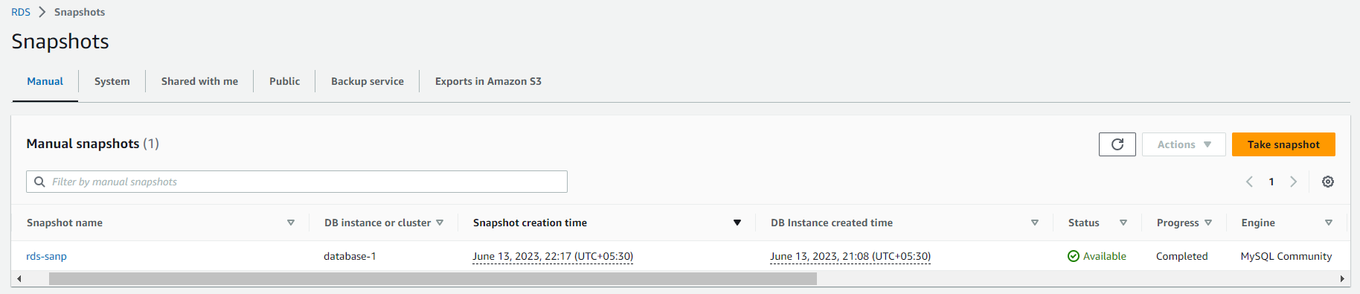

**And Now, we will restore the db after deleting the RDS-DB;**

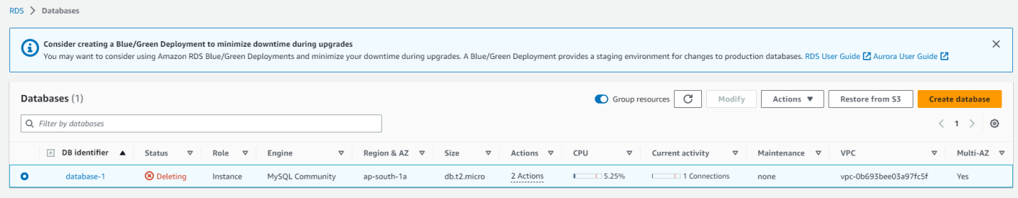



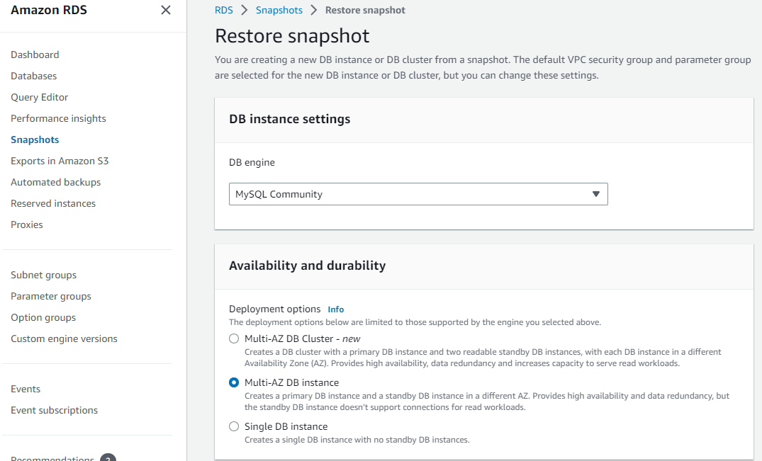

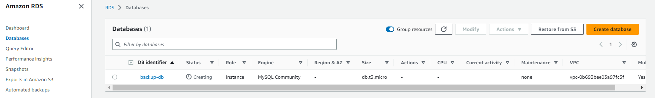

**Now, we have to take our new endpoint and try to connect with ec2;**

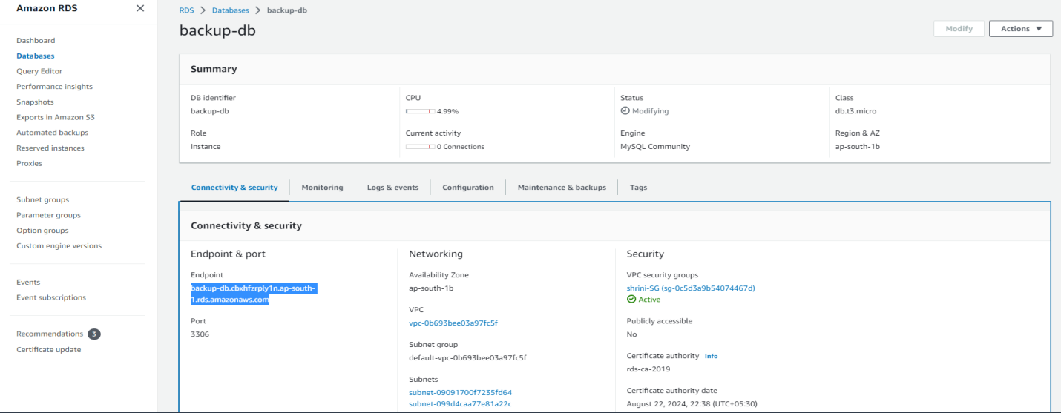

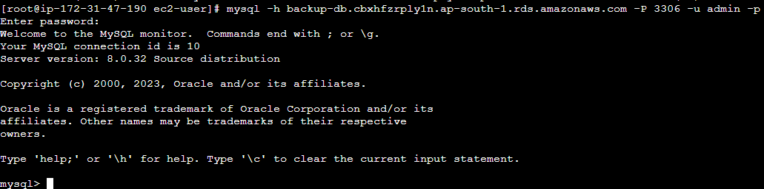

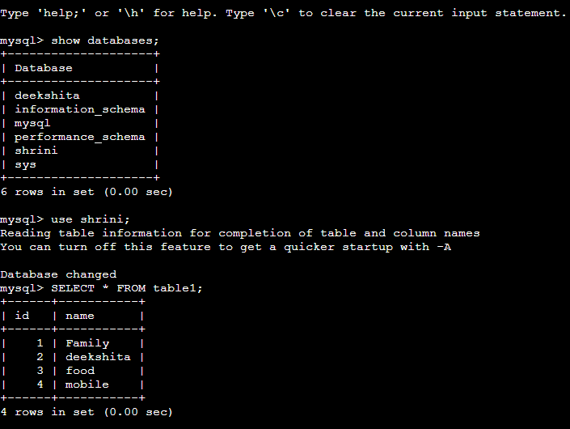

**“By restoring the db we are getting our databases with the help of snapshot”**

**7)** **Create ReadReplca**

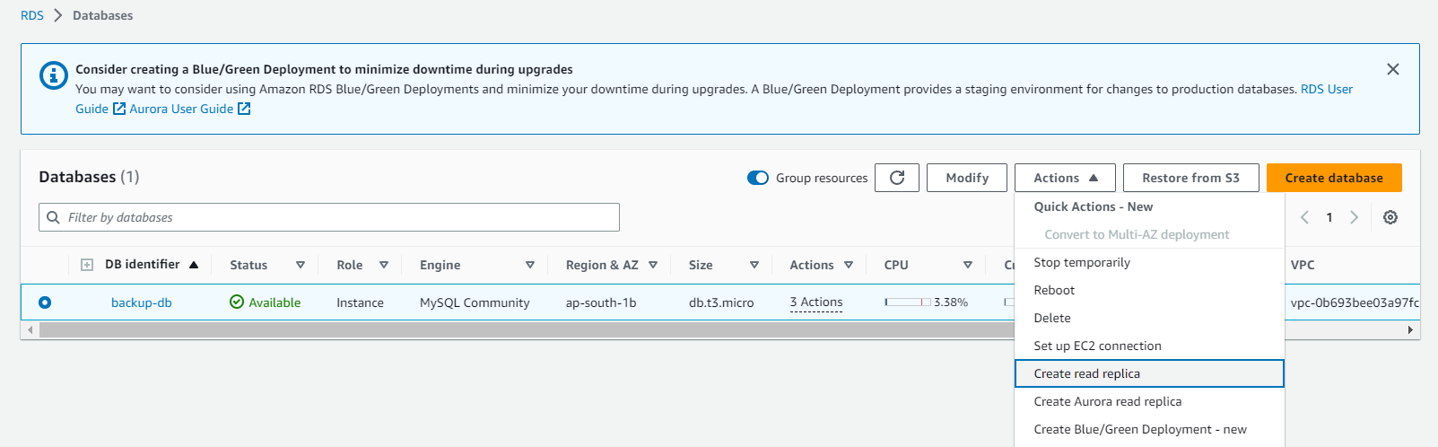

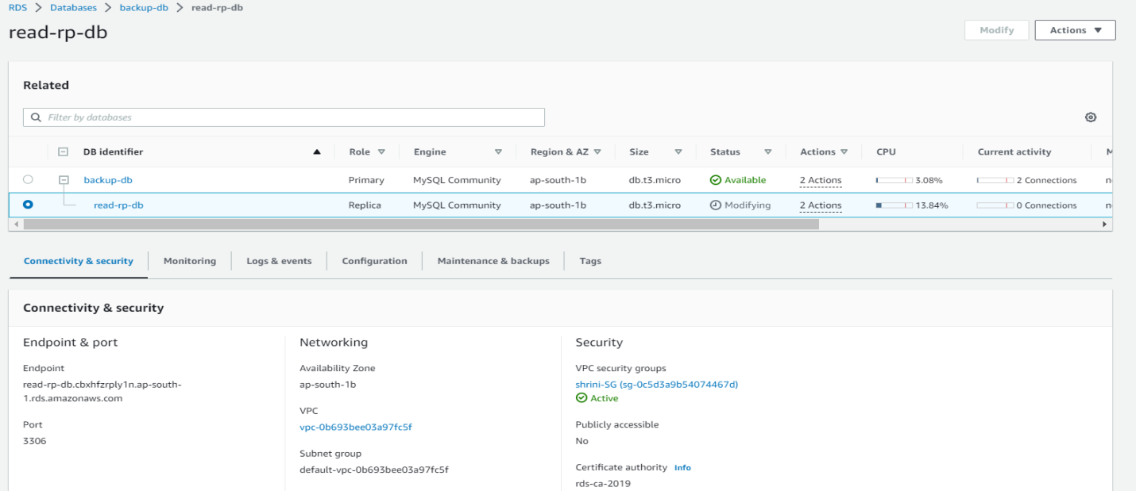

**\*\*If we want to use the read replica-db we have to take endpoint of replica   
“You can find the below error we can’t able to write ant thing on db”**

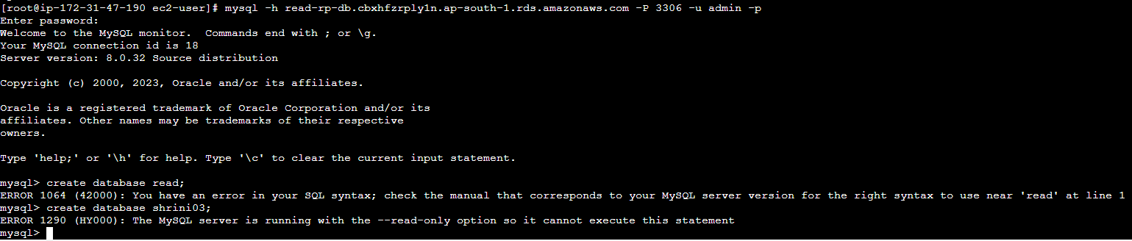

**8) Migrate database from ec2 to RDS.**

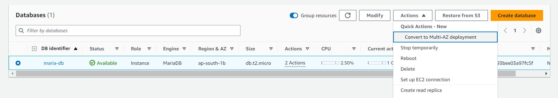

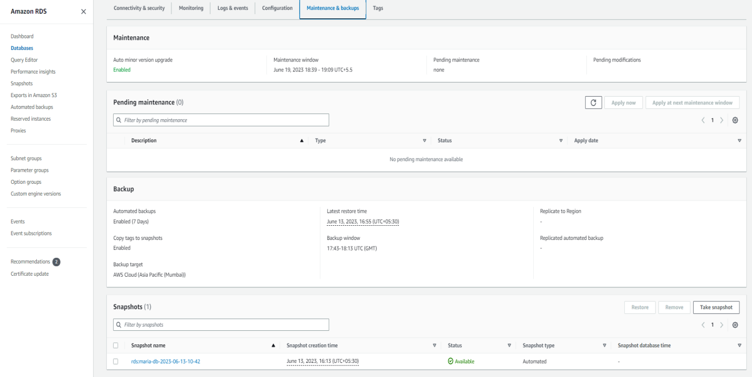

**9) Migrate database from ec2 to RDS.**

