Terraform task- 1&2  
===================

1) Install Terraform on your PC

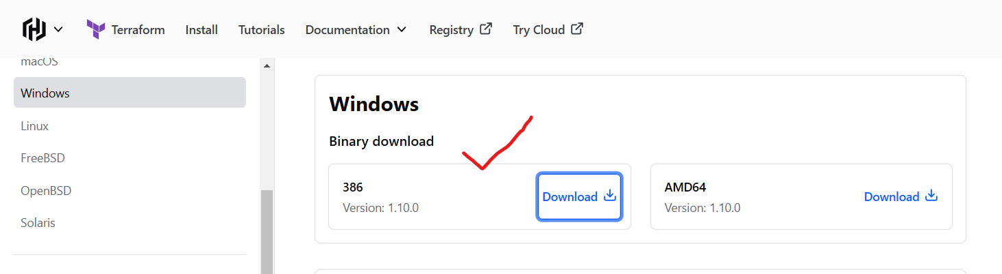

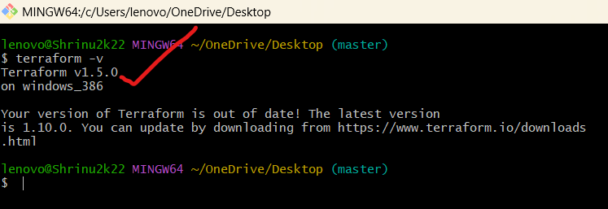

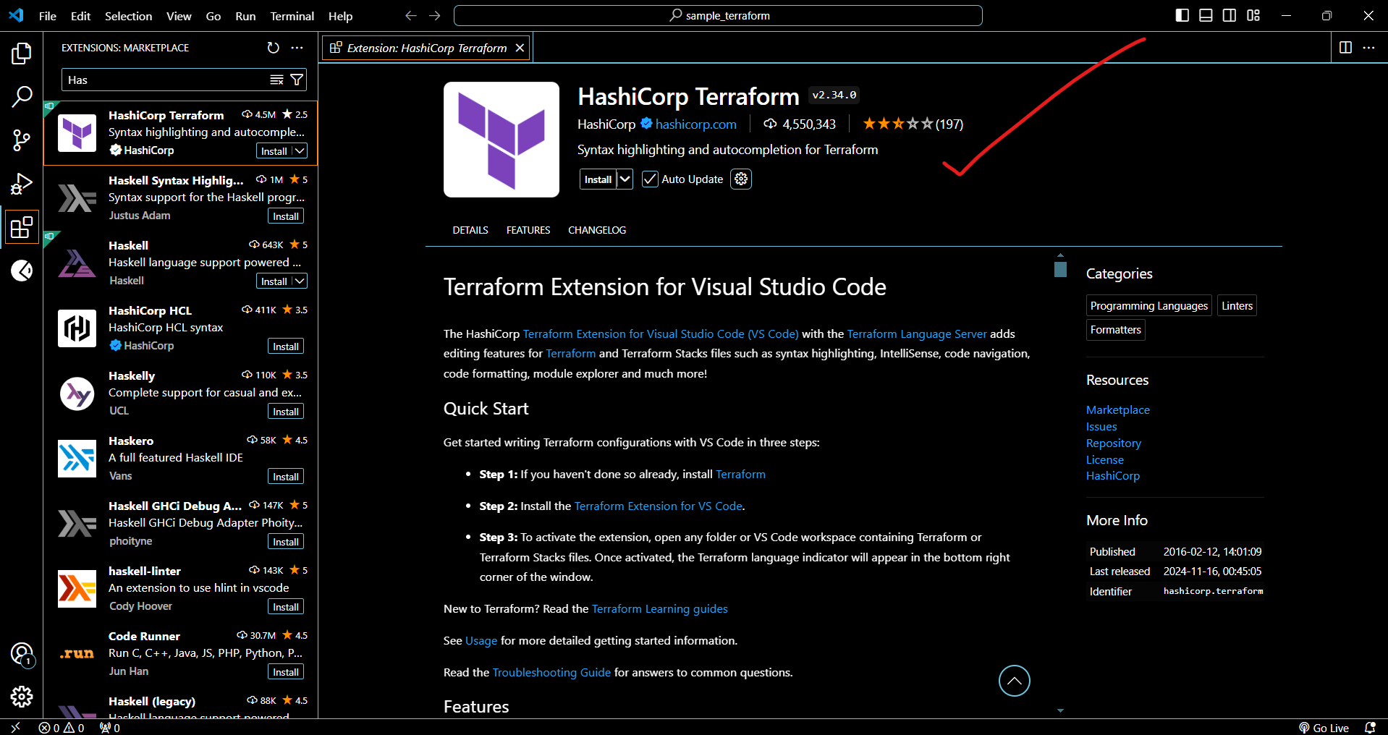

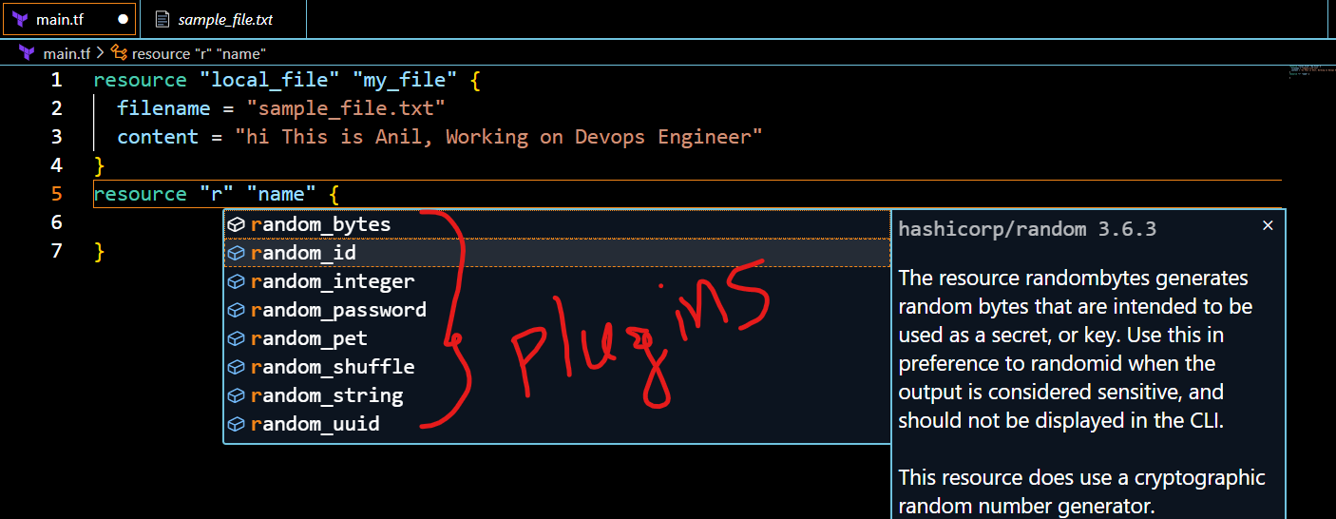

2) Execute all the templates shown in video.

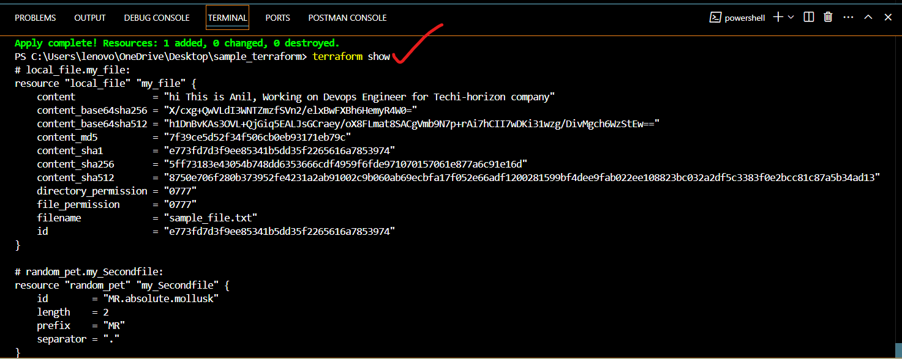

3) Note down below points,

Terraform Init: Terraform init command help us to initialize our repository, similar to git.

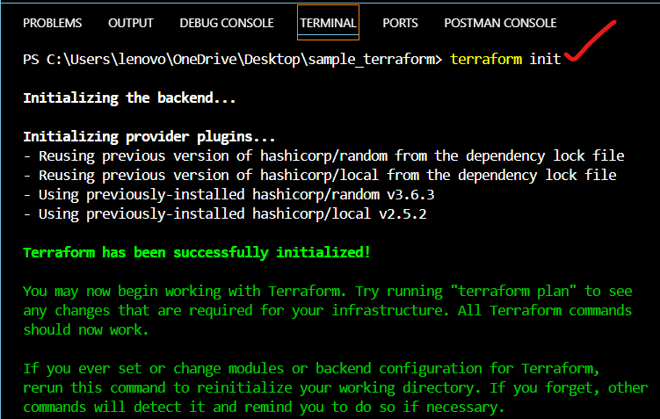

Terraform Plan: Terraform apply commands will help us to actually its kind of “dryrun”.

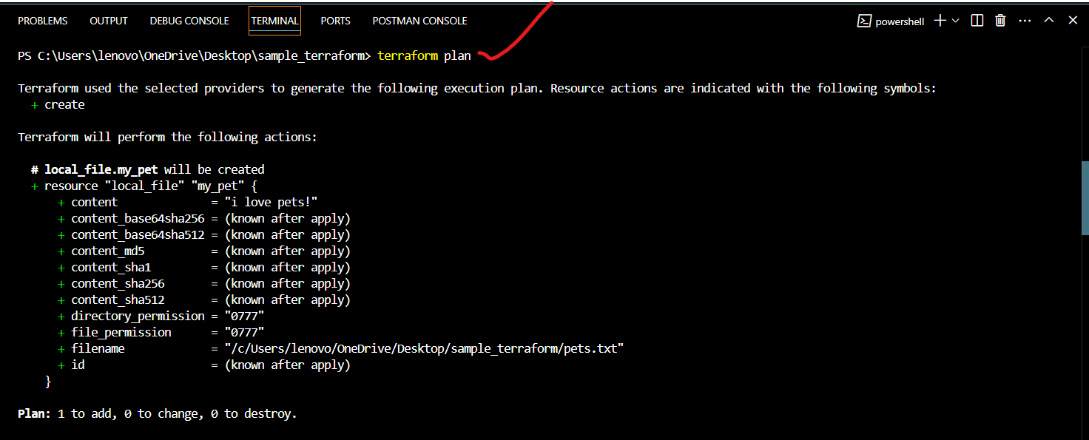

Dryrun checks the how the changes will be implemented (or) executed in machines

Terraform Apply: Terraform apply commands will help us to execute file

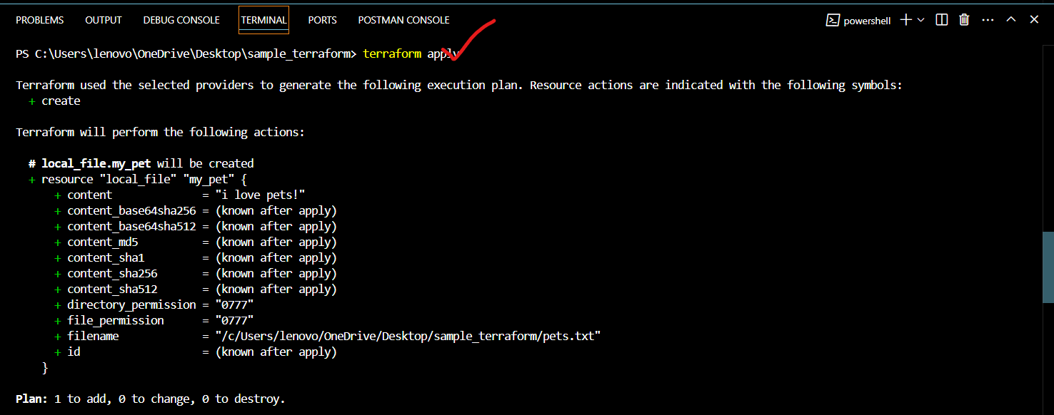

Terraform Provider: Terraform provide is a complete package of API calls to communicate with our resource.

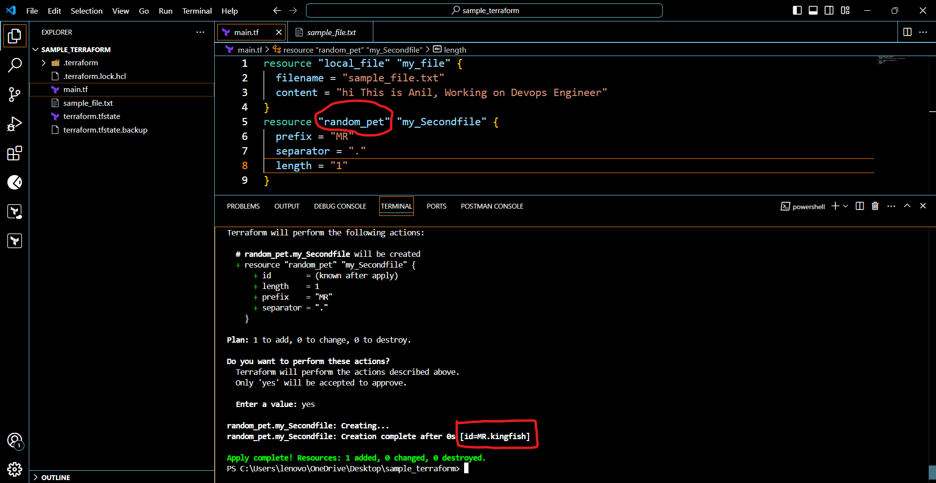

**4) Integrate a sample Terraform template in jenkins.**

# To integrate a sample Terraform template in Jenkins.

* + First we need to launch ec2 server.
  + With in the server you need to install Jenkins.
  + Go to the Jenkins GUI.
  + Go to manage Jenkins > Plugins.
  + Click on Available plugins there you need to search terraform plugin.
  + Click on check box and install.

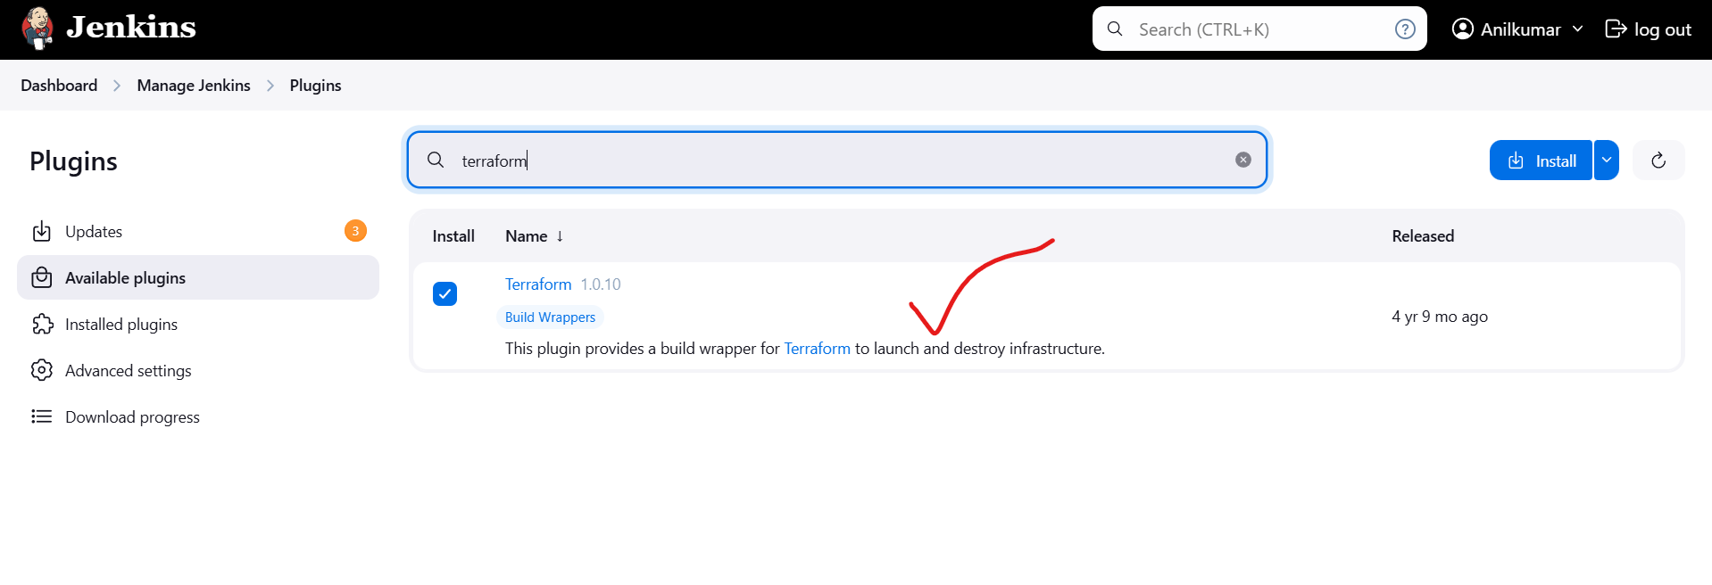

sudo yum install -y yum-utils shadow-utils

sudo yum-config-manager --add-repo https://rpm.releases.hashicorp.com/AmazonLinux/hashicorp.repo

sudo yum -y install terraform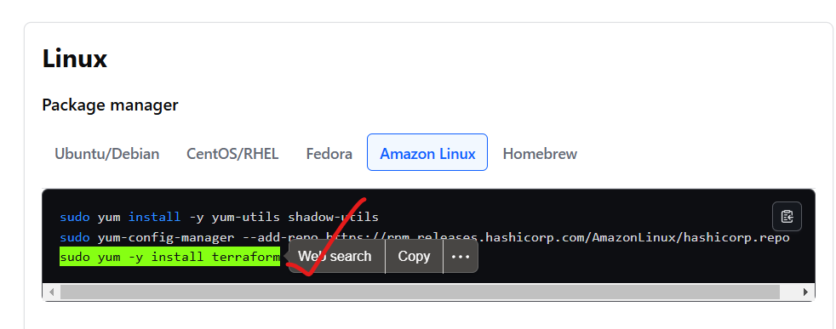  
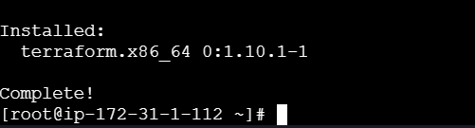

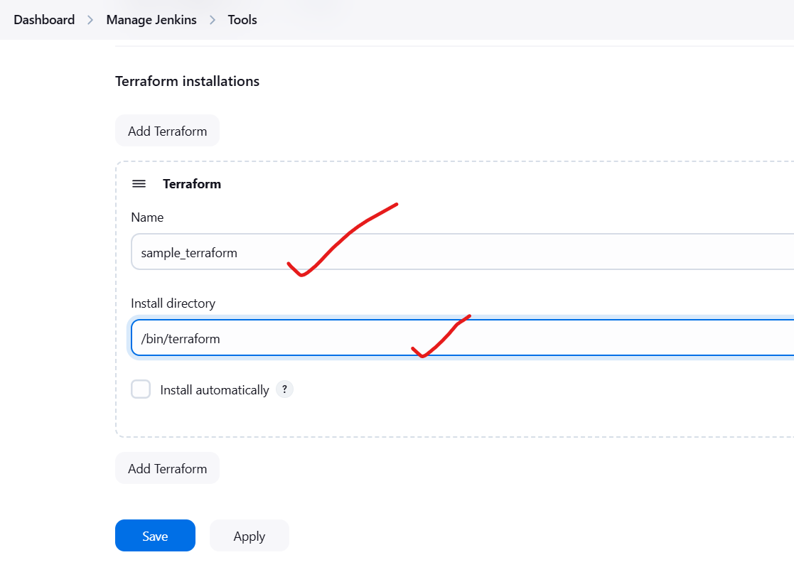

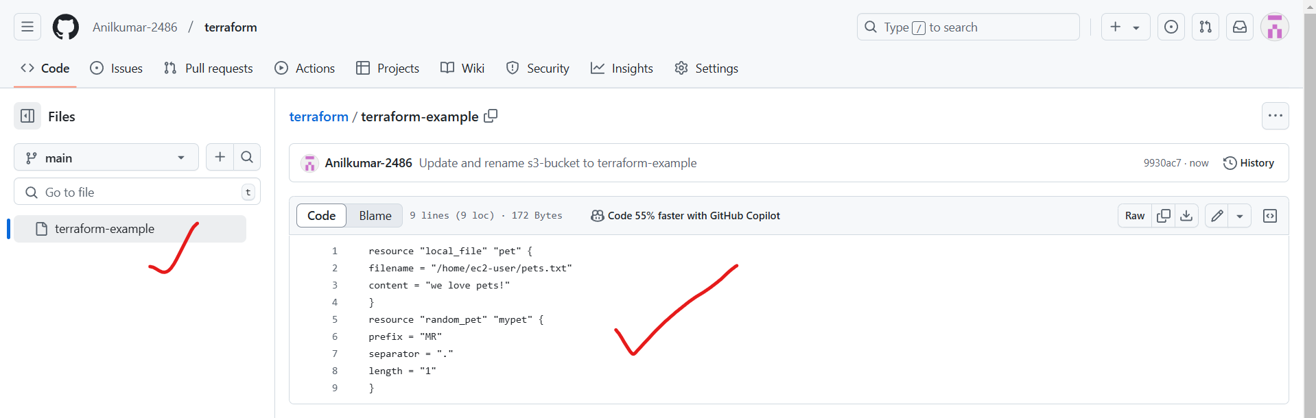

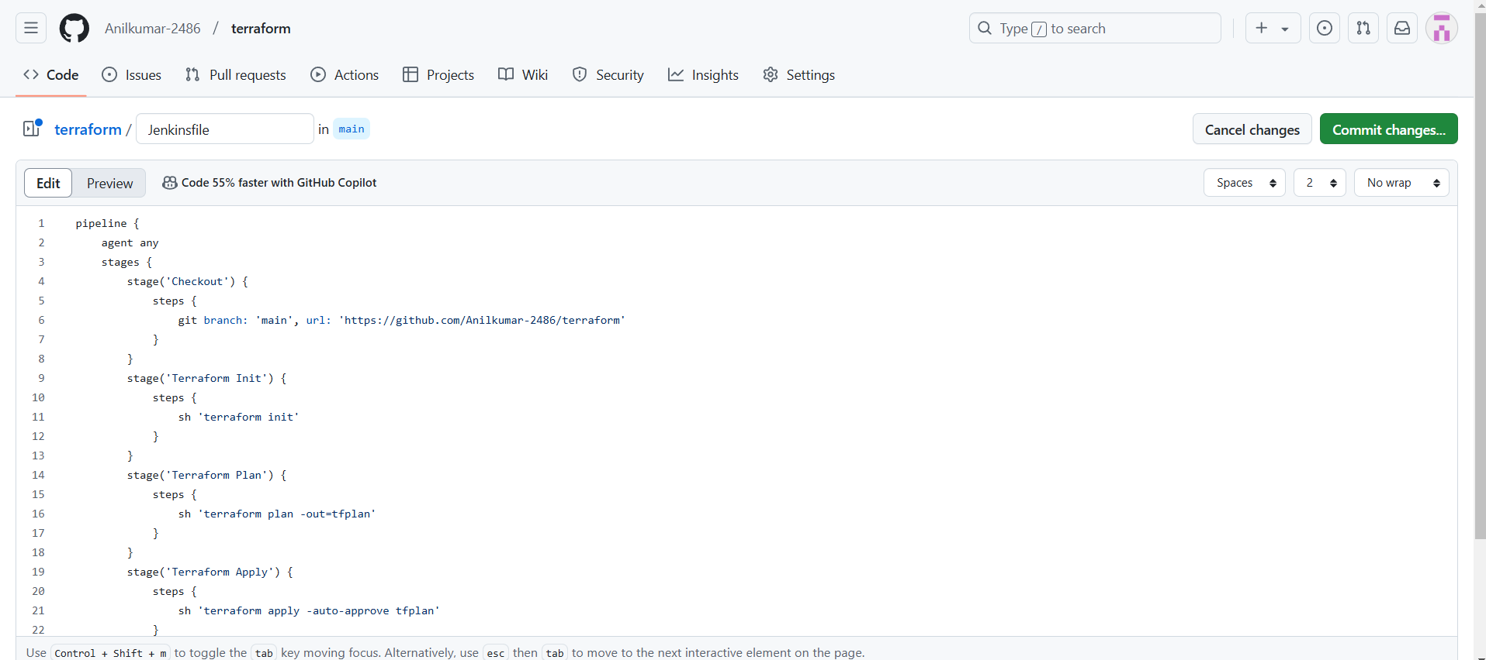

Now I went to the Jenkins GUI and I am created the one pipelinejob.

* + The job name given as Terraform_Local_provider
  + Select job – pipeline
  + Click on ok.
  + After that go to the pipeline and select pipeline script from SCM
  + Give repo URL
  + Credentials are not required because this is not private repo.

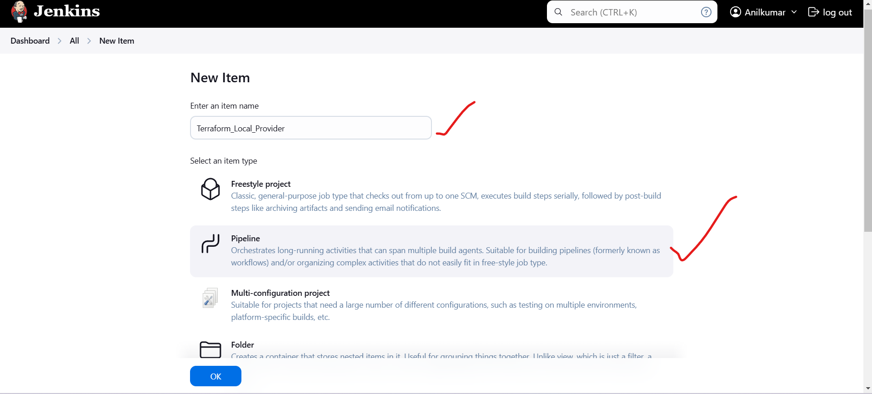

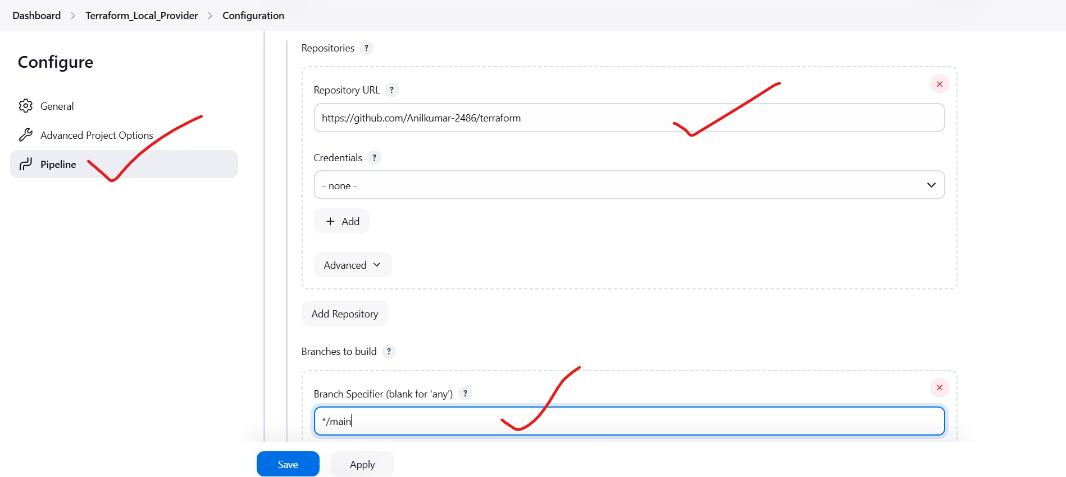

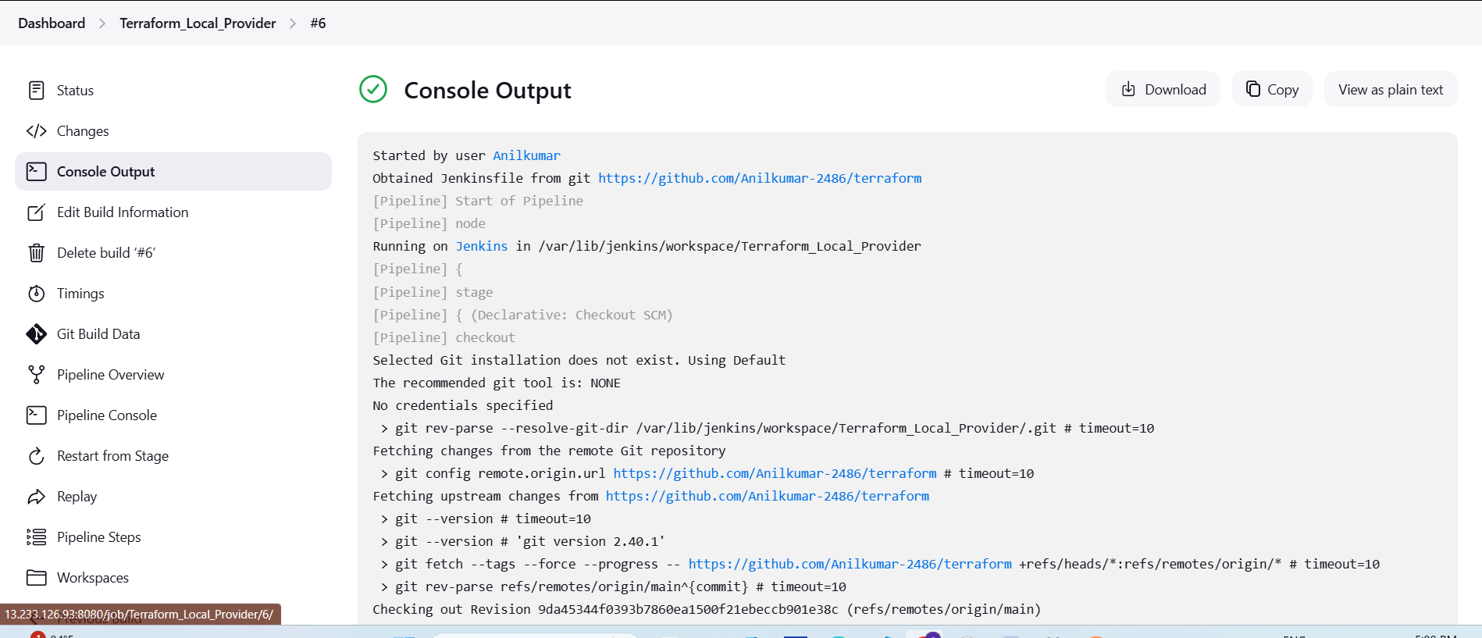



5) Watch the terraform-02 video.

completed

6) Execute all the templates shown in video.

