**Jenkins-01  
==============**

**1) Install jenkins and run jenkins on port number 8081.**

**== >**  vi /usr/lib/systemd/system/jenkins.service

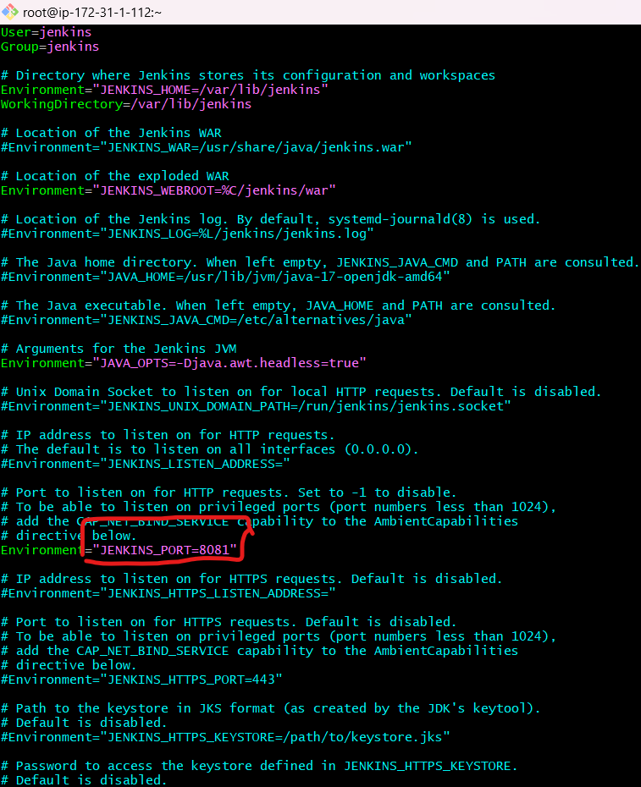

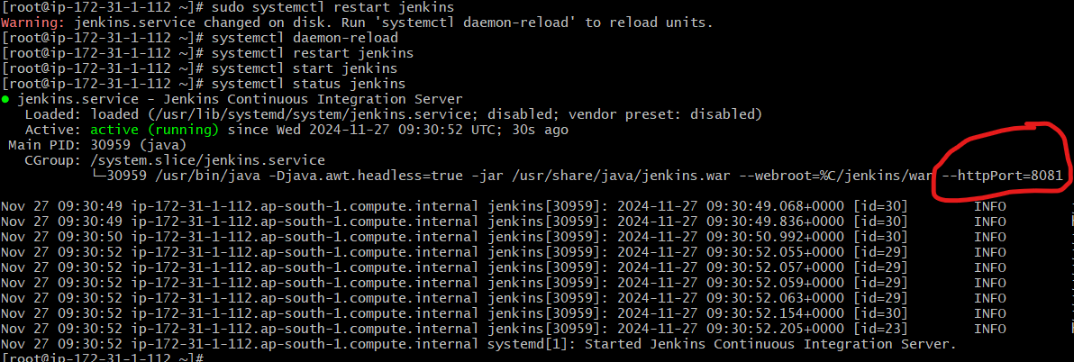

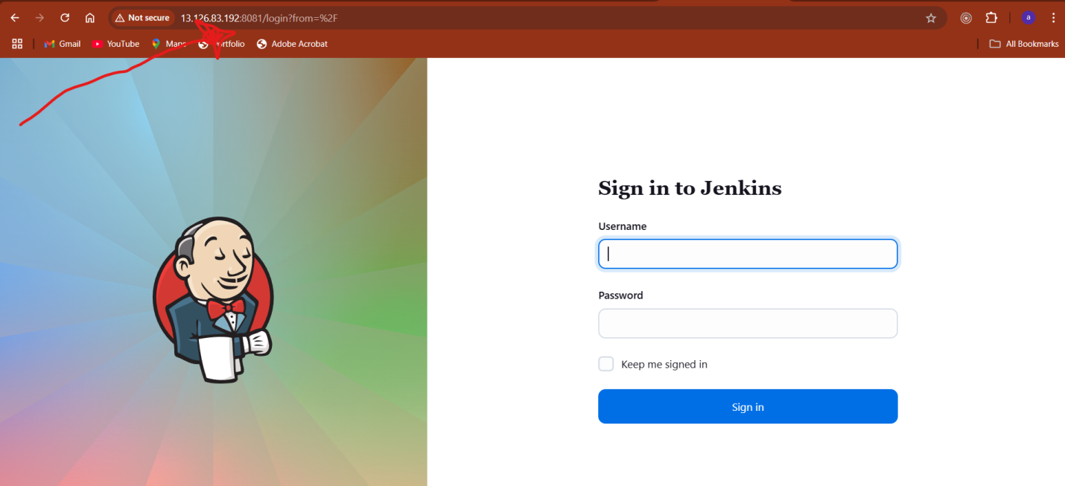

**2) Secure Jenkins server  
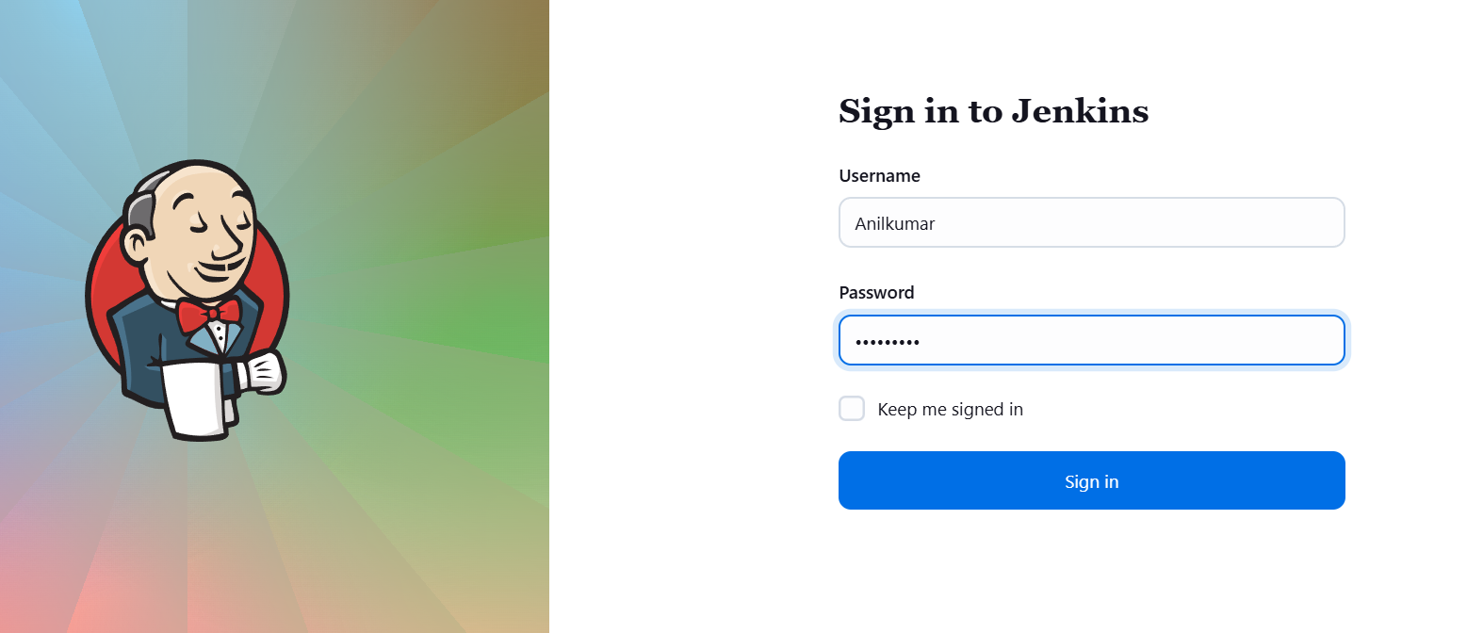**

**3) Create users called Devops, Testing in Jenkins with Limited access.**

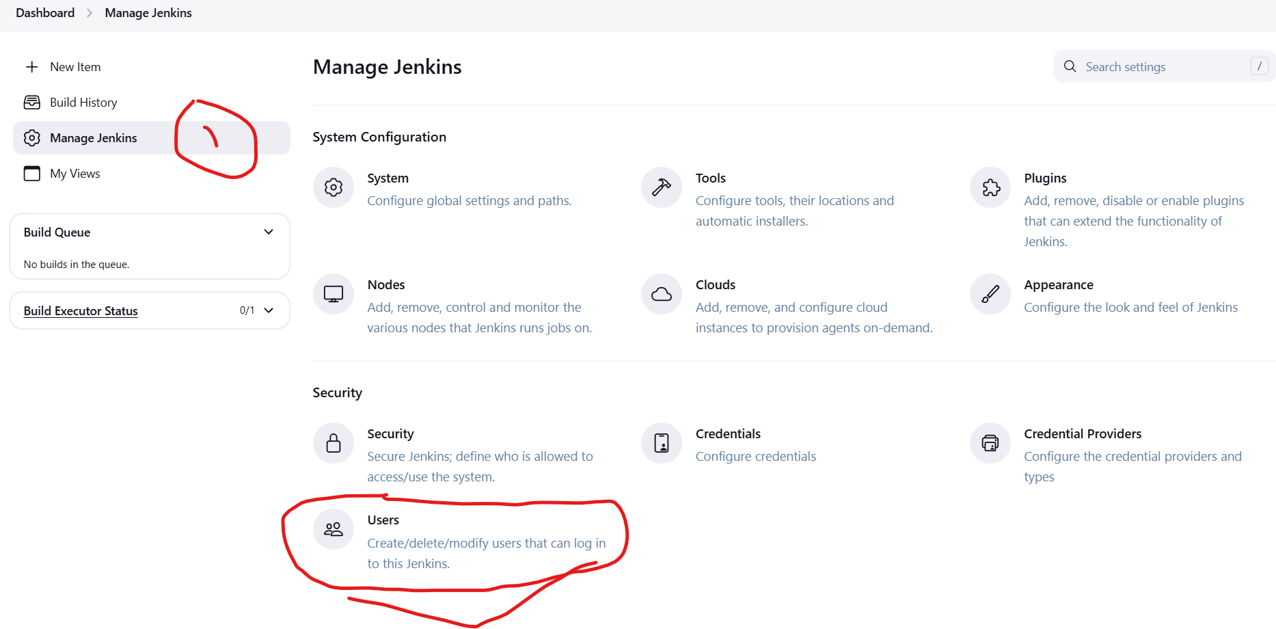

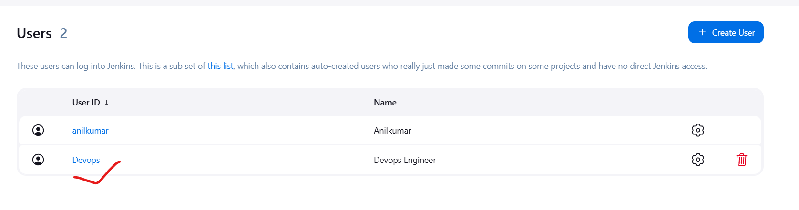

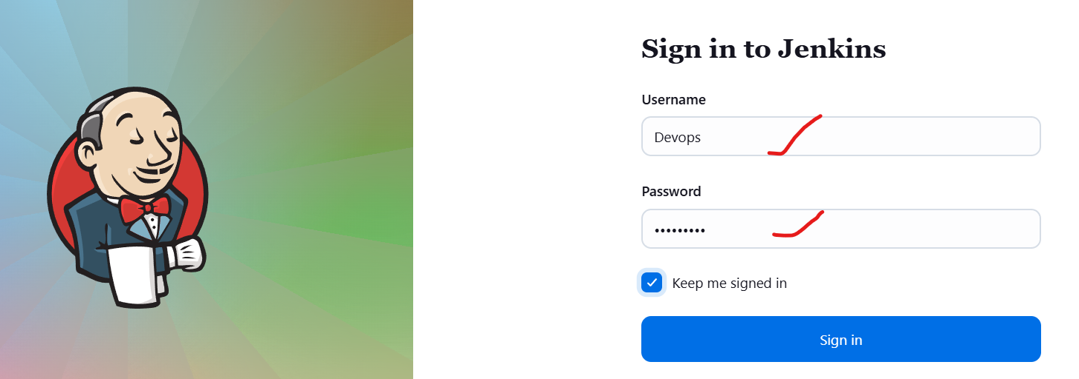

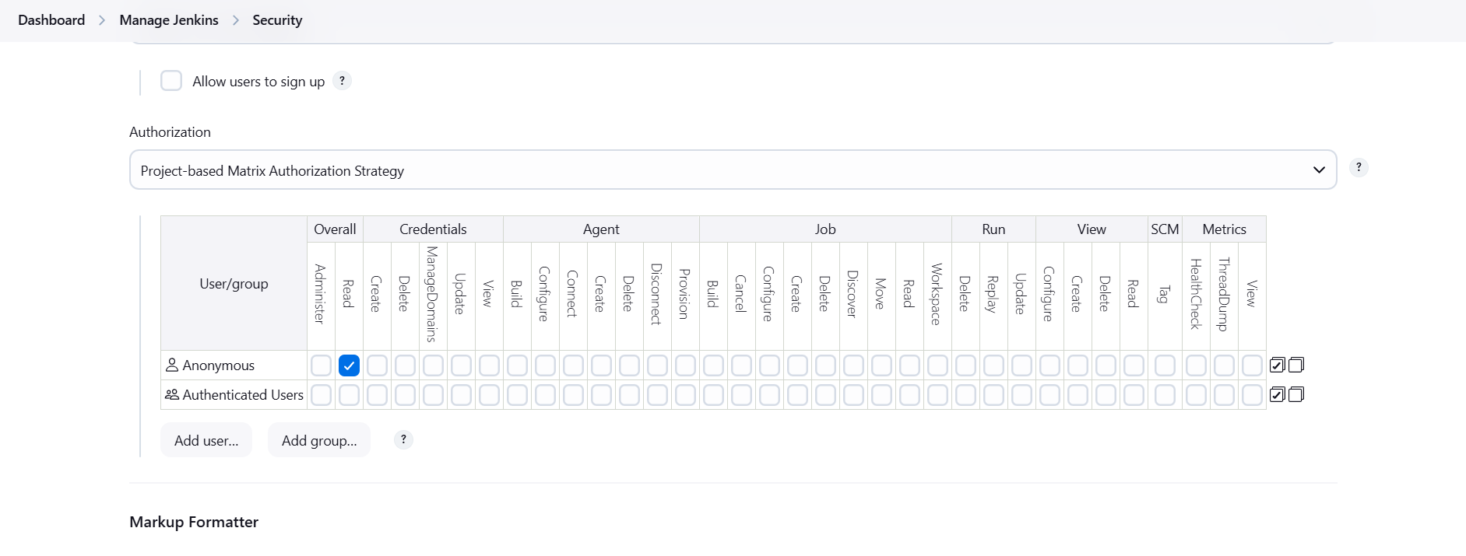

**4) Configure labels and restrict the jobs to execute based on label only**

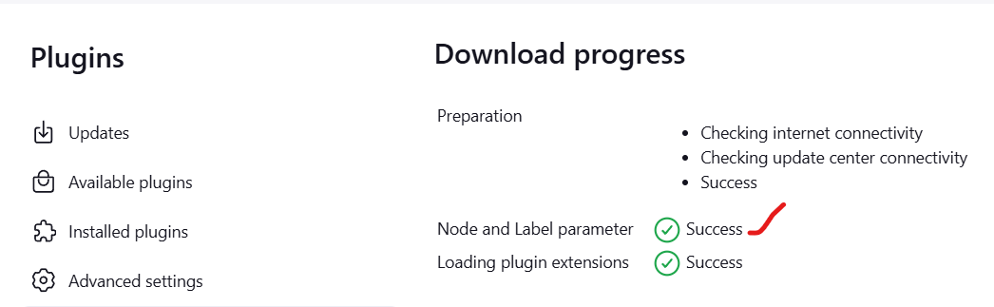

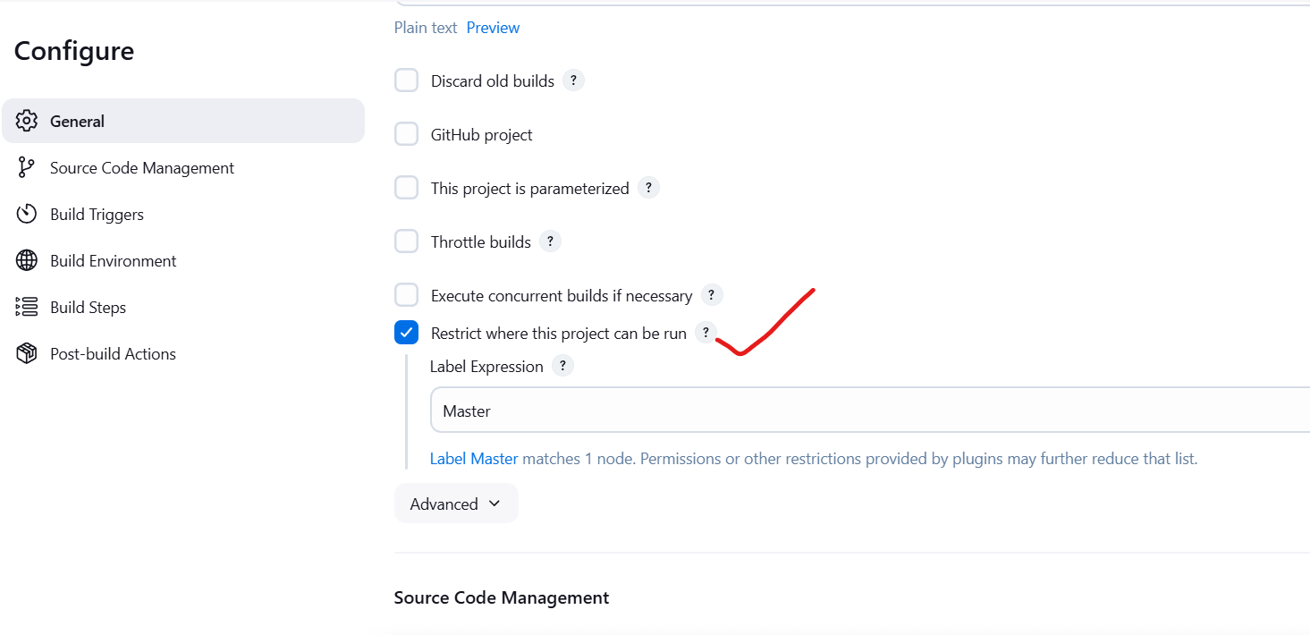

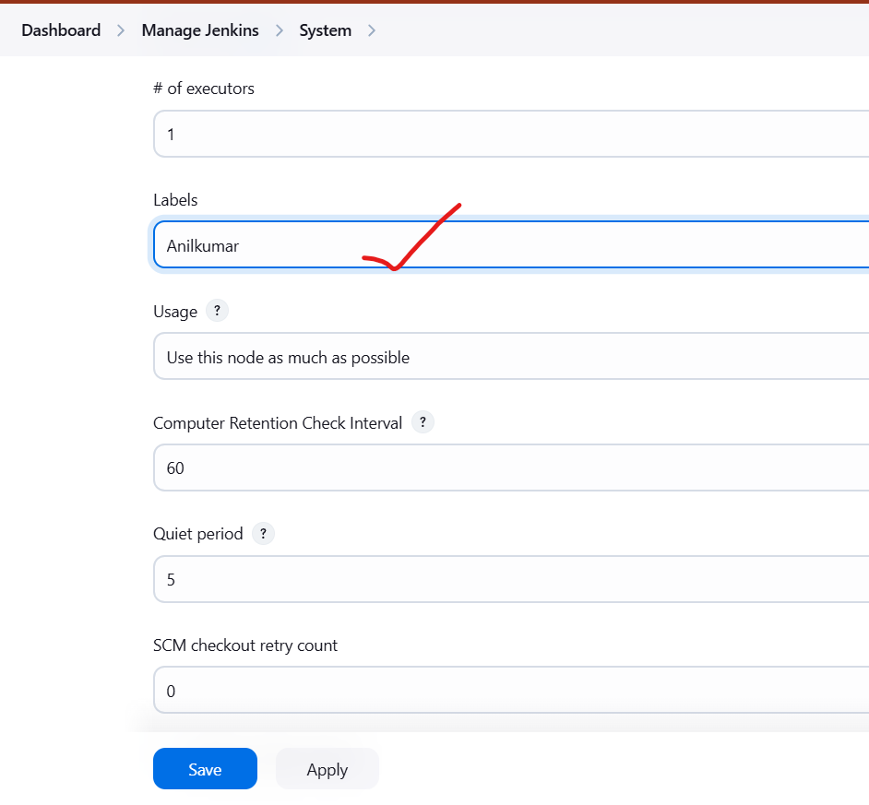

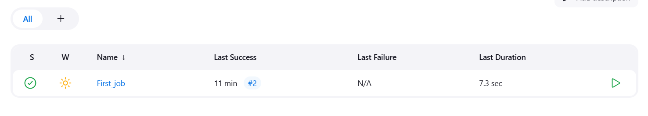

**5) Create Three sample jobs using the below URL.**

[**https://github.com/betawins/Techie_horizon_Login_app.git**](https://github.com/betawins/Techie_horizon_Login_app.git)

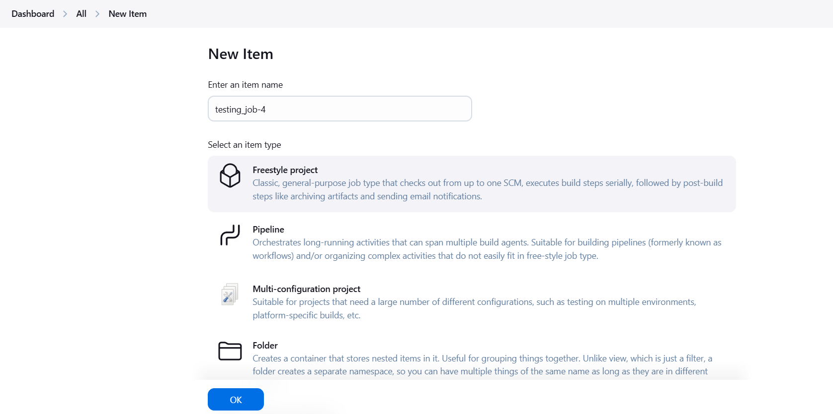

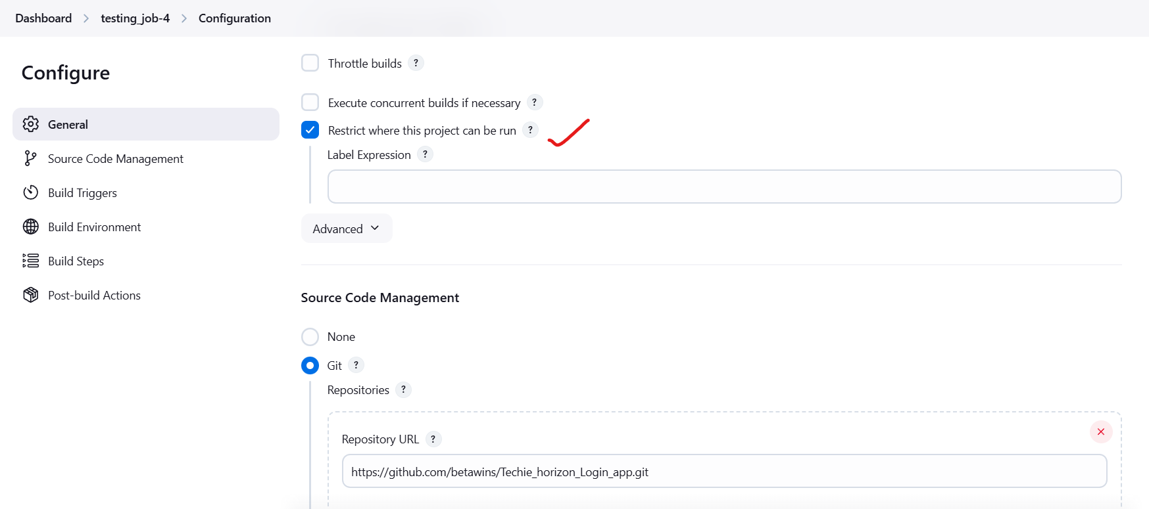

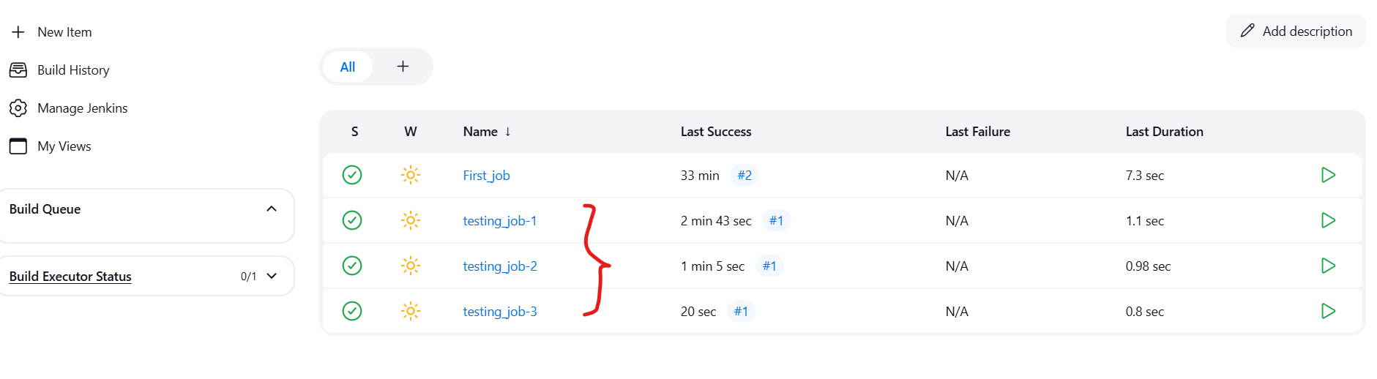

**6) Create one jenkins job using git hub Private repository.**

