1. Create user with name Techie and provide sudo access to user.

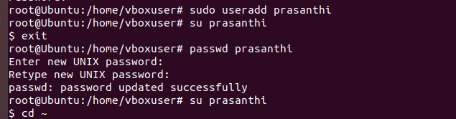

1. Navigate to home directory

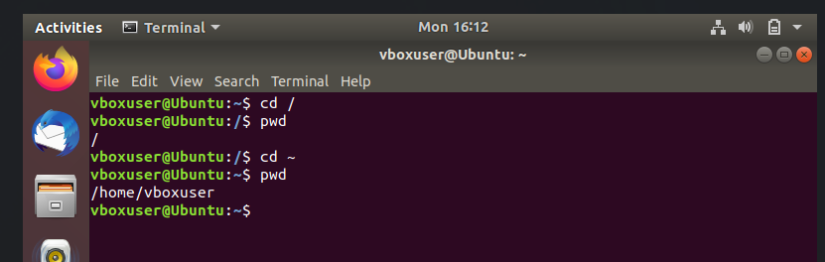

1. Create a new directory
2. List the contents of the directory
3. Change the current directory.
4. Create a new empty file.
5. View the contents of a file

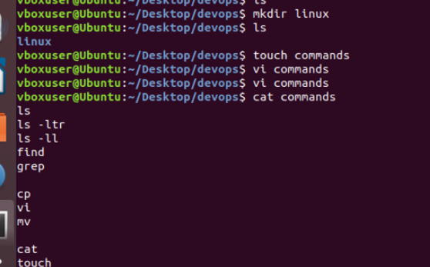

1. Copy a file to another location.
2. Move a file to another location.
3. Rename a file.
4. Delete a file.

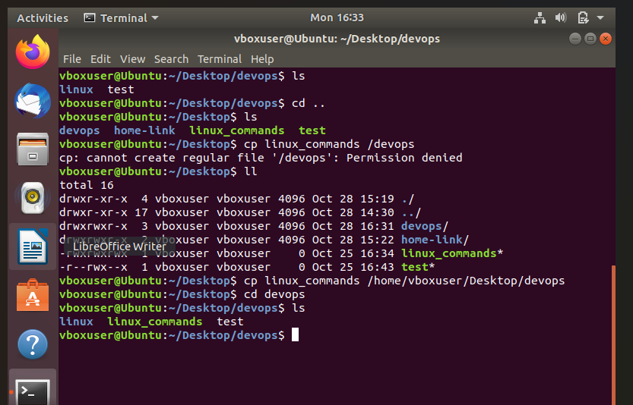

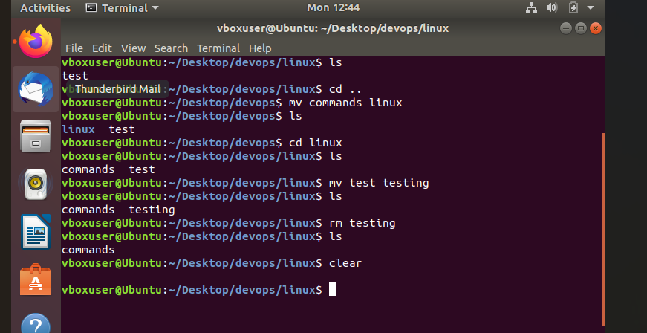

1. Grant or revoke permissions on a file or directory.
2. View the current date and time.
3. Check the system uptime.

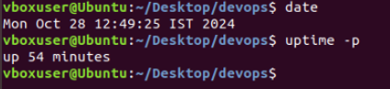

1. View the running processes.

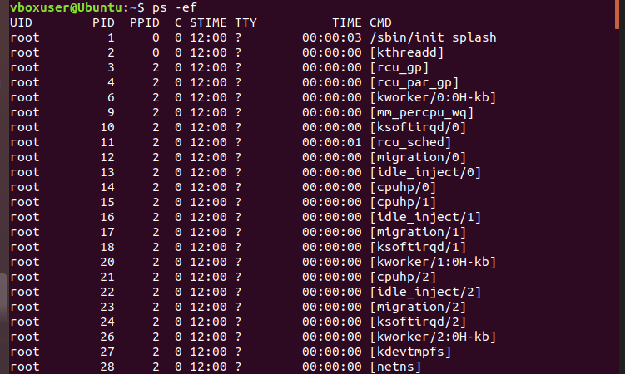

1. Kill a running process

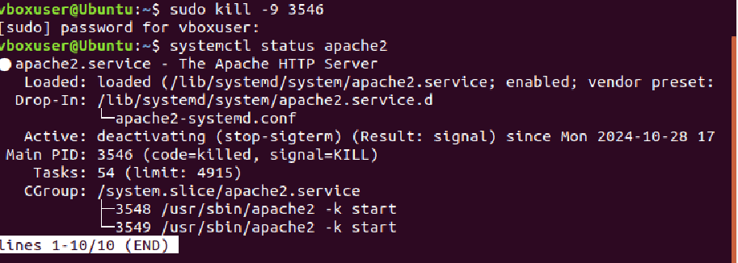

1. Install a package using the package manager (e.g., apt or yum).
2. Update the system packages.

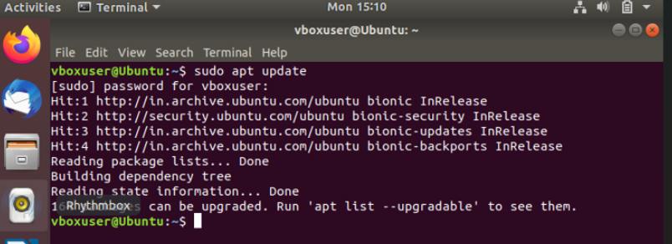

1. Create a symbolic link.

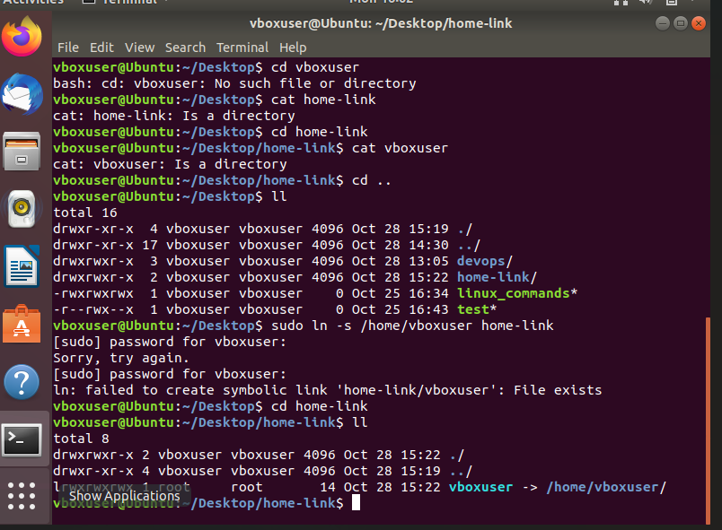

1. Search for files using the find command.

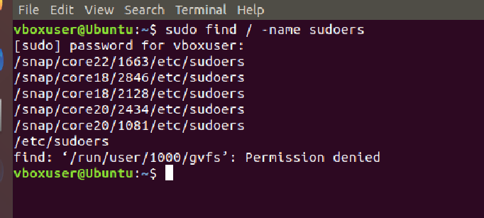

1. Compress and decompress files using tar.
2. Monitor system resources with top or htop.

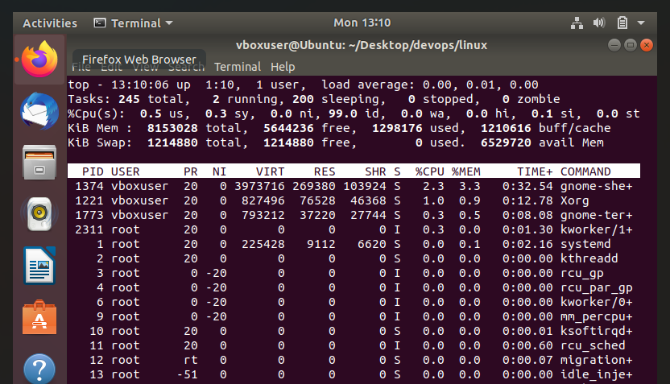

1. Create and manage user groups.

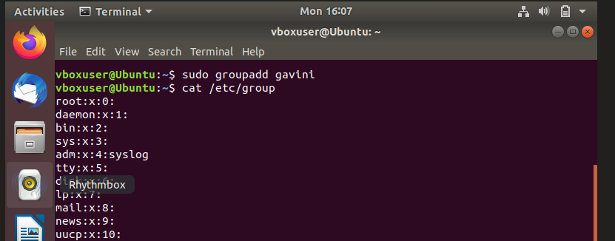

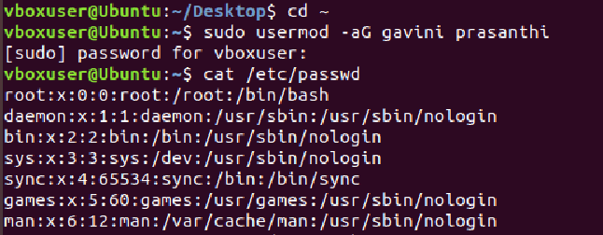

1. Set up SSH password less authentication.
2. Monitor log files using tail or grep.

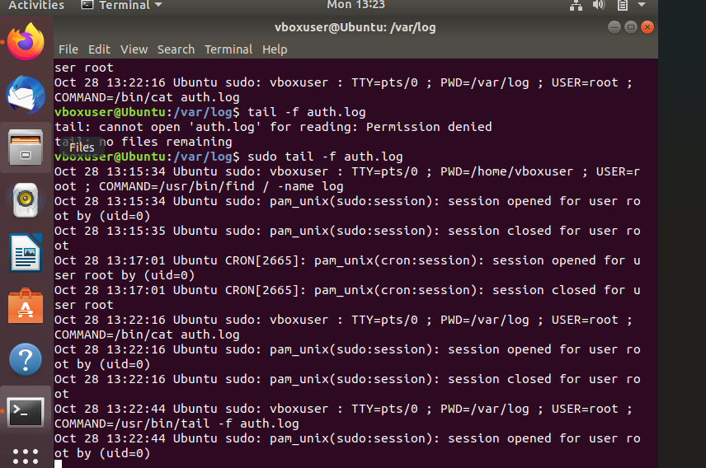

1. Set up a web server (e.g., Apache or Nginx).

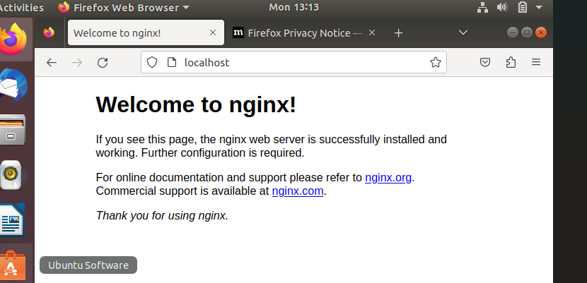

1. Configure and secure a MySQL Database.

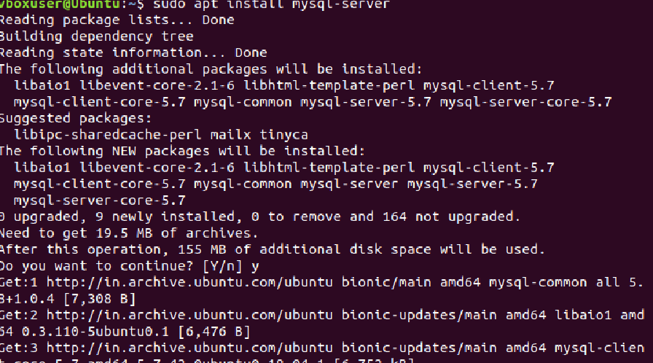

1. Set up a Application Server (e.g.,Apache Tomcat)
2. create a service file for Apache Tomcat.(Should execute by using systemtctl command)
3. Print specific columns from a delimited file.

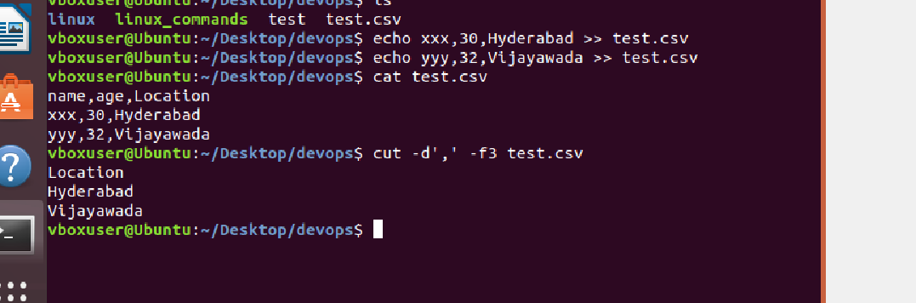

1. Filter and print lines based on a specific pattern or condition.

Using grep command

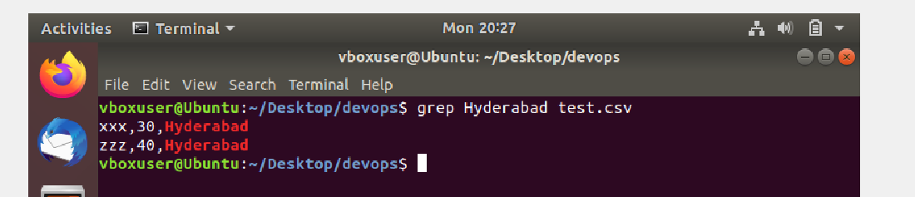

Using awk command

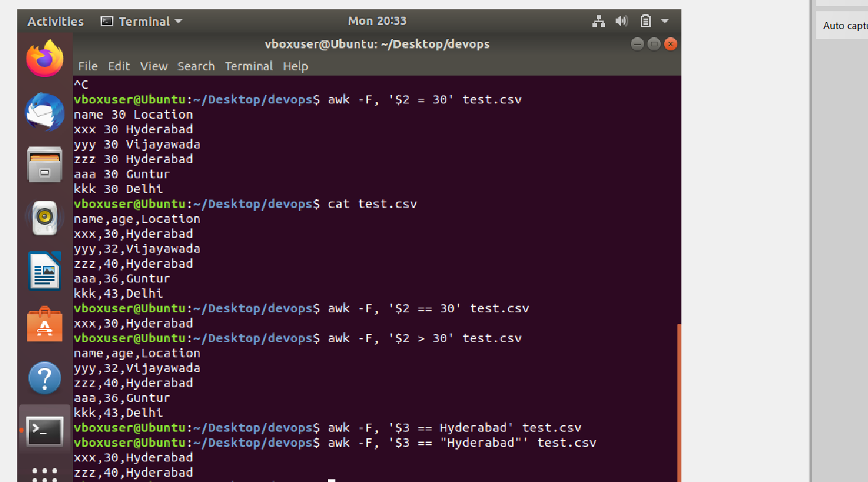

1. Calculate and print the average, sum, or other statistics of a column.

We can awk command for calculations of specific column

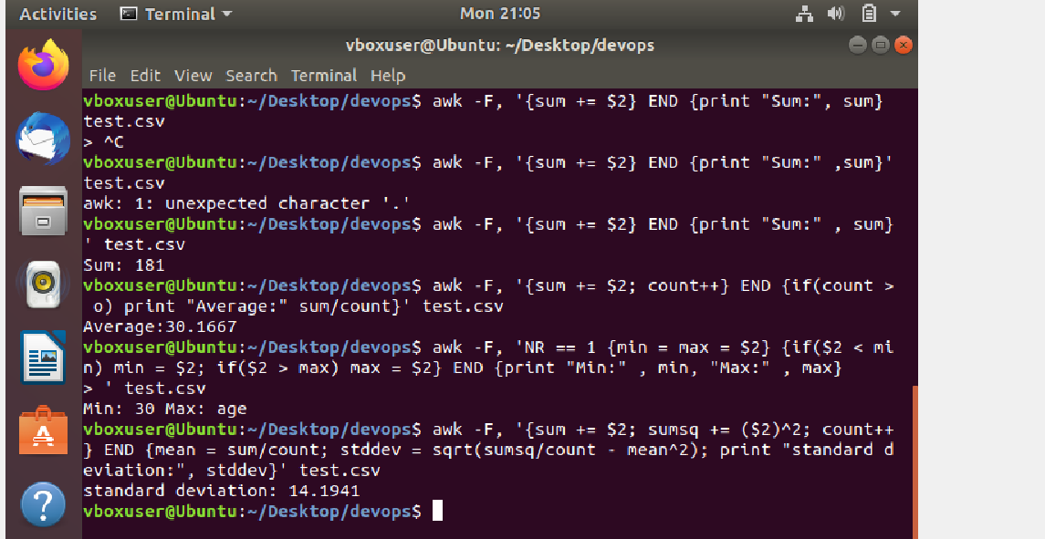

1. Perform string manipulation, such as extracting substrings or changing case.

Extracting sub strings with awk

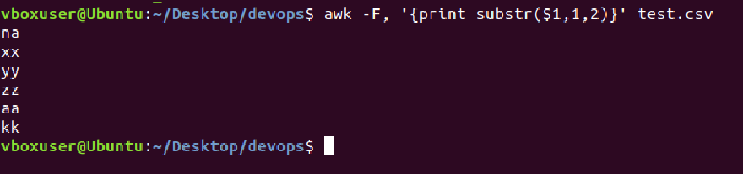

Convert the string to uppercase using tr command

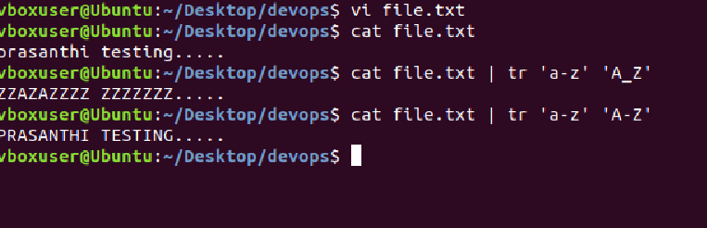

1. Count the occurrences of a specific pattern in a file.

Gives the no.of occurrence of specific string in a file

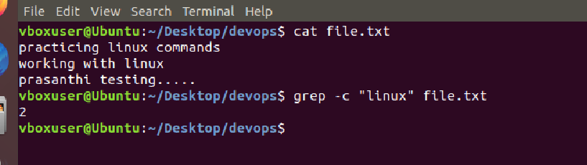

1. Sort lines based on a specific field or column.



1. Merge multiple files based on a common field or column.

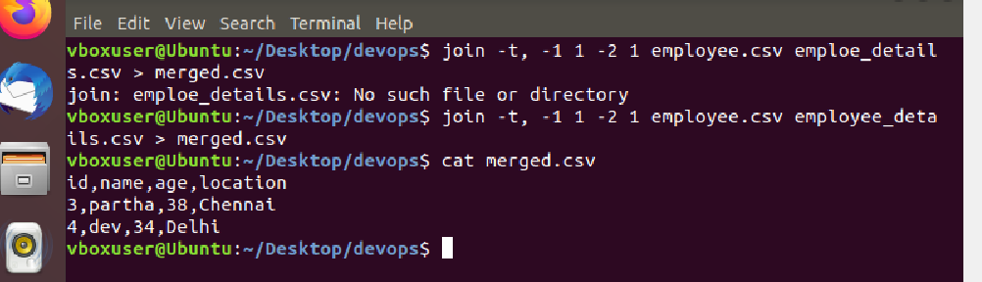

37.Substitute text in a file using search and replace.

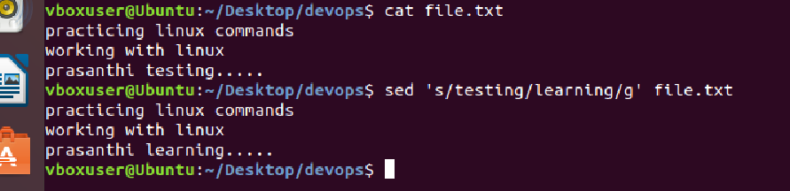

1. Delete specific lines based on a pattern or line number.

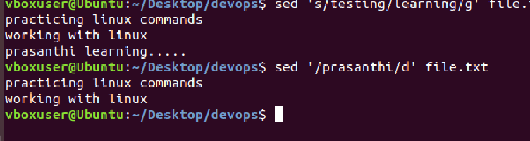

1. Append or insert text before or after a specific pattern or line.

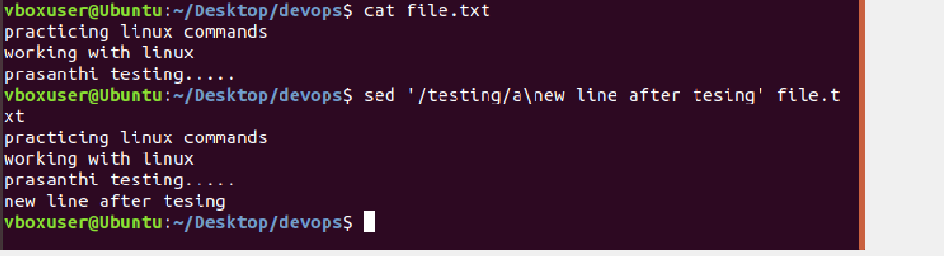

40.Print only specific lines from a file.

