**Maddi. Anilkumar**

**Requirements:-**

# Features :-

* People can view All Movies, Find Movies and Book Tickets.

* One person can book tickets up

## State of art/Research :-

* Designing and implementing of Movie ticket booking using basic programming.

## 4W'S and 1-H :-

* What- It is the portal for booking the tickets for movies.

* Why- This portal is easy to book your tickets instead standing in the line and easy to pay the payment .

* Where- It is available to use all gadgets like smartphone,tabs and laptop for booking the tickets and get your in the cinema hall.

* When- If any movie releases then you can book your ticket.

* How- If you open the portal we can view all movies, then find your mob=vie and book your ticket and make payment.

## Strengths :-

* It's easy to use and understand.

* Physical tickets- to count visitors

* Always up to speed on upcoming movies.

## Weaknesses :-

* Mostly limited to urban areas, as Indians are still wary about online transactions.

* There are a lot of features, which makes the programme a little difficult to use.

## Opportunities :-

* Make some of the options more intuitive

* Acquiring more partnerships with various bussiness entities.

## Threats :-

* Improved functionalities by competitive online booking ticket portals.

* Newly emerging competitive online booking ticket portals.

## High-level Requirements :-

* User should be able to view the list of movies which are running near to his location (based on GPS).

* User should be able select the seat as per his choice in the hall.

* User should have different options of payment.

## Low-Level Requirements :-

* Application should be lightweight and give quick response.

* The user's data should be kept safe.

**Architechure& Design:**

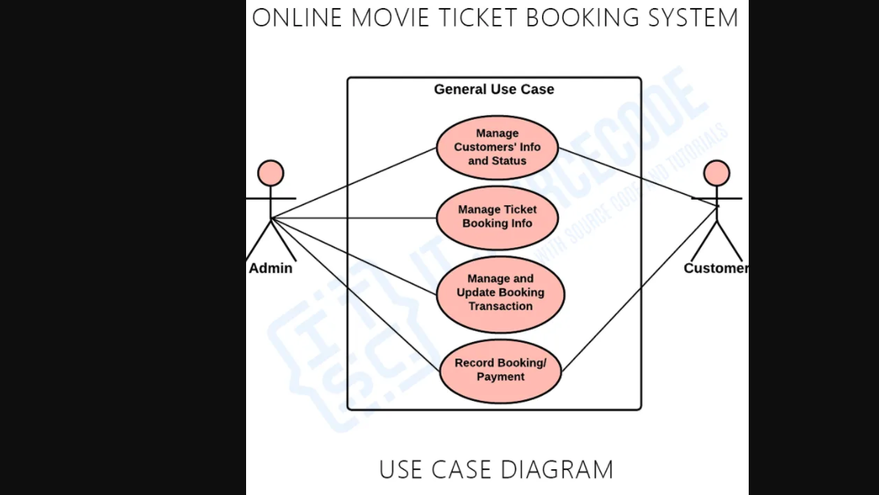

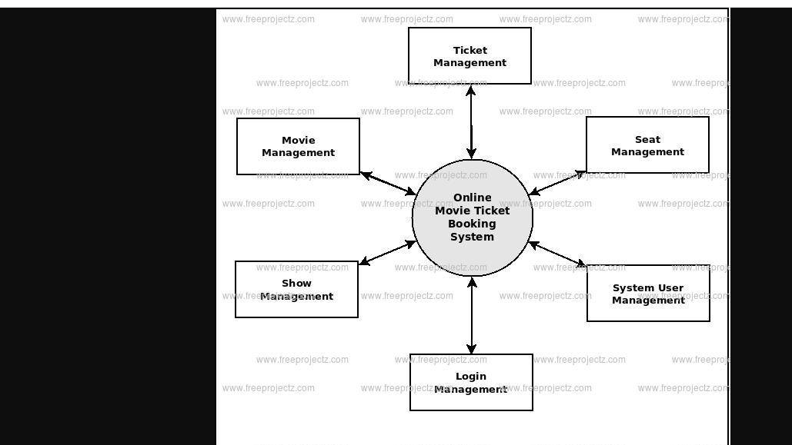

**Outputs :**

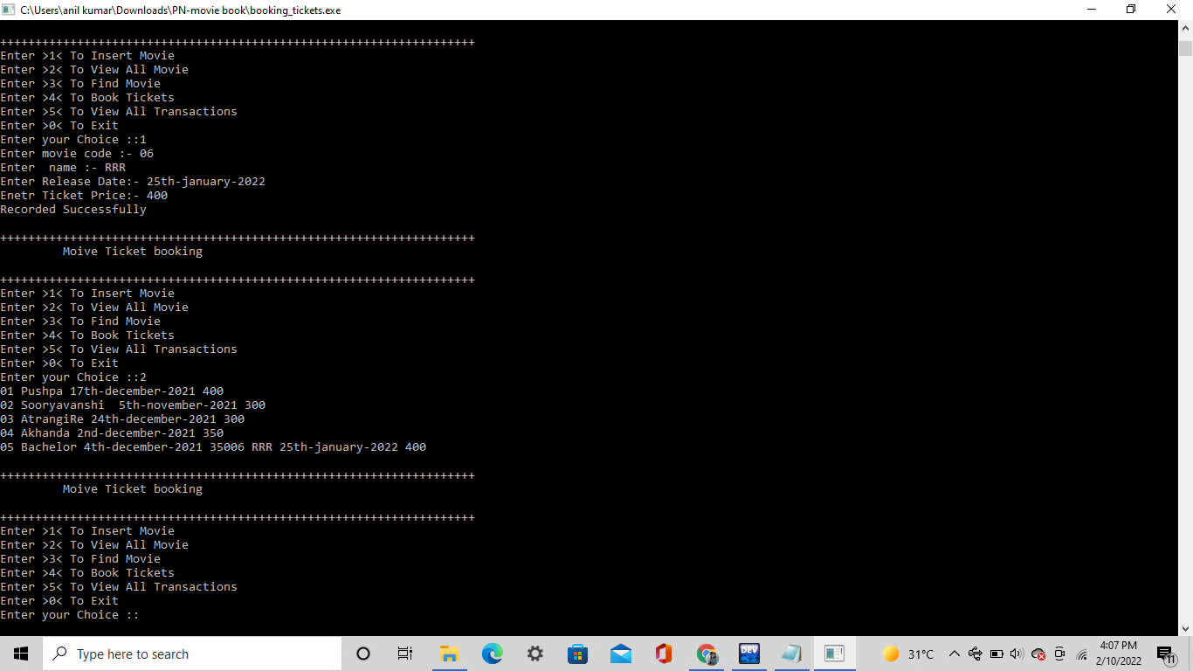

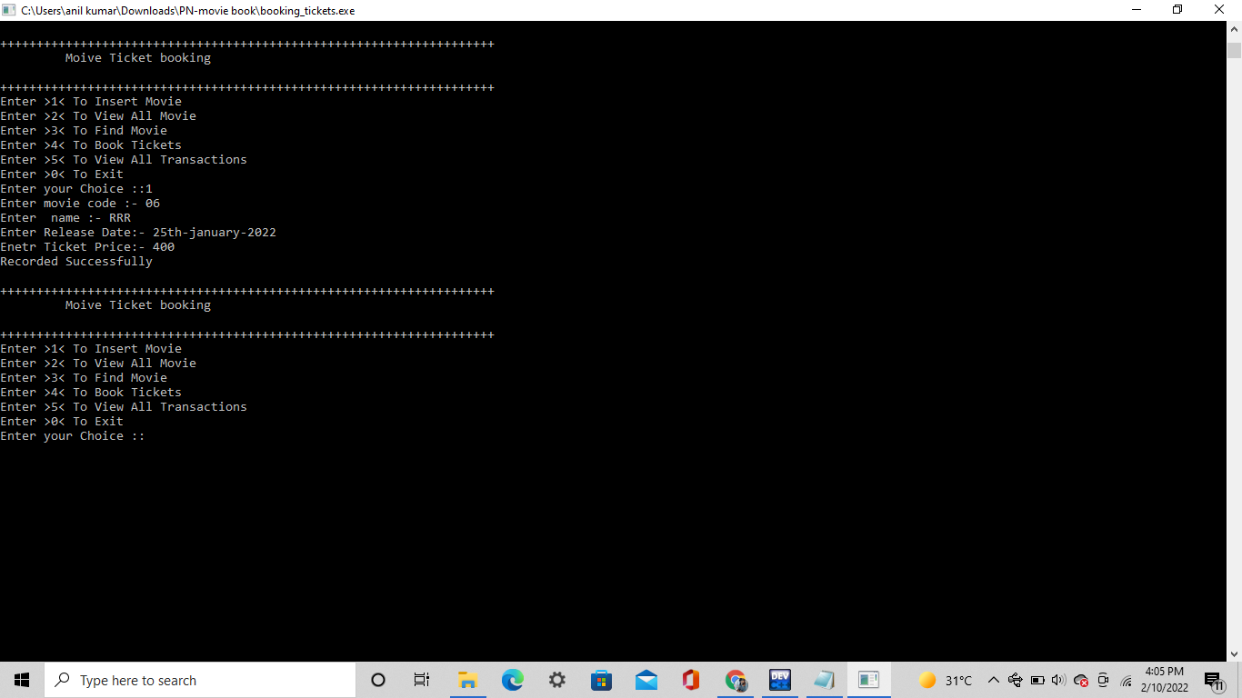

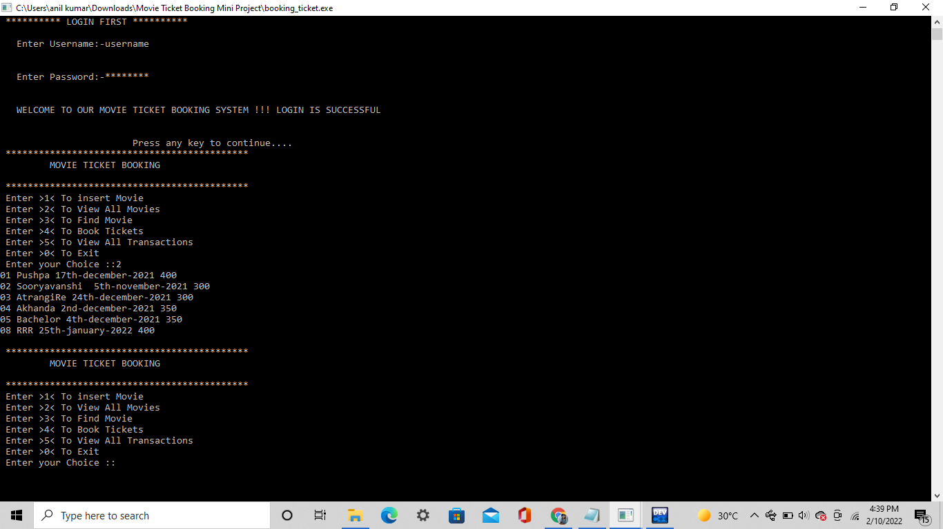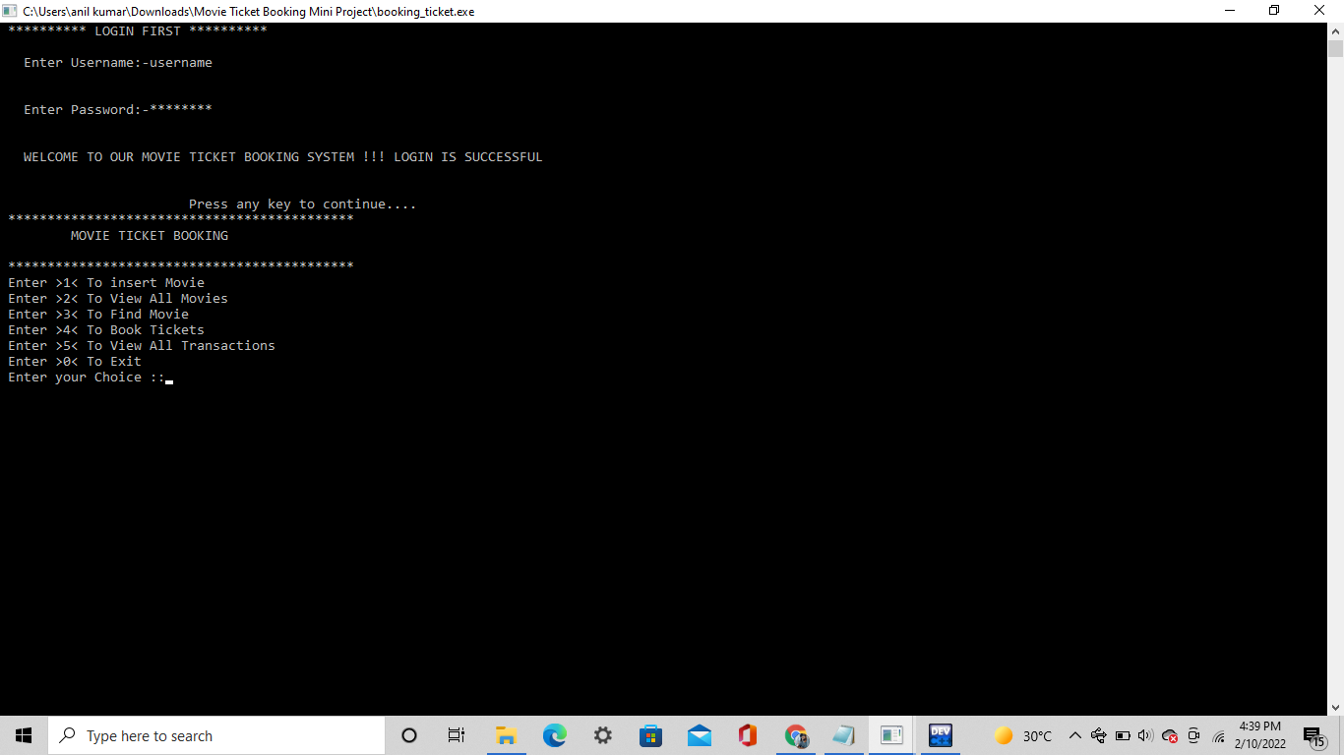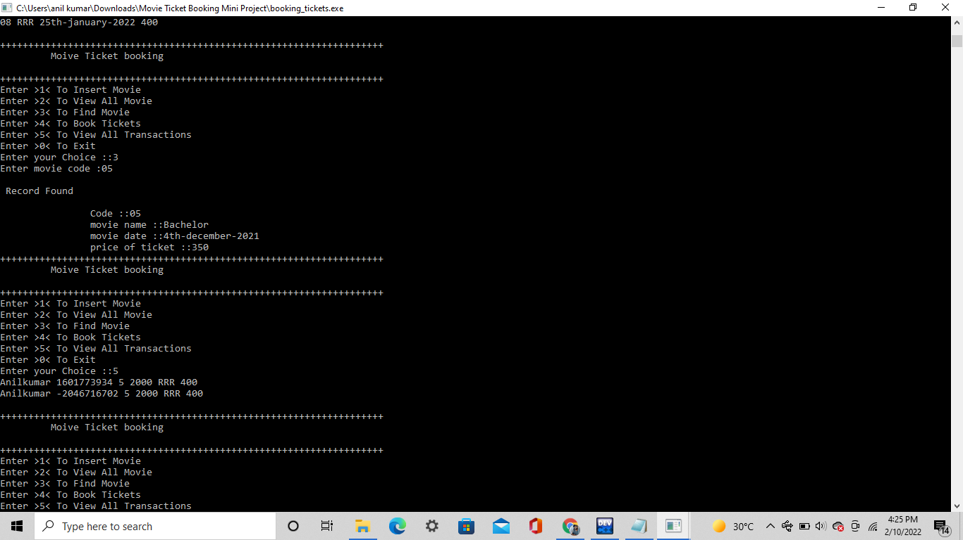

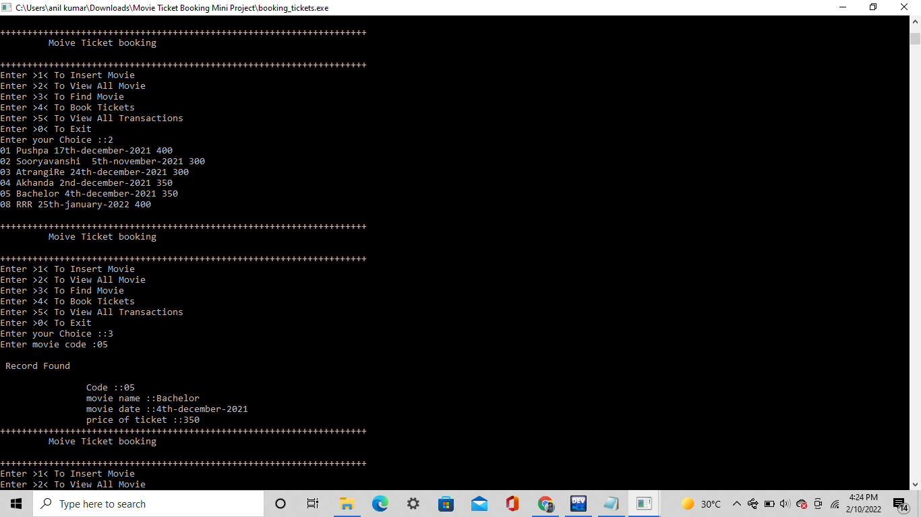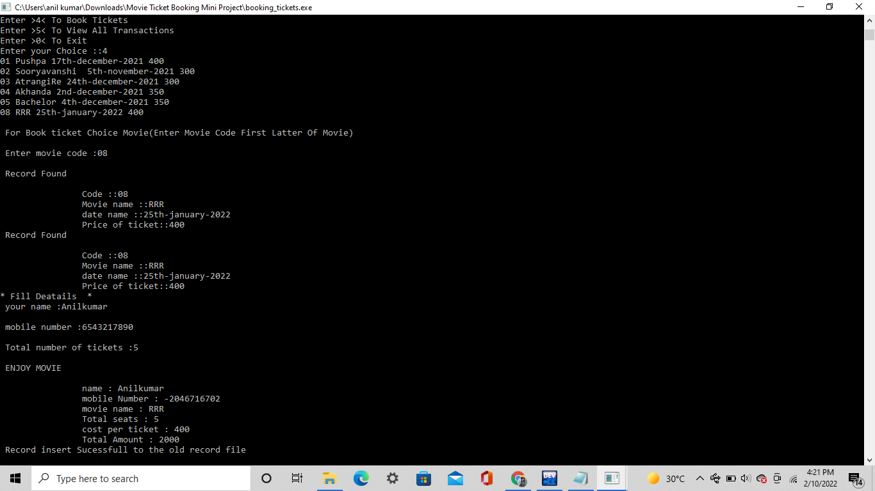

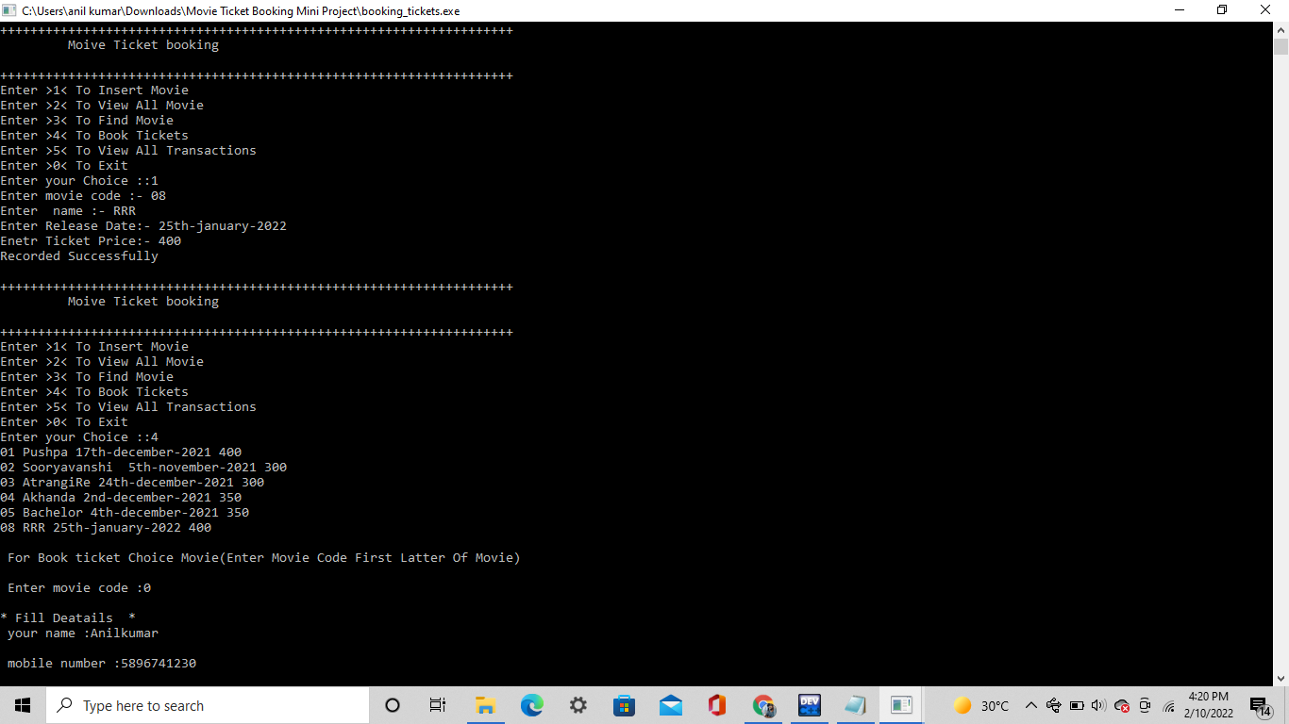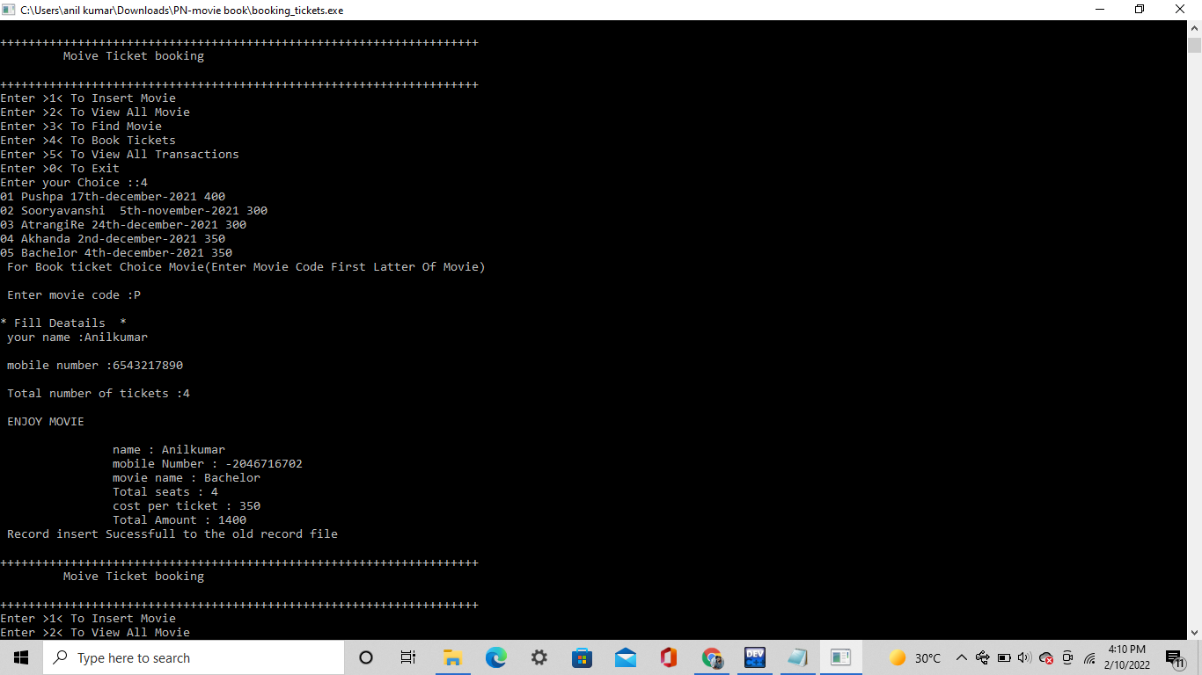

**Badges:**

[![Codacy Badge](https://app.codacy.com/project/badge/Grade/6db2357439a5496b9bde23db11274fa6)](https://www.codacy.com/gh/Anilkumar1608/M1_Projectgoal_Movie-Ticket-Booking/dashboard?utm_source=github.com&amp;utm_medium=referral&amp;utm_content=Anilkumar1608/M1_Projectgoal_Movie-Ticket-Booking&amp;utm_campaign=Badge_Grade)

[![Contribution check - Git inspector](https://github.com/Anilkumar1608/M1_Projectgoal_Movie-Ticket-Booking/actions/workflows/Git.yml/badge.svg)](https://github.com/Anilkumar1608/M1_Projectgoal_Movie-Ticket-Booking/actions/workflows/Git.yml)

**References :**

https://itsourcecode.com/uml/online-movie-ticket-booking-system-use-case-diagram/

https://www.freeprojectz.com/dfd/online-movie-ticket-booking-system-dataflow-diagram

https://projectnotes.org/it-projects/movie-ticket-booking-in-c-c-with-source-code/