1. **Sales Details**

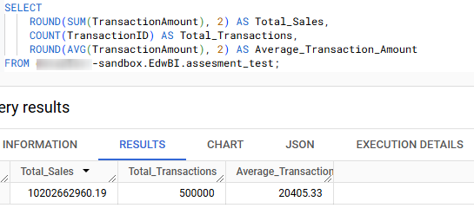

1. The total sales revenue and number of transactions give a snapshot of business performance.
2. The average transaction amount provides insights into purchasing behaviour and trends.

**Key Insights from the Query Results:**

1. **Total Sales Revenue**:
   * **Total Sales: 10,202,662,960.19**
     + This is the cumulative revenue generated from all transactions within the dataset. A large total sales figure indicates substantial business activity and overall revenue generation.
2. **Total Transactions**:
   * **Total Transactions: 500,000**
     + This shows the total number of individual transactions processed. A high transaction count suggests significant customer activity or multiple smaller transactions.
3. **Average Transaction Amount**:
   * **Average Transaction Amount: 20,405.33**
     + This value provides insight into the average value of each transaction. A relatively high average transaction amount could suggest that the business deals in higher-value products, or that customers tend to spend more per visit or order.

**2)Sales by Region**

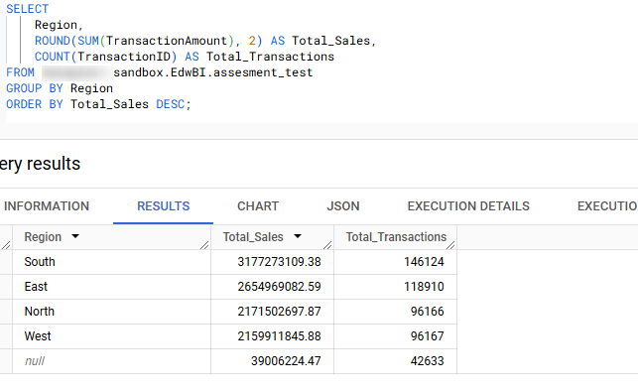

1. The regional breakdown of total sales and transactions highlights the strengths of each area and identifies regions with growth potential. Tailoring strategies to each region’s unique strengths and challenges can lead to more efficient resource allocation, increased sales, and overall business growth.

**Insights on Sales by Region**  
  
**South** region's dominance in both sales and transactions indicates it as the highest-performing market. To maintain this momentum, consider focusing on customer retention strategies and further expanding product offerings.

**East** shows strong sales but fewer transactions, suggesting that this market could benefit from efforts aimed at increasing customer engagement and transaction frequency (e.g., through loyalty programs or targeted promotions).

**North** and **West** regions could be considered for deeper market exploration. Lower transaction volumes in these regions offer opportunities for increased promotional efforts, customer acquisition, and engagement. Analyzing the buying behavior and targeting specific customer segments could drive more sales.

**3)Top Products**

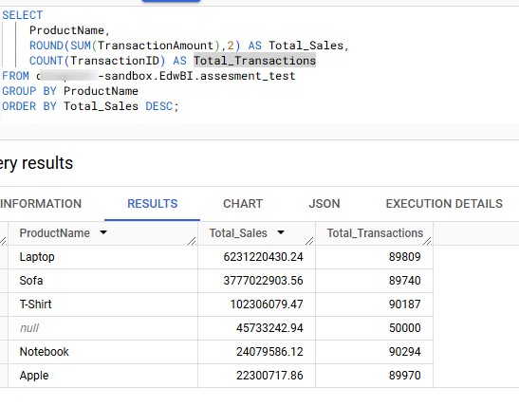

The data reveals that while products like **Laptops** and **Sofas** contribute most significantly to total sales, **T-shirts** and **Notebooks** have high transaction volumes but lower sales per transaction. Optimizing pricing strategies, marketing efforts, and bundling could improve the overall performance of all product categories. By targeting specific customer segments and using data-driven marketing tactics, the business can enhance both sales and customer engagement across product lines.

The **Laptop** and **Sofa** are the top-performing products, contributing significantly to total sales with high values and strong transaction counts, indicating high demand. The **T-Shirt** and **Notebook** have many transactions but comparatively lower total sales, suggesting they are lower-priced or sold in large volumes. The **Apple** product, while mid-range in total sales, enjoys a high number of transactions, highlighting strong adoption. Focusing on upselling or bundling strategies for these products could drive higher overall revenue.

**4) promotional sales**

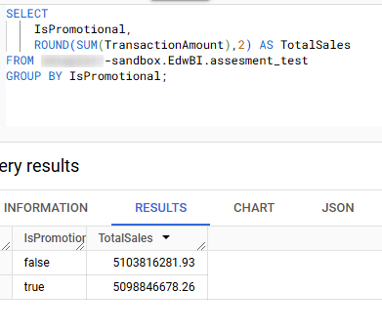

The analysis of promotional vs non-promotional sales provides valuable insights into the sales dynamics of the dataset. While promotional sales contribute significantly to overall revenue, non-promotional transactions still account for a larger share, indicating that customer loyalty and product demand play a substantial role in driving sales. The key conclusion is that promotions, although impactful, do not necessarily outperform regular sales in total volume, highlighting the importance of focusing on both customer retention and targeted promotional efforts.

**5)Return Rate**

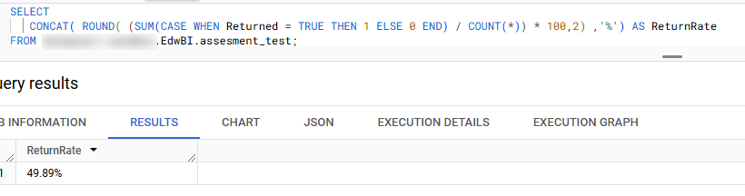

The Return Rate 49.89%, meaning that nearly half of the transactions in the dataset resulted in returns. This metric provides key insights into customer satisfaction and product quality, reflecting potential issues in either the products or the purchasing experience.

6) Sales by Age  
  
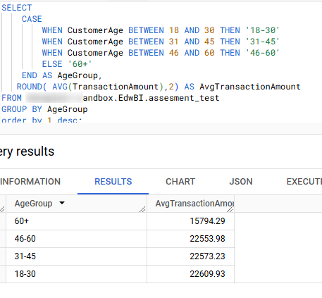

The analysis shows that younger customers (18-30) and middle-aged customers (31-45) have the highest average transaction amounts, indicating stronger purchasing power. Older customers (60+) exhibit the lowest spending, which may require tailored offerings or discounts to boost sales. Marketers should focus on younger and middle-aged segments for high-value transactions. Segmenting products and pricing based on age groups can optimize sales. Understanding these trends helps refine targeting strategies and improve customer satisfaction.