Flow diagram:
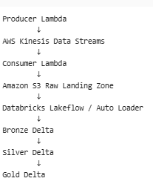
Sample Order from source system:
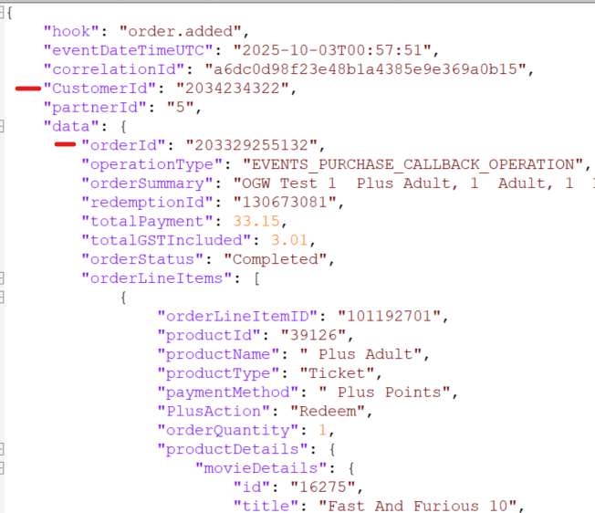
Data pushed from producer lambda to Kinesis:
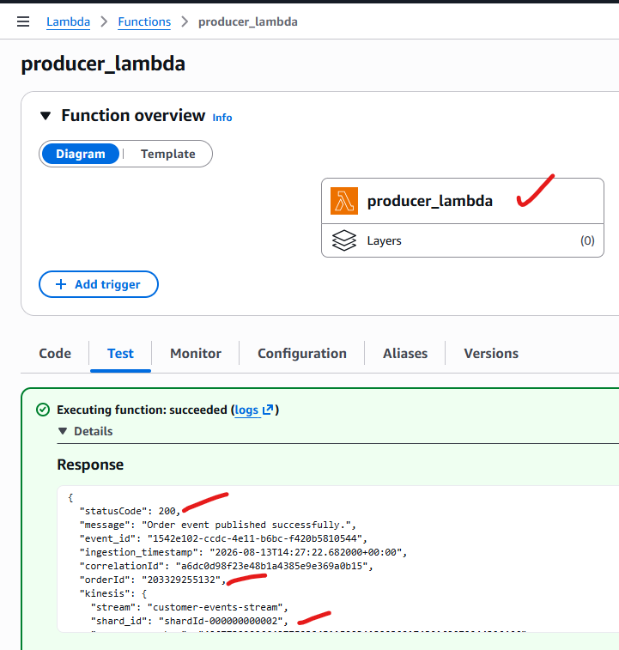
Data loaded into Kinesis:
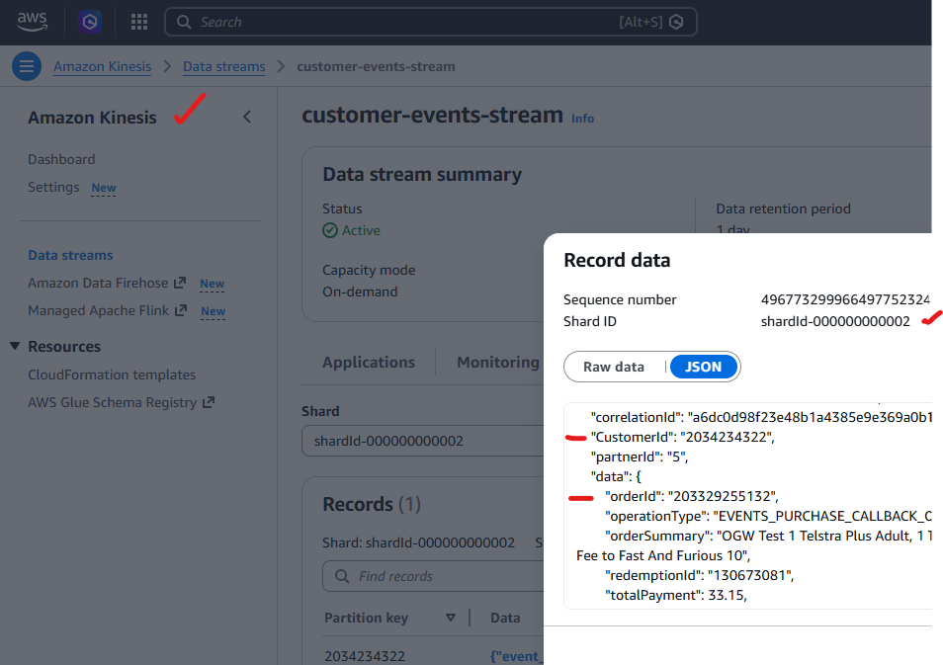
Consumer lambda reads from Kinesis and loads into S3 bucket
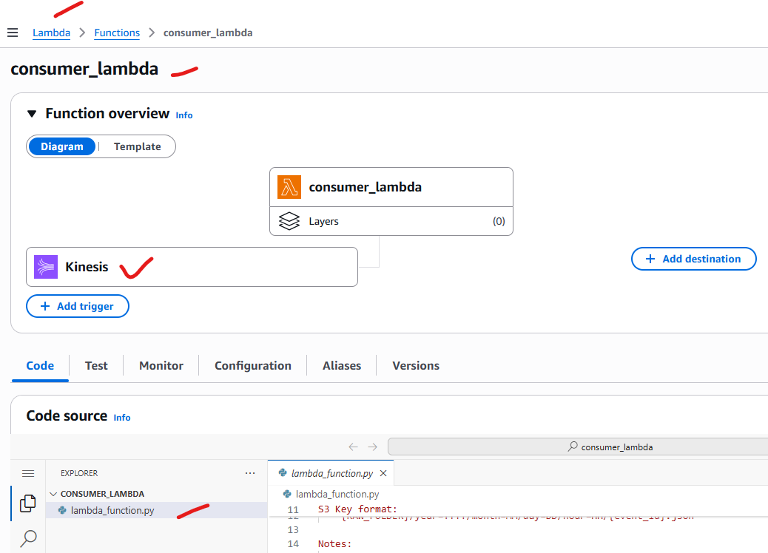
The same data is pushed and loaded in S3 bucket:
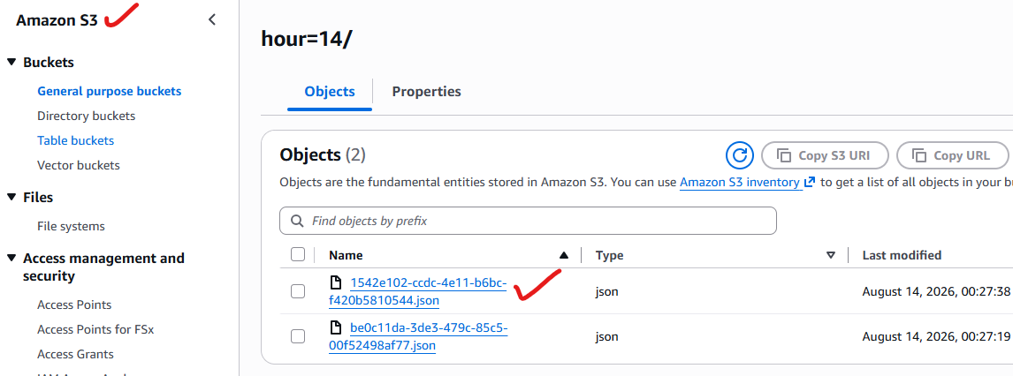

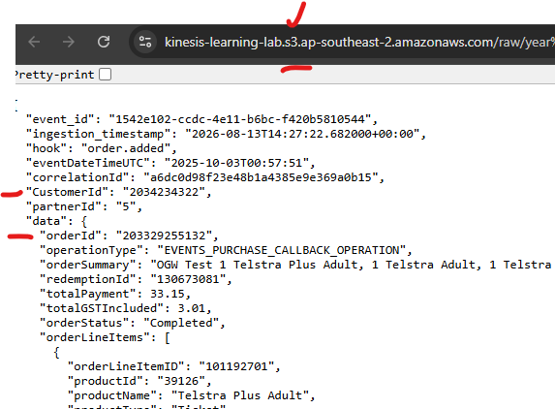

S3 bucket is able to access from Databricks:
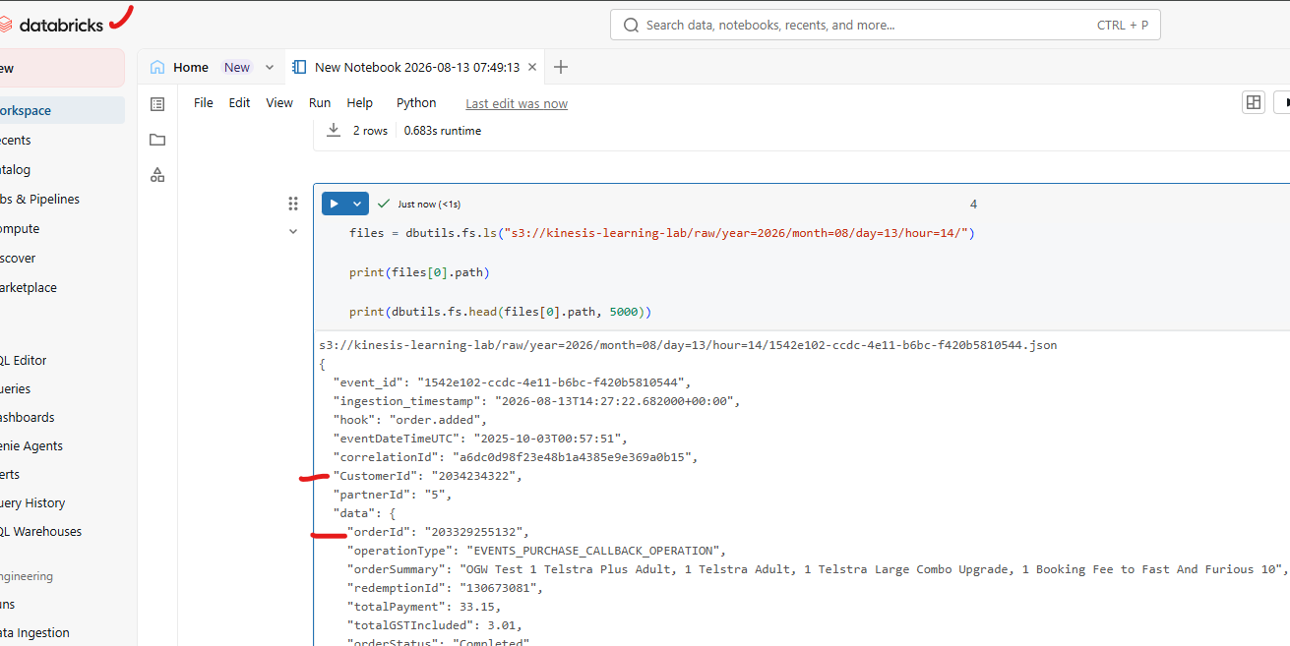
Data loaded into Bronze Delta table:
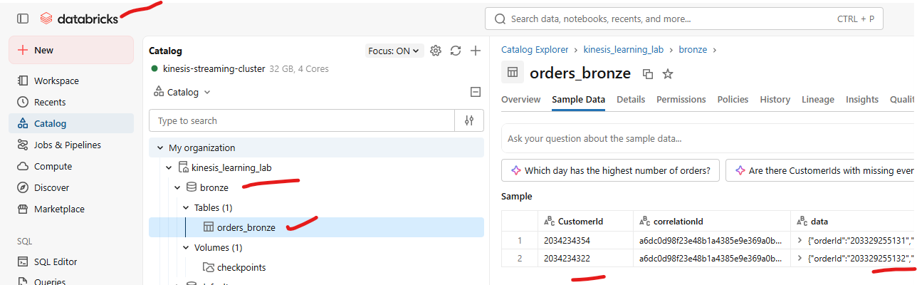
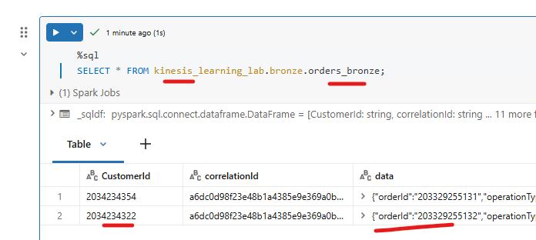
Silver Delta table:
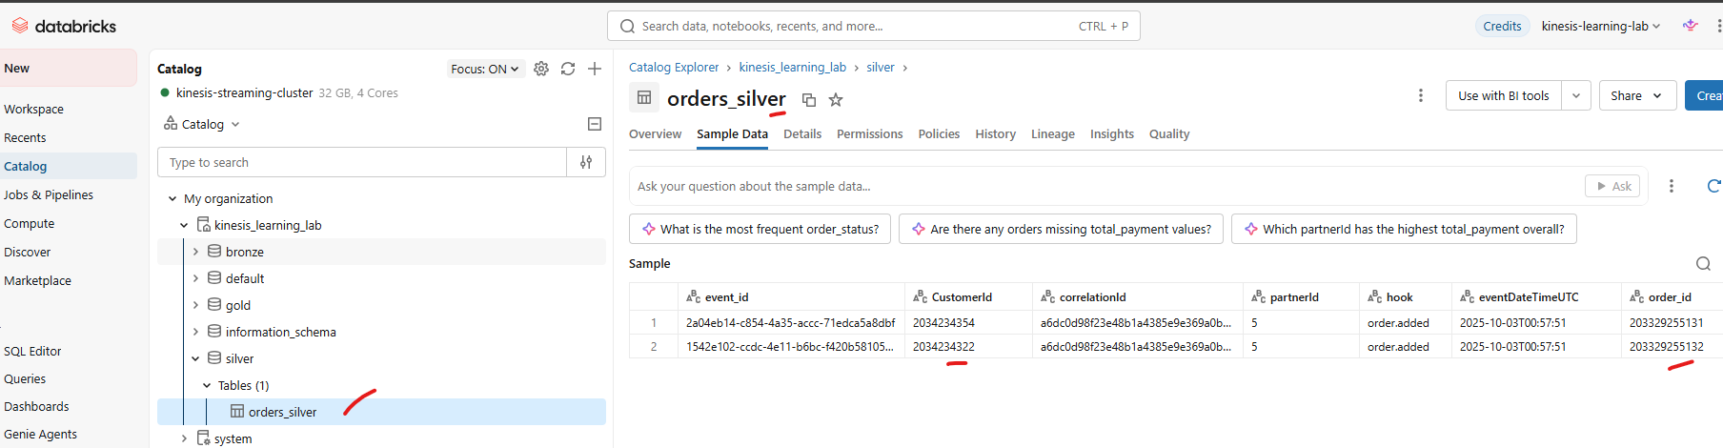
Schedule the code in pipelines: