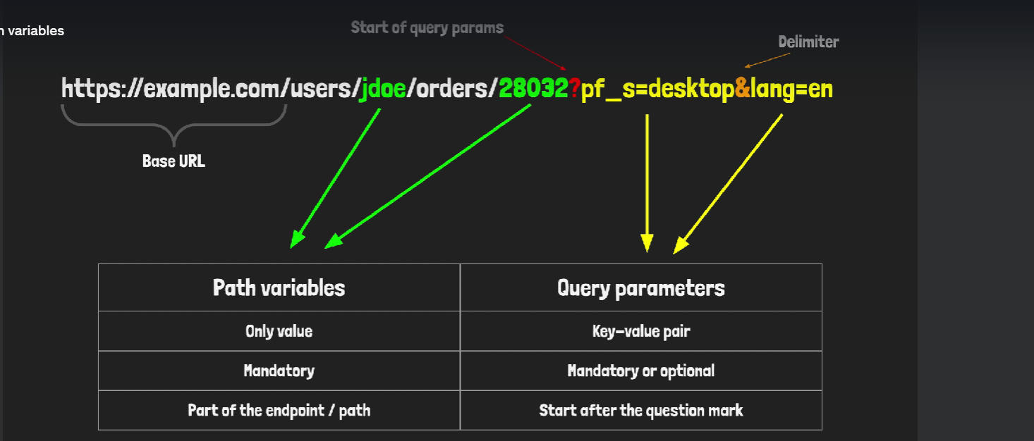

{
"accessToken": "5a11cf6302c2c4ca94a48430e63b4872b812527469a85805f22144b9fb053e41"
}

