Create and Manage PGP Keys

Step 1: gpg --gen-key



Step 2: Select 1

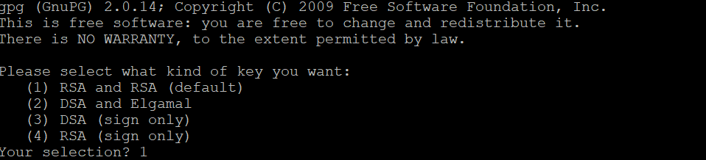

Step 3: Type 2048



Step 4: Enter the Year 2y



Step 5 Enter the key y



Step 6 Enter the Real Name & Email ID

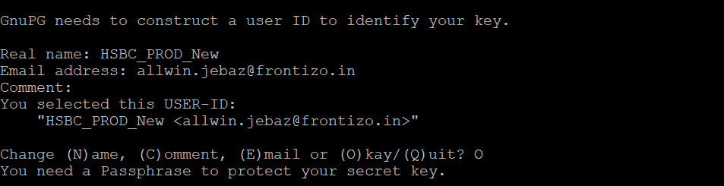

Step 7 Enter O

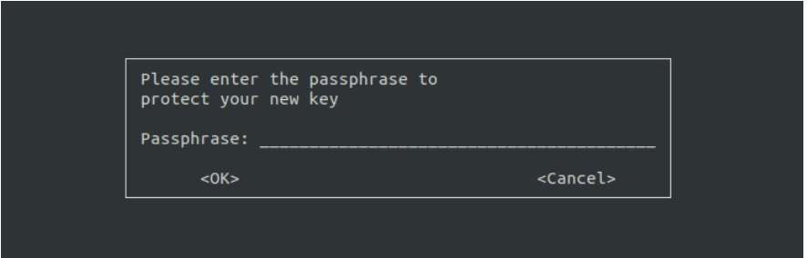

Enter the New passphrase & Repeat passphrase

Success fully Key created



Export the Public Key with Real Name



Export the Private Key with Real Name

Now convert **.asc** format into **.gpg** format for privatekey filename and share the .gpg filename.

Use command to convert from **.asc**  to **.gpg extension**:

**gpg -o filename.gpg --dearmor filename.asc**



Notes:

1. To view list of existing old public keys, use command :

**gpg --list-key**

1. To view list of existing old secret(private) keys, use command:

**gpg --list-secret-key**

1. To delete existing old public keys, use command :

**gpg --delete-key <serial number of key>**

1. To delete existing old secret(private) keys, use command :

**gpg** **--delete-secret-key <serial number of key>**