Required setup:

1 master node

2OSD (compute nodes)

1 monitoring node

Configured lab setup

10.10.121.194 muc4auludb194 - Master Node  
10.10.121.94  k8node1 - Compute node  
10.10.121.105 k8node2 - Compute node  
10.10.121.30  k8master - Monitoring

Create a user with name “**cephadm**” on all the nodes and we will be using this user for ceph deployment and configuration and Now assign admin rights to user cephadm via sudo (similarly create the same user in all the nodes)

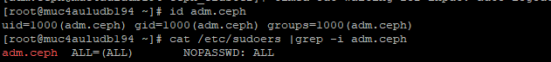

Configure Passwordless authentication from Ceph admin to all OSD and monitor nodes

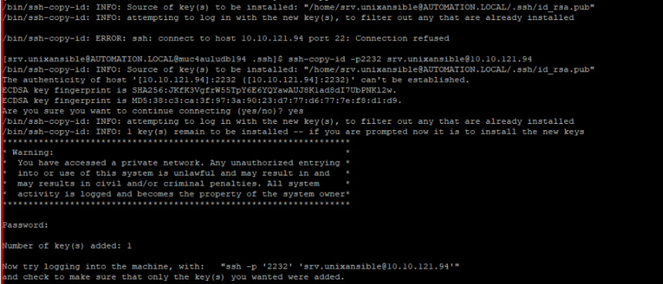

It recommended to add the following in the file “~/.ssh/config”

And chmod 644 ~/.ssh/config

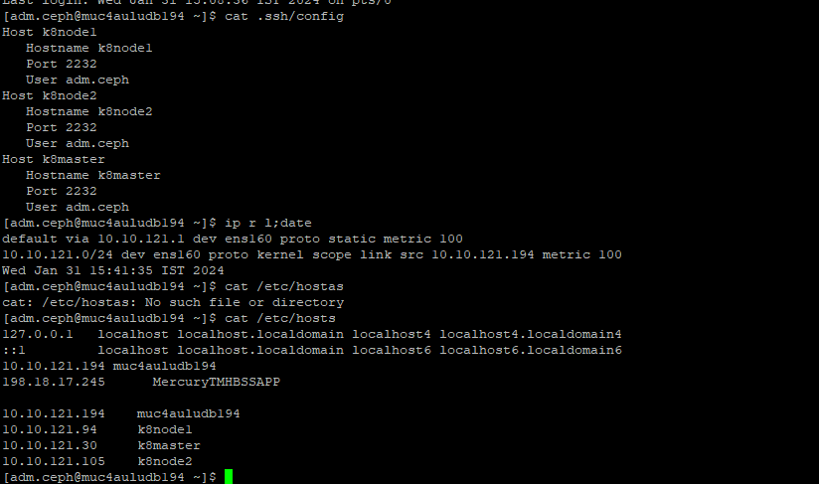

Configure Passwordless authentication from Ceph admin to all OSD and monitor nodes and Enable EPEL repository as well,

rpm -Uvh <https://download.ceph.com/rpm-mimic/el7/noarch/ceph-release-1-1.el7.noarch.rpm>

yum install -y <https://dl.fedoraproject.org/pub/epel/epel-release-latest-7.noarch.rpm>

Install the Ceph-deploy utility using the following yum command,

yum install ceph-deploy python2-pip -y

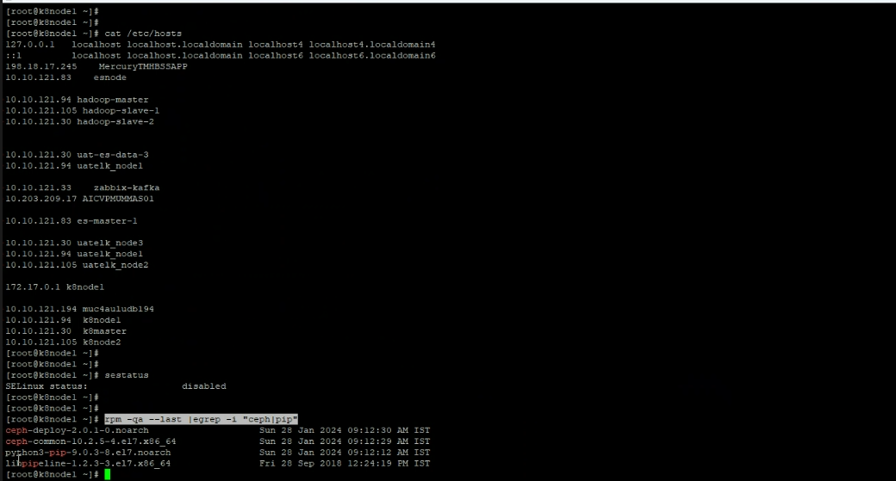

Now generate the cluster configuration by executing the ceph-deploy utility on ceph-admin node, we are registering ceph-monitor node as monitor node in ceph cluster. Ceph-deploy utility will also generate “**ceph.conf**” in the current working directory.

ceph-deploy new k8master

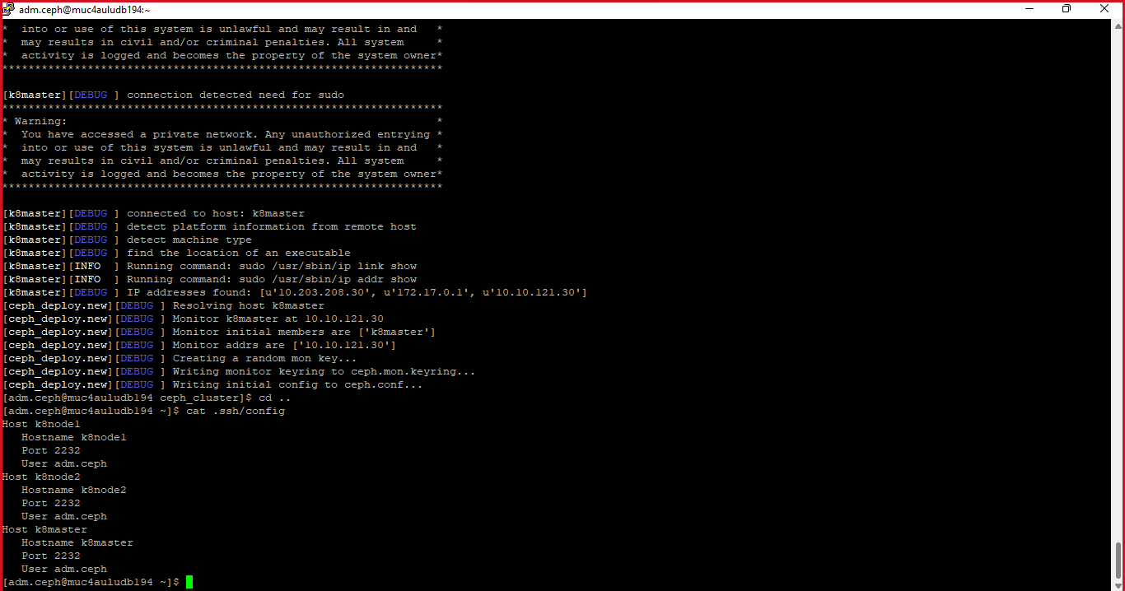

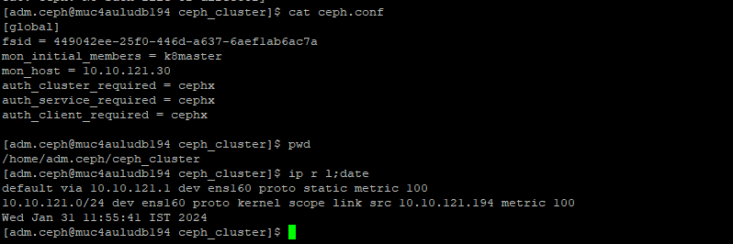

Update Network address (public network) under the global directive in**ceph.conf** file,  Here Public network is the network on which Ceph nodes will communicate with each other and external client will also use this network to access the ceph storage,

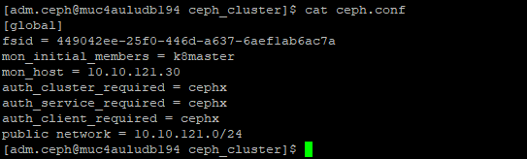

Now Install ceph on all the nodes from the ceph-admin node, run the “**ceph-deploy install**” command

Before this installation make sure EPEL repo available on all the nodes to install the dependencies for CEPH and internet should be mandatory

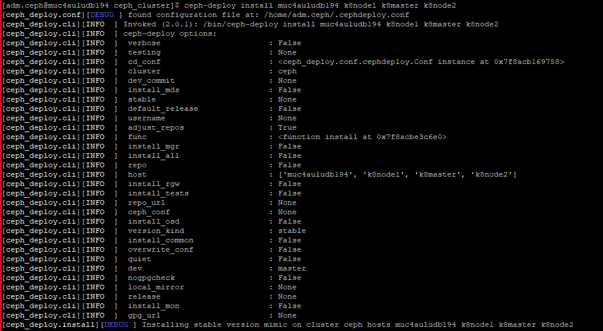

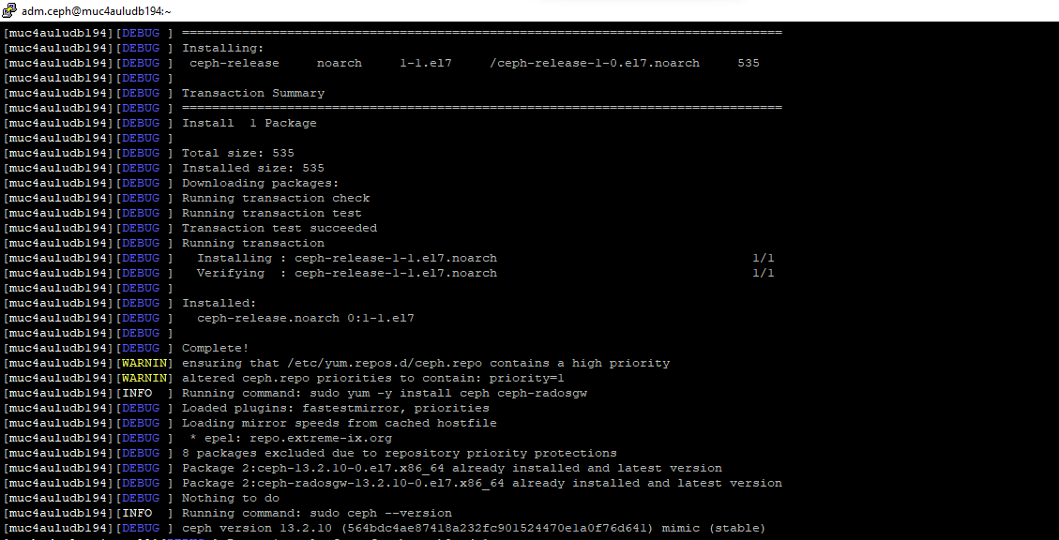

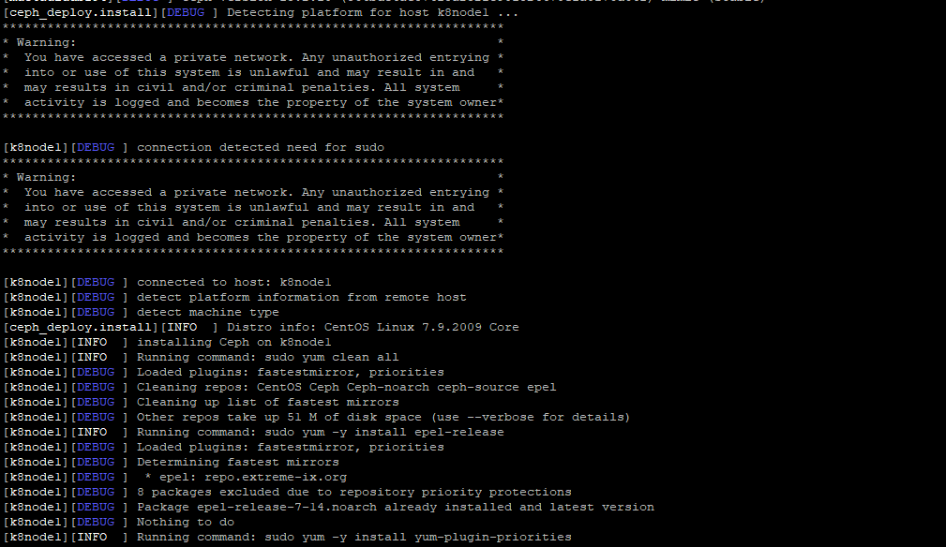

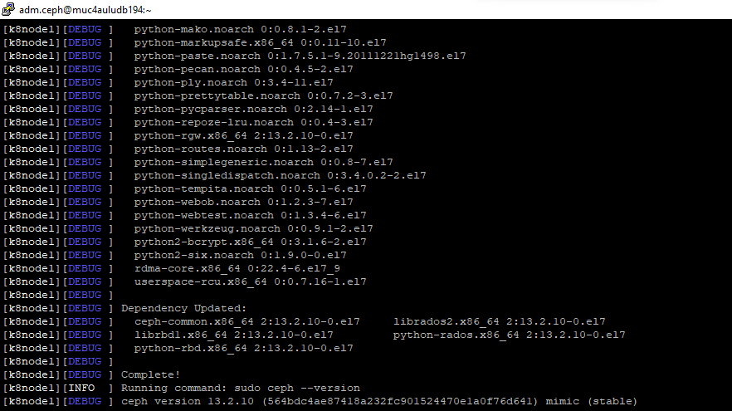

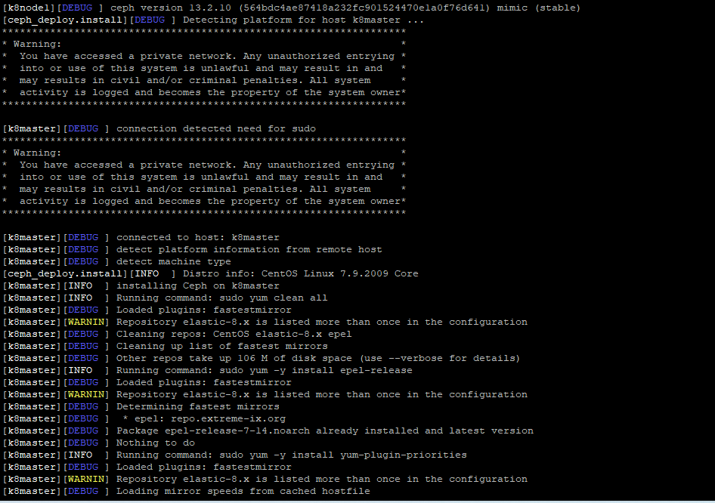

Execute “**ceph-deploy mon create-initial**” command from ceph-admin node, it will deploy the initial monitors and gather the keys.

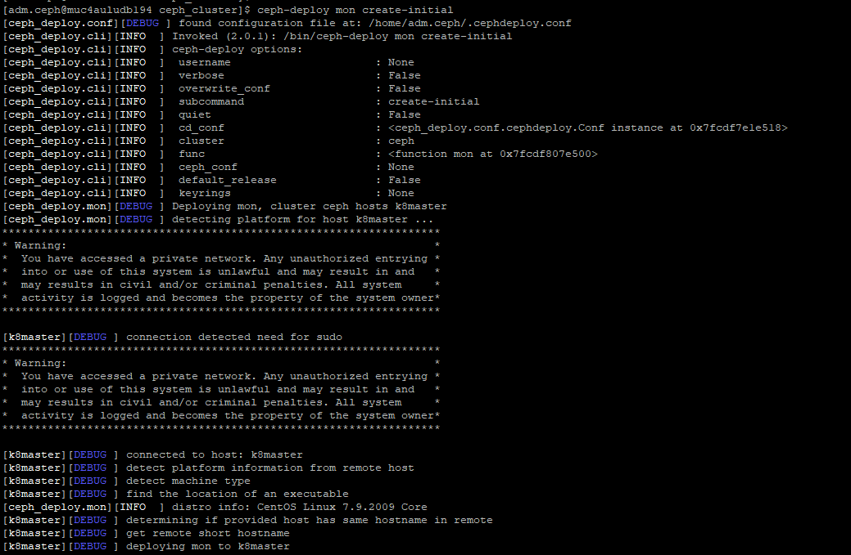

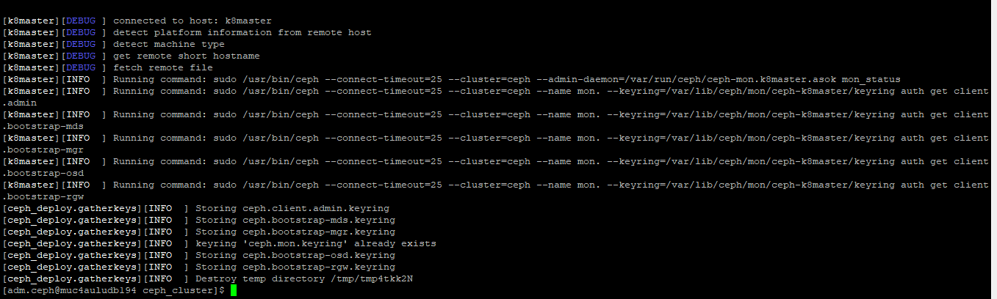

Execute “**ceph-deploy admin**” command to copy the configuration file from ceph-admin node to all ceph nodes so that one can use ceph cli command without specifying the monitor address.

ceph-deploy admin muc4auludb194 k8node1 k8master k8node2

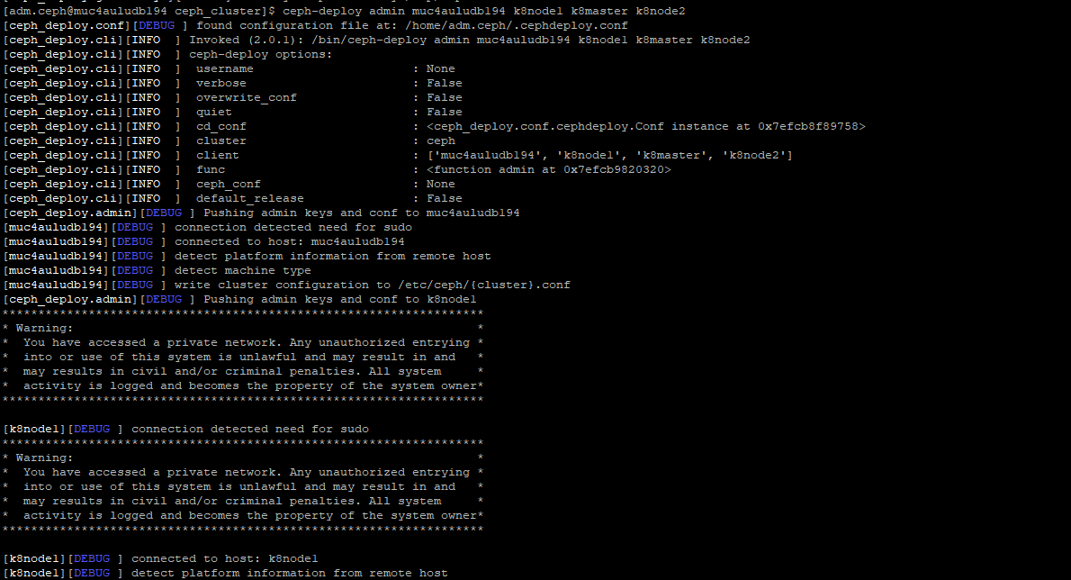

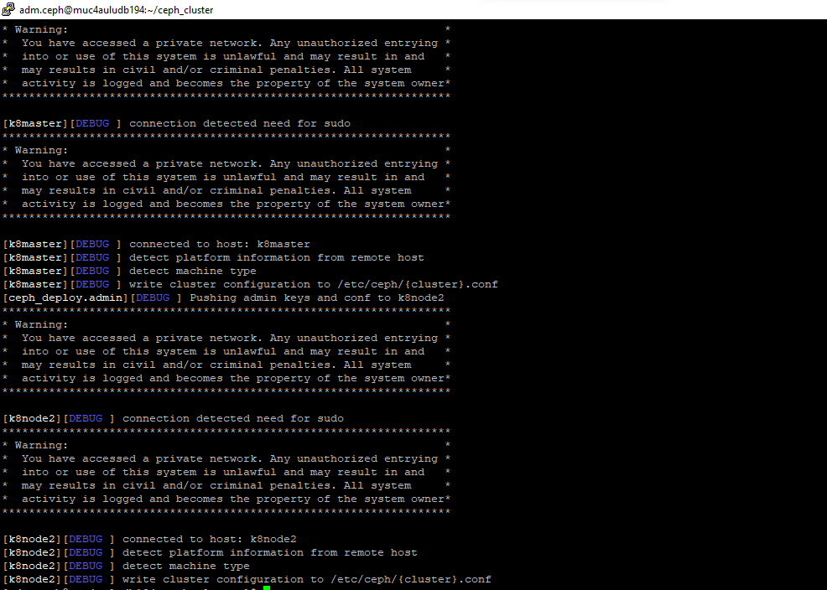

Install the **Manager daemon** from Ceph-admin node on Ceph Compute Nodes (OSD) using the following command

(here we are including mon node as compute node)

ceph-deploy mgr create k8node1 k8node2 k8master

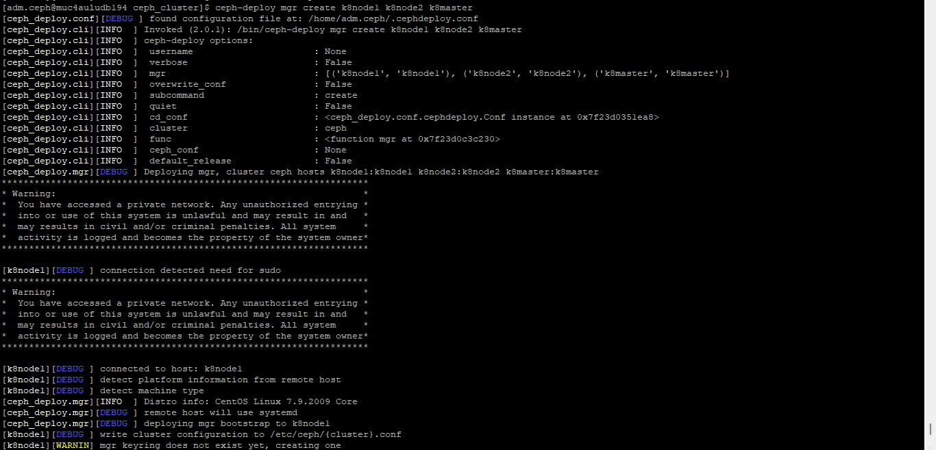

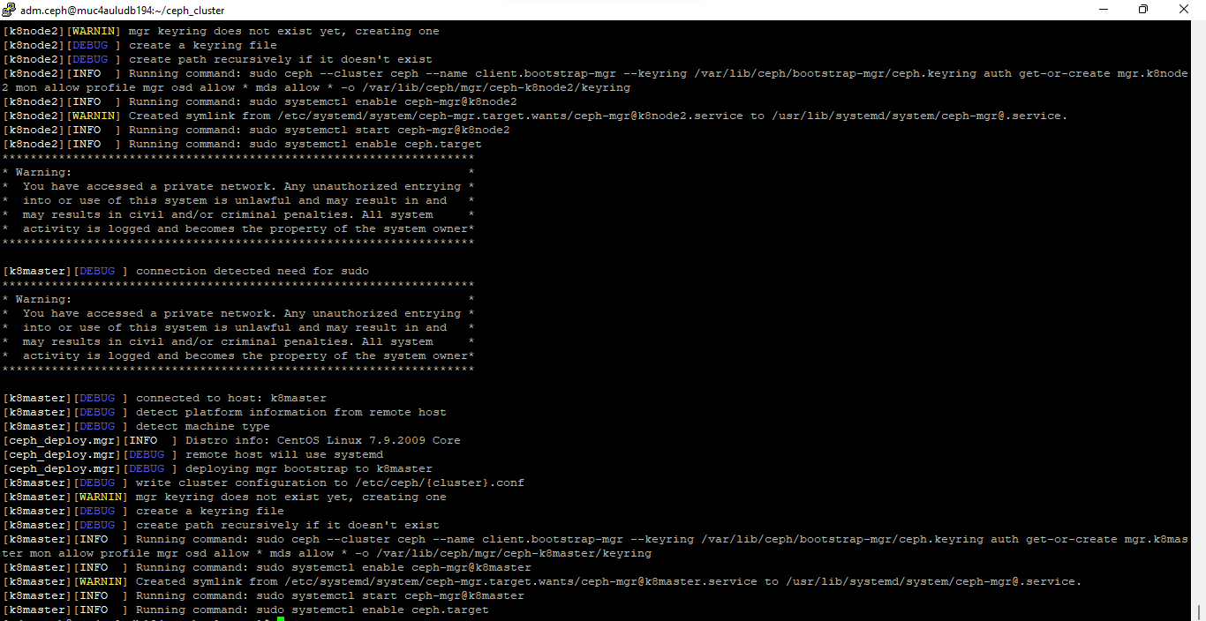

Let’s verify whether ceph-deploy utility can see these disks or not. Run the “**ceph-deploy disk list**” command from ceph-admin node,

ceph-deploy disk list k8node1 k8node2 k8master

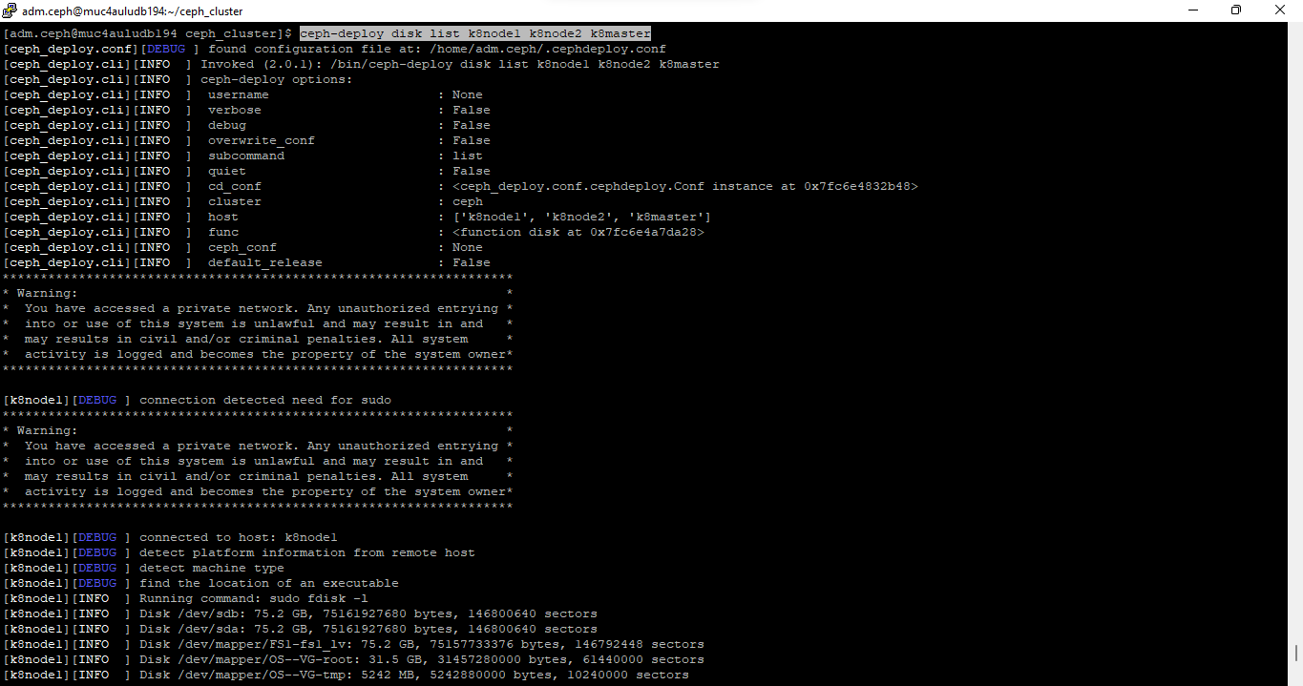

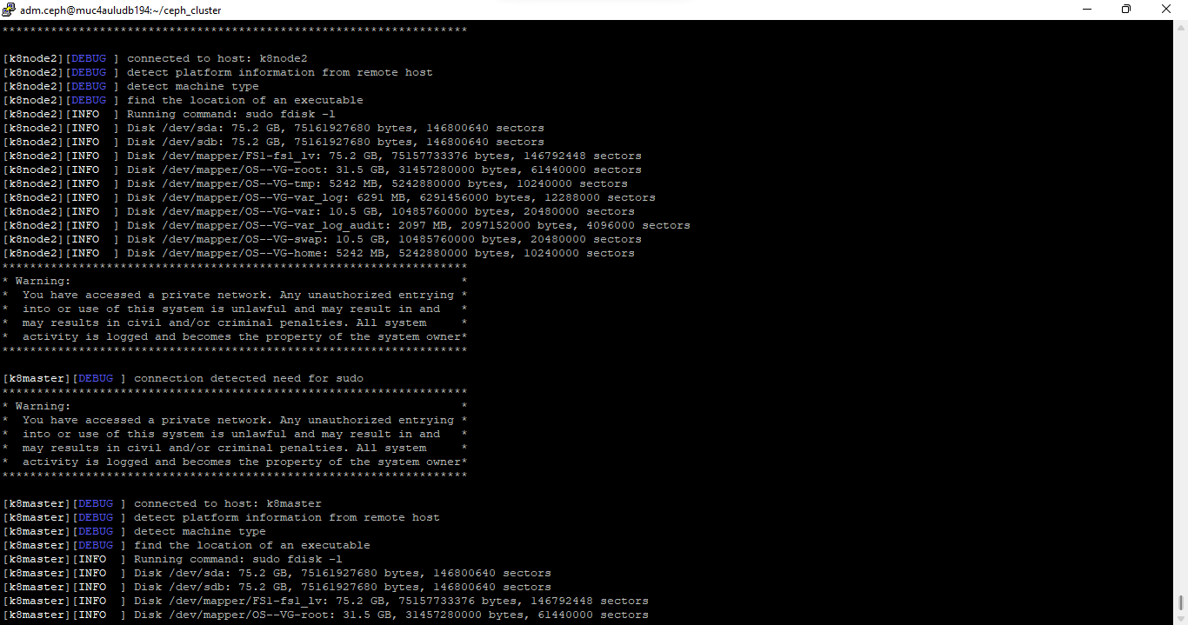

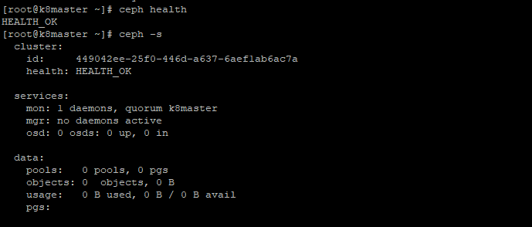

**Note:** Make sure these disks are not used anywhere and does not contain any data

To clean up and delete data from disks use the following commands,

ceph-deploy disk zap k8node1 /dev/sdc

ceph-deploy disk zap k8node1 /dev/sdd

ceph-deploy disk zap k8node2 /dev/sdc

ceph-deploy disk zap k8node2 /dev/sdd

ceph-deploy disk zap k8master /dev/sdc

ceph-deploy disk zap k8master /dev/sdd

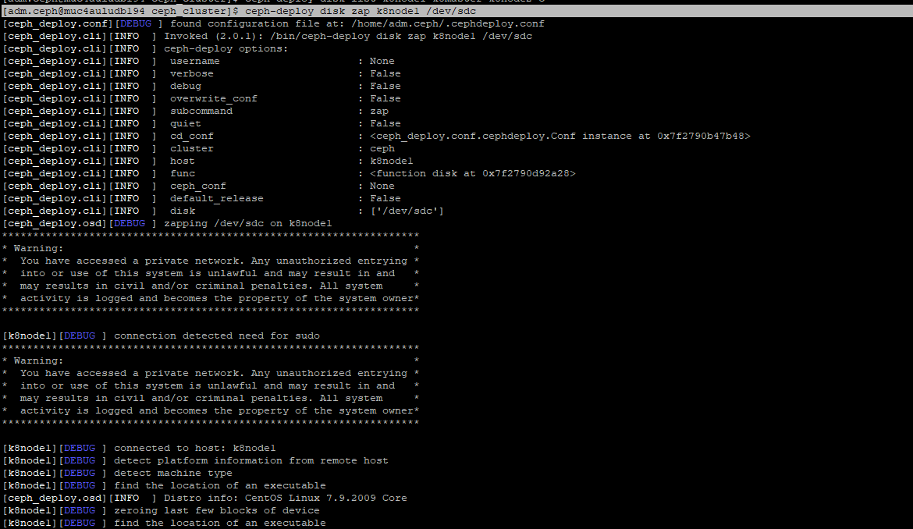

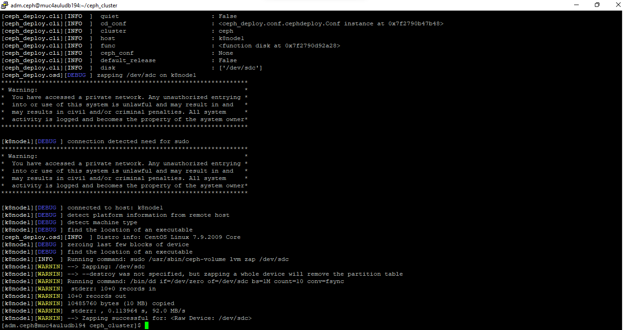

Now Mark these disks as OSD using the following commands

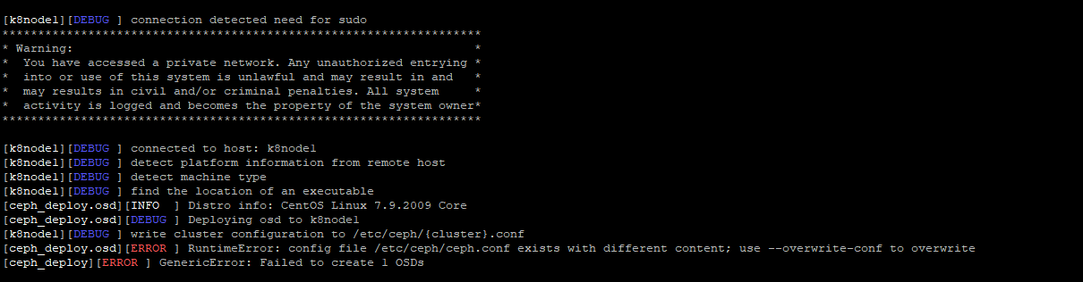

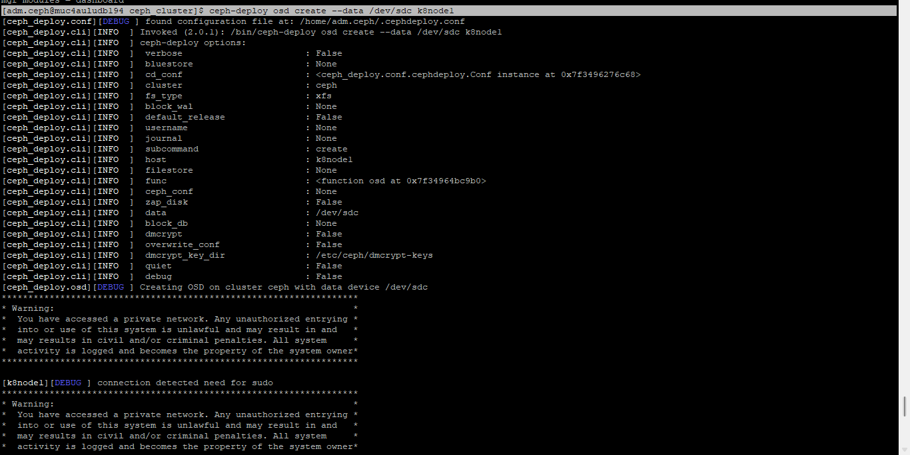

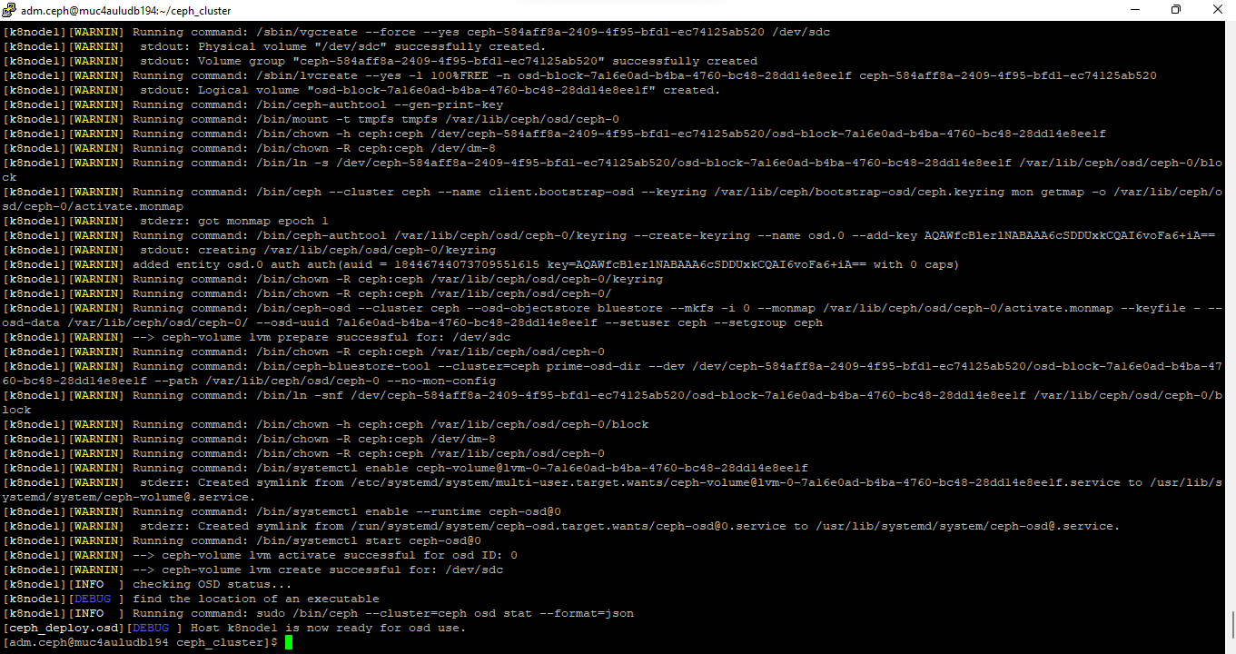

Once the disks are configured under Ceph we could see the respective path will be configured on disk

