**TOPIC: Report on Tribute to Frontline Corona Warriors**

**Name : Anilkumar. S.K**

**College : Vivekananda Institution Of Technology**

**USN : 1VK17CS004**

## Overview

**In response to COVID-19, countries around the world have put in place a range of public health and social measures, which are actions by individuals, institutions, communities, local and national governments, and international bodies, to suppress or stop community spread of COVID-19. The purpose of this document is to provide an overview of public health and social measures, and to propose strategies to limit any possible harm resulting from these interventions. The document is intended to inform national and local health authorities and other decision-makers at all levels.**

## About Warriors

## Needless to say, doctors, nurses and people working in health-care sectors are particularly vulnerable to the highly infectious disease. In response to the global pandemic, the under-resourced doctors are facing unprecedented challenges.

## The list of the sleep-deprived heroes includes doctors, nurses, medical cleaners, pathologists, paramedics, ambulance drivers, and health-care administrators. In the fight against coronavirus, the brave medical army stands strong with thermometers, stethoscopes, and ventilators as their weapons. Not to forget, medical researchers are working day in and night out against all odds, hoping to find the antidote to the disease.

## Healthcare workers, sanitation staff, those who run grocery and medical shops, government officals in general –- all of form the frontline in the battle against the novel coronavirus, but the police are in the frontline of the frontline.

## The Covid-19 outbreak has brought our lives to a standstill and has confronted the entire world with a crisis like ever before, redefining the way we exit. With numerous businesses across the world having had to pull their shutters, and most countries being under lockdown, the economy has taken a severe hit, forcing everyone to fight the pandemic in the best way they can.

## Since the beginning of the outbreak, healthcare professionals have truly been selfless warriors, giving everthing to upload their job responsibilities, even at the cost of cutting themselves off from their families and loved ones.

**Although most doctors have experienced the gratification of healing patients and saving their lives, many battles have also been lost along the way with several doctors going to the extent of even sacrificing their own lives in the line of duty.**

**Doctors, nurses and many others in the healthcare sector have donned the role of a brave medical army fighting coronavirus, standing strong with thermometers, stethoscopes and ventilators as their weapons.**

## Prevention

**Although there is no vaccine available to prevent COVID-19, you can take steps to reduce your risk of infection. WHO and CDC recommend following these precautions for avoiding COVID-19:**

* **Avoid large events and mass gatherings.**
* **Avoid close contact (within about 6 feet, or 2 meters) with anyone who is sick or has symptoms.**
* **Stay home as much as possible and keep distance between yourself and others (within about 6 feet, or 2 meters), especially if you have a higher risk of serious illness. Keep in mind some people may have COVID-19 and spread it to others, even if they don't have symptoms or don't know they have COVID-19.**
* **Wash your hands often with soap and water for at least 20 seconds, or use an alcohol-based hand sanitizer that contains at least 60% alcohol.**
* **Cover your mouth and nose with your elbow or a tissue when you cough or sneeze. Throw away the used tissue. Wash your hands right away.**
* **Avoid touching your eyes, nose and mouth.**
* **Avoid sharing dishes, glasses, towels, bedding and other household items if you're sick.**
* **Clean and disinfect high-touch surfaces, such as doorknobs, light switches, electronics and counters, daily.**
* **Stay home from work, school and public areas if you're sick, unless you're going to get medical care. Avoid public transportation, taxis and ride-sharing if you're sick.**

## Tool Used

## Visual Studio Code

## Live Server

## Source Code

## //HTML Code//

## <!-----Author @ Anilkumar S K--------->

## <!DOCTYPE html>

## <html lang="en">

## <head>

## <meta charset="UTF-8">

## <meta name="viewport" content="width=device-width, initial-scale=1.0">

## <title>Tribute page</title>

## <link rel="stylesheet" type="text/css" href="style.css">

## </head>

## <body>

## <!-----header--------->

## <div class="header">

## <div class="a1">

## <h1 class="a2">A TRIBUTE TO FRONTLINE CORONA WARRIORS</h1>

## </div>

## </div>

## <!-----end of header--------->

## <!-------image------->

## <div class="a3">

## <img src="images/img.jpg" alt="" class="img" width="100%" height="500px">

## <div class="middle">

## <div class="text"><b>"What would the world look like without you?you have such an important job to do.

## I so admire what you to do make this a better world for all of us. I cannot express my

## admiration and gratitude in words!"</b>

## <br><b><i>THANK YOU!.....</i></b></p>

## </div>

## </div>

## </div>

## <!-----end of image--------->

## <!-----gallery--------->

## <div class="g1">

## <div class="responsive">

## <div class="gallery">

## <img src="images/doctor.jpg" alt="" width="600" height="400">

## <div class="desc">Thank you! Thank you for working your butts off during this pandemic.

## I appreciate that you're risking your health to care for our community. I'm staying

## home to do my part. I wish you rest, and quiet from the storm

## Once again, thank you.<hr> <b><i>Thank You!</i></b>

## </div>

## </div>

## </div>

## <div class="responsive">

## <div class="gallery">

## <img src="images/police.jpg" alt="" width="600" height="400">

## <div class="desc1">I just wanted to let you know how much we appreciate your efforts on

## a daily basis in protecting us and maintaining the stability of our county.

## Once again, thank you for always on the front line of danger for us to be safe.<hr> <b><i>Thank You!</i></b></div>

## </div>

## </div>

## <div class="responsive">

## <div class="gallery">

## <img src="images/courier.jpg" alt="" width="600" height="400">

## <div class="desc2">Thank you for working your butts off during this pandemic.Thank you for risking your lives to

## deliver the essential needs during this panademic sutiations.

## Once again, thank you for always on the front line of danger for us to be safe.<hr><b><i>Thank You!</i></b>

## </div>

## </div>

## </div>

## <div class="responsive">

## <div class="gallery">

## <img src="images/ambulance.jpg" alt="" width="600" height="400">

## <div class="desc3">Thank You! Emergency services workers

## I appreciate that you're risking your health to care for our community.Thank you for risking your lives.

## Once again, thank you for always on the front line of danger for us to be safe.<hr> <b><i>Thank You!</i></b>

## </div>

## </div>

## </div>

## </div>

## <!-----end of gallery--------->

## <img src="images/img4.jpg" alt="" class="img" width="100%" height="500px">

## <div class="abc"> <hr>

## <p><b><i>THANK YOU!....</i></b></p><hr></div>

## </body>

## </html>

## //CSS Code//

## Body {

## margin: 0;

## font-family : Arial;

## font-size: 18px;

## }

## @keyframes animate

## {

## 0%

## {

## filter:hue-rotate(0deg);

## }

## 100%

## {

## filter:hue-rotate(360deg);

## }

## }

## .a1{

## position: absolute;

## top:0;

## left: 0;

## width:100%;

## height: 15%;

## background:#00adff;

## z-index:1;

## mix-blend-mode:color ;

## animation:animate 10s linear infinite;

## display:flex;

## justify-content: center;

## align-items: center;

## overflow:hidden;

## }

## .a2{

## text-shadow: 0 0 10px rgba(255,255,255,1),

## 0 0 20px rgba(255,255,255,1),

## 0 0 40px rgba(255,255,255,1),

## 0 0 80px rgba(255,255,255,1),

## 0 0 160px rgba(255,255,255,1);

## }

## .header,.a3{

## max-width: 100%;

## margin-top: 95px;

## }

## div.gallery {

## border: 1px solid #ccc;

## }

## div.gallery img {

## width: 100%;

## height: 200px;

## }

## div.desc {

## padding: 15px;

## text-align: center;

## color: green;

## }

## div.desc1 {

## padding: 15px;

## text-align: center;

## color: blue;

## }

## div.desc2 {

## padding: 15px;

## text-align: center;

## color:salmon;

## }

## div.desc3 {

## padding: 15px;

## text-align: center;

## color: violet;

## }

## * {

## box-sizing: border-box;

## }

## .responsive {

## padding: 0 6px;

## float: left;

## width: 24.99999%;

## margin-bottom: 30px;

## margin-top: 20px;

## }

## .g1{

## margin-top: 20px;

## }

## .img{

## opacity: 1;

## display: block;

## transition: 0.5s ease;

## backface-visibility: hidden;

## }

## .middle {

## transition: .5s ease;

## opacity: 0;

## position: absolute;

## top: 50%;

## left: 50%;

## transform: translate(-50%, -50%);

## -ms-transform: translate(-50%, -50%);

## text-align: center;

## }

## .a3:hover .img {

## opacity: 0.6;

## }

## .a3:hover .middle {

## opacity: 1;

## }

## .text {

## font-size: 30px;

## padding: 16px 32px;

## mix-blend-mode:color ;

## animation:animate 1s linear infinite;

## color: green;

## font-family: 'Lucida Sans', 'Lucida Sans Regular', 'Lucida Grande', 'Lucida Sans Unicode', Geneva, Verdana, sans-serif;

## text-shadow: 0 0 10px rgba(255,255,255,1),

## 0 0 20px rgba(255,255,255,1),

## 0 0 40px rgba(255,255,255,1),

## 0 0 80px rgba(255,255,255,1),

## 0 0 160px rgba(255,255,255,1);

## }

## .abc{

## text-align: center;

## color: red;

## font-size: larger;

## }

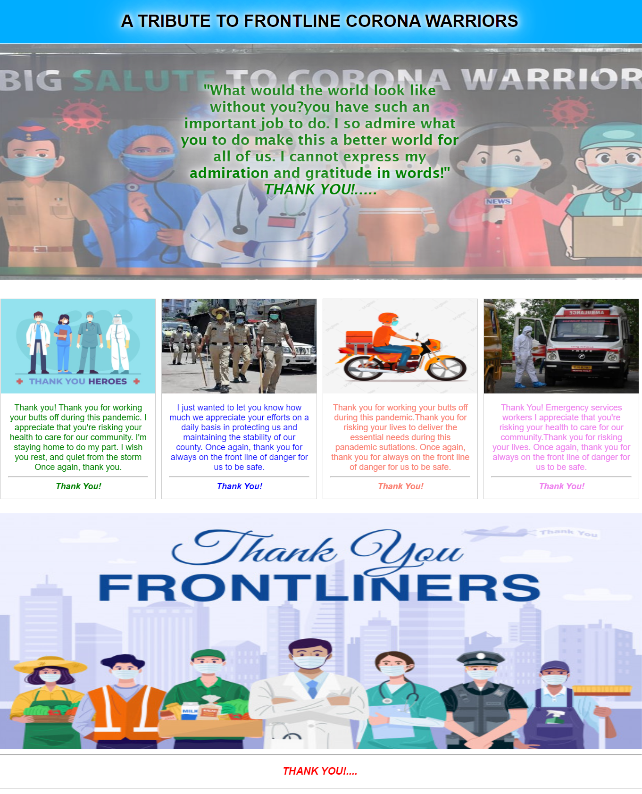

Fig: Website Page