# Model 1:

Jsp and servlet are the main technologies to create web pages.

**Servlet** is superior to CGI.servlet doesn’t creates process,rather it creates thread bcz by creating thread we cant provide separate memory area.thats why many subsequent threads are handled by the servlet.

Business and presentation logic are not separated.

Recompile the servlet when any designing code is modified.

**Jsp** overcomes all the problems of servlet.here the business and presentation logics are separated.

No need to redeploy the project when designing code is modified.

Jsp provides the support to develop the web pages using javaBean,JSTL and custom tags.

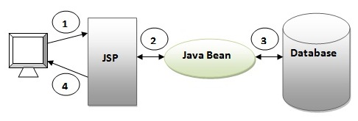

1.the request goes to the jsp page.

2.jsp page accesses the javaBean and invokes business logic.

3.javaBean connects to the database save/get the data.

4.the response sent back to the browser.

# Advantage of Model 1 Architecture

Easy and Quick to develop web application

# Disadvantage of Model 1 Architecture

1.Navigation control is decentralized since every page contains the logic to determine the next page. If JSP page name is changed that is referred by other pages, we need to change it in all the pages that leads to the maintenance problem.

2.Time consuming You need to spend more time to develop custom tags in JSP. So that we don't need to use scriptlet tag.

3.Hard to extend It is better for small applications but not for large applications.

Model2:

Model2 based on MVC design pattern.It consists of three modules Model,View and Controller.

Model: It connects to the database and invokes the business logic,stores the data.

View: it displays data.

Controller: It is interface between model and view.

It receives all the requests and commands to model/view to change accordingly.

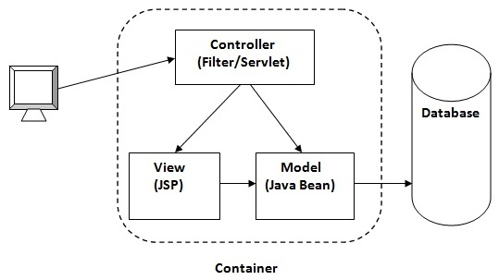

Navigation control is centralized Now only controller contains the logic to determine the next page.

Easy to maintain

Easy to extend

Easy to test

Better separation of concerns

Disadvantage of Model 2 (MVC) Architecture

We need to write the controller code self. If we change the controller code, we need to recompile the class and redeploy the application.