GitHub Course
- Git & GitHub both are different
- GitHub – It is one example of Remote Repository Hosting Service.
- Git – It is a Version Control System (VCS)
- For example, we’re creating a website which having traffic. Developers add updates regularly and redeploy the website.
- In software development knowingly or unknowingly received some bugs. If the developer provides an update and it contains some bugs but the update was deployed in website already then at some point of time the website will crash and the user experience will be affected.
- Then the developer needs to revert back the updates as soon as possible. After that resolve the bugs and then deploy the updates in website.
- If the developer needs to revert back to older version that version should be stored somewhere else then only, he can revert it back to older version otherwise cannot.
- So, to store the Version changes & Project saving the developers used Version Control System (VCS) which is a remote server.
- Git is one of the Version Control Systems which is a remote server.

- Remote Repository: -
- It’s just a package or folder for a project which deployed in remote server
- This Remote repository hosting service is GitHub.

- To upload files/folders in git repository: -
- First, go to the command prompt and initialize the respective folder by using the command git init.
- F:\My_Courses>git init
Initialized empty Git repository in F:/My_Courses/.git/
- Once initialized the folder the .git hidden file will create automatically. It means the folder was initialized in the Git.
- And check whether that folder contains any files or not using command
git status.

- Create a file whatever the extension like .txt etc., in the initialized folder and check the status of it using git status command.
- F:\My_Courses>git status
On branch master
No commits yet
Untracked files:
(use "git add <file>..." to include in what will be committed)
AWS/
Cloud_Engineer_RoadMap
Cloud_Engineer_RoadMap_Pdf.pdf
DEVOPS/
Javascript/
Networking_Course
Redhat_Cert/
SQL/
VS_Code/
nothing added to commit but untracked files present (use "git add" to track)

- Git Flow: -
- Working directory (git init)

Staging Area (git add)

Local Repository (git commit)

Remote Repository (git push)
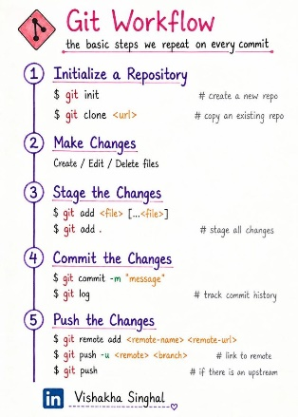

- Git status - It shows the files present in working directory and staging area
- F:\My_Courses\AWS>git status
On branch master
No commits yet
Changes to be committed:
(use "git rm --cached <file>..." to unstage)
new file: AWS_02.txt
Untracked files:
(use "git add <file>..." to include in what will be committed)
247909766-12cc10b6-724c-42c9-b07b-d8a7ce124e24.png
AWS/
AWS_Credentials.log
- In the above output, AWS_02.txt file is in Staging area. Once, the file gets committed then it moves to Local Directory.
- To commit the file the command is
git commit -m “AWS learning file2”
F:\My_Courses\AWS>git commit -m "AWS learning file2" AWS_02.txt
[master (root-commit) aba2fc6] AWS learning file2
1 file changed, 181 insertions (+)
create mode 100644 AWS_02.txt

- In GitHub, create a repository and then push the file in to the repository. Then, the file moves from Local directory to Remote repository.
- git remote add origin https://github.com/Anilsiva/anil-calculator-project.git
- F:\My_Courses\AWS>git branch
* master
- git push -u origin master
- F:\My_Courses\AWS>git push -u origin master
info: please complete authentication in your browser...
Enumerating objects: 3, done.
Counting objects: 100% (3/3), done.
Delta compression using up to 4 threads
Compressing objects: 100% (2/2), done.
Writing objects: 100% (3/3), 4.14 KiB | 1.38 MiB/s, done.
Total 3 (delta 0), reused 0 (delta 0), pack-reused 0 (from 0)
To https://github.com/Anilsiva/anil-calculator-project.git
* [new branch] master -> master
branch 'master' set up to track 'origin/master'.

- Branches: -
- git branch – this command is used to find what are the existing branches on the repo.
- git checkout – this command is used to jump between the branches
- git checkout -b “copy1” – this command is used to create a new branch and move into it.
- git push --set-upstream origin copy1 – this command will push the code to copy1 branch.

