S3 TASKS:

1. Create s3 bucket and upload some objects to s3.

Step1:- I am opening aws console then I am searching s3 serviece

Step2:- then open s3 serviece

Step3:-then I have taken create bucket option

Step4:-I heve mention bucket name riyazanna

Step5:- I have create one s3 bucket

Step6:-then click on create bucket

Step7:-then click on upload option then add files in my local machine

Then click on save

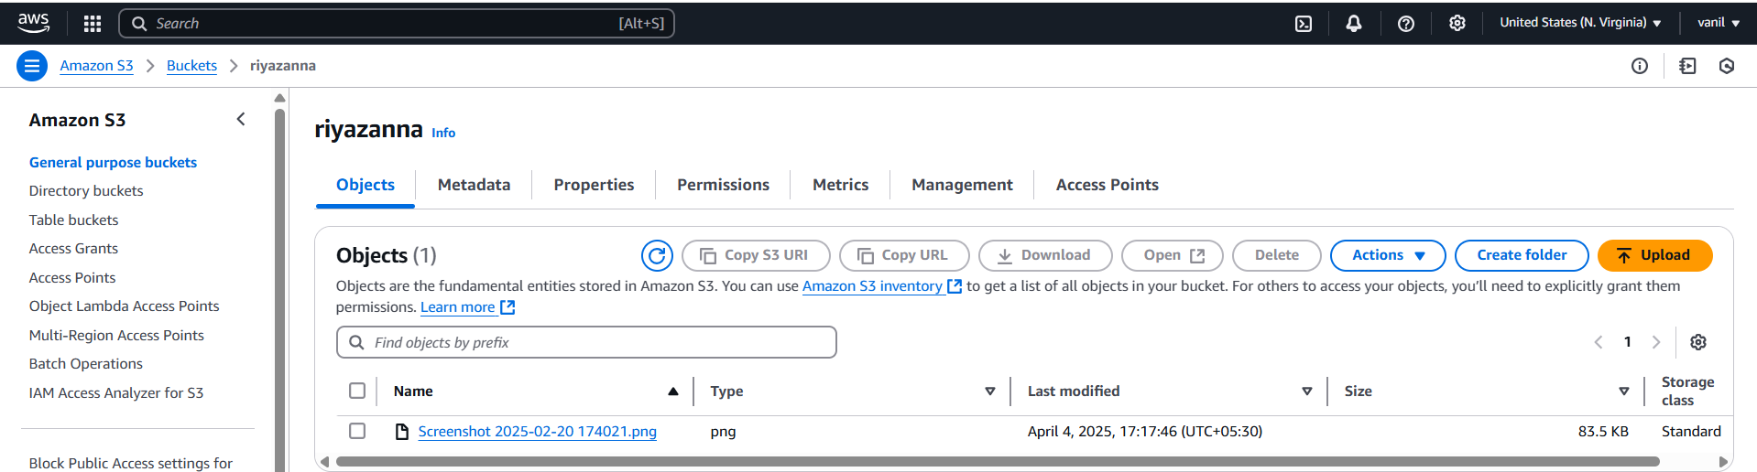

1. Deploy static website in s3 bucket.

Step1:- first I have create txt.file then I have add welcome to s3 bucket content inside txt.file

Step2:-then goto my s3 bucket then click on already created bucket then upload txt.file

Step3:-then I have given make public using acl then click on save option

Step4:-then click on object overview then copy to object url

Step5:-then I have taken new tab in browser then paste that url then click on enter then it will show the output

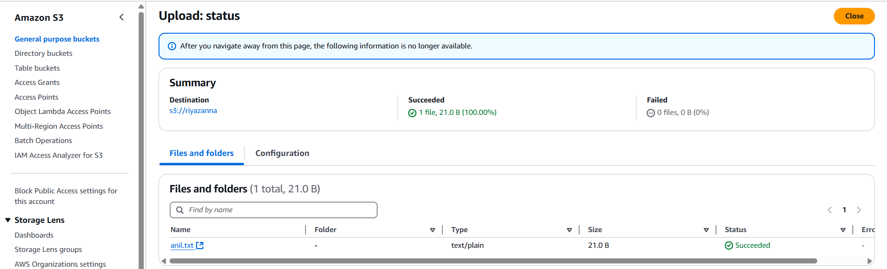

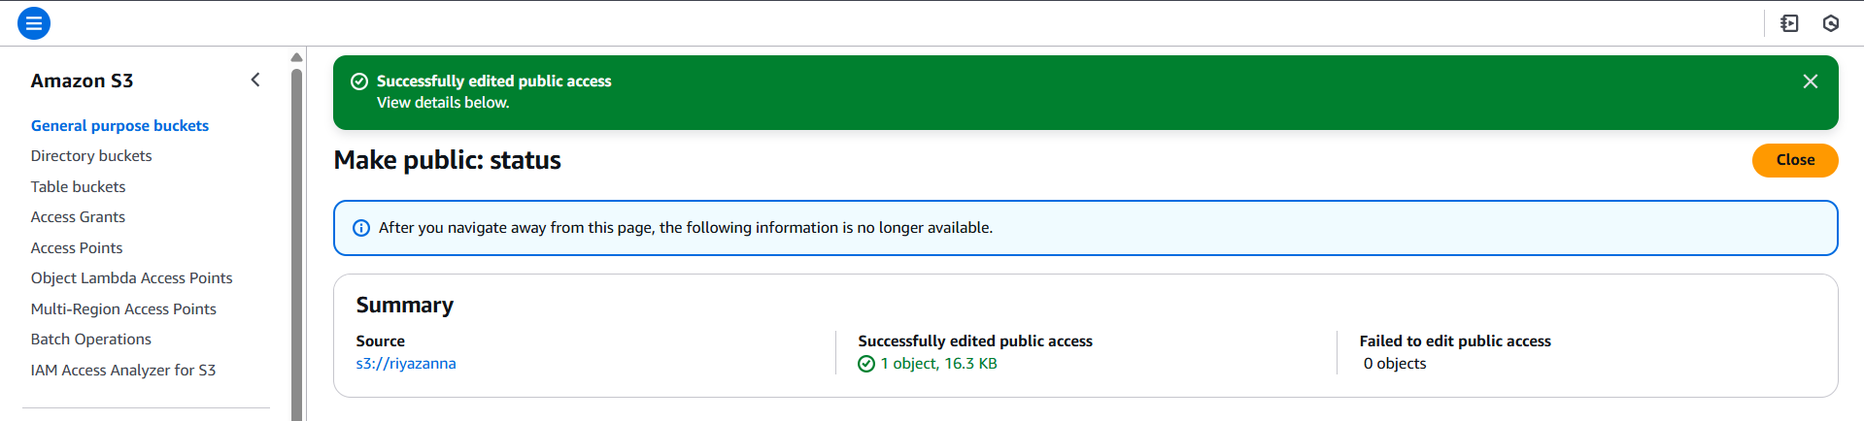 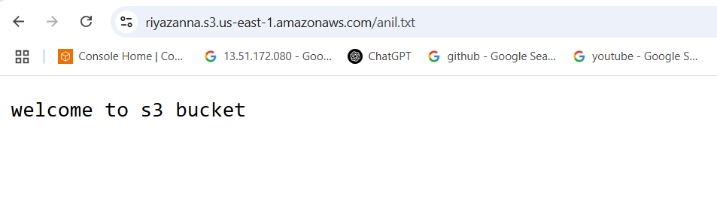

1. Enable cross region replication on s3 buckets.
2. Configure bucket policy,only Admin user can see the objects of s3 bucket.
3. Setup lifecycle policies to automatically transition or delete objects based on specific criteria.
4. Push some objects in s3 using AWS CLI.
5. Write a bash script to create s3 bucket.
6. Upload one 1 gb of file to s3 using cli.