VPC 01 TASKS:-

1. Create VPC with 2 private and 2 public subnets.

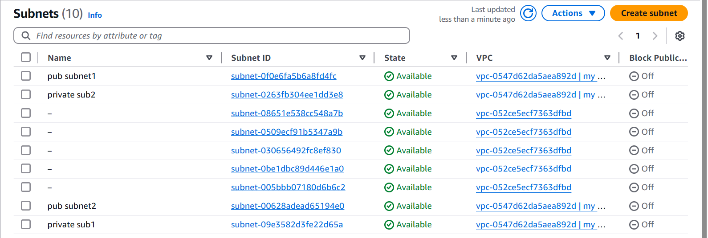

1. Enable DNS Hostname in VPC

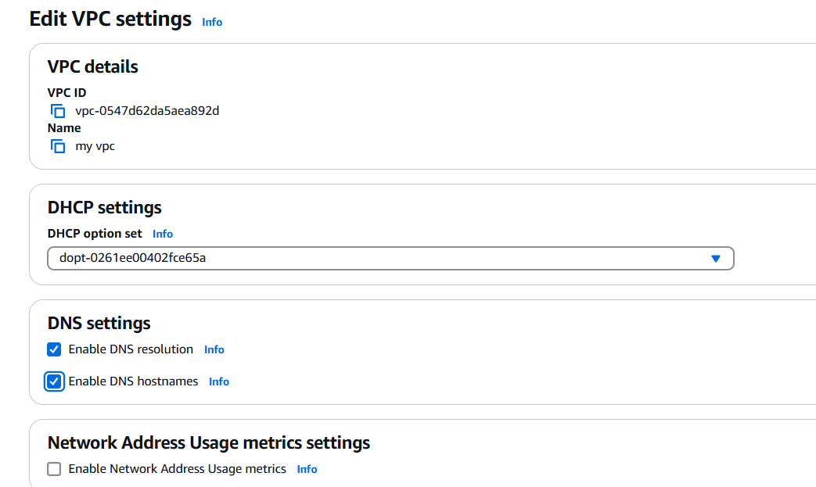

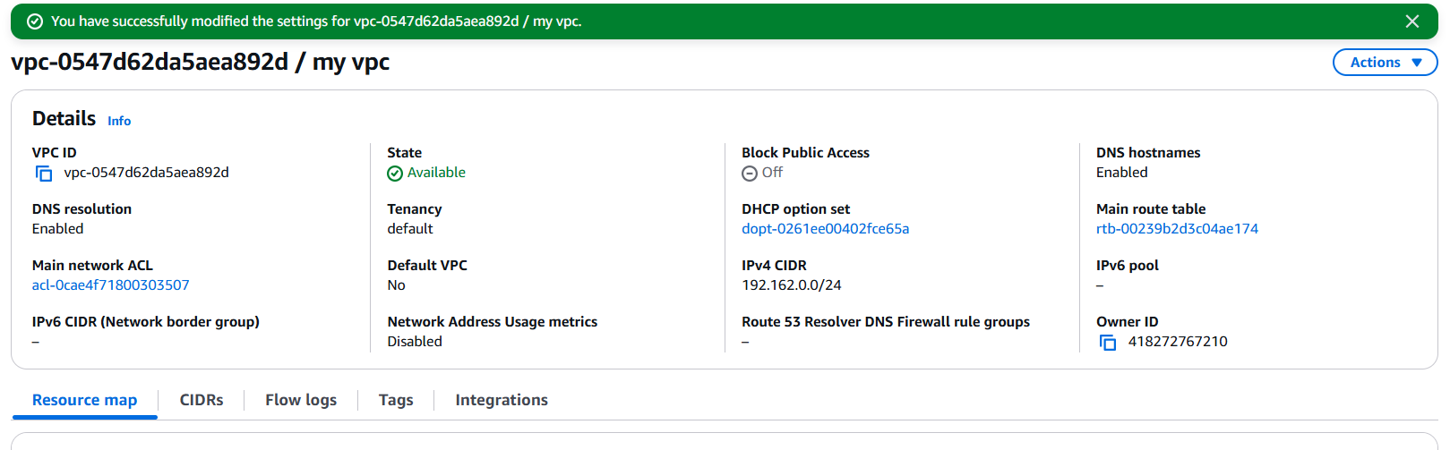

1. Enable Auto Assign Public ip in 2 public subnets

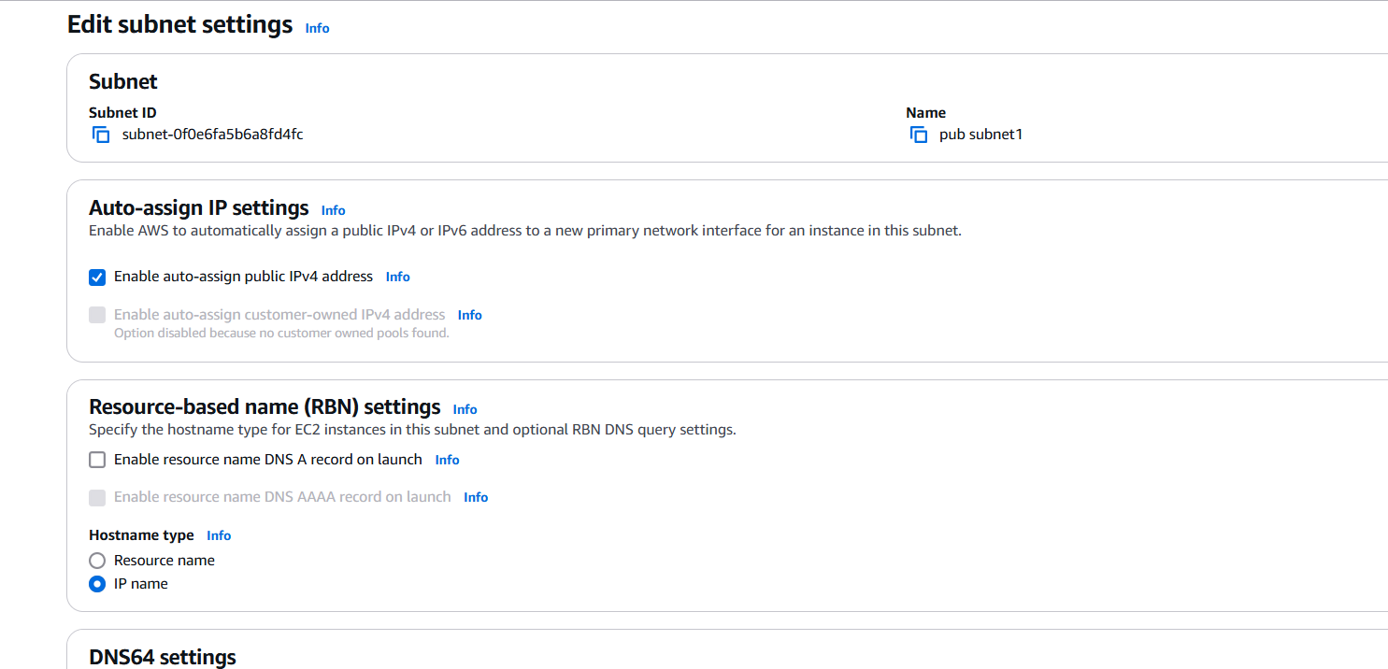

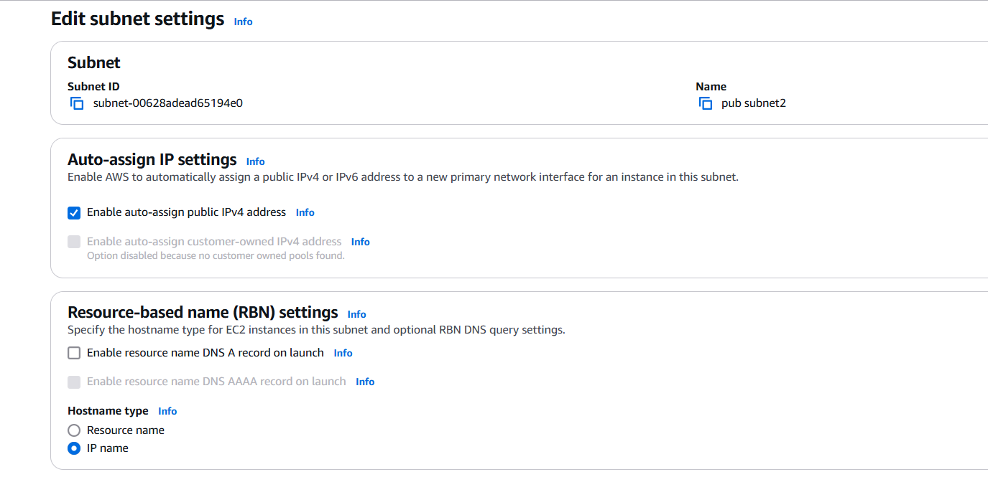

1. Add 2 private subnets in private route table

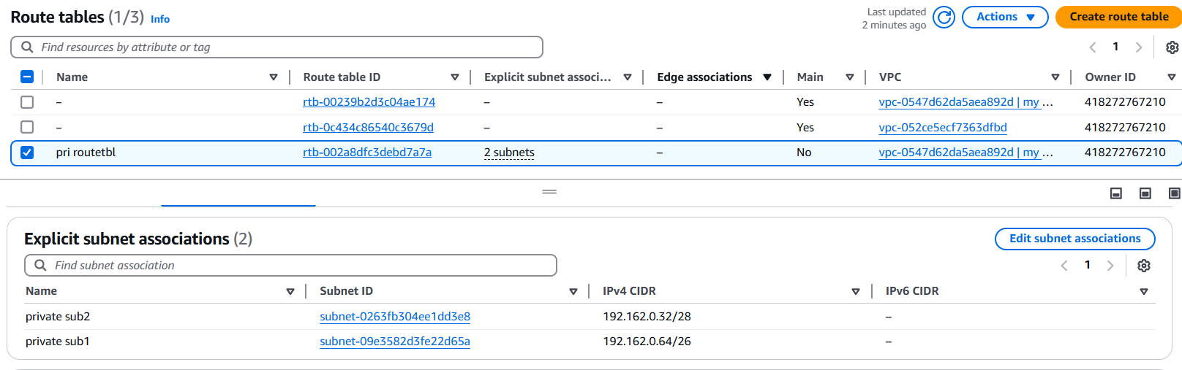

1. Add 2 public subnets in public route table

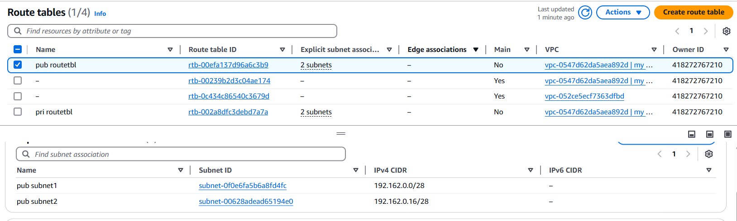

1. Public route table will have the routes to internet and local

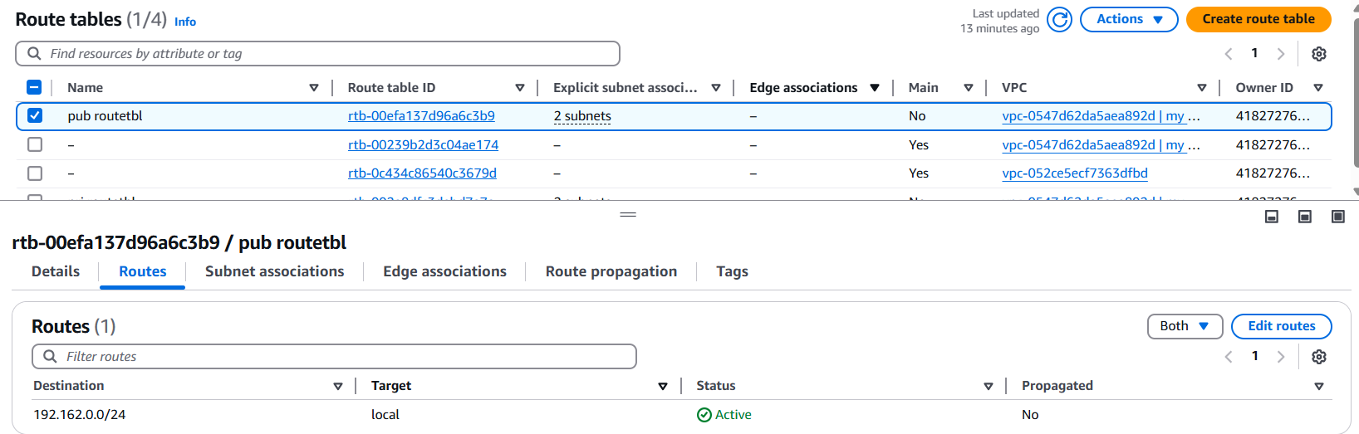

1. Create Ec2 in public subnet with t2micro and install php

* First we have to create one vpc with name “my vpc”

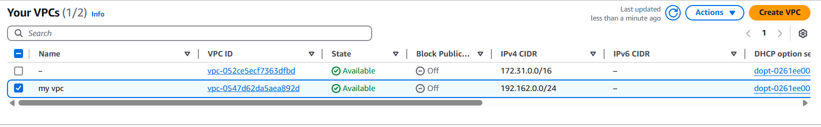

* We have to create one public subnet

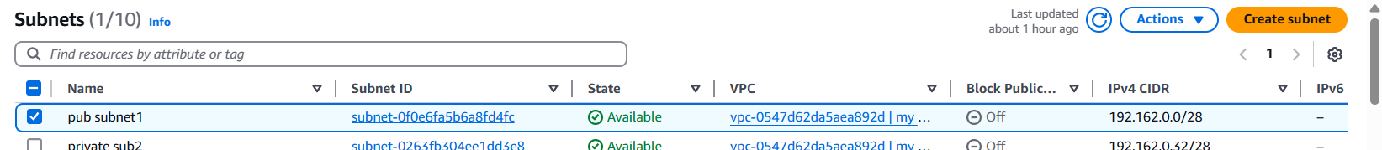

* We have to create route table

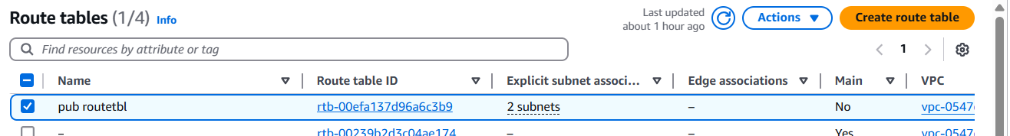

* We have to create internet gateway then attached to route table

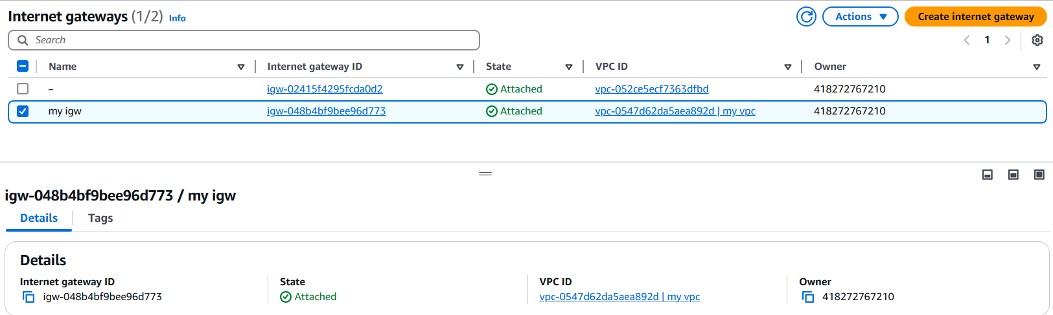

* We have create one ec2 instance with name public subnet1

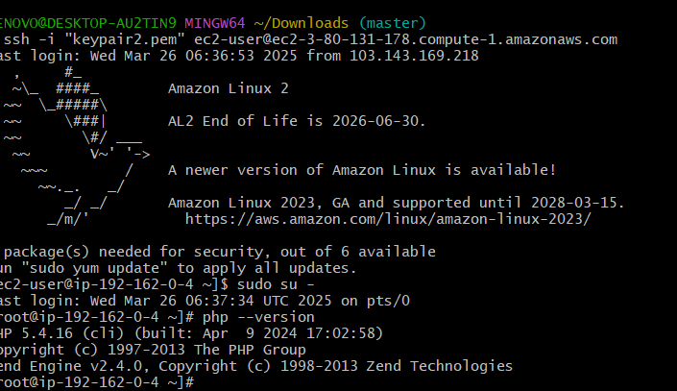

1. COnfigure Nat gateway in public subnet and connect to private Instance

1.we have to create one vpc then 1 public subnet and private subnet create

2.we have to create one public route table and one private route table

3.we have to create nat gateway with elastic ip with attach to private route table

4.we have to select public subnet

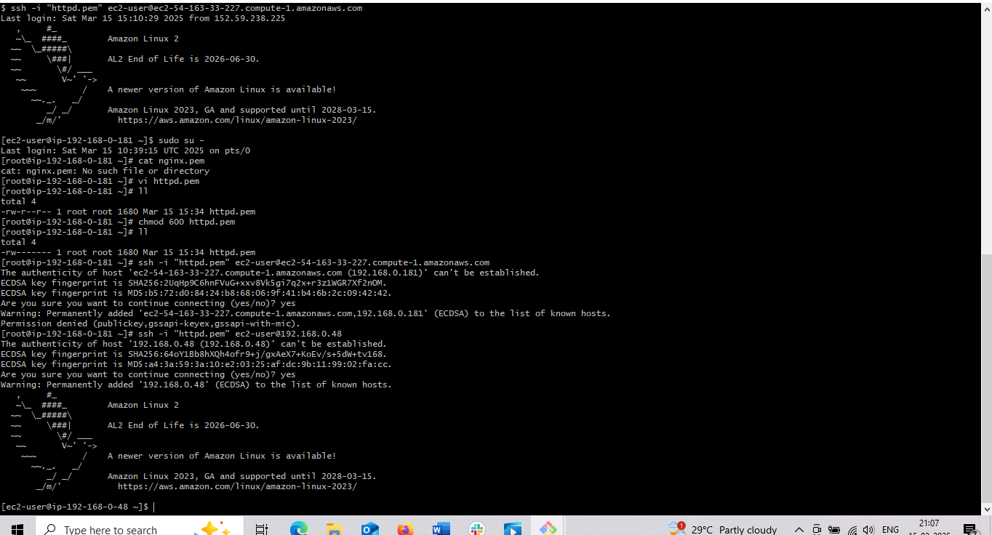

1. Install Apache Tomcat in private ec2 and deploy a sample app.

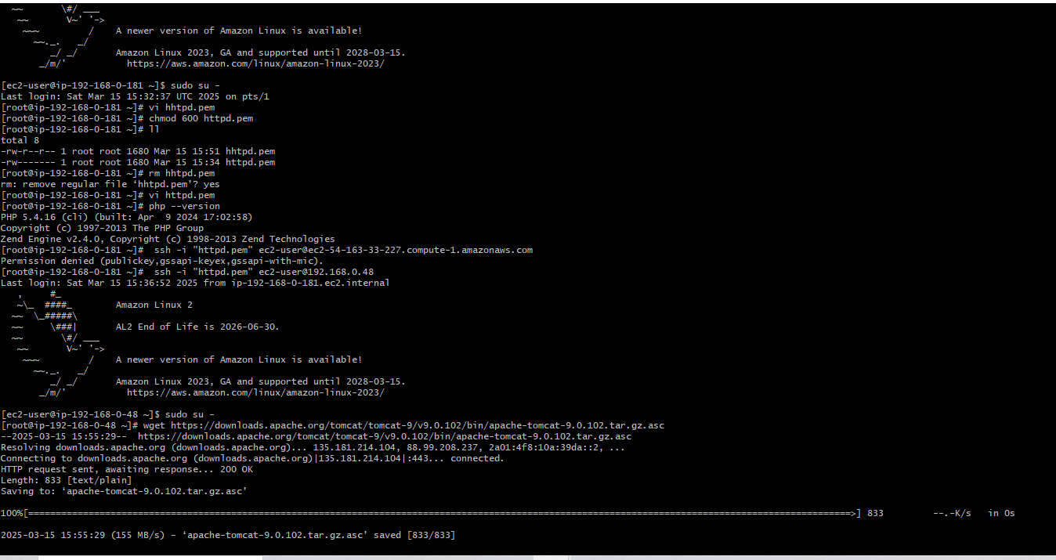

1. Configure VPC flow logs and store the logs in s3 and CloudWatch.

