**Moderate to Severe Evaluation**

Sample_ID: FVPUJE (DOG)

Cats and dogs:

Any two of the following:

(

High Red Flag Megamonas OR (failed)

High Red Flag Sutterella OR (failed)

High Red Flag Collinsella OR (failed)

Low Red Flag Bacteroides OR (failed)

Low Red Flag Blautia (failed)

);

OR

Dogs:

8 or more yellow flags: (failed)

OR 8 or more red flags: (failed)

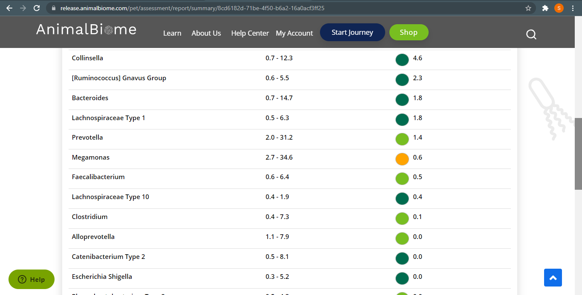

Low group evaluation

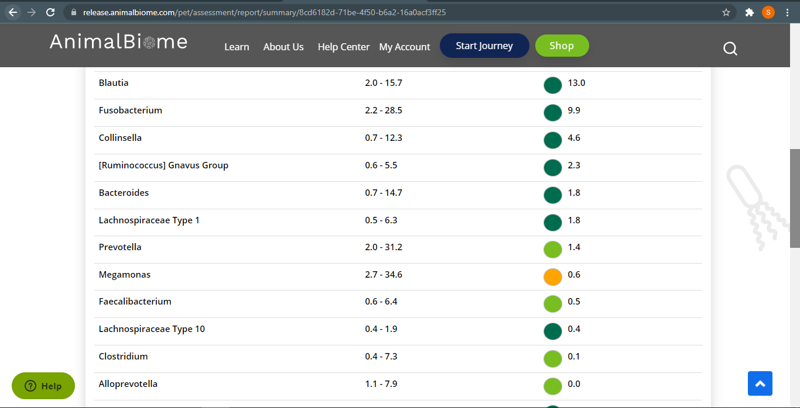

Low red bacteriorides: passed.

Low red blautia: failed.

Total yellow flags: 2

Total Red flags: 2

Moderate to severe evaluation result: failed.

**Mild to Moderate evaluation**

Mild to Moderate

Cats and dogs:

Any Two

(High Yellow Flag Megamonas OR (failed)

High Yellow Flag Sutterella OR (failed)

High Yellow Flag Collinsella OR (failed)

Low Yellow Flag Bacteroides OR (failed)

Low Yellow Flag Blautia (failed)

)

OR

Dogs: 4-7 Yellow Flags: (failed)

OR 5-7 Red Flags: (failed)

OR diet recommendation of increase fiber (failed)

OR diet recommendation of increase protein (failed)

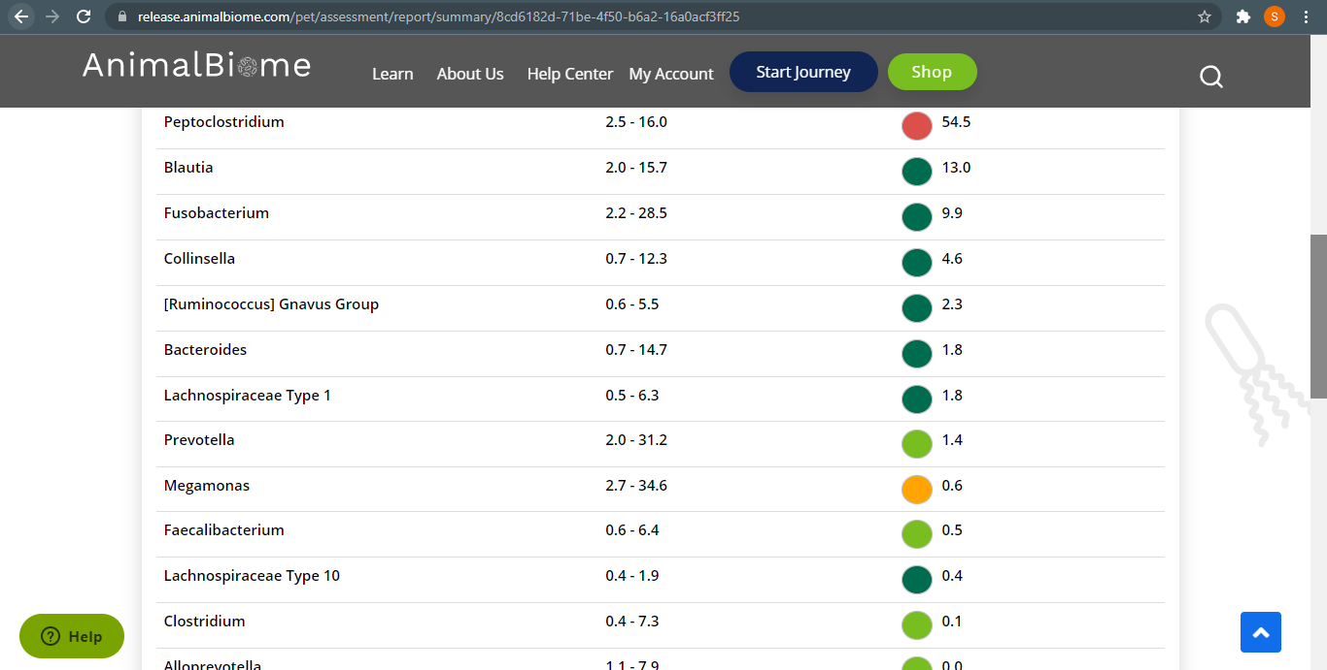

The result: False False False False False

Expected result: Balanced

Achieved result: passed

